import java.util.ArrayList;
import java.util.List;
public class VisitorAccessControl {
public static void main(String[] args){
VisitorValidator validator = new VisitorValidator();
int panduId = validator.addEmployee("pandu","se2");
int pallavId = validator.addEmployee("pallav","sse");
int karthikId = validator.addVisitor("karthik", "to meet HR");
int randomId = 33;
System.out.println(validator.isValid(panduId));
System.out.println(validator.isValid(pallavId));
System.out.println(validator.isValid(karthikId));
System.out.println(validator.isValid(randomId));
}
}

abstract class Identity{
private int id;
private String name;
public Identity(int id, String name) {
this.id = id;
this.name = name;
}
public int getId() {
return id;
}
}

class EmployeeIdentity extends Identity{
public static int empId=0;
private String designation;
public EmployeeIdentity(int id, String name, String designation) {
super(id, name);
this.designation = designation;
}
}

class VisitorIdentity extends Identity{
public static int visitorId=0;
private String purposeOfVisit;
public VisitorIdentity(int id, String name, String purposeOfVisit) {
super(id,name);
this.purposeOfVisit = purposeOfVisit;
}
}

class VisitorValidator{
List<Identity> identityList=new ArrayList<>();
public boolean isValid(int id){
for (Identity identity : this.identityList) {
if(identity.getId() == id){
return true;
}
}
return false;
}
public int addEmployee(String name,String designation){
EmployeeIdentity.empId += 1;
this.identityList.add(new EmployeeIdentity(EmployeeIdentity.empId, name, designation));
return EmployeeIdentity.empId;
}
public int addVisitor(String name, String purposeOfVisit){
VisitorIdentity.visitorId++;
this.identityList.add(new VisitorIdentity(VisitorIdentity.visitorId, name, purposeOfVisit));
return VisitorIdentity.visitorId;
}
}

UML:

Class Diagram:

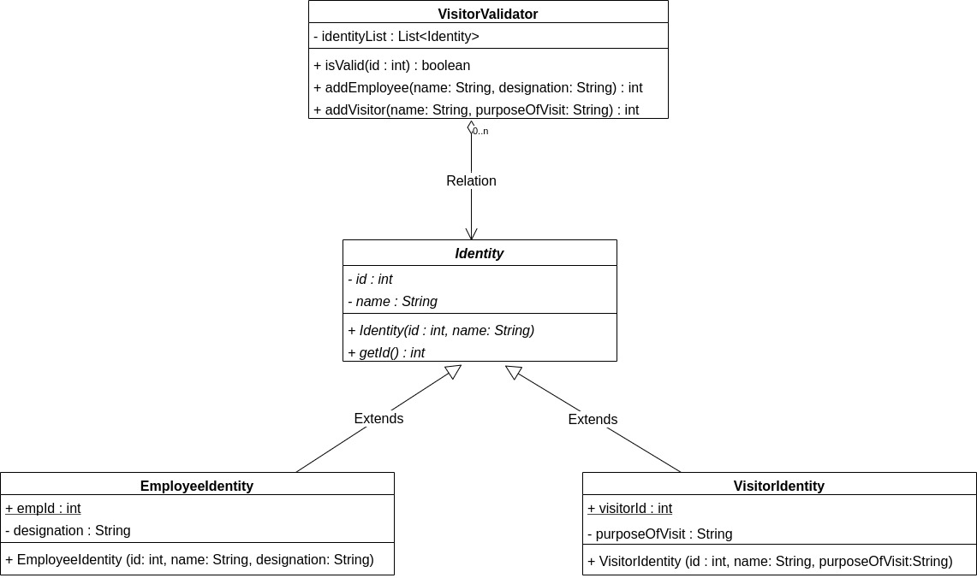

UML:

Sequence Diagram:

