**Bug#1: Text is coming out of the box, First Name and last Name field should allow only the alphabet**

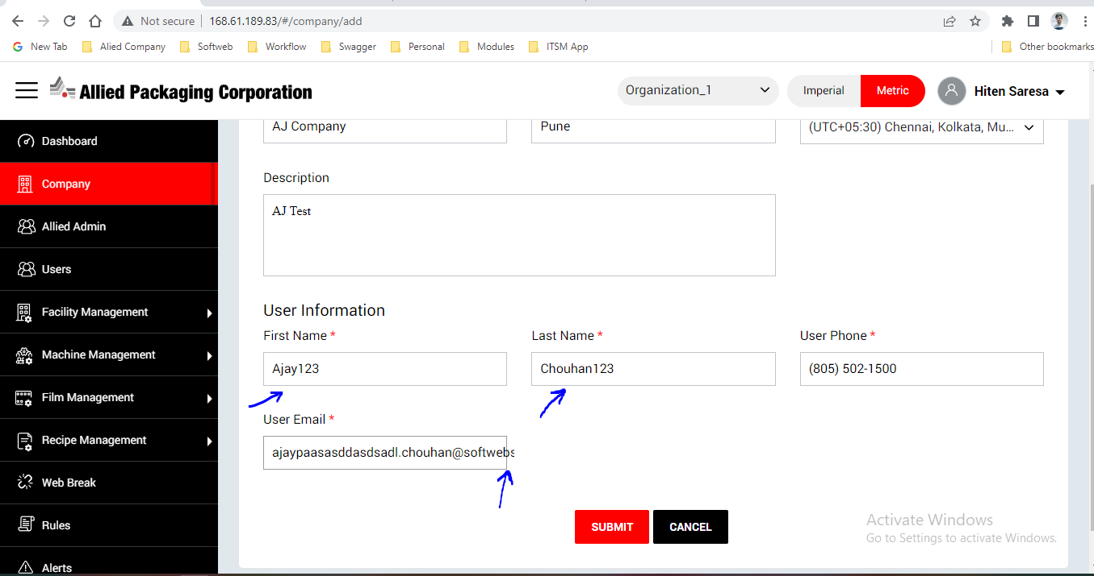

**Bug#2 – No successful message after creating a company**

**Bug#3 – After I created a company, it is showing in the company details but not showing in the drop down**

**Bug#4 – I created a Facility but I got an error of “Cannot read properties on null”**

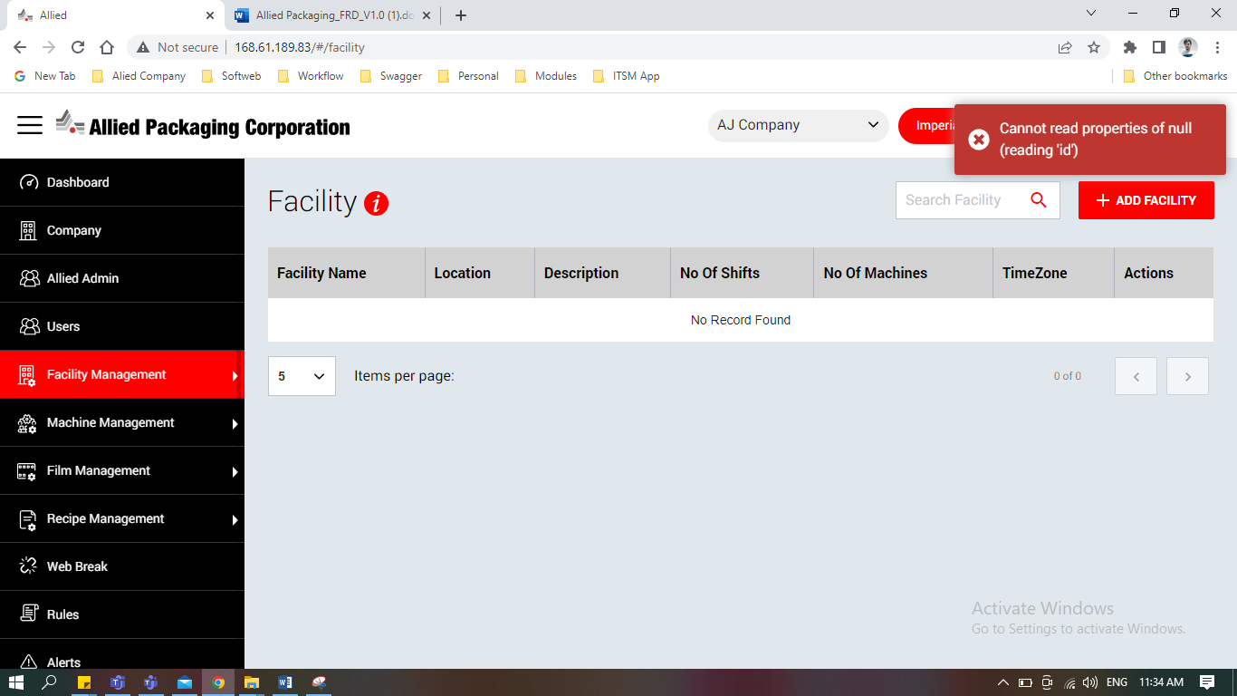

**Bug#5- While editing the Recipe I do not see the already data I have entered, it should be there, so that I can change**

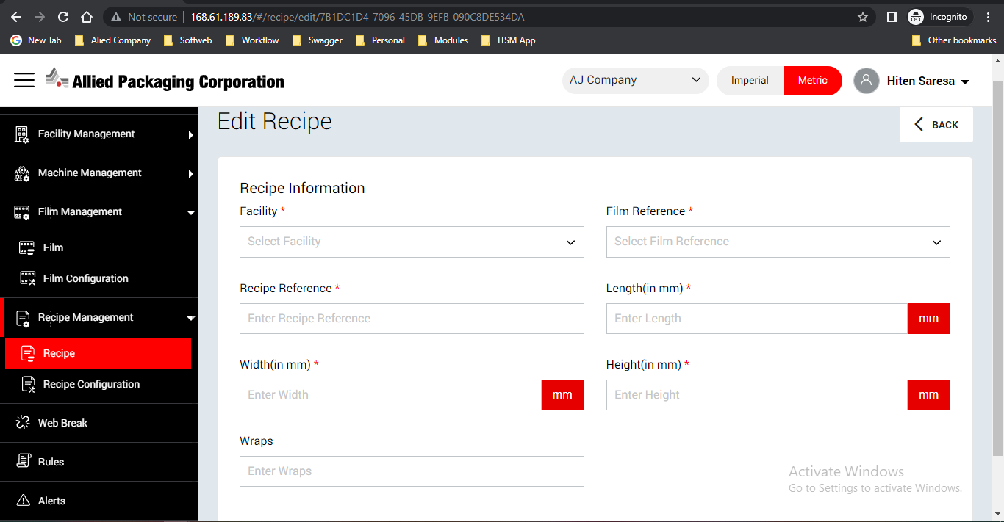

**Bug#6- As per the document, Facility column should be sort but currently it is not sorting**

**Bug#7- Company and Facilities fields are not populating when I edit the user**

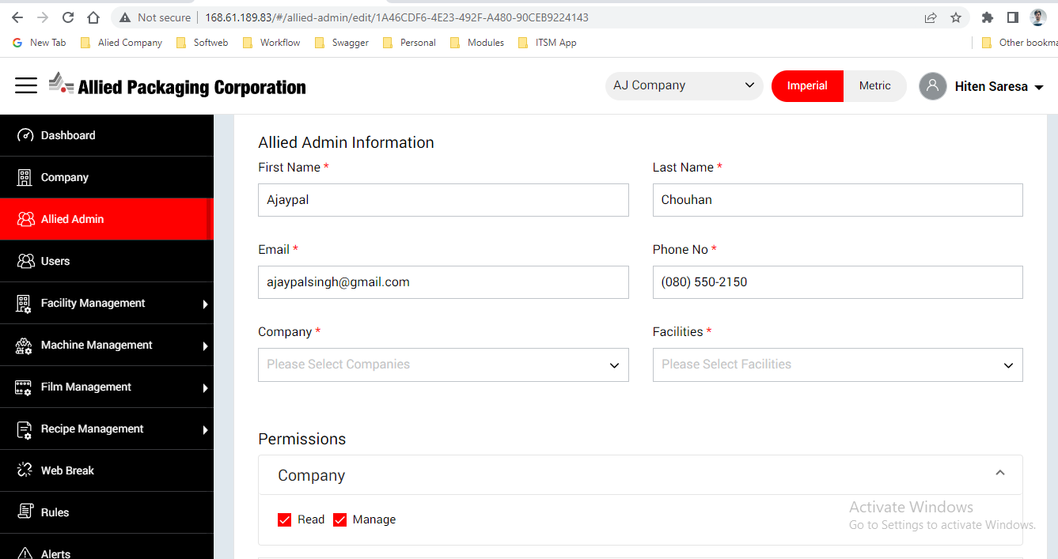

**Bug#8- Incorrect validation message when I tried to login**

1. Actual Message - Email or Password is not valid

Expected Message - Please enter valid Email ID or Password

**Bug#9-** I have not entered 8 character but no validation message for entering 8 characters

**Bug#10-** Once the user edits anything from Profile, user should be displayed as Undefined

**Bug#11-** I have not received an email when I entered the data for new user