OLYMPIC GAMES DATA ANALYSIS
Historical Trends, Sports, Participants, Medals and Regional Representation
Project Documentation
Organisation: AccioJob
Project: Olympics Data Analysis and Visualisation
Tools Used: SQL, Microsoft Excel and Microsoft Power BI
Prepared by: Panduranga Katti

1. Project Overview
The Olympic Games are an international sporting event that brings together athletes from different countries and regions to compete across a wide range of sports and events. Historical Olympic data provides an opportunity to understand how the Games have evolved over time in terms of participation, sports, events, medals, host cities and regional representation.
This project analyses historical Olympic data using a relational database containing interconnected tables for Olympic editions, cities, sports, events, participants, medals and regions. The data is explored to identify historical patterns, compare different aspects of Olympic participation and develop meaningful insights through data analysis and visualisation.
SQL and exploratory data analysis are used to examine the available data, while Microsoft Excel and Microsoft Power BI are used to organise the findings and present them through charts, summaries and interactive reports.
The final output is intended to provide a clear and accessible overview of the history and evolution of the Olympic Games, supported by analytical findings and visual representations of the data.
2. Problem Statement
The objective of this analysis is to gain valuable insights into the historical data of the Olympic Games by exploring various dimensions, including Games, sports, events, participants, medals and regional representation.
The analysis covers multiple editions of the Olympics and aims to identify trends, patterns and significant observations across these dimensions. The primary goal is to provide a detailed overview of the history and evolution of the Olympic Games.
The findings are intended to support a better understanding of Olympic participation, sporting events, medal distribution, host locations and regional representation. Based on these observations, the project also seeks to develop recommendations that may help inform future Olympic organisation, sports selection and representation of diverse regions.
The final deliverables include an analytical report, Excel-based analysis and Power BI visualisations presenting the findings and historical significance of the Olympic Games.
3. Project Objectives
The major objectives of this project are:
- Analyse Olympic history: Explore Olympic editions across different years and distinguish between Summer and Winter Games.
- Study sports and events: Examine the range of sports and events represented in the dataset.
- Understand participant demographics: Analyse participant counts, gender distribution and age-related patterns.
- Explore medal distribution: Examine recorded medal outcomes across sports, events and participating regions.
- Study hosting patterns: Identify host cities and examine how Olympic editions are distributed across locations.
- Analyse regional representation: Explore participant and medal representation across regions, while considering historical changes in regional affiliations.
- Develop visual insights: Present the analysis through charts, summaries and interactive Power BI reports.
- Communicate findings: Document the methodology, insights, limitations and potential recommendations in a clear and structured format.
4. Scope of the Project
The project focuses on the historical Olympic dataset provided for analysis. The scope includes the following areas:
- Olympic editions, years and seasons.
- Sports and associated events.
- Participant information, including gender, age, height and weight where available.
- Recorded medal outcomes.
- Host cities associated with Olympic editions.
- National Olympic Committee (NOC) codes and regional representation.
- Historical trends and comparisons presented through analytical reports.
The analysis is limited to the fields and records available in the supplied dataset. Findings should therefore be interpreted in the context of the dataset's coverage, historical naming conventions and structural limitations.
The project is descriptive and exploratory in nature. It identifies patterns in historical data rather than establishing causal relationships or making definitive predictions about future Olympic outcomes.

5. Dataset Description and Database Structure
5.1 Dataset Overview
The project uses a relational Olympic Games dataset stored in a PostgreSQL database named olympics_db. The database contains information about Olympic editions, host cities, sports, events, participants, medals and regional representation.
The database consists of 11 tables in the public schema. These tables are connected through identifiers and bridge tables, allowing information from different parts of the Olympic dataset to be analysed together.
Based on the supplied database description, the dataset contains the following reference counts:
Dataset component | Number of records
Olympic Games editions | 51
Host cities | 42
Sports | 66
Events | 757
People | 128,854
Games competitor records | 180,252
Competitor-event records | 260,971
Medal categories | 4
NOC/region records | 231
Person-region associations | 130,521
Games-city associations | 52
These counts describe the supplied database and should be interpreted according to the structure of each table. For example, a person record represents an individual, while a Games competitor record represents a person's participation in a particular Olympic edition. These are different units of analysis.
5.2 Description of Database Tables
1. Games
The games table records Olympic editions and includes the Games identifier, year, edition name and season. It supports comparisons across time and between Summer and Winter Olympics.
2. City
The city table contains unique city identifiers and city names. It is used to identify host locations associated with Olympic editions.
3. Games City
The games_city table links Olympic editions to cities. It acts as a bridge between the Games and City tables and supports analysis of hosting patterns.
4. Sport
The sport table contains the unique identifiers and names of sports represented in the dataset. It supports comparisons of sporting disciplines.
5. Event
The event table contains event identifiers, event names and their associated sport identifiers. Event names can contain descriptions of gender categories and competition types, although classifications derived from event names may require validation.
6. Person
The person table contains information about individual participants, including their identifiers, names, recorded gender, height and weight.
7. Games Competitor
The games_competitor table links people to Olympic editions in which they participated. It includes the competitor record identifier, Games identifier, person identifier and recorded age.
8. Competitor Event
The competitor_event table links competitor records to events and records the associated medal identifier. It is central to analysing event participation and recorded medal outcomes.
9. Medal
The medal table defines medal outcome categories. The supplied database description reports four records, including a category with a missing medal name that represents the non-medal outcome in the source data.
10. NOC Region
The noc_region table contains NOC codes, identifiers and region names. It provides descriptive information for regional comparisons, but historical region names should not automatically be interpreted as modern country boundaries.
11. Person Region
The person_region table links people to region records through person and region identifiers. A person may have more than one region association, so this table must not be treated as a one-row-per-person dataset.
5.3 Data Dictionary
A separate worksheet named Data Dictionary is included in the Excel workbook. It documents the database tables, important columns, their meanings and their roles in the data model.
The data dictionary supports interpretation of the dataset and helps explain how the tables relate to one another. Primary keys identify records, while foreign keys and bridge tables connect related entities.
The dictionary should reflect the actual database schema. Any additional fields created during analysis, such as a decade grouping, should be identified as derived fields rather than original database columns.
6. Tools and Technologies Used
The project uses PostgreSQL, Python, SQLAlchemy, Pandas, Microsoft Excel and Microsoft Power BI. Each tool serves a distinct purpose in the analytical workflow.
6.1 PostgreSQL
PostgreSQL is the relational database management system used to store the Olympic dataset. It provides structured tables and relationships that allow data to be retrieved and analysed using SQL.
SQL was used to query the database, inspect records, select relevant columns, join related tables and calculate summaries needed to answer the exploratory analysis and reporting questions.
6.2 Python
Python was used as the programming environment for connecting to PostgreSQL and executing SQL queries during the exploratory analysis stage.
It provided a convenient way to run queries repeatedly, inspect results and transfer the outputs into a tabular format for further examination.
6.3 SQLAlchemy
SQLAlchemy was used to establish the connection between Python and PostgreSQL.
The database connection was configured using SQLAlchemy's database URL functionality, with the PostgreSQL driver, host, port and database name specified in the connection configuration.
The connection was then used to execute SQL statements against the database. This allowed the analysis to be performed directly on the database without manually exporting every source table first.
6.4 Pandas
Pandas was used to receive SQL query results and represent them as DataFrames in Python.
A DataFrame is a two-dimensional tabular data structure containing rows and columns. It is suitable for inspecting query results, checking column names, reviewing returned records and preparing data for further analysis or export.
In this project, the workflow used pandas.read_sql() to read the results of SQL queries executed through the SQLAlchemy connection.
The Python helper function sql() returned the result of a query as a Pandas DataFrame. Additional helper functions were used to preview table records, inspect available columns and identify columns shared between tables.
This approach provided several benefits:
- It made query results easy to inspect directly in Python.
- It allowed table structures and column names to be examined without manually opening each database table.
- It supported an iterative exploratory workflow in which SQL queries could be adjusted and their outputs reviewed.
- It provided a tabular representation suitable for subsequent analysis and export when required.
SQL remained responsible for retrieving and aggregating the database data, while Pandas provided the Python-side tabular representation of the query results. The workflow therefore combined database querying with Python-based inspection rather than requiring the entire database to be loaded into memory at once.
6.5 Microsoft Excel
Microsoft Excel was used to organise and present the EDA outputs.
The workbook contains separate worksheets for the 18 exploratory analysis questions, together with summary and supporting sheets. This structure makes individual query results easier to locate and compare.
Excel also supports the presentation of summary tables and charts that communicate the main observations from the analysis.
6.6 Microsoft Power BI
Microsoft Power BI was used to build an interactive reporting layer on top of the PostgreSQL dataset.
The tables were loaded into Power BI Desktop, and relationships were established between related entities. DAX measures and visualisations were then used to examine Olympic editions, sports, events, participants, medals and regional representation.
The completed report is organised into five pages:
- Olympic Overview
- Sports & Events
- Athlete Demographics
- Medal Analysis
- Regional Participation
These pages group related questions into logical sections and allow users to explore different aspects of the dataset through charts and available filters.

7. Data Extraction and Analysis Methodology
The project followed a structured workflow to explore the historical Olympic dataset, answer 18 analytical questions, and prepare the results for reporting and visualization.
7.1 Database Connection
PostgreSQL was used as the primary database for storing and querying the Olympic dataset. Python was connected to the olympics_db database using SQLAlchemy. This connection allowed SQL queries to be executed from the Python environment in Visual Studio Code.
7.2 Data Inspection
Before performing the analysis, the database tables were inspected to understand their structure and contents. Python helper functions were used to retrieve sample records, examine column names, and identify common columns between tables. This helped establish which tables and fields were relevant to each analytical question.
7.3 SQL-Based Exploratory Data Analysis
A set of 18 SQL queries was developed to investigate different aspects of the Olympic Games. The queries covered historical Games editions, sports and events, athlete demographics, medal performance, participation, and regional representation.
Each query was designed to address a specific project question by retrieving, filtering, grouping, joining, or aggregating relevant data from the database tables.
7.4 Use of Python and Pandas
Python was used to execute the SQL queries and manage their results. SQLAlchemy provided the database connection, while Pandas was used to receive the query results in a structured tabular format called a DataFrame.
The pandas.read_sql() function was used with the SQLAlchemy connection to execute a query and load its results into a Pandas DataFrame. This made it easier to inspect the returned records, review column names, and work with the results in Python.
Helper functions were also used to retrieve sample records and examine table columns. These functions supported database exploration and helped organize the analysis workflow.
Role of Pandas in the project: Pandas served as the bridge between SQL query results and Python-based analysis. PostgreSQL performed the database queries, while Pandas provided a convenient way to access and inspect the resulting tables. The analysis results were then organized into an Excel workbook containing 18 query-result sheets, corresponding to the 18 exploratory questions.
7.5 Excel-Based Results Organization
The results from the 18 SQL queries were organized into an Excel workbook. Each of the 18 analysis sheets represented the output of a corresponding exploratory question. The workbook provided a consolidated way to review the results and supported the documentation and reporting stages of the project.
7.6 Power BI Visualization
Power BI Desktop was connected to the PostgreSQL database to build interactive dashboards. The database tables and their relationships were used to create visualizations for the Olympic overview, sports and events, athlete demographics, medal analysis, and regional participation.
The dashboards helped present the analysis in a visual format, making historical trends, comparisons, and patterns easier to interpret.
7.7 Overall Workflow
The overall workflow was:
- Connect Python to the PostgreSQL database using SQLAlchemy.
- Inspect database tables, sample records, and column structures.
- Develop and execute 18 SQL queries to answer the project questions.
- Load query results into Pandas DataFrames for structured inspection.
- Organize the 18 query outputs into an Excel workbook.
- Connect Power BI to PostgreSQL and develop interactive dashboard pages.
- Interpret the findings and prepare conclusions and recommendations.
This workflow combined database querying, Python-based result handling, spreadsheet-based organization, and business intelligence visualization to analyze the historical Olympic dataset.

8. Database Relationships and ER Diagram
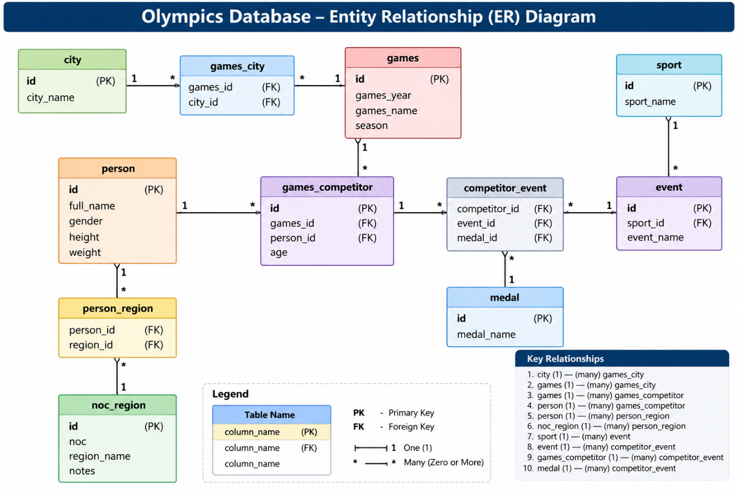
8.1 Introduction
An Entity Relationship (ER) Diagram is a visual representation of the tables in a database and the relationships between them. It helps explain how information is stored, connected, and retrieved.
The Olympic database contains 11 tables: city, games_city, games, games_competitor, person, person_region, noc_region, sport, event, competitor_event, and medal.
These tables collectively store information about Olympic editions, host cities, athletes, sports, events, medals, and regional representation. The ER diagram provides an overview of the database structure and supports understanding the joins required for SQL analysis and Power BI reporting.
8.2 Explanation of the Tables
1. City
The city table stores information about cities associated with the Olympic Games. Its primary key is id, and city_name stores the city name.
2. Games
The games table stores information about Olympic editions, including the year, Games name, and season. Its primary key is id. The season identifies whether an edition was held in Summer or Winter.
3. Games City
The games_city table connects Olympic editions with their host cities. It contains games_id and city_id, which reference the games and city tables, respectively. This linking table allows the database to represent the association between Games editions and cities.
4. Person
The person table stores athlete information, including the person's ID, full name, gender, height, and weight. The primary key is id.
5. Games Competitor
The games_competitor table connects athletes to particular Olympic editions. It contains an athlete reference (person_id), a Games reference (games_id), and the athlete's age for that participation record. Its id identifies each participation record.
6. Sport
The sport table stores the list of sports represented in the dataset. Its primary key is id, and sport_name stores the sport name.
7. Event
The event table stores individual Olympic events. It contains sport_id, which references the sport associated with an event, along with the event name. Its primary key is id.
8. Competitor Event
The competitor_event table connects athlete participation records with specific events and medal outcomes. It contains competitor_id, event_id, and medal_id, which link to games_competitor, event, and medal, respectively.
9. Medal
The medal table stores medal categories through its id and medal_name fields. The dataset contains three named medal categories and one record with a blank medal name, which should be interpreted according to the source data rather than assumed to be a fourth medal type.
10. NOC Region
The noc_region table stores National Olympic Committee (NOC) codes and associated region names. Its primary key is id. The table provides the regional labels used in participation and medal analyses.
11. Person Region
The person_region table links people to regional records using person_id and region_id. These fields reference person and noc_region, respectively. Because a person can have more than one regional record, this table should not automatically be treated as a one-person-to-one-region mapping.
8.3 Explanation of the Relationships
The principal database relationships are as follows:
- City and Games City: One city can be associated with multiple records in games_city, and each games_city record references a city.
- Games and Games City: One Olympic edition can have one or more associated city records. The linking table connects each record to its Games edition.
- Games and Games Competitor: One Olympic edition can have many athlete participation records.
- Person and Games Competitor: One person can have multiple participation records across different Olympic editions.
- Person and Person Region: One person can have multiple regional association records in the bridge table.
- NOC Region and Person Region: One region can be associated with multiple records in person_region.
- Sport and Event: One sport can contain multiple events, while each event references a sport.
- Event and Competitor Event: One event can be associated with multiple competitor-event records.
- Games Competitor and Competitor Event: One athlete participation record can be associated with multiple event records.
- Medal and Competitor Event: One medal category can be referenced by multiple competitor-event records.
These relationships make it possible to combine information across tables using SQL joins and to build a connected data model in Power BI.
8.4 Importance of the ER Diagram
The ER diagram is important for this project for several reasons:
- It explains how the Olympic database is organized.
- It helps identify the primary and foreign keys needed to join tables.
- It supports the creation of SQL queries involving athletes, Games, sports, events, medals, and regions.
- It helps establish relationships between tables in Power BI.
- It reduces the risk of interpreting a table in isolation when the analysis requires information from multiple tables.
8.5 Conclusion
The Olympic database uses a relational structure in which separate tables represent different entities and linking tables connect related records. Understanding these relationships provided the foundation for the 18 SQL-based exploratory analyses and the Power BI dashboards developed for the project.

9. Exploratory Data Analysis (EDA) and Key Findings
9.1 Overview of the Analysis
Exploratory Data Analysis (EDA) was performed to identify historical trends and patterns in Olympic Games data. Eighteen analytical questions were addressed using SQL queries executed against the PostgreSQL database. The results were retrieved into Pandas DataFrames and organized into an Excel workbook, with a separate result sheet for each question.
The analysis covered Olympic history, Games scale, sports and events, gender representation, athlete demographics, regional participation, medal performance, and changes in participation over time.
The following sections summarize the questions investigated, the analytical approach, and the key findings obtained from the Excel results.
9.2 Analysis of the 18 Questions
Q1. How frequently have the Olympic Games been hosted throughout history?
Analysis approach: Olympic editions were examined by year and season to identify the frequency of the Games and the intervals between editions.
Key finding: The dataset records Summer and Winter Olympic editions across multiple decades. Gaps are visible in the historical year sequence, particularly around the World War periods.
Interpretation: The year sequence helps illustrate the historical continuity and interruptions in the recorded Games. The database identifies the gaps, but it does not independently establish their historical causes.
Q2. How has the scale of the Olympic Games changed over time?
Analysis approach: The number of events and participant records was compared across Olympic editions, separately for Summer and Winter Games.
Key findings:
- Summer Olympic events increased from 42 in 1896 to 306 in 2016.
- Summer participant records increased from 72 in 1896 to 11,176 in 2016.
- Winter Olympic events increased from 17 in 1924 to 98 in 2014.
- Winter participant records increased from 265 in 1924 to 2,743 in 2014.
Interpretation: The recorded data shows a substantial expansion in the scale of both Summer and Winter Olympic competitions. Actual Games duration in days could not be calculated because opening and closing dates are not available in the database.
Q3. Which Olympic editions stand out in terms of participation and event scale?
Analysis approach: Olympic editions were compared using participant counts, event counts, and competitor-event records.
Key findings:
- The 1896 Summer Olympics in Athina had the smallest recorded participant count in the analysis, at 72.
- The 2016 Summer Olympics in Rio de Janeiro had the largest recorded participant count, at 11,176.
Interpretation: These editions illustrate the difference between the scale of the early modern Olympics and the latest edition represented in the dataset. This comparison identifies notable editions by scale rather than by specific historical incidents.
Q4. Which sports appear as more recent additions in the dataset?
Analysis approach: Sports were examined using their first observed year, latest observed year, number of editions represented, and distinct event counts.
Key findings: Rugby Sevens, Taekwondo, and Triathlon appear among the sports with relatively recent first-observed years in the query results. Rugby Sevens is first observed in 2016, while Taekwondo and Triathlon are first observed in 2000.
Interpretation: These results help identify sports that appear more recently in the available records. A sport's first observed year in this dataset should not automatically be treated as its official Olympic introduction year.
Q5. Which sports show stronger participation and event presence over time?
Analysis approach: Participation counts, event counts, and competitor-event records were compared across sports and Olympic editions.
Key finding: Athletics has the highest peak participant count in the query results, followed by Swimming.
Interpretation: These measures help compare the scale of sports within the Olympic programme. Participation and event counts indicate Olympic presence, but they do not directly measure television audiences, public interest, or overall popularity.
Q6. How does participation vary by region and sport?
Analysis approach: The analysis grouped participation by region and sport, comparing unique participants, editions participated in, and distinct events.
Key finding: The results provide a detailed region-by-sport view that can be used to identify concentrations of participation in particular sports.
Interpretation: This analysis supports comparisons of regional representation across sports. However, participation patterns alone do not prove that a sport is culturally specific to a region or that a region performs better in medal competition.
Q7. How are Olympic events distributed across gender categories?
Analysis approach: Event names were classified into Men, Mixed / Combined, and Unspecified categories, and the number of events in each category was counted.
Key findings:
- Men: 458 events
- Mixed / Combined: 211 events
- Unspecified: 88 events
Interpretation: The results provide an initial overview of gender-related event classification in the dataset. Because these categories were derived from event names, the classification should be validated before drawing firm conclusions about gender equality or programme balance.
Q8. Which individual events appear as recent additions in the dataset?
Analysis approach: Individual events were examined using their first observed year, latest observed year, and number of editions represented.
Key finding: The query identifies events whose first observed year is relatively recent within the available participation records. Examples in the results include Rugby Sevens events and certain women's events recorded in 2016.
Interpretation: This analysis helps identify events for further investigation into Olympic programme changes. The first observed year in the available records is not, by itself, proof of the official introduction year.
Q9. Which events are no longer observed in the latest dataset year?
Analysis approach: The last observed year for each event was compared with the latest dataset year, 2016.
Key finding: The analysis identifies 451 event records whose last observed year is earlier than 2016.
Interpretation: These records can help identify events that may have changed, been replaced, or disappeared from later editions represented in the dataset. However, an earlier last-observed year does not prove that an event was officially discontinued.
Q10. How have athlete height and weight patterns changed over time?
Analysis approach: Average and median height and weight were compared by year, gender, and season. The number of participants with measurements was also considered.
Key finding: The results provide year-by-year comparisons of athlete body measurements, allowing differences across genders, seasons, and Olympic editions to be explored.
Interpretation: Changes in these measurements may reflect differences in sport composition, participant characteristics, and the availability of measurements. They should not automatically be interpreted as evidence of a universal increase in athlete size or performance.
Q11. Which regions have the highest medal counts across different sports?
Analysis approach: Medal-bearing competitor-event records were grouped by region and sport, with gold, silver, and bronze totals compared.
Key finding: The analysis provides a detailed breakdown of medal awards across regions and sports, enabling comparisons within individual sports.
Interpretation: Comparing regions within the same sport is useful because sports differ in the number of events and medal opportunities. In addition, team events may contribute medal-bearing records for multiple athletes, so these counts should not always be interpreted as counts of unique medals awarded to a region.
Q12. How do medal-entry rates vary by region, sport, gender, and age group?
Analysis approach: Competitor-event entries and medal-winning entries were compared across regions, sports, gender categories, and age groups. Medal-entry rates were calculated for these groups.
Key finding: The results show variation in medal-entry rates across different combinations of region, sport, gender, and age group.
Interpretation: These comparisons help identify groups for further analysis of competitive outcomes. They are descriptive associations and do not establish that age, gender, region, or any single factor causes better performance. The meaning of the rate also depends on the query's definition of an entry and a medal-winning entry.
Q13. Which regions demonstrate consistent medal-winning presence across Olympic editions?
Analysis approach: Regions were compared using the number of editions in which they recorded medals, total medal-bearing records, gold medal counts, and average medal awards per medal-winning edition.
Key findings:
- In the Summer Games results, the UK recorded medal presence in 29 editions.
- In the Winter Games results, Canada recorded medal presence in 22 editions.
Interpretation: These results highlight regions with repeated medal-winning presence over time. Consistency here means appearing among medal-winning regions across multiple editions, not necessarily finishing first in each edition.
Q14. How does medal performance differ between regions within individual sports?
Analysis approach: Medal-bearing records were grouped by region and sport, with total, gold, silver, and bronze counts compared.
Key finding: The results provide a detailed region-by-sport medal table, allowing sport-specific comparisons of medal performance.
Interpretation: This analysis acts as a drill-down from the overall regional medal analysis in Q11. It helps distinguish overall medal totals from performance within particular sports.
Q15. Which regional medal achievements may be worth investigating as notable first appearances?
Analysis approach: Medal records were examined by year, season, region, and sport to identify potential first-appearance cases and notable recent medal outcomes.
Key finding: Fiji in Rugby Sevens, Australia in Rugby Sevens, and Croatia in Sailing appear among the recent cases identified by the query.
Interpretation: These results provide candidates for further historical investigation. They should not be described as definitive first-ever medals or unexpected victories without validating the relevant region's complete medal history and the query's first-appearance logic.
Q16. How has Olympic participation changed across regions over time?
Analysis approach: Regional participant counts were compared across editions, including absolute changes and percentage changes from the previous edition.
Key finding: The results allow increases and decreases in regional participation to be examined over time.
Interpretation: The analysis helps identify changes in representation across Olympic editions. Percentage changes can be unusually large when the previous edition had very few participants, so both absolute changes and underlying counts should be reviewed before interpreting a large percentage as a major trend.
Q17. Which regions show notable participation and medal patterns within specific sports?
Analysis approach: Unique participants, editions participated in, competitor-event entries, medal-winning entries, and medal-entry rates were compared by region and sport.
Key finding: The results identify differences in participation levels and medal-entry rates across region-sport combinations. For example, the workbook includes detailed comparisons for Alpine Skiing across several regions.
Interpretation: These comparisons can reveal sport-specific patterns that may be hidden by overall medal totals. The data can identify associations for further investigation, but it cannot independently establish cultural or geographical causes of those patterns.
Q18. Which regions have the highest overall medal impact in the dataset?
Analysis approach: Total medal-bearing competitor-event records, gold, silver, and bronze counts, editions with medals, and sports with medals were compared by region.
Key findings:
- USA ranks first in the query results with 5,414 medal-bearing competitor-event records.
- Soviet Union ranks second with 2,658 medal-bearing competitor-event records.
- Germany follows with 2,395 medal-bearing competitor-event records.
Interpretation: The results highlight regions with substantial recorded medal-bearing participation across the dataset. These figures are based on competitor-event records, so multiple athletes from a team event may each contribute a record. They should not be treated as counts of unique medal objects.
9.3 Overall Insights from the EDA
The 18 analyses provide several broad insights into the historical Olympic dataset:
- Expansion of the Games: Event counts and participant records increased substantially between the earliest and latest editions represented in the dataset.
- Changes in sports and events: First-observed and last-observed years help identify sports and events that merit further research into programme changes.
- Regional variation: Participation and medal records differ by region and sport, making sport-specific comparisons more informative than relying only on overall totals.
- Athlete demographics: Height and weight data allow descriptive comparisons by year, gender, and season, subject to measurement availability and differences in the sports represented.
- Gender classification: The event-name analysis offers an initial view of gender categories, but its results require validation before being used to evaluate programme balance.
- Repeated competitive presence: Some regions appear among medal-winning regions across many editions, demonstrating sustained participation in medal competition.
- Need for careful interpretation: Participation counts, medal-bearing records, and first- or last-observed years are useful analytical measures, but they do not independently prove popularity, causation, or official historical programme changes.
9.4 Conclusion of the EDA
The exploratory analysis transformed the Olympic database into a structured set of findings covering historical Games editions, sports and events, athlete demographics, regional participation, and medal performance.
The 18 SQL query outputs were organized into Excel sheets so that results could be reviewed individually and compared across related questions. These findings provided a basis for selecting visualizations and developing the Power BI dashboard.
The EDA also highlighted the importance of understanding the database structure, checking how counts are defined, and acknowledging limitations when interpreting historical trends. These considerations were carried forward into the dashboard design and final project recommendations.

10. Power BI Dashboard Development and Visualization
10.1 Introduction
Power BI Desktop was used to develop an interactive dashboard for presenting the findings of the Olympic data analysis. The dashboard connects to the PostgreSQL database and uses relationships between the database tables to analyze Olympic editions, sports, events, athlete demographics, medals, and regional participation.
The report consists of five pages. Each page focuses on a different aspect of the analysis, allowing users to explore historical patterns and compare results through visualizations.
The five dashboard pages are:
- Olympic Overview
- Sports & Events
- Athlete Demographics
- Medal Analysis
- Regional Participation
Screenshots of all five pages are included in this report to document the final dashboard layout and the visualizations developed.
10.2 Dashboard Page 1: Olympic Overview
Purpose: To provide a high-level overview of Olympic editions, host cities, and the distribution of Games across different decades and seasons.
Visualizations included:
- Total Olympic editions by season, comparing Summer and Winter Games.
- Hosted Olympic editions by city, showing cities associated with multiple editions.
- Total Olympic editions by decade, illustrating the historical distribution of the Games.
Key observations:
- The dataset contains more Summer editions than Winter editions.
- Athens and London appear among the cities associated with multiple Olympic editions in the displayed results.
- The decade chart shows the distribution of recorded Olympic editions across the historical timeline, including periods with interruptions in the sequence.
Interpretation: This page establishes the historical context of the dataset. It helps users understand how the Games are distributed across seasons, cities, and decades before exploring sports, athletes, and medals in greater detail.

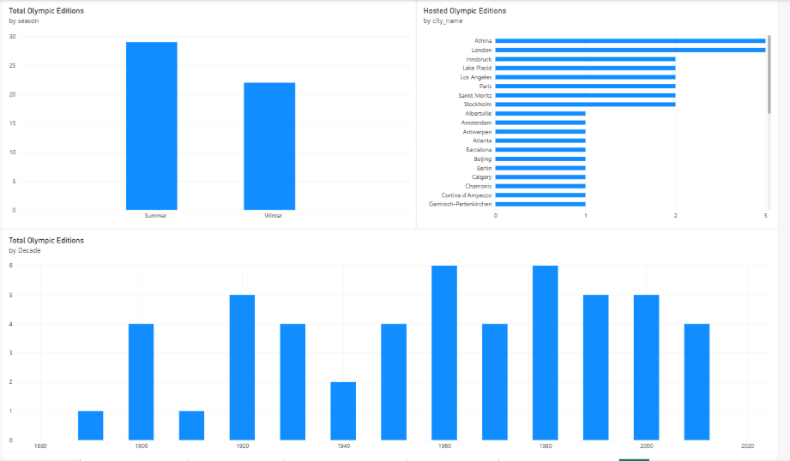
10.3 Dashboard Page 2: Sports & Events
Purpose: To explore the sports represented in the Olympic Games, compare event counts, and examine how participation and event numbers have changed over time.
Visualizations included:
- A stacked chart comparing Olympic editions and sports.
- A time-series chart showing participant counts by year and sport.
- A doughnut chart showing the distribution of events by gender category.
- A horizontal bar chart showing total events by sport.
- A second horizontal bar chart comparing event counts across sports.
- A line chart showing events by edition for Summer and Winter Games.
Key observations:
- Athletics and Shooting appear among the sports with the highest event counts in the displayed bar charts.
- The event-gender chart contains 757 classified event records: 458 Men, 211 Women, and 88 Mixed / Combined or Unspecified records according to the categories used in the analysis.
- The event-by-edition chart shows an overall increase in the number of events across the historical timeline, with Summer and Winter Games following different trajectories.
Interpretation: This page helps compare sports and examine changes in the Olympic programme. The gender classification is based on the analysis categories and should be interpreted with that classification method in mind. The participant time-series chart also requires care when interpreting fluctuations across sports and years.
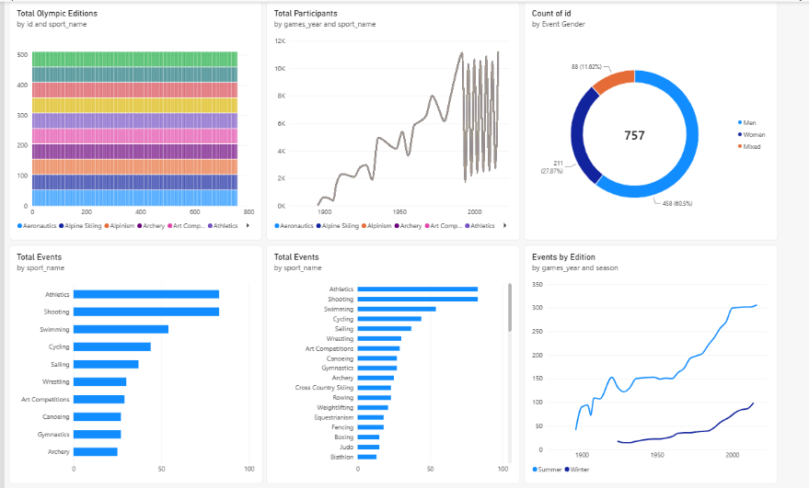
10.4 Dashboard Page 3: Athlete Demographics
Purpose: To examine athlete participation across regions and genders and compare the average age of participants across Olympic editions and seasons.
Visualizations included:
- A horizontal bar chart showing participants by region.
- A doughnut chart showing total participant entries by gender.
- A column chart comparing average age by Games name and season.
Key observations:
- The USA has the largest participant count among the regions visible in the displayed chart, followed by the UK and France.
- The gender chart shows approximately 132,000 male participation entries and 48,000 female participation entries.
- The average-age chart shows variation across Olympic editions, with the displayed averages generally falling within the low-to-upper twenties.
Interpretation: This page provides a demographic view of Olympic participation. The gender chart represents participation entries rather than necessarily counting unique individuals. Likewise, differences in average age between editions may reflect changes in the sports and athletes represented, rather than a single underlying cause.
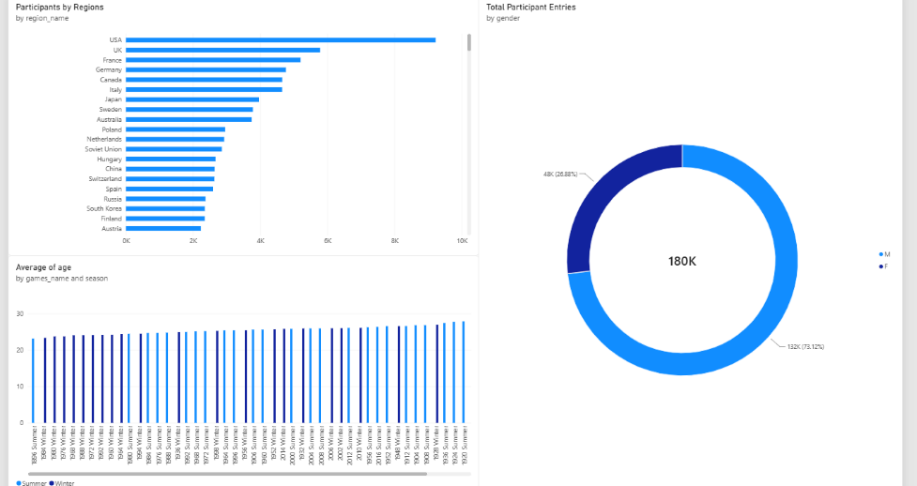
10.5 Dashboard Page 4: Medal Analysis
Purpose: To analyze medal-related records across Olympic editions, sports, and National Olympic Committee (NOC) codes.
Visualizations included:
- A column chart showing total medal records by Olympic edition.
- A horizontal bar chart showing gold medal records by NOC.
- A horizontal bar chart showing total medal records by sport.
Key observations:
- The displayed results show higher medal-record counts in later Olympic editions than in many earlier editions.
- The USA appears at the top of the displayed gold-medal-by-NOC chart, followed by the USSR and Germany.
- Athletics has the highest total medal-record count among the sports visible in the chart, followed by Gymnastics and Swimming.
Interpretation: The page enables comparisons of medal-related records over time and across sports and NOCs. These totals should be understood according to the measures used in the report: a medal-bearing competitor-event record is not necessarily equivalent to one unique physical medal, particularly in team events.
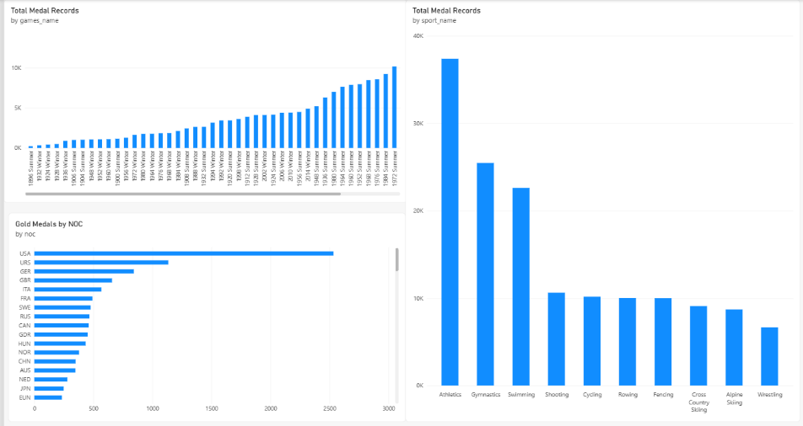
10.6 Dashboard Page 5: Regional Participation
Purpose: To examine the representation of regions across Olympic editions and compare regional participation and medal-record distributions.
Visualizations included:
- A line chart showing regions represented by Olympic year.
- A stacked horizontal bar chart showing medal records by region and medal category.
- A horizontal bar chart showing participants by region.
Key observations:
- The number of represented regions increases substantially across much of the historical timeline.
- The USA has the highest participant count among the regions visible in the displayed chart, followed by the UK and France.
- The medal-by-region visualization shows differences in the volume and composition of medal records across regions.
Interpretation: This page helps explore how regional representation and participation have changed over time. The region totals should be interpreted with care because the database can contain multiple regional associations for a person, and historical NOC or region labels do not always correspond directly to modern national boundaries. The medal chart also displays a blank medal category, which should be considered when interpreting the totals.
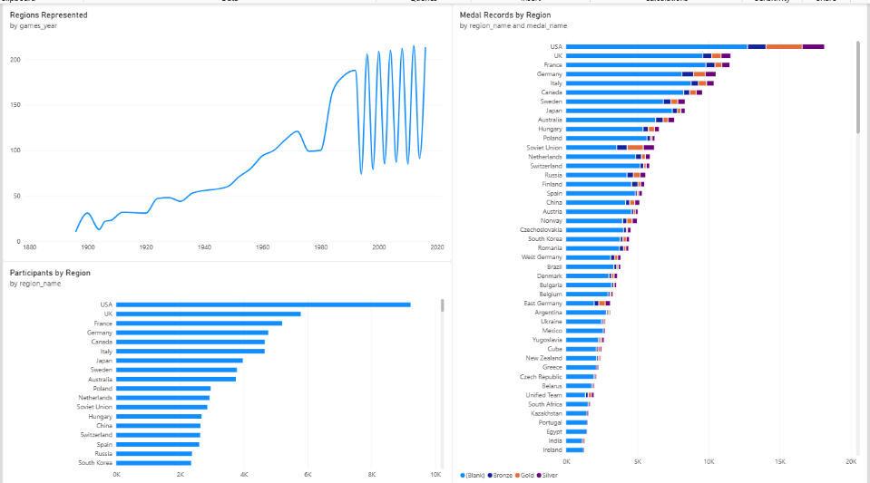
10.7 Dashboard Design and Analytical Value
The five-page dashboard organizes the analysis into distinct subject areas, allowing users to move from an overall historical view to more detailed comparisons of sports, athlete demographics, medals, and regional participation.
The dashboard supports the following analytical tasks:
- Comparing Summer and Winter Olympic editions.
- Reviewing the distribution of Olympic events across sports.
- Exploring participation by gender, region, and age.
- Comparing medal-related records across sports and NOCs.
- Examining changes in regional representation over time.
The combination of bar charts, line charts, column charts, and doughnut charts provides different ways to compare categories, distributions, and trends.
10.8 Limitations of the Visualizations
The dashboard is based on the available dataset and the measures used in the underlying SQL and Power BI analyses. Some charts require careful interpretation:
- Participant counts may represent participation entries rather than unique individuals.
- Medal-record counts may include multiple athlete records for team events.
- Gender categories derived from event names may not capture every historical classification consistently.
- Regional labels and associations may change over time.
- Abrupt fluctuations in time-series charts should be checked against the underlying data and aggregation method before being interpreted as historical changes.
These limitations do not prevent the dashboard from being useful, but they should be considered when drawing conclusions or making recommendations.
10.9 Conclusion
The Power BI dashboard presents the findings of the Olympic data analysis through five connected report pages. Each page addresses a distinct analytical theme, from the history and scale of the Games to sports, athlete demographics, medal records, and regional participation.
The dashboard complements the 18 SQL-based exploratory analyses and the Excel workbook by providing a visual interface for comparing results. Together, these deliverables form the basis for the project's key insights, limitations, recommendations, and final conclusion.

11. Key Insights and Findings
The analysis of the Olympic dataset revealed several patterns relating to the historical development of the Games, sports and events, athlete participation, medal records, and regional representation.
11.1 Growth in Olympic Participation and Events
The dataset shows substantial growth in the scale of the Olympic Games over time. Summer Olympic event counts increased from 42 in 1896 to 306 in 2016, while recorded participant entries increased from 72 to 11,176. Winter Olympic event counts also increased, from 17 in 1924 to 98 in 2014.
11.2 Changes in the Sports Programme
The analysis identified sports and events with different first-observed and last-observed years in the available records. These comparisons help highlight changes in the Olympic programme and identify areas for further historical investigation.
11.3 Differences Across Sports
The event and medal analyses show that sports differ in their recorded event counts and medal-bearing competitor-event records. Athletics, for example, appears among the sports with the highest event and medal-record counts in the dashboard results.
11.4 Gender Representation
The event classification analysis identified 458 Men, 211 Women, and 88 Mixed / Combined or Unspecified event records. The athlete participation visualization also shows more male than female participation entries in the dataset. These findings highlight differences in recorded representation, although the classification method and historical context should be considered when interpreting them.
11.5 Athlete Demographics
The dashboard enables comparisons of average athlete age across Olympic editions and seasons. The height and weight analysis also provides a basis for examining athlete characteristics over time. Such comparisons must account for missing or placeholder measurements and differences in the sports represented.
11.6 Regional Participation and Medal Records
The regional analyses show substantial variation in participation and medal-bearing records across regions. The USA has the highest participant count among the regions visible in the dashboard. The medal analysis also places the USA at the top of the displayed gold-medal-by-NOC chart.
11.7 Sustained Medal-Winning Presence
The EDA identified regions that recorded medals across multiple Olympic editions. The UK recorded medal presence in 29 Summer editions in the query results, while Canada recorded medal presence in 22 Winter editions. These results indicate repeated medal-winning presence within the available dataset.
11.8 Importance of Data Interpretation
The project also demonstrated the importance of distinguishing unique athletes, participation entries, competitor-event records, and medal awards. Understanding these measures is essential for avoiding misleading comparisons, particularly for team events and historical regional representation.
12. Limitations
Although the analysis provides useful insights into Olympic history and participation, several limitations should be considered.
- Historical coverage: The dataset covers a defined period and ends with the 2016 Summer Olympics and 2014 Winter Olympics. It does not represent subsequent editions.
- Data availability: Some fields may be missing, incomplete, or recorded using placeholder values. Height and weight values, for example, require care because zero values may not represent genuine measurements.
- Regional representation: Historical NOC codes and region labels may not map directly to present-day countries. Some people have multiple regional records, which can affect regional counts.
- Medal counting: Competitor-event records are not always equivalent to unique medals. Team events can produce records for multiple athletes associated with the same medal outcome.
- Classification: Gender categories derived from event names may not capture every historical category consistently.
- Descriptive analysis: The SQL queries and dashboard visualizations identify patterns and associations. They do not independently establish causation or explain every historical change.
- Visualization interpretation: Trends and fluctuations should be interpreted alongside the underlying counts, aggregation methods, and definitions used in each measure.
These limitations were considered when interpreting the findings and formulating recommendations.
13. Recommendations
Based on the analysis, the following recommendations can support further Olympic data exploration and reporting.
13.1 Monitor Participation and Programme Growth
Future analysis could track changes in athlete participation and event counts across new Olympic editions. This would help stakeholders understand how the scale and structure of the Games evolve over time.
13.2 Review Sports and Events Over Time
Sports with relatively recent first-observed years and events absent from later records could be investigated further using official Olympic programme histories. This would help distinguish temporary gaps in the dataset from formal programme changes.
13.3 Improve Representation Analysis
Future reporting should compare participation and medal outcomes by gender while accounting for changes in event availability and historical classifications. This would support more meaningful comparisons across editions.
13.4 Use Sport-Specific Performance Comparisons
Regional medal performance should be examined within individual sports as well as across the entire Games. This can help avoid conclusions driven solely by differences in the number of available events.
13.5 Improve Data Quality and Definitions
Placeholder measurements, blank medal labels, and historical regional mappings should be reviewed and documented. Clear definitions should also be maintained for unique athletes, participation entries, medal-bearing records, and unique medal awards.
13.6 Maintain and Extend the Dashboard
The Power BI report can be updated when additional data becomes available. Future enhancements could include more detailed filtering by Games edition, sport, gender, and region, along with clearer metric definitions and data-quality notes.
14. Conclusion
This project analyzed historical Olympic data using PostgreSQL, Python, SQLAlchemy, Pandas, Excel, and Power BI Desktop. The work combined relational database querying, structured result handling, exploratory analysis, and interactive visualization.
Eighteen SQL-based exploratory questions were investigated, covering the history of Olympic editions, sports and events, athlete demographics, medal performance, and regional participation. The results were organized into an Excel workbook, while the Power BI dashboard presented the analysis through five report pages.
The project identified substantial growth in the recorded scale of the Games, differences across sports, variations in athlete representation, and regional patterns in participation and medal records. It also highlighted the importance of understanding data definitions, historical context, and the limitations of descriptive analysis.
Overall, the project demonstrates how database technologies and business intelligence tools can be combined to turn structured historical data into useful analytical findings. The resulting workbook, SQL analysis, and Power BI dashboard provide a foundation for further Olympic data exploration and reporting.
15. References and Appendix
15.1 References
- Olympic dataset supplied for the project.
- PostgreSQL database documentation: https://www.postgresql.org/docs/
- Pandas documentation: https://pandas.pydata.org/docs/
- SQLAlchemy documentation: https://docs.sqlalchemy.org/
- Microsoft Power BI documentation: https://learn.microsoft.com/power-bi/
15.2 Appendix
The project supporting materials include:
- Excel workbook containing the 18 EDA query-result sheets and supporting analysis sheets.
- SQL queries used to investigate the 18 project questions.
- ER diagram illustrating the Olympic database structure and relationships.
- Screenshots of the five Power BI dashboard pages.
- Power BI project file containing the report and data model.
These materials support the methodology, findings, and visualizations documented in this report.

