**What is SDLC?**

* SDLC stands for Software Developing life Cycle. SDLC is a structure that meance if any user want to develop any software product then user can defines planning, implementation, analysis, deployment, testing, and maintenance and other support too.
* SDLC have number of features and that are

1. Requirements Gathering
2. Analysis
3. Design
4. Implementation
5. Testing
6. Maintenance

* As mentioned above features are very useful to develop any software product very effectively.

**What is Software Testing?**

* Software testing is when developer develop any software product then sometimes attempt negative thoughts and things, in that case testing is applied on that product and find out mistakes, bugs or errors and make proper developing of that software product.
* After testing developer improve that negative things and make effective developing as per clients requirements.
* This life cycle we partition into different types of phases like requirement gathering, analysis, design, testing, and maintenance. Testing going into this all phases of the related software product and make quality software product.

**What is agile methodology?**

* A agile methodology is an interactive approach to project management and software development that uses feedback and test for software development.
* In this model not fixed time duration or requirements, clients can change requirements at any times. In this model we can work parallel in all phases. We can change in any phases as per our priorities.
* In this methodology all phases work together and communicate each other and do the best practice.
* This model is project management framework that breaks project down into several dynamic phases.
* After each development developer can see if there was anything want to improve their adjust strategy for the next sprint.
* Agile methodology process had started an early in the software development and started becoming valuable on time during its flexibility and adaptability.

**What is SRS?**

* SRS stands Software Requirement Specification. SRS is a document that describe to what to do software perform and how it will expected to perform. It also describe the functionality of the product needs of the all stakeholders.
* Software Requirement is also all description of the software behavior

to be develop. SRS also added the use cases, also define as functional requirements and all of the connecters. It also describe the non-functional requirements.

* This pattern describes the all possible structure, content, and quality of software product requirement specification of the customer.

**What is OOP?**

* OOP stands for object Oriented Programming that can identify objects of the class and methods and accessing anywhere.
* One object communicate to all object of the classes and methods and also access property of the classes. In OOP each class have a unique object that can identify easily for proper communicate.
* OOP have different types and that are following

1. Object
2. Class
3. Encapsulation
4. Inheritance
5. Abstraction
6. Polymorphism

* Overriding
* Overloading

**Write basic concept of OOP**

* Object Oriented Programming identify object and object communicate each other for access all property of the particular class, and methods.
* Object specifies always as unique attribute and behavior of the particular class and that’s why all object of the classes and methods can easily access and communicate each other.
* OOP have several types of like object, class, encapsulation, inheritance, abstraction, and polymorphism. This all have a different concept and behavior and this all types are very usable in real time product.
* Using OOP structure user can develop any software product easily with less code.

**What is Object?**

* Object is run time entity that can access all attributes and properties of the class and method.
* Object is a unique identifier that’s why it can communicate easily. Object has own responsibility to inform for what to do.
* Object is anything in the world like pen, pencil, mobile, computer, book anything.
* Object is the key to understand object oriented technology.

**What is Class?**

* A class is structure that can represent which type of object, properties, and behavior and which type of work of this particular class.
* Class name is described the class behavior and object. It’s defined that what will process in this structure of the class.
* Class is the definition or a template for object and properties.

**What is Encapsulation?**

* Encapsulation is the wrapping of data and behavior of the class.
* Other functions can not show or access any properties of the other class.
* Only object can access data or properties for data placing and functions also same work for the same object.
* Encapsulation is one big container that can hide all properties, and behavior in front of other functions. Only unique object can access and communicate those properties. Object is one and only that know the responsibilities of that functions, and class.
* With encapsulation we can hide data or properties of internal state. We can expose this with two methods like getter or setter. We can any update to the objects internals only with these two methods.

**What is Inheritance?**

* Inheritance is very important concept of the oop because one class inherits property and attributes into another class. With this feature user can reusable of the programming code.
* Inheritance concept describes the relation between two classes. Parent class

Give some characteristics to the child class. Child class also known as derives class.

* With this concept we can access features of the parent class and add different types of functionality into the derive classes.
* For example Grandparents is the main class and parent and child class are another classes. Parent and child classes can access attributes of the grandparent class using inheritance.
* Using this concept we can reduce the code and develop quality wise software.

**What is Polymorphism?**

* Polymorphism is considered one main important features in Object oriented Programming. Polymorphism allows as performing a single action in different ways.
* Polymorphism allows as defining one interface and having multiple implementations.
* For example a one person play different role like father, husband, and an employee. So the one person have different behavior just like same as in polymorphism using any one interface play the multiple role in different situation.
* Polymorphism have two types of like
* Compile Time Polymorphism(overloading)
* Runtime Polymorphism (Overriding)
* Overloading polymorphism create when same function or same operator.

Overloading polymorphism not allowed same function name or operator in different function in one programming.

* Overriding polymorphism concept is when create same methods multiple time in one programming at that time execute overriding.

**Draw use case on online book shopping**

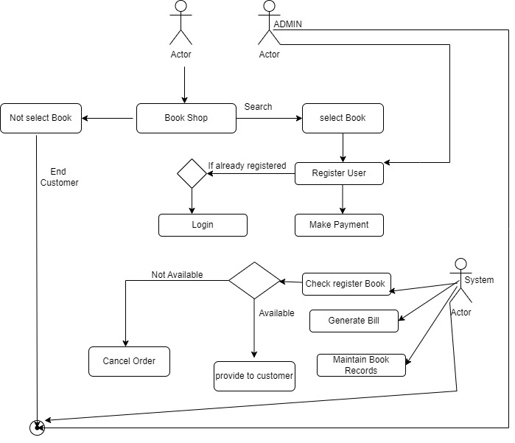

**Draw use case on online bill payment system (paytm)**

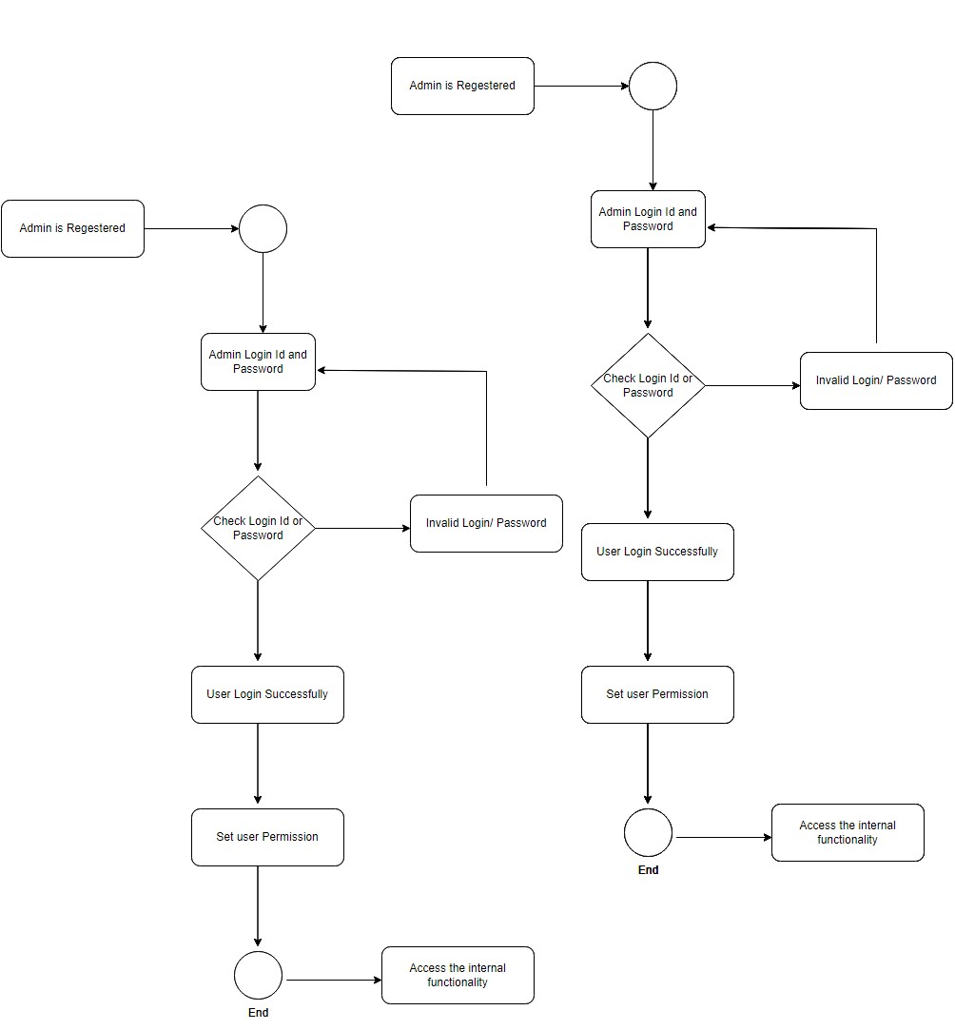

**Write SDLC phases with basic introduction**

* Software Development Life Cycle have some phases and that are following
* Requirement Gathering
* Analysis
* Design
* Implementation
* Testing
* Maintenance
* **Requirement Gathering**
* Requirement Gathering needed for when any client want to develop any product or feature then requirement gathering is the basic step. this phase used to collect the information and showing that how to develop and what are the basic things are needed for to develop this product or project.
* When all information we have then after we can developed any product or project otherwise we cannot developed any things in right way.
* Without collecting information developing is not possible and whenever developed any things without this then client also not satisfied with their requirement.
* **Analysis**
* Analysis phase describe that how to client requirement sufficient, how to fulfill all requirements of the client.
* This phase required to documentaries to fulfill all requirement from the client describing goals.
* This phase represent the WHAT and HOW phase.
* We need to analysis system behavior, structure, design, architecture,

Definition, or many more details are required for developed any product and project.

* In this phase write the document how to implement and what are the definition and send to document architecture.
* **Design**
* Design phase describe plan for the implementation and decide the flow as compare with requirements. Which type of implementation will be processed that’s based on the analysis?
* Designing prepared on as documentation and developer developed those types of features and functionalities.
* **Implementation**
* Implementation phase comes from designing phase.
* As per designing phase done the implementation. Implementation defines as reusability of the guidelines.
* Whenever we do the implementation then focus on previous errors and bugs that are not generate once again.
* Implementation mainly focuses on performance, issues, baselines, and debugging.
* Implementation does with many techniques.
* **Testing**
* Testing phase is very important for quality tested.
* This phase is totally different phase related to other phases because of this phase done by testing team. In this phase check the quality, performance, and errors.
* Implementation done as per client requirement is very important, this type of testing by this phase.
* Sometimes do the testing before implementation that’s call the early testing. Testing have done by five main types and these are following.
* Regression Testing
* Internal Testing
* Unit Testing
* Application Testing
* Stress Testing
* **Maintenance**
* Maintenance phase is the comes when implementation and testing phase completed. When software deployment is completed then after maintenance will be applied on that software.
* When deployment is done then check the system for not generating any errors or bugs.
* Maintenance have three types of corrective maintenance, Adaptive maintenance, and perfective maintenance.
* When software installment was done then check the whole system for not interrupt any feature or functions.

**Explain phases of the Waterfall Model?**

* Waterfall model also known as classical software cycle.
* Waterfall model have different phases like…
* Requirement Collection
* Analysis
* Design
* Implementation
* Testing
* Maintenance
* Waterfall model used for short term project and no longer duration of any project
* In this model requirements of clients had already fixed and then after developer developed

Project of this model.

* Using this model if one time developing start then requirements cannot be change because
* If any want to change requirements then developer must be start developing at first phase that’s why it is not possible using this model.
* This model is not good for object oriented project and complex.
* This model used for static data, some data is fixed from admin side. It is not suitable for big amount. It is simply arrange and used.
* Requirements and documentation are well managed.
* In this module developer work in static way, if client clear late requirements then not possible to change any process because developer cannot work together in each phases.

**Write phases of the Spiral Model?**

* Spiral model is very widely used in the software industry. When requirements are not sure at that time used this model.
* This model used for long term project to develop natural project and also high risk project, when client want to change requirement at anytime than developer can do.
* Sometime project is to big at that time difficult to understand properly.
* Requirements are easy to capture.
* Developers do partition of the big project and difficult requirement develop earlier which help for better risk manage. Spiral model have four phases and this are following.
* Spiral model do the process of continuously across in all this phases infinite times. That’s why time is not limited for this development.
* Planning
* Risk Analysis
* Engineering
* Customer Evolution
* **Planning**

Planning phase determines the projects scope and creates a plan for the subsequent iteration of the spiral model. In this phase done all panning like how many recourses we need to develop this project, which types of atmosphere we need to develop this project because of when go into the testing at that time not generate any issues.

* **Risk Analysis**

Risk Analysis phase determines decide to which type of risks will be generated when developed this project. That’s types of analysis are done by this phase.

When project is big and do the partition and then after we decided that which type of risks generate when developing start.

* **Engineering**

When this all things are done than after developing start. This phase is actual implementation of the different feature. All the developing features are verify through testing.

* **Customer Evolution**

Customer evolution phase evaluated by the customer. It’s also includes the risk identification and showing cost of the next phase planning.

**Explain working methodology of agile model and also write pros and cons**

* Agile methodology is the software development is an efficient methodology that helps to team to process work with team to develop quality software quickly with flexibility.
* In this methodology requirements and demand may change as per priority according to importance of adaptability and continues improvement.
* Work with this model is the project management approach that allows successful and efficient execution of the project while improvement of project and team collection.
* When work on agile methodology it’s have strong documentation.
* Agile methodology work for customer satisfaction and developers try to frequent delivery of the software to the customer.
* Developers can measures the progress easily and any difficult developing if stay then done that first because of when developing complete than start testing of that task.
* Using agile model developers have done technical excellence.

**Pros**

* When customer change requirements then this methodology is flexible
* It’s support to team work and cross platform
* Less rules and delivers early in some shot of solution
* Planning is not required
* Developers can change implementation as per customer priority
* It is a very realistic methodology to develop software.
* Features can develop as per client needed.
* It can manage easily
* Developer can start early developing without planning.
* Resources are not more required

**Cons**

* More time and commitment
* Lack of necessary documents
* Less predictable, the flexibility at the core of agile method also means a much lower degree of predictability.
* Sometime without planning and requirements projects easily fall off track because of less structure determines that why developers do not clear what is the original scope of the project.

**Draw Use case on online shopping product using COD.**

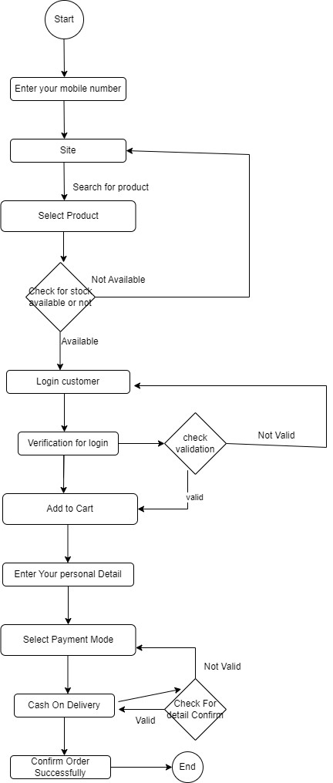

**Draw Use case on online shopping product using payment gateway.**

