PANER, Luke Eleazar R.

2ECE-A

1. isWordGuessed(secretWord, lettersGuessed):

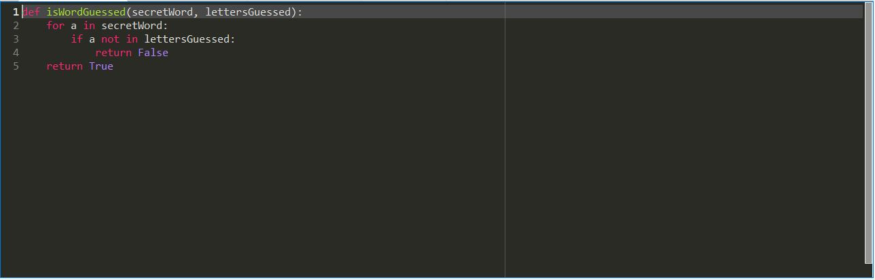

1. getGuessedWord(secretWord, lettersGuessed):

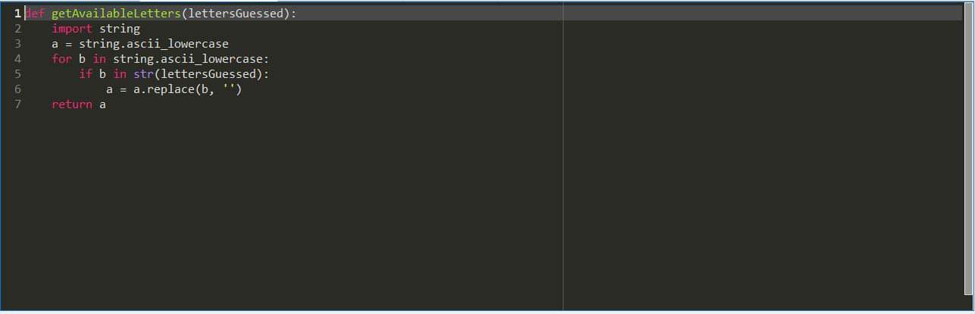

1. getAvailableLetters(lettersGuessed):

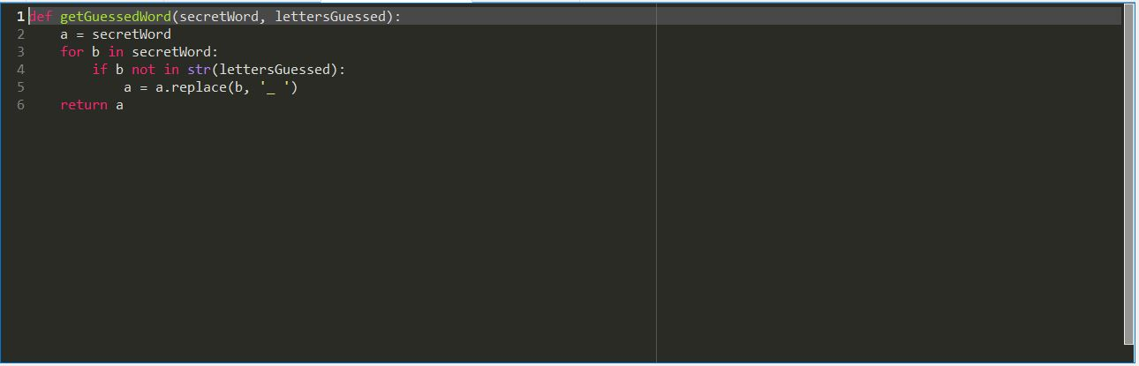

1. Hangaroo(secretWord):

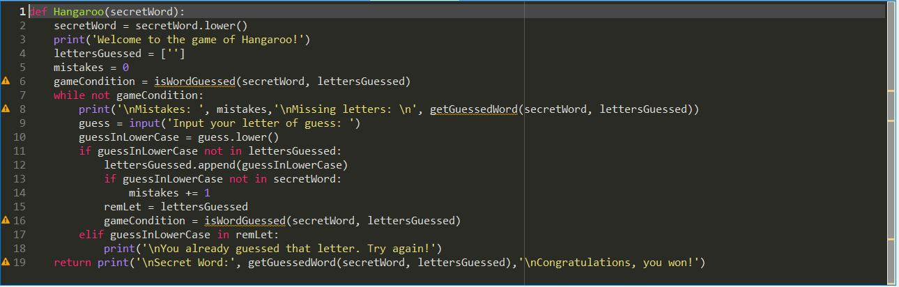

Tests:

