## Assignment #1

**Student:** Aidar Aidyn  
**Group:** MT-2406

### Goal of the Task

The purpose of this assignment was to understand the role of HTML in building web pages, to practice using different HTML elements for creating a personal site, to work with text, images, links, tables, forms, and also to try publishing a webpage online.

### HTML Elements Applied

During the task I used structural elements such as header, main, section, and footer. For text formatting I worked with headings from h1 to h3, paragraphs, bold and italic text, line breaks and horizontal rules. I added images with captions using img, figure, and figcaption. I included external links with the a tag. For structuring data I created lists with ul, ol, and also experimented with description lists using dl, dt, dd. I built a table with caption, thead, tbody, th, and td. Finally, I implemented forms with form, label, input, select, textarea, and button.

### Workflow

First I created a file called index.html and wrote the standard HTML boilerplate. I set the page title as “Aidar Aidyn — Simple Page”. 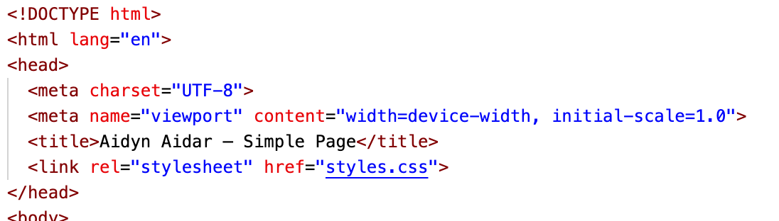After that I added headings and paragraphs with my name, course, group and a short description “About Me”. 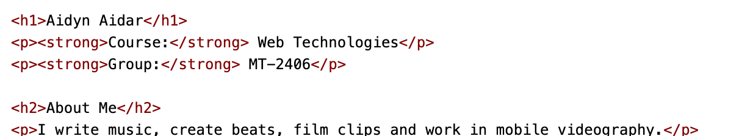

Then I included my hobbies and favorite sites. 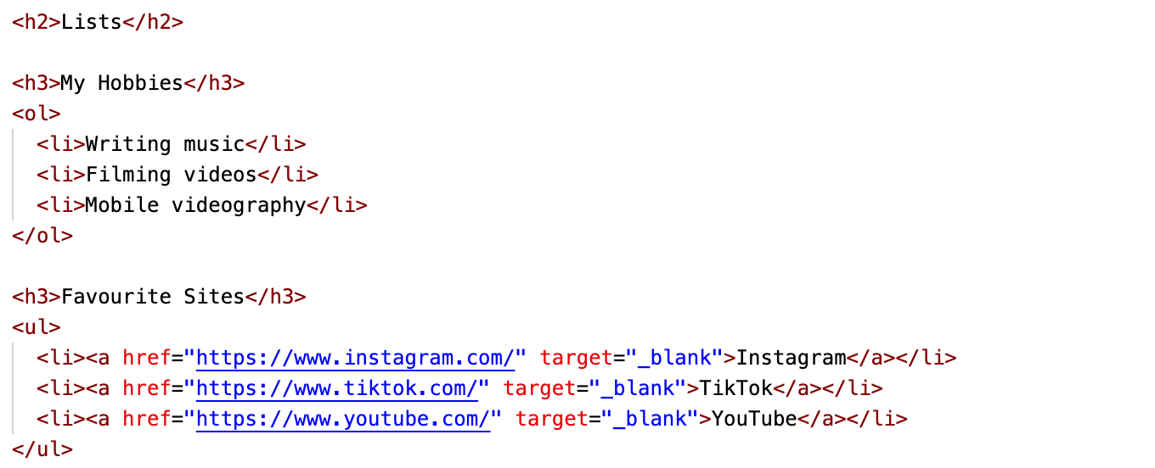 I also inserted my own photo and added links to my Instagram and music profile. 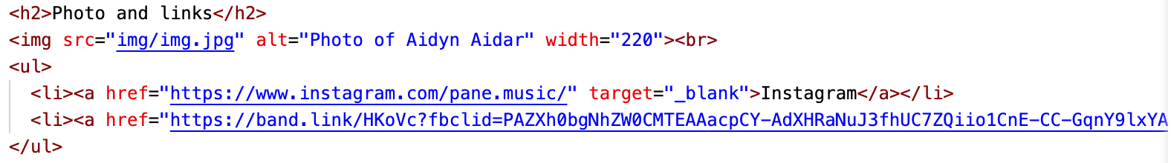After that I placed a button that shows an alert message when clicked. 

Next, I created a table with three columns: class, day, and time. 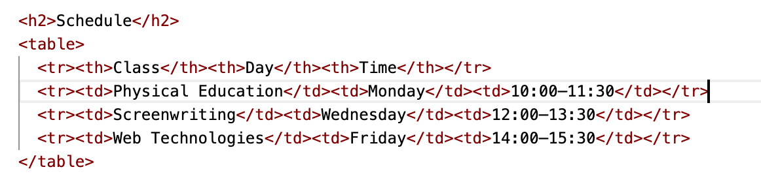

In addition, I built a form where the user can type their name, use an email field with my student email, pick a favorite color, and send the form.

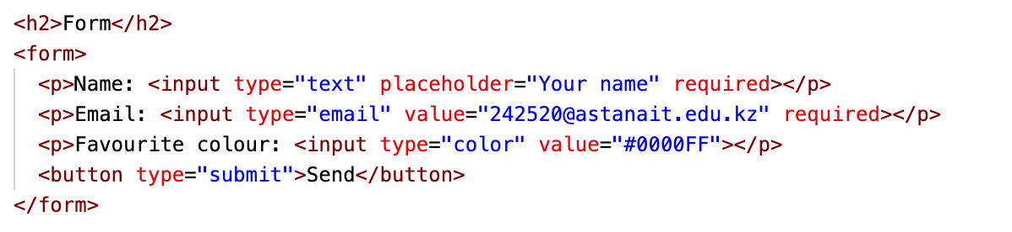

At the last stage I uploaded my project to GitHub and activated GitHub Pages. This allowed me to access my site online through the repository link.

### Reflection

While working on this project I learned how to structure an HTML page and understood the role of different tags. I practiced adding text, media, links, buttons, tables, and forms. I also managed to publish a working version of the site online. This assignment gave me my first complete experience of building and sharing a web page.