Trigeminal Neuralgia Treatment Patterns: Temporal Comparison
Pre-COVID (2016-2019) vs Post-COVID (2022-2025) Extended Analysis
Generated: January 26, 2026 at 08:13 AM
Data Source: Epic Cosmos Database
Pre-COVID Period: November 27, 2016 - November 27, 2019 (n=154,435)
Post-COVID Period: November 28, 2022 - November 27, 2025 (n=302,971)
Inclusion: Patients with ICD-10 code G50.0 (Trigeminal Neuralgia)
Geographic Scope: 9 U.S. Census Regions
Note: Values of '10 or fewer' were imputed as 5 (midpoint)
TABLES
Table 1. National Medication Utilization: Pre-COVID vs Post-COVID
Medication | Pre-COVID N | Pre-COVID % | Post-COVID N | Post-COVID % | Change (pp) | P-value
Carbamazepine/Oxcarbazepine | 66,499 | 43.1 | 127,741 | 42.2 | -0.9 | <0.001
Gabapentin | 71,830 | 46.5 | 154,330 | 50.9 | +4.4 | <0.001
Pregabalin | 17,530 | 11.4 | 49,174 | 16.2 | +4.9 | <0.001
Baclofen | 22,499 | 14.6 | 49,563 | 16.4 | +1.8 | <0.001
Lamotrigine | 8,081 | 5.2 | 20,064 | 6.6 | +1.4 | <0.001
pp = percentage points. All comparisons significant at p < 0.001.

Table 2. National Procedure Utilization: Pre-COVID vs Post-COVID
Procedure | Pre-COVID N | Pre-COVID % | Post-COVID N | Post-COVID % | Change (pp) | Relative Δ | P-value
MVD | 1,857 | 1.20 | 4,072 | 1.34 | +0.14 | +11.8% | <0.001
SRS | 685 | 0.44 | 1,752 | 0.58 | +0.13 | +30.4% | <0.001
Rhizotomy | 1,681 | 1.09 | 2,937 | 0.97 | -0.12 | -10.9% | <0.001
Botox | 1,079 | 0.70 | 2,785 | 0.92 | +0.22 | +31.6% | <0.001
MVD = Microvascular Decompression; SRS = Stereotactic Radiosurgery; pp = percentage points.

Table 3. Surgical Escalation Rates by Medication Group
Medication | Pre-COVID Surgery % | Post-COVID Surgery % | Surgery Change (pp) | P-value | Significant
Carbamazepine/Oxcarbazepine | 4.51 | 5.40 | +0.89 | <0.001 | Yes
Baclofen | 6.52 | 7.09 | +0.57 | 0.006 | Yes
Gabapentin | 3.54 | 3.87 | +0.33 | <0.001 | Yes
Lamotrigine | 6.75 | 7.10 | +0.36 | 0.294 | No
Pregabalin | 5.36 | 5.47 | +0.11 | 0.568 | No
No TN Medication | 1.09 | 0.65 | -0.45 | <0.001 | Yes
Surgery includes MVD, SRS, and Rhizotomy. Percentage of patients in each medication group receiving any surgical intervention.

Table 4. Chi-Square Tests for Regional Distribution Changes
Treatment | Chi-Square | df | P-value | Significant
Carbamazepine/Oxcarbazepine | 643.6 | 8 | <0.001 | Yes
MVD | 17.9 | 8 | 0.022 | Yes
SRS | 113.3 | 8 | <0.001 | Yes
Pregabalin | 173.1 | 8 | <0.001 | Yes
Tests whether the regional distribution of each treatment changed between periods.

FIGURES
Figure 1. Regional Changes in Treatment Utilization (Post-COVID minus Pre-COVID)
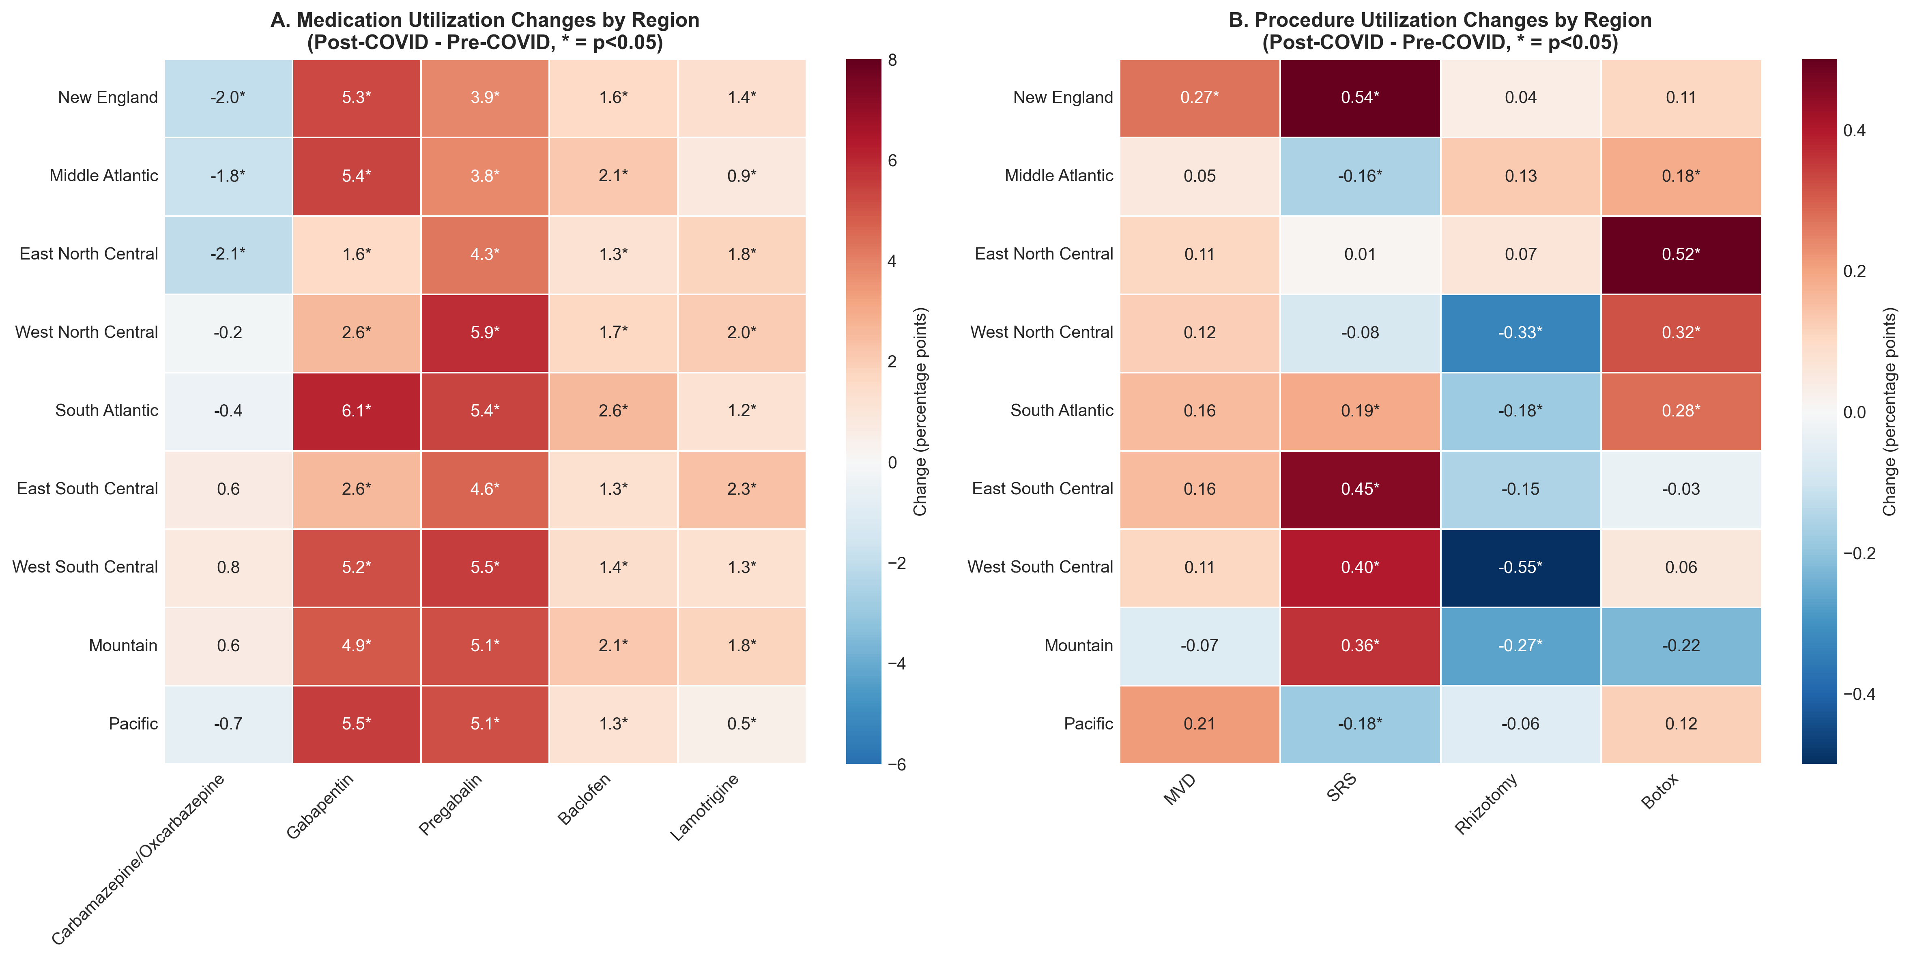
(A) Change in medication utilization rates by U.S. Census Region. (B) Change in procedure utilization rates by U.S. Census Region. Values represent percentage point change. Asterisks (*) indicate p < 0.05. Red = increase; Blue = decrease.

Figure 2. Surgical Escalation Rates by Medication Group
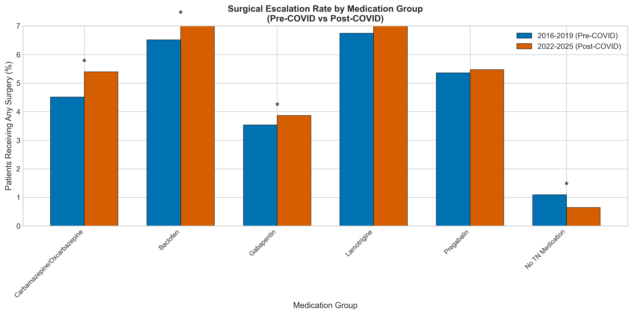
Percentage of patients within each medication group who received any surgical intervention (MVD, SRS, or Rhizotomy). Blue bars = Pre-COVID (2016-2019); Orange bars = Post-COVID (2022-2025). Asterisks (*) indicate statistically significant difference (p < 0.05).

KEY FINDINGS
1. Medication Utilization Shifts
Gabapentin utilization increased from 46.5% to 50.9% (+4.4 percentage points, p<0.001). Pregabalin showed the largest relative increase (+43%), rising from 11.4% to 16.2%. Carbamazepine/Oxcarbazepine (first-line therapy) showed a modest decrease from 43.1% to 42.2% (-0.9 pp).
2. Procedure Utilization Shifts
Less invasive procedures showed the largest relative increases: SRS (+30.4% relative) and Botox (+31.6% relative). Rhizotomy decreased by 10.9% relative. MVD (gold standard surgery) increased modestly (+11.8% relative).
3. Regional Variation
Pregabalin increases were uniform across all 9 regions (all p<0.001), suggesting a national prescribing pattern shift. New England was the only region with a statistically significant increase in MVD rates (+0.27 pp, +45% relative, p=0.010).
4. Patient Volume
Total TN patients increased from 154,435 (2016-2019) to 302,971 (2022-2025), a 96.2% increase. This likely reflects expanded Epic Cosmos network coverage rather than true incidence changes.

