Trigeminal Neuralgia Treatment Patterns: Temporal Analysis
Extended Analysis: Pre-COVID vs Post-COVID Comparison
Generated: January 26, 2026

Executive Summary
This analysis compares trigeminal neuralgia treatment patterns between the pre-COVID era
(November 2016 - November 2019; n=154,435) and post-COVID era
(November 2022 - November 2025; n=302,971), representing a +96.2%
increase in patient volume.

1. Regional Changes in Treatment Patterns
Figure 1 shows the change in medication and procedure utilization rates across all 9 US census
regions. Values represent the percentage point change (Post-COVID rate minus Pre-COVID rate).
Asterisks (*) indicate statistically significant changes (p < 0.05).
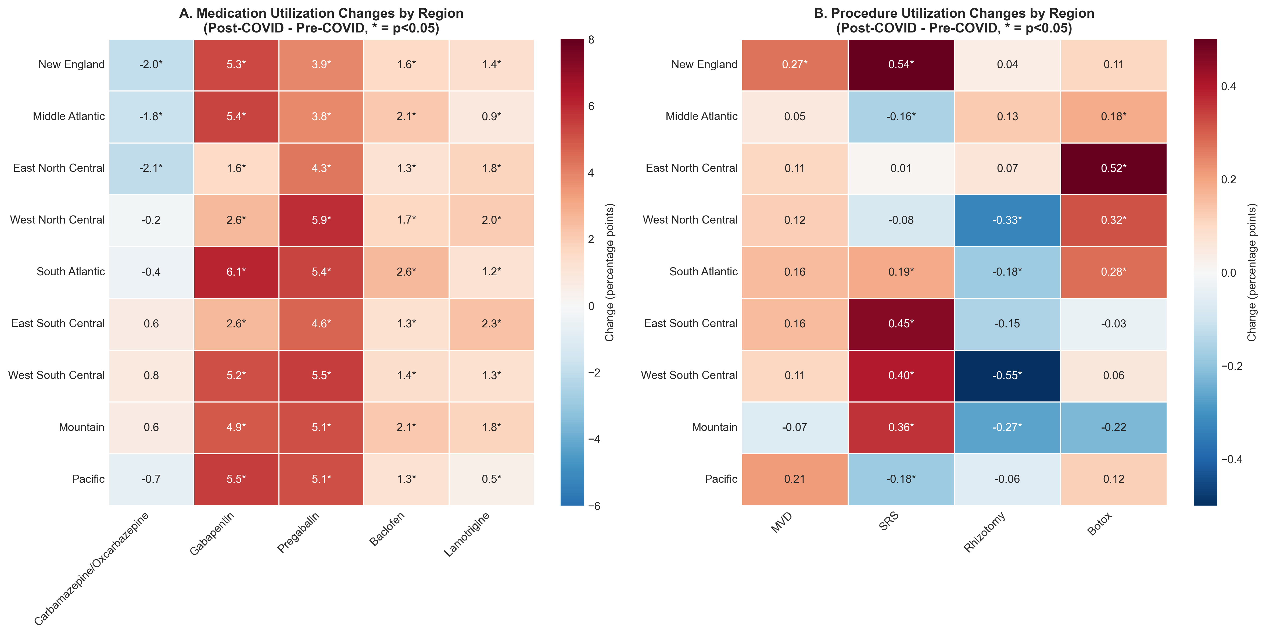
Figure 1. Regional changes in treatment utilization (Post-COVID - Pre-COVID)

2. Treatment Pathway Analysis
This analysis examines surgical escalation rates among patients in different medication groups.
The question: Among patients on a specific medication, what percentage received any surgical
intervention (MVD, SRS, or Rhizotomy)?
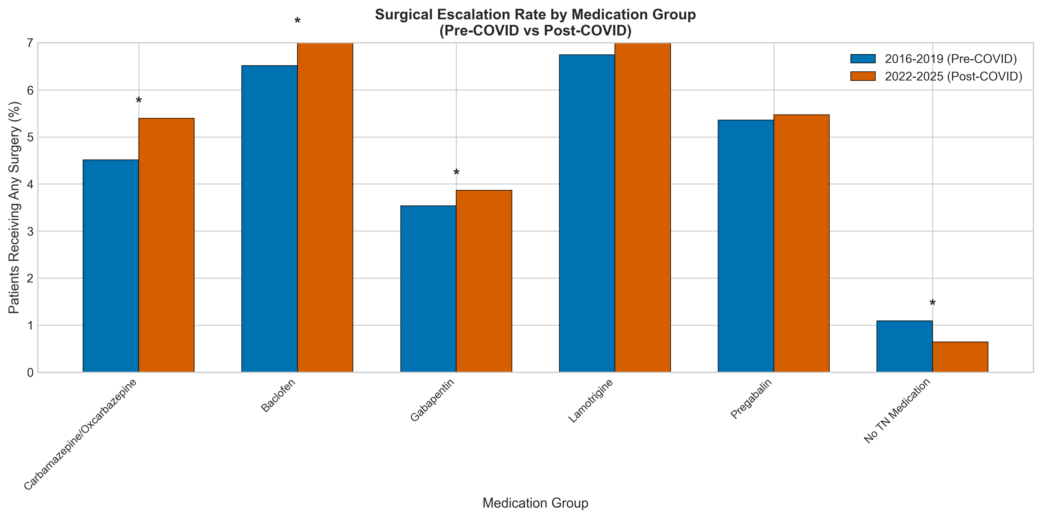
Figure 2. Surgical escalation rate by medication group

Table 1. Surgical Escalation Rates by Medication Group
Medication | Pre-COVID Surgery % | Post-COVID Surgery % | Change (pp) | P-value | Significant
Carbamazepine/Oxcarbazepine | 4.51 | 5.40 | +0.89 | <0.001 | Yes
Baclofen | 6.52 | 7.09 | +0.57 | 0.006 | Yes
Gabapentin | 3.54 | 3.87 | +0.33 | <0.001 | Yes
Lamotrigine | 6.75 | 7.10 | +0.36 | 0.294 | No
Pregabalin | 5.36 | 5.47 | +0.11 | 0.568 | No
No TN Medication | 1.09 | 0.65 | -0.45 | <0.001 | Yes

3. Chi-Square Tests for Regional Distribution Changes
These tests examine whether the regional distribution of each treatment changed between periods.
A significant result indicates that the proportion of patients receiving that treatment shifted
among regions (i.e., some regions gained or lost "market share").

Table 2. Chi-Square Tests for Regional Distribution Changes
Treatment | Chi-Square | df | P-value | Significant
Carbamazepine/Oxcarbazepine | 643.6 | 8 | <0.001 | Yes
MVD | 17.9 | 8 | 0.022 | Yes
SRS | 113.3 | 8 | <0.001 | Yes
Pregabalin | 173.1 | 8 | <0.001 | Yes

4. Deep Dive: Key Findings

4a. SRS and Botox Increases
Stereotactic Radiosurgery (SRS) showed a 30.4% relative increase nationally, while Botox
showed a 31.6% relative increase. These increases were relatively uniform across regions,
suggesting a national shift toward less invasive interventions rather than regional
variations in access.

4b. New England MVD Increase
New England was the only region showing a statistically significant increase in MVD rates
(+0.27 percentage points, +45% relative increase, p=0.010). This could reflect regional
differences in neurosurgical capacity or referral patterns.

4c. Pregabalin Regional Breakdown
Pregabalin utilization increased significantly across ALL regions (all p<0.001), with
absolute increases ranging from +3.4 to +7.5 percentage points. This uniform national
increase suggests a systemic shift in prescribing patterns rather than regional variation.

