Trigeminal Neuralgia Treatment Patterns: Tables and Figures
Generated: January 11, 2026 at 01:31 PM
Data Source: Epic Cosmos Database
Study Period: November 28, 2022 - November 27, 2025
Inclusion: Patients with ICD-10 code G50.0 (Trigeminal Neuralgia)
Geographic Scope: 50 US States + District of Columbia
Note: Values of '10 or fewer' were imputed as 5 (midpoint)
TABLES

Table 1. Study Cohort Characteristics
Characteristic | N | Percentage
Total TN Patients | 290,088 | 100.0%
Census Region
South Atlantic | 65,578 | 22.6%
East North Central | 58,542 | 20.2%
Middle Atlantic | 37,997 | 13.1%
West South Central | 31,208 | 10.8%
Pacific | 25,353 | 8.7%
West North Central | 19,768 | 6.8%
New England | 19,196 | 6.6%
Mountain | 17,432 | 6.0%
East South Central | 15,014 | 5.2%
Study Period | Nov 28, 2022 - Nov 27, 2025
Data Source | Epic Cosmos
ICD-10 Code | G50.0 (Trigeminal Neuralgia)
TN = Trigeminal Neuralgia

Table 2. National Treatment Utilization in Trigeminal Neuralgia
Treatment | N | Rate (%) | 95% CI
MEDICATIONS
Carbamazepine/Oxcarbazepine | 123,851 | 42.7 | (42.5-42.9)
Gabapentin | 148,000 | 51.0 | (50.8-51.2)
Pregabalin | 47,032 | 16.2 | (16.1-16.3)
Baclofen | 47,736 | 16.5 | (16.3-16.6)
Lamotrigine | 19,266 | 6.6 | (6.6-6.7)
OnabotulinumtoxinA | 14,972 | 5.2 | (5.1-5.2)
PROCEDURES
Microvascular Decompression (MVD) | 4,033 | 1.39 | (1.35-1.43)
Stereotactic Radiosurgery (SRS) | 1,813 | 0.62 | (0.60-0.65)
Percutaneous Rhizotomy | 972 | 0.34 | (0.31-0.36)
Glycerol Rhizotomy | 2,616 | 0.9 | (0.87-0.94)
Botox Injection | 2,069 | 0.71 | (0.68-0.74)
CI = Confidence Interval; MVD = Microvascular Decompression; SRS = Stereotactic Radiosurgery

Table 3. Treatment Utilization Rates by U.S. Census Region
Census Region | N Patients | Carb/Oxcarb (%) | Gabapentin (%) | Pregabalin (%) | Baclofen (%) | MVD (%) | SRS (%) | RHIZOTOMY (%)
South Atlantic | 65,578 | 42.6 | 52.4 | 17.4 | 17.0 | 1.61 | 0.71 | 0.41
East North Central | 58,542 | 43.0 | 50.0 | 15.7 | 17.1 | 1.05 | 0.21 | 0.23
Middle Atlantic | 37,997 | 41.7 | 50.2 | 14.1 | 16.0 | 1.2 | 0.64 | 0.29
West South Central | 31,208 | 47.2 | 56.3 | 19.0 | 17.1 | 1.69 | 0.62 | 0.21
Pacific | 25,353 | 38.4 | 49.9 | 15.5 | 15.4 | 2.27 | 0.34 | 0.66
West North Central | 19,768 | 45.1 | 50.4 | 15.8 | 15.3 | 1.21 | 0.61 | 0.5
New England | 19,196 | 37.9 | 47.3 | 12.5 | 13.7 | 0.93 | 1.62 | 0.16
Mountain | 17,432 | 40.3 | 47.6 | 16.9 | 16.5 | 1.31 | 0.95 | 0.37
East South Central | 15,014 | 48.1 | 51.6 | 18.3 | 17.9 | 1.03 | 0.7 | 0.21
Rates expressed as percentage of patients within each region. Carb/Oxcarb = Carbamazepine/Oxcarbazepine; MVD = Microvascular Decompression; SRS = Stereotactic Radiosurgery

Table 4. Chi-Square Tests for Regional Treatment Variation
Test | Chi-Square | df | P-value | Result
Medication Preferences by Region | 597.8 | 32 | <0.001 | Significant
Surgical Preferences by Region | 681.7 | 24 | <0.001 | Significant
Chi-square tests assess whether treatment preferences vary significantly across U.S. Census Regions. Significance threshold: p < 0.05.

FIGURES
Figure 1. National Treatment Utilization Rates in Trigeminal Neuralgia
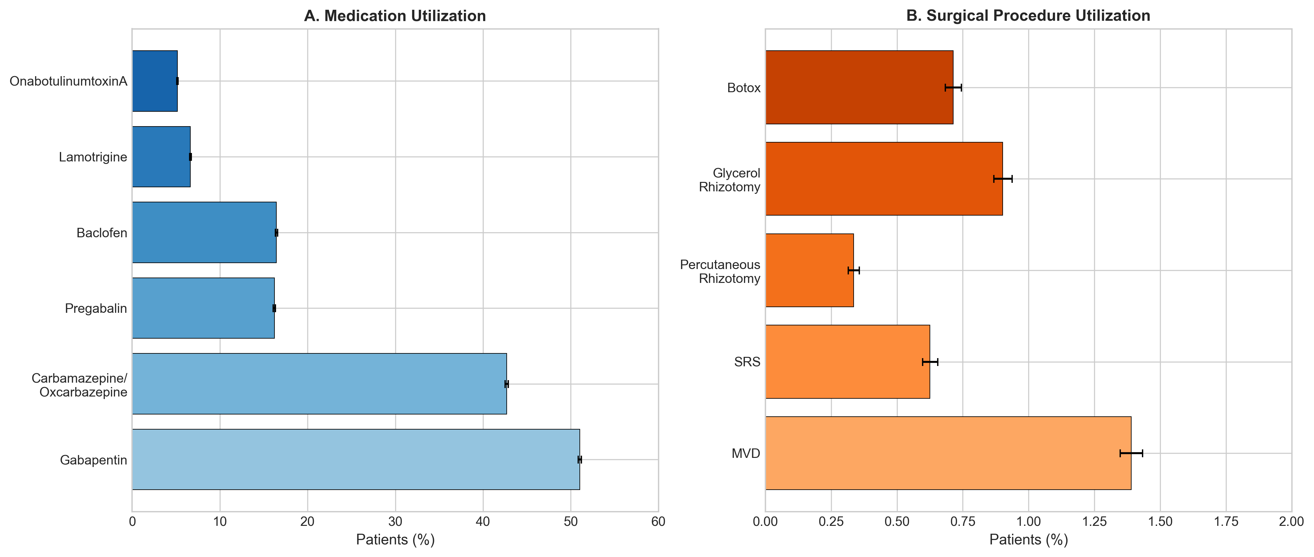
(A) Medication utilization showing percentage of TN patients prescribed each drug class. (B) Surgical procedure utilization showing percentage of patients undergoing each intervention. Error bars represent 95% confidence intervals.

Figure 2. State-Level Variation in First-Line Medication Utilization
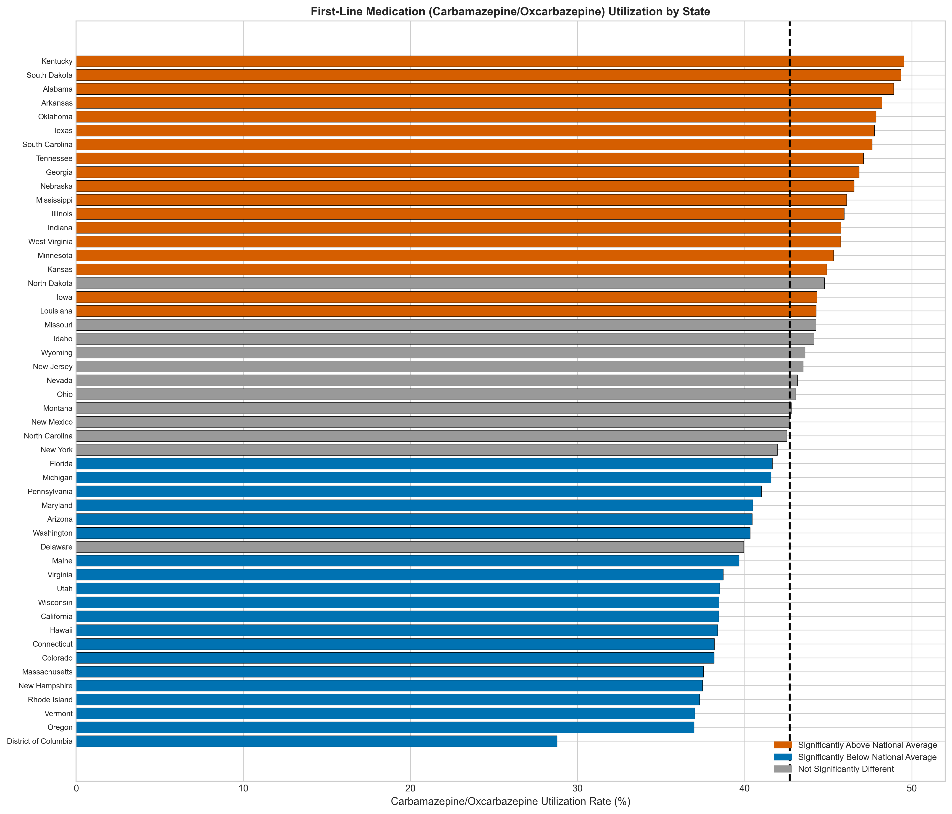
Carbamazepine/Oxcarbazepine utilization rates by state. States colored red show significantly higher utilization than the national average (dashed line); states colored blue show significantly lower utilization. Gray indicates no significant difference from national average (two-tailed z-test, p < 0.05).

Figure 3. State-Level Variation in Microvascular Decompression Utilization
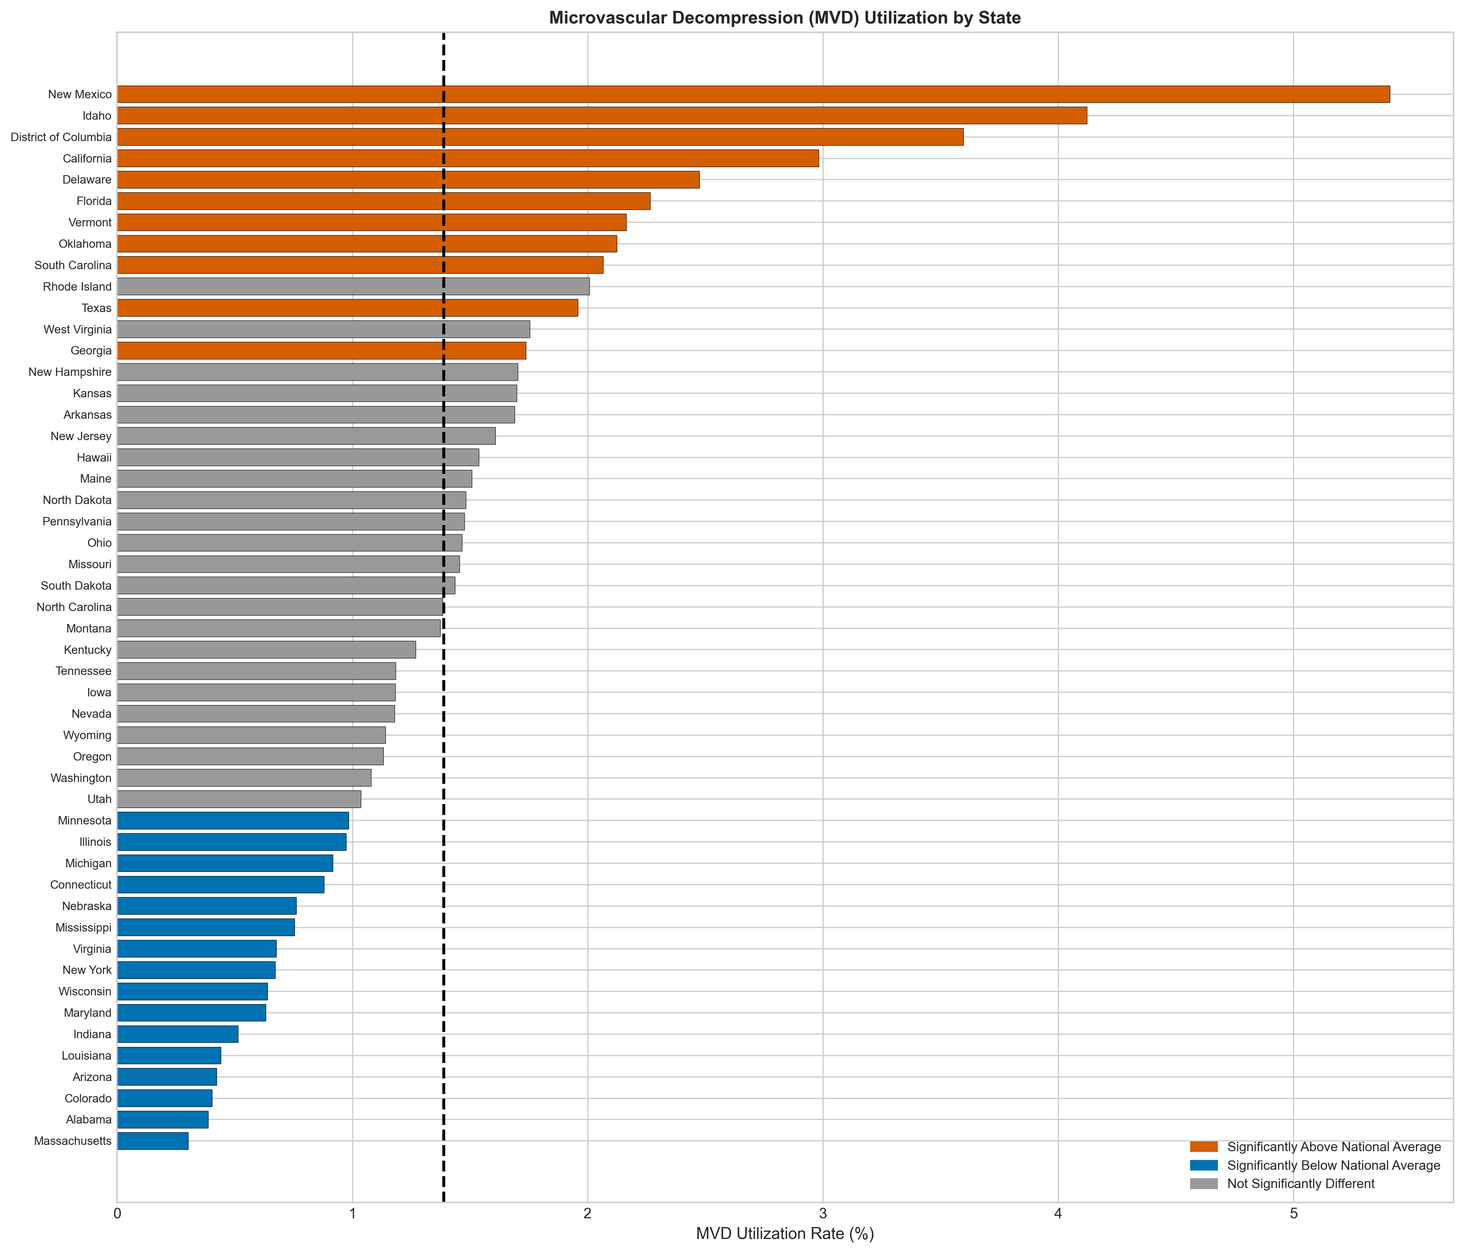
Microvascular decompression (MVD) utilization rates by state. States colored red show significantly higher utilization than the national average (dashed line); states colored blue show significantly lower utilization. Gray indicates no significant difference from national average (two-tailed z-test, p < 0.05).

Figure 4. Regional Treatment Utilization Patterns
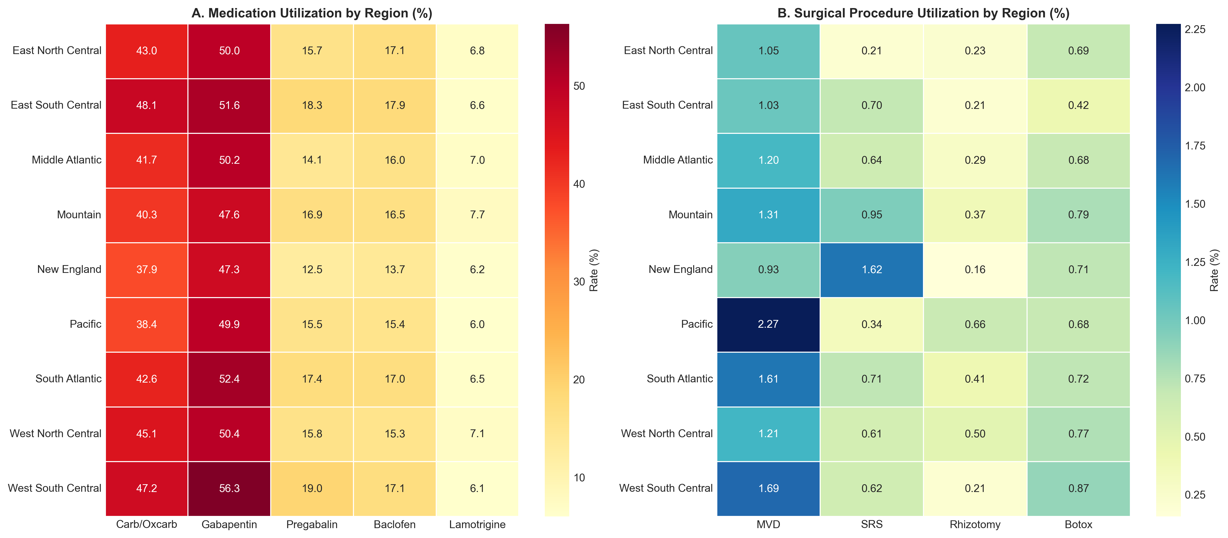
(A) Medication utilization rates (%) by U.S. Census Region. (B) Surgical procedure utilization rates (%) by U.S. Census Region. Carb/Oxcarb = Carbamazepine/Oxcarbazepine; MVD = Microvascular Decompression; SRS = Stereotactic Radiosurgery.

Figure 5. Surgical Intervention Rates by Medication Group
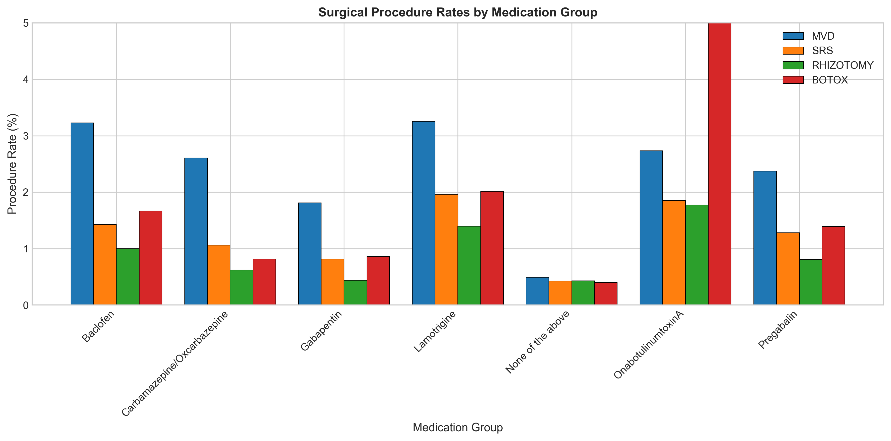
Rates of surgical procedures among patients grouped by their medication use. This analysis examines treatment escalation patterns, showing the proportion of patients within each medication group who underwent each type of surgical intervention. MVD = Microvascular Decompression; SRS = Stereotactic Radiosurgery.

