Trigeminal Neuralgia Treatment Patterns in the United States
Tables and Figures for Publication

Data Source: Epic Cosmos
Study Period: November 28, 2022 - November 27, 2025
ICD-10 Code: G50.0 (Trigeminal Neuralgia)

TABLES

Table 1. Distribution of Trigeminal Neuralgia Patients by Census Region
Census Region | States (n) | TN Patients (n) | Percentage (%)
East North Central | 5 | 58,542 | 20.2
East South Central | 4 | 15,014 | 5.2
Middle Atlantic | 3 | 37,997 | 13.1
Mountain | 8 | 17,432 | 6.0
New England | 6 | 19,196 | 6.6
Pacific | 5 | 25,353 | 8.7
South Atlantic | 9 | 65,578 | 22.6
West North Central | 7 | 19,768 | 6.8
West South Central | 4 | 31,208 | 10.8
Total | 51 | 290,088 | 100.0
Note: Data from Epic Cosmos, November 2022 - November 2025. N = total patients with ICD-10 G50.0 diagnosis.

Table 2. National Medication Utilization Rates for Trigeminal Neuralgia
Medication | N | Rate (%) | 95% CI
Gabapentin | 148,000 | 51.0 | (50.8-51.2)
Carbamazepine/Oxcarbazepine | 123,851 | 42.7 | (42.5-42.9)
No TN Medication | 63,719 | 22.0 | (21.8-22.1)
Baclofen | 47,736 | 16.5 | (16.3-16.6)
Pregabalin | 47,032 | 16.2 | (16.1-16.3)
Lamotrigine | 19,266 | 6.6 | (6.6-6.7)
OnabotulinumtoxinA | 14,972 | 5.2 | (5.1-5.2)
Note: Rates calculated as percentage of total TN patients. Patients may be on multiple medications. 95% CI calculated using Wilson score interval.

Table 3. National Surgical Procedure Utilization Rates for Trigeminal Neuralgia
Procedure | N | Rate (%) | 95% CI
MVD | 4,033 | 1.39 | (1.35-1.43)
SRS (Radiosurgery) | 1,813 | 0.62 | (0.60-0.65)
Percutaneous Rhizotomy | 972 | 0.34 | (0.31-0.36)
Glycerol Rhizotomy | 2,616 | 0.9 | (0.87-0.94)
Botox | 2,069 | 0.71 | (0.68-0.74)
No Procedure | 279,762 | 96.44 | (96.37-96.51)
Note: MVD = Microvascular Decompression; SRS = Stereotactic Radiosurgery. Rates calculated as percentage of total TN patients.

Table 4. Chi-Square Tests for Regional Treatment Preferences
Test | Description | Chi-Square | df | P-value
Medication Preferences | Distribution of 6 medication types across 9 regions | 840.7 | 40 | <0.001
Surgical Preferences | Distribution of 5 procedure types across 9 regions | 1016.1 | 32 | <0.001
Note: Tests evaluate whether distribution of treatment types differs significantly across census regions.

Table 5. Chi-Square Tests for Regional Treatment Preferences (Census Region Analysis)
Test | Description | Chi-Square | df | P-value | Significant
Medication Preferences | Distribution of 5 medication types across 9 regions | 637.2 | 32 | <0.001 | Yes
Surgical Preferences | Distribution of 4 procedure types across 9 regions | 1090.1 | 24 | <0.001 | Yes
Note: Analysis at census region level (n=9 regions) to minimize privacy masking effects.

FIGURES

Figure 1. National Medication and Procedure Utilization Rates for Trigeminal Neuralgia
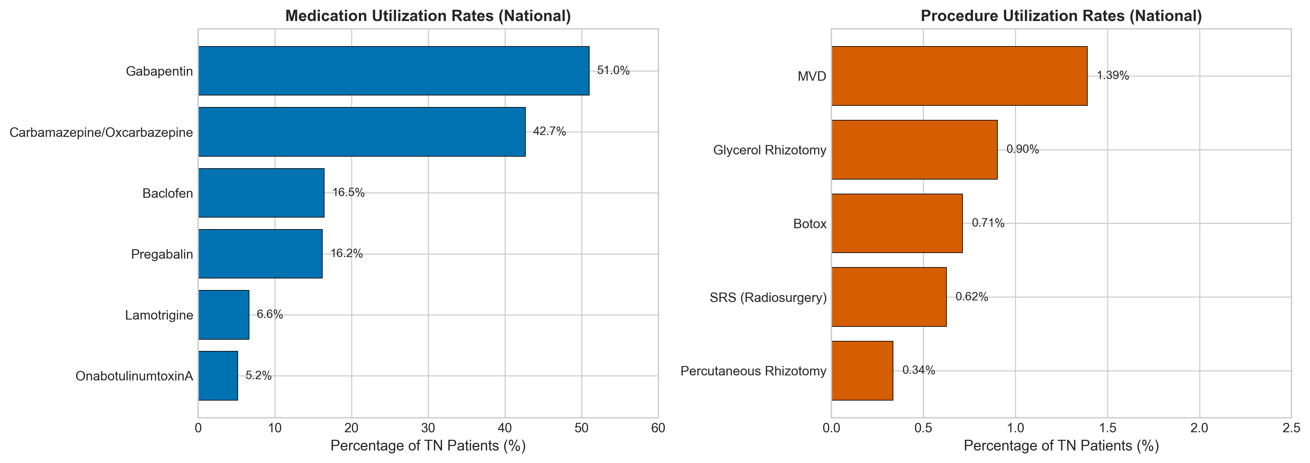
Bar charts showing percentage of TN patients receiving each medication (left) and procedure (right). Error bars represent 95% confidence intervals.

Figure 2. Medication Utilization Rates by Census Region
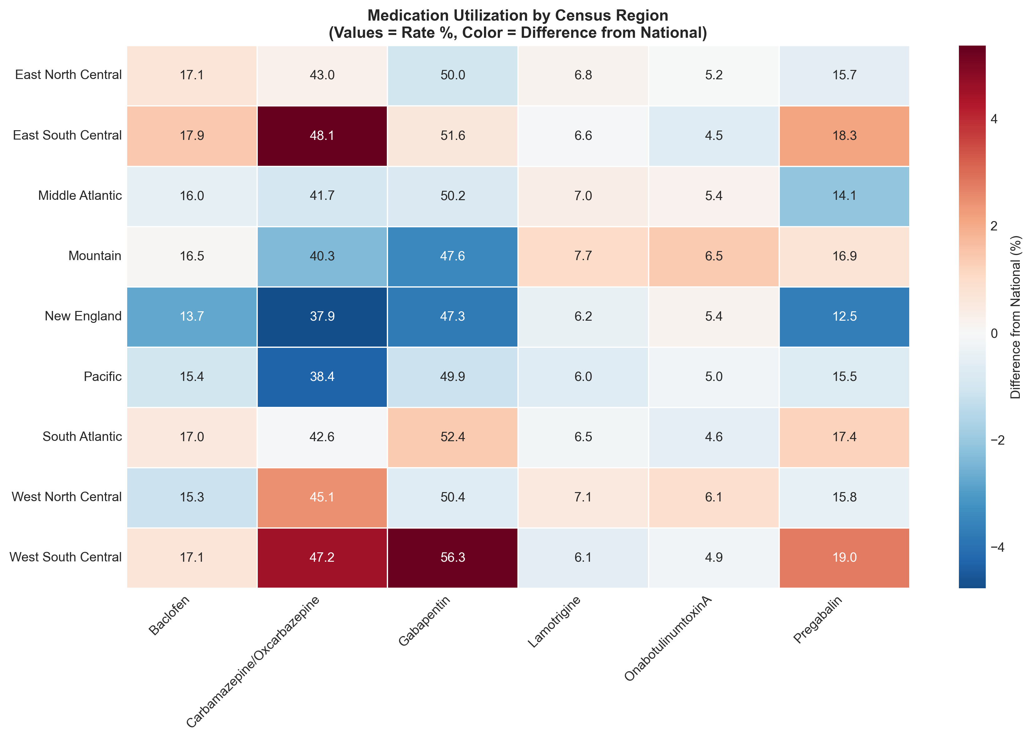
Heatmap showing percentage of TN patients receiving each medication type across 9 US census regions. Darker colors indicate higher utilization rates.

Figure 3. Surgical Procedure Rates by Census Region
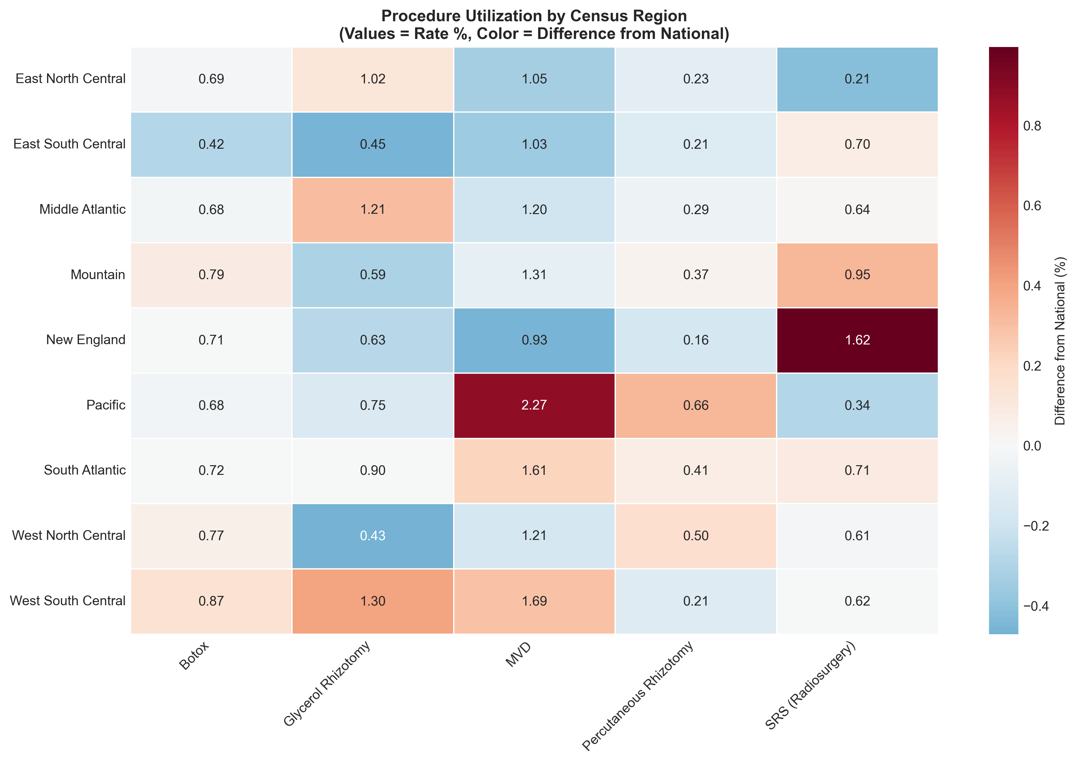
Heatmap showing percentage of TN patients receiving each procedure type across 9 US census regions.

Figure 4. Procedure Utilization by Medication Group
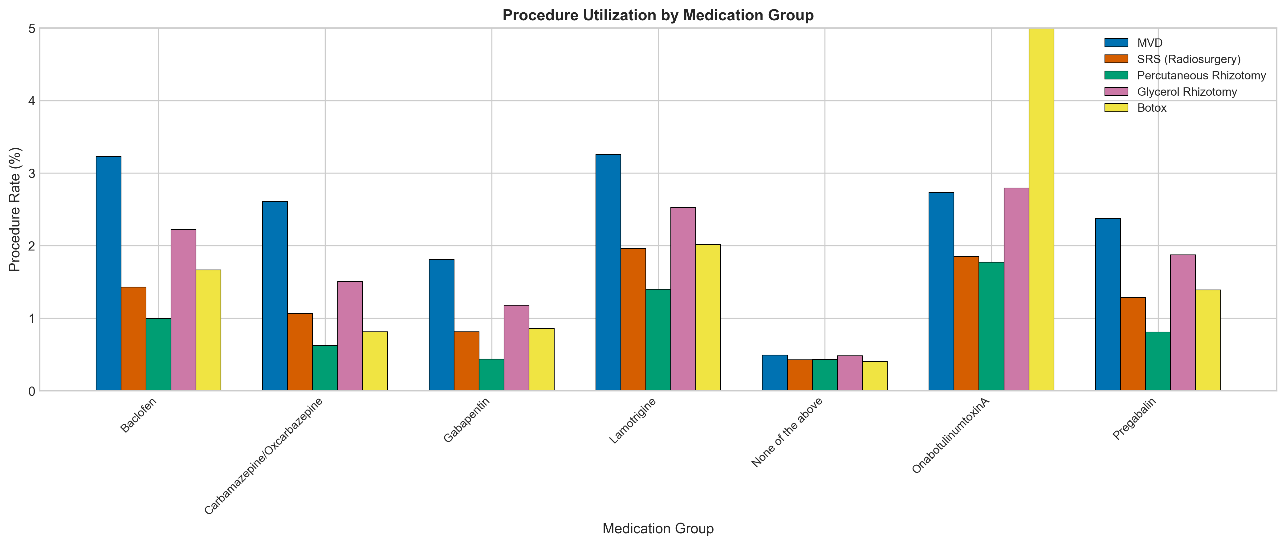
Grouped bar chart showing procedure rates among patients stratified by medication type. Higher procedure rates among patients on onabotulinumtoxinA may reflect treatment escalation patterns.

Figure 5. State-Level Variation in Treatment Utilization
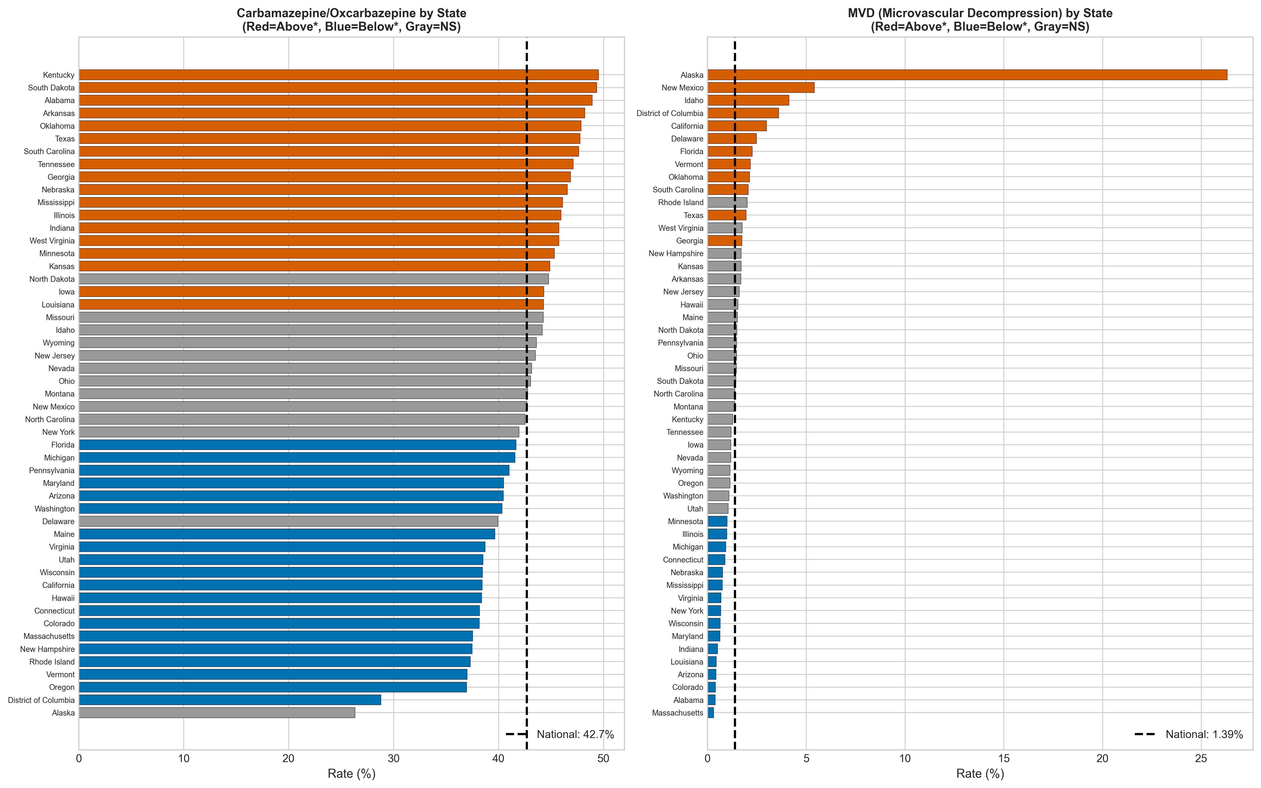
Horizontal bar charts showing (left) carbamazepine/oxcarbazepine rates and (right) MVD rates by state. Red = significantly above national average; Blue = significantly below; Gray = not significant (p<0.05).

Figure 6. Treatment Utilization Heatmaps by Census Region
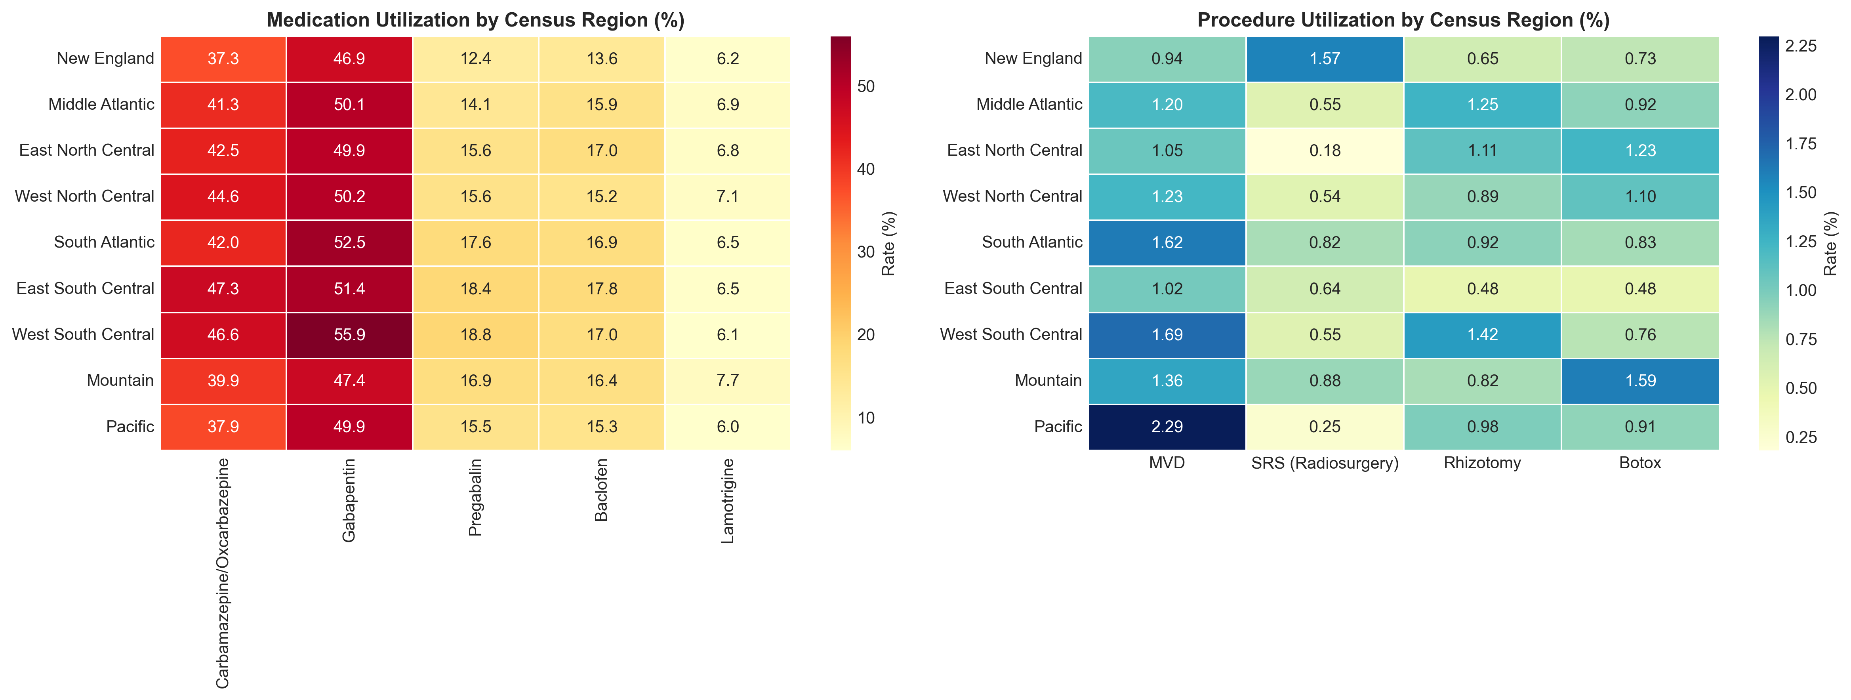
Heatmaps showing medication (left) and surgical procedure (right) utilization rates across 9 US census regions.

Figure 7. Regional Treatment Rates vs. National Average
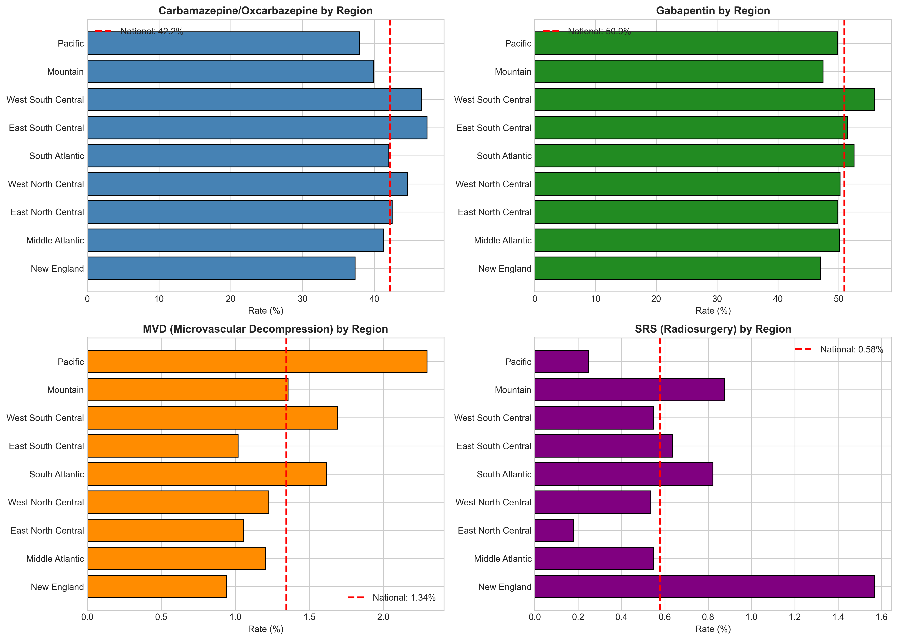
Bar charts comparing each census region to national average for key treatments. Red dashed line indicates national average.

