Trigeminal Neuralgia Treatment Patterns: Tables and Figures
Generated: January 11, 2026 at 01:43 PM
Data Source: Epic Cosmos Database
Study Period: November 28, 2022 - November 27, 2025
Inclusion: Patients with ICD-10 code G50.0 (Trigeminal Neuralgia)
Geographic Scope: 50 US States + District of Columbia
Population Data: 2024 US Census Bureau Estimates
Note: Values of '10 or fewer' were imputed as 5 (midpoint)
TABLES

Table 1. Study Cohort Characteristics
Characteristic | N | Percentage
Total TN Patients | 290,088 | 100.0%
Census Region
South Atlantic | 65,578 | 22.6%
East North Central | 58,542 | 20.2%
Middle Atlantic | 37,997 | 13.1%
West South Central | 31,208 | 10.8%
Pacific | 25,353 | 8.7%
West North Central | 19,768 | 6.8%
New England | 19,196 | 6.6%
Mountain | 17,432 | 6.0%
East South Central | 15,014 | 5.2%
Study Period | Nov 28, 2022 - Nov 27, 2025
Data Source | Epic Cosmos
ICD-10 Code | G50.0 (Trigeminal Neuralgia)
TN = Trigeminal Neuralgia

Table 2. Per Capita Trigeminal Neuralgia Diagnosis Rates by State
State | Abbrev | TN Patients | Population | Per 100,000 | Census Region
Ohio | OH | 21,746 | 11,785,935 | 184.5 | East North Central
Connecticut | CT | 6,137 | 3,617,176 | 169.7 | New England
North Dakota | ND | 1,282 | 783,926 | 163.5 | West North Central
Kentucky | KY | 6,696 | 4,526,154 | 147.9 | East South Central
Maine | ME | 2,055 | 1,395,722 | 147.2 | New England
Mississippi | MS | 4,241 | 2,939,690 | 144.3 | East South Central
Vermont | VT | 924 | 647,464 | 142.7 | New England
South Carolina | SC | 7,648 | 5,373,555 | 142.3 | South Atlantic
Pennsylvania | PA | 18,076 | 12,961,683 | 139.5 | Middle Atlantic
Wisconsin | WI | 7,982 | 5,910,955 | 135.0 | East North Central
Iowa | IA | 4,314 | 3,207,004 | 134.5 | West North Central
North Carolina | NC | 14,442 | 10,835,491 | 133.3 | South Atlantic
Virginia | VA | 11,515 | 8,683,619 | 132.6 | South Atlantic
West Virginia | WV | 2,280 | 1,770,071 | 128.8 | South Atlantic
Oregon | OR | 5,386 | 4,233,358 | 127.2 | Pacific
Arizona | AZ | 2,600 | 7,431,344 | 35.0 | Mountain
New Mexico | NM | 684 | 2,114,371 | 32.4 | Mountain
Alabama | AL | 1,290 | 5,108,468 | 25.3 | East South Central
District of Columbia | DC | 139 | 678,972 | 20.5 | South Atlantic
Alaska | AK | 19 | 733,406 | 2.6 | Pacific
Top 15 and bottom 5 states by per capita TN diagnosis rate. Population data from 2024 US Census Bureau estimates. Rates expressed per 100,000 population.

Table 3. National Treatment Utilization in Trigeminal Neuralgia
Treatment | N | Rate (%) | 95% CI
MEDICATIONS
Carbamazepine/Oxcarbazepine | 123,851 | 42.7 | (42.5-42.9)
Gabapentin | 148,000 | 51.0 | (50.8-51.2)
Pregabalin | 47,032 | 16.2 | (16.1-16.3)
Baclofen | 47,736 | 16.5 | (16.3-16.6)
Lamotrigine | 19,266 | 6.6 | (6.6-6.7)
OnabotulinumtoxinA | 14,972 | 5.2 | (5.1-5.2)
PROCEDURES
Microvascular Decompression (MVD) | 4,033 | 1.39 | (1.35-1.43)
Stereotactic Radiosurgery (SRS) | 1,813 | 0.62 | (0.60-0.65)
Percutaneous Rhizotomy | 972 | 0.34 | (0.31-0.36)
Glycerol Rhizotomy | 2,616 | 0.9 | (0.87-0.94)
Botox Injection | 2,069 | 0.71 | (0.68-0.74)
CI = Confidence Interval; MVD = Microvascular Decompression; SRS = Stereotactic Radiosurgery

Table 4. Treatment Utilization Rates by U.S. Census Region
Census Region | N Patients | Carb/Oxcarb (%) | Gabapentin (%) | Pregabalin (%) | Baclofen (%) | MVD (%) | SRS (%) | RHIZOTOMY (%)
South Atlantic | 65,578 | 42.6 | 52.4 | 17.4 | 17.0 | 1.61 | 0.71 | 0.41
East North Central | 58,542 | 43.0 | 50.0 | 15.7 | 17.1 | 1.05 | 0.21 | 0.23
Middle Atlantic | 37,997 | 41.7 | 50.2 | 14.1 | 16.0 | 1.2 | 0.64 | 0.29
West South Central | 31,208 | 47.2 | 56.3 | 19.0 | 17.1 | 1.69 | 0.62 | 0.21
Pacific | 25,353 | 38.4 | 49.9 | 15.5 | 15.4 | 2.27 | 0.34 | 0.66
West North Central | 19,768 | 45.1 | 50.4 | 15.8 | 15.3 | 1.21 | 0.61 | 0.5
New England | 19,196 | 37.9 | 47.3 | 12.5 | 13.7 | 0.93 | 1.62 | 0.16
Mountain | 17,432 | 40.3 | 47.6 | 16.9 | 16.5 | 1.31 | 0.95 | 0.37
East South Central | 15,014 | 48.1 | 51.6 | 18.3 | 17.9 | 1.03 | 0.7 | 0.21
Rates expressed as percentage of patients within each region. Carb/Oxcarb = Carbamazepine/Oxcarbazepine; MVD = Microvascular Decompression; SRS = Stereotactic Radiosurgery

Table 5. Chi-Square Tests for Regional Treatment Variation
Test | Chi-Square | df | P-value | Result
Medication Preferences by Region | 597.8 | 32 | <0.001 | Significant
Surgical Preferences by Region | 681.7 | 24 | <0.001 | Significant
Chi-square tests assess whether treatment preferences vary significantly across U.S. Census Regions. Significance threshold: p < 0.05.

FIGURES
Figure 1. National Treatment Utilization Rates in Trigeminal Neuralgia
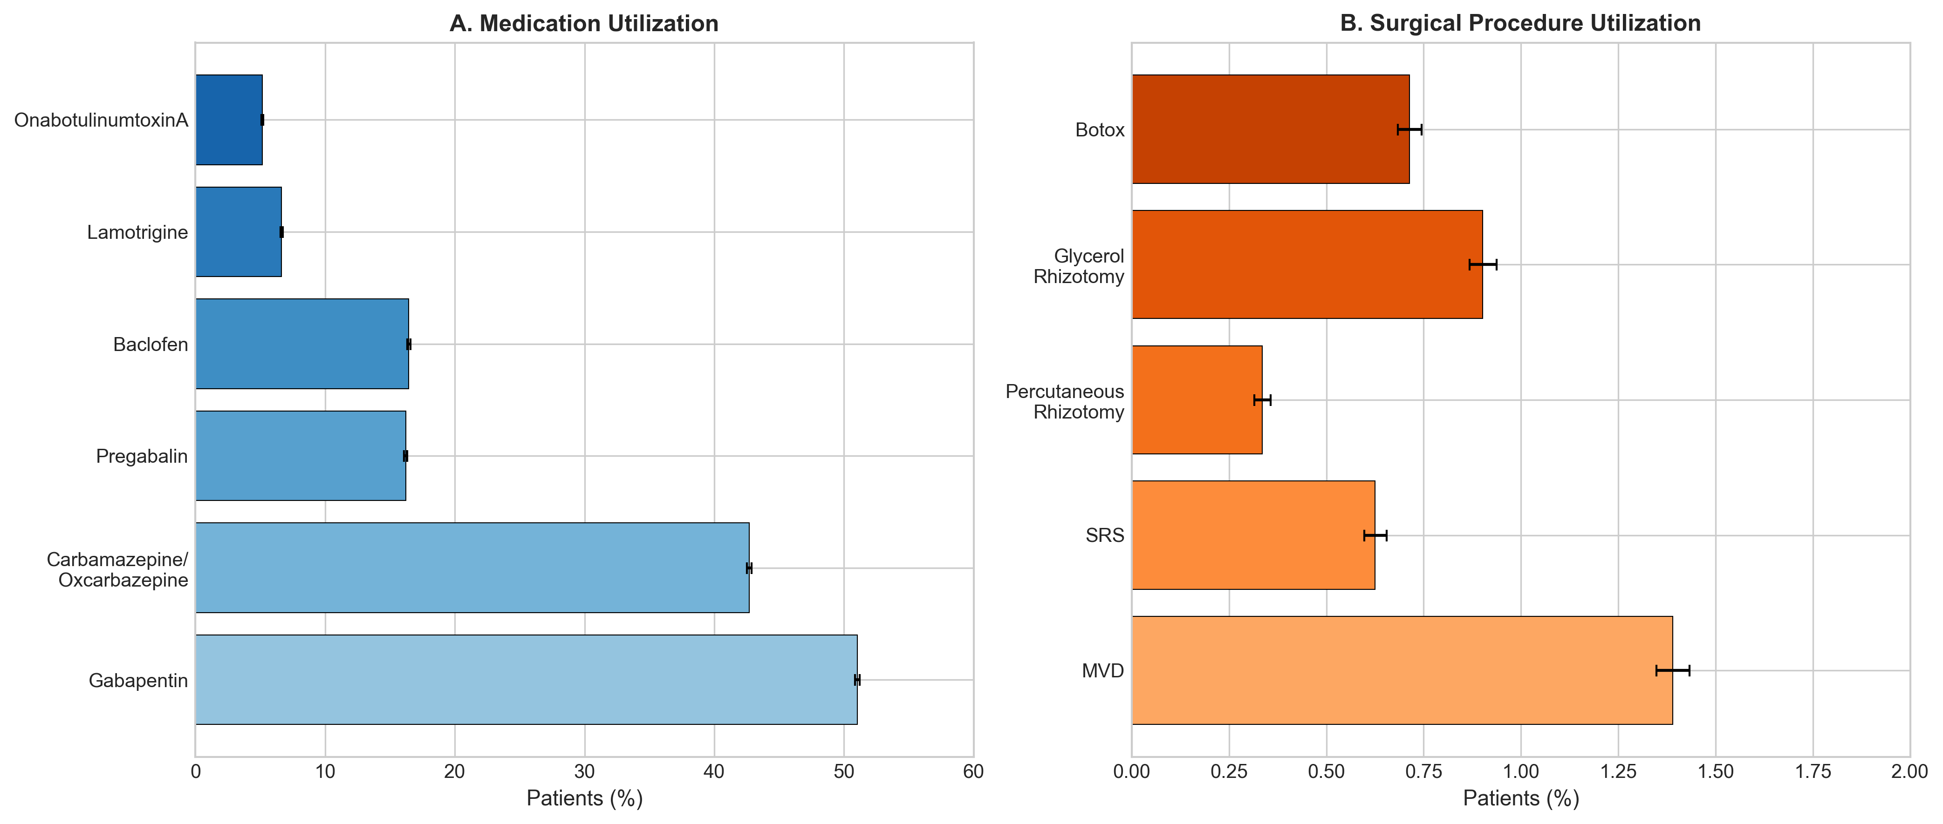
(A) Medication utilization showing percentage of TN patients prescribed each drug class. (B) Surgical procedure utilization showing percentage of patients undergoing each intervention. Error bars represent 95% confidence intervals.

Figure 2. Geographic Distribution of Trigeminal Neuralgia Diagnoses (Per Capita)
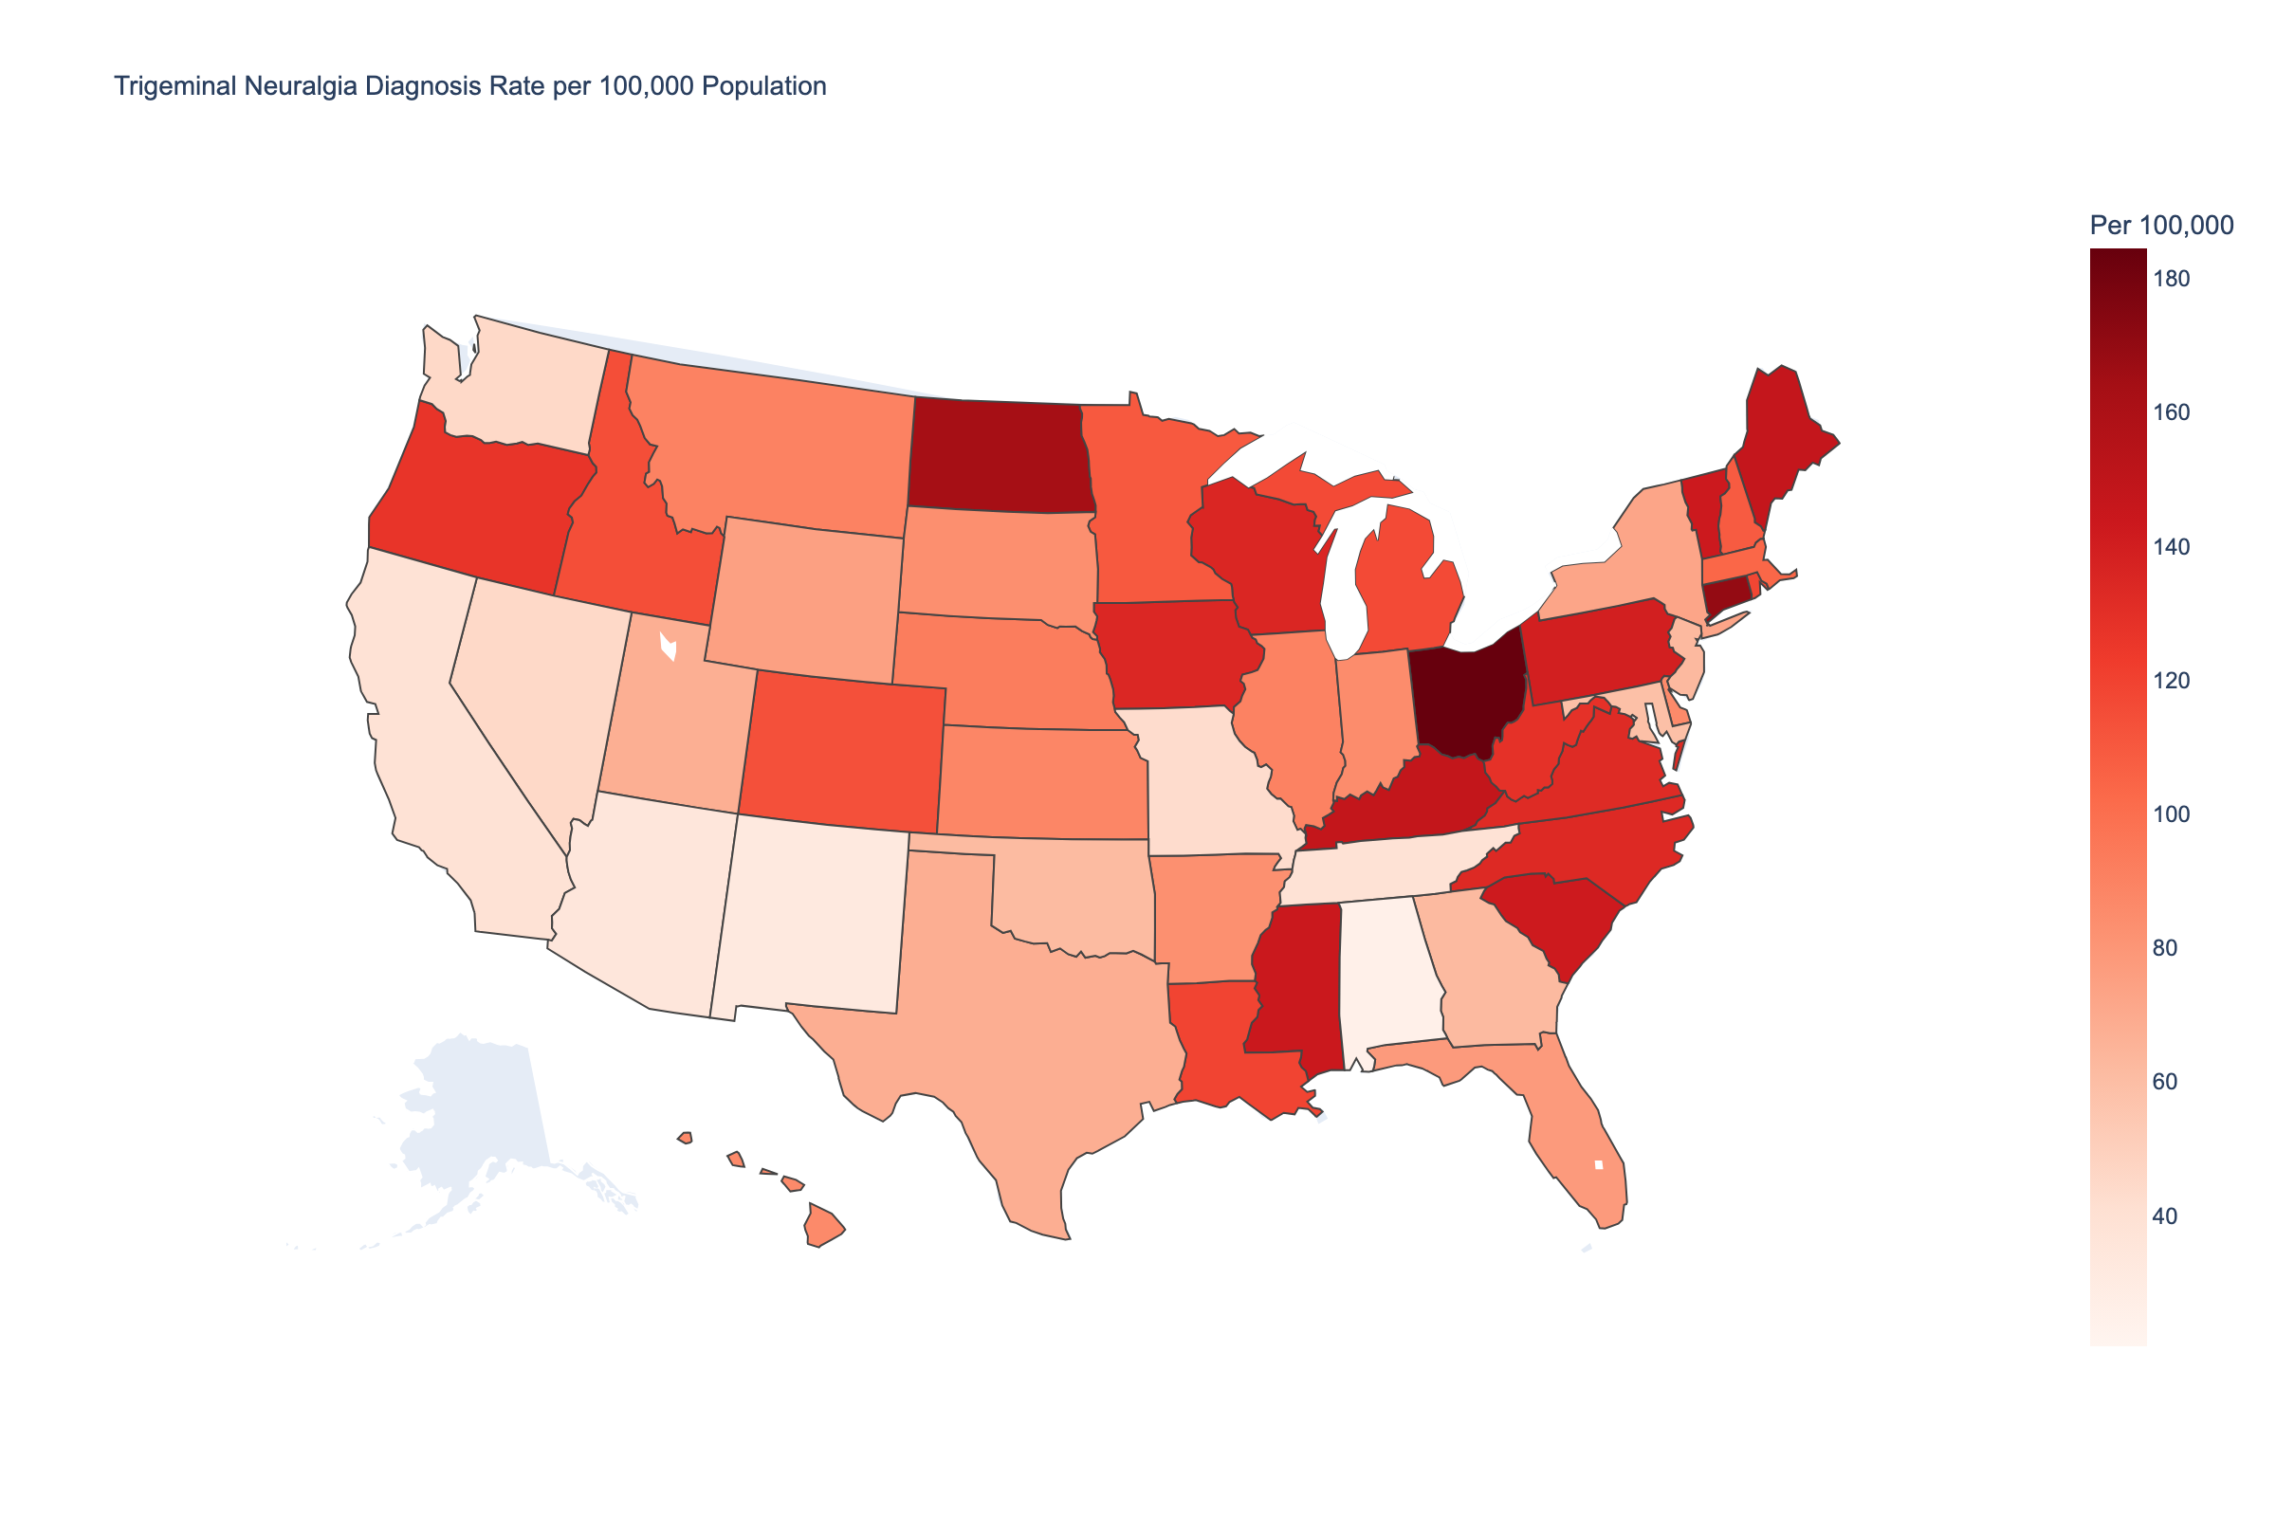
Choropleth map showing trigeminal neuralgia diagnosis rates per 100,000 population by state. Population data from 2024 US Census Bureau estimates. Darker shading indicates higher per capita rates. This visualization controls for state population size, revealing true geographic variation in TN burden.

Figure 3. State-Level Variation in First-Line Medication Utilization
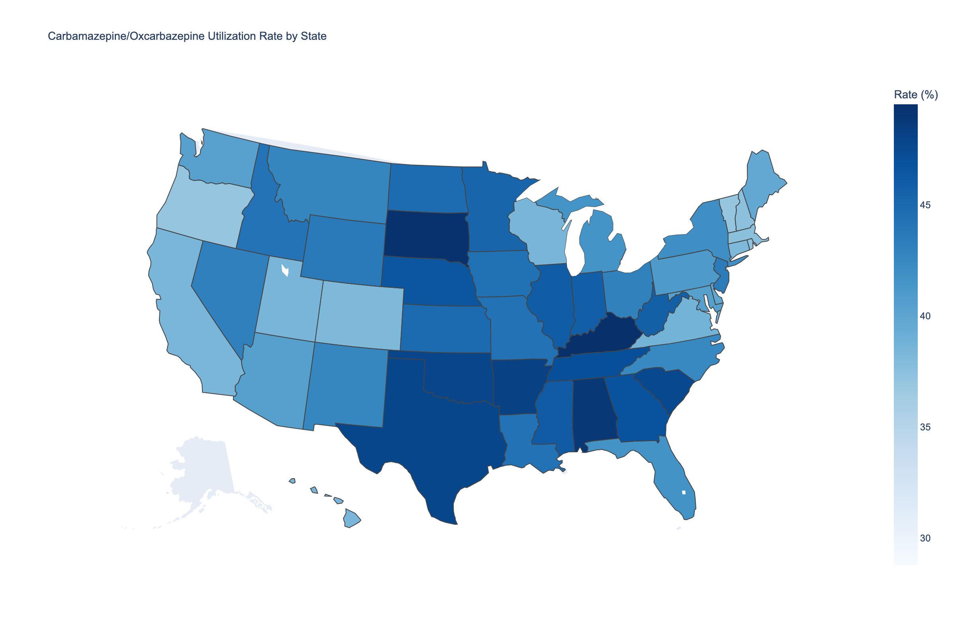
Choropleth map showing carbamazepine/oxcarbazepine utilization rates by state. Darker shading indicates higher utilization. These first-line agents are the recommended initial pharmacotherapy for trigeminal neuralgia per current guidelines.

Figure 4. State-Level Variation in Microvascular Decompression Utilization
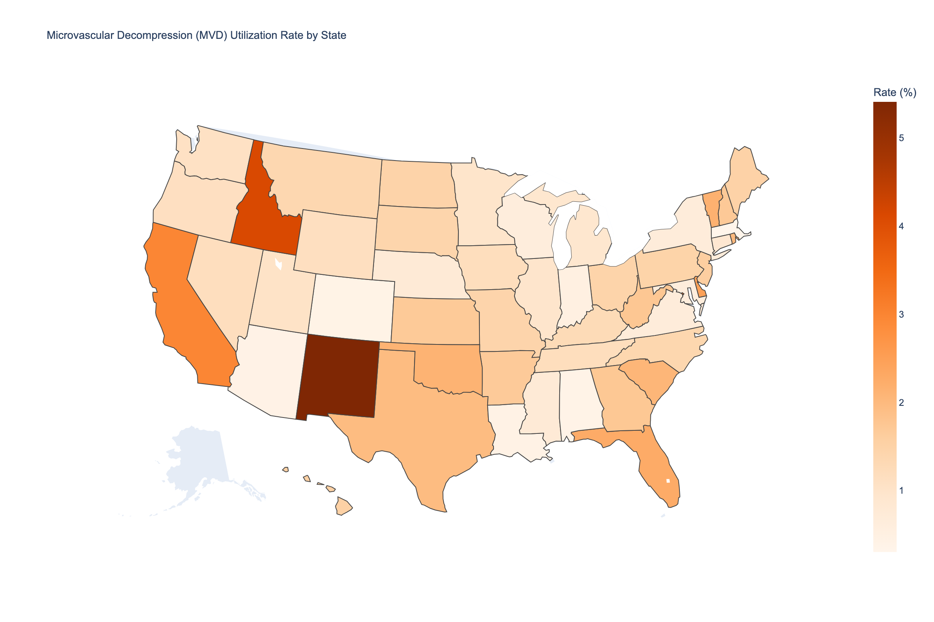
Choropleth map showing microvascular decompression (MVD) utilization rates by state. Darker shading indicates higher surgical intervention rates. Geographic variation may reflect differences in access to neurosurgical expertise, referral patterns, or patient preferences.

Figure 5. Regional Treatment Utilization Patterns
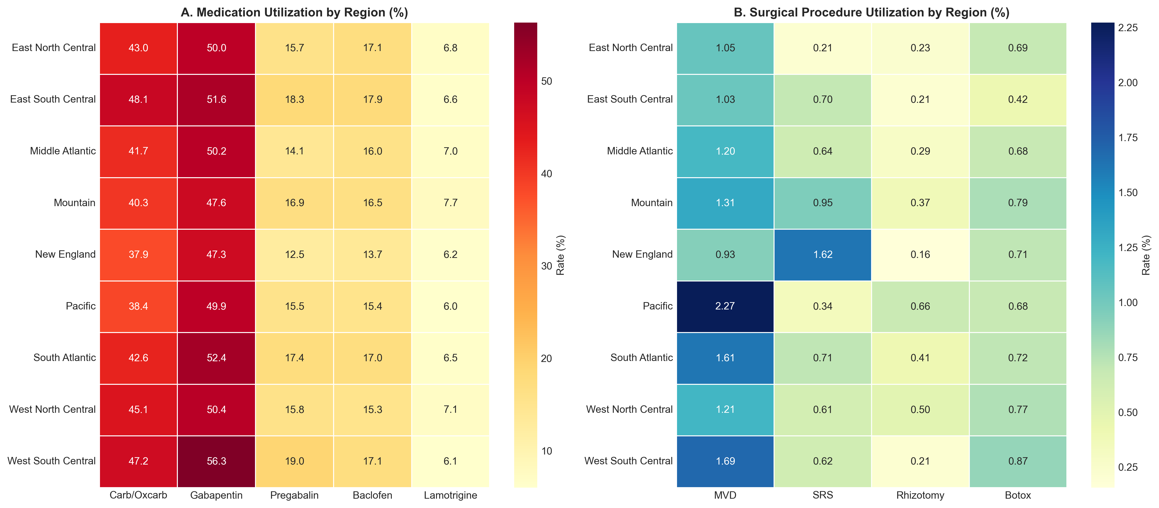
(A) Medication utilization rates (%) by U.S. Census Region. (B) Surgical procedure utilization rates (%) by U.S. Census Region. Carb/Oxcarb = Carbamazepine/Oxcarbazepine; MVD = Microvascular Decompression; SRS = Stereotactic Radiosurgery.

Figure 6. Surgical Intervention Rates by Medication Group
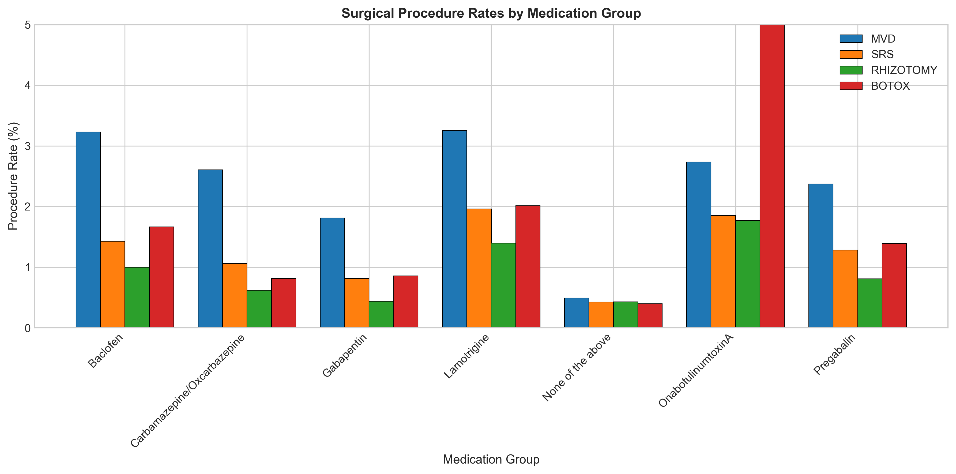
Rates of surgical procedures among patients grouped by their medication use. This analysis examines treatment escalation patterns, showing the proportion of patients within each medication group who underwent each type of surgical intervention. MVD = Microvascular Decompression; SRS = Stereotactic Radiosurgery.

SUPPLEMENTARY FIGURES
Figure S1. State-Level Carbamazepine/Oxcarbazepine Utilization (Bar Chart)
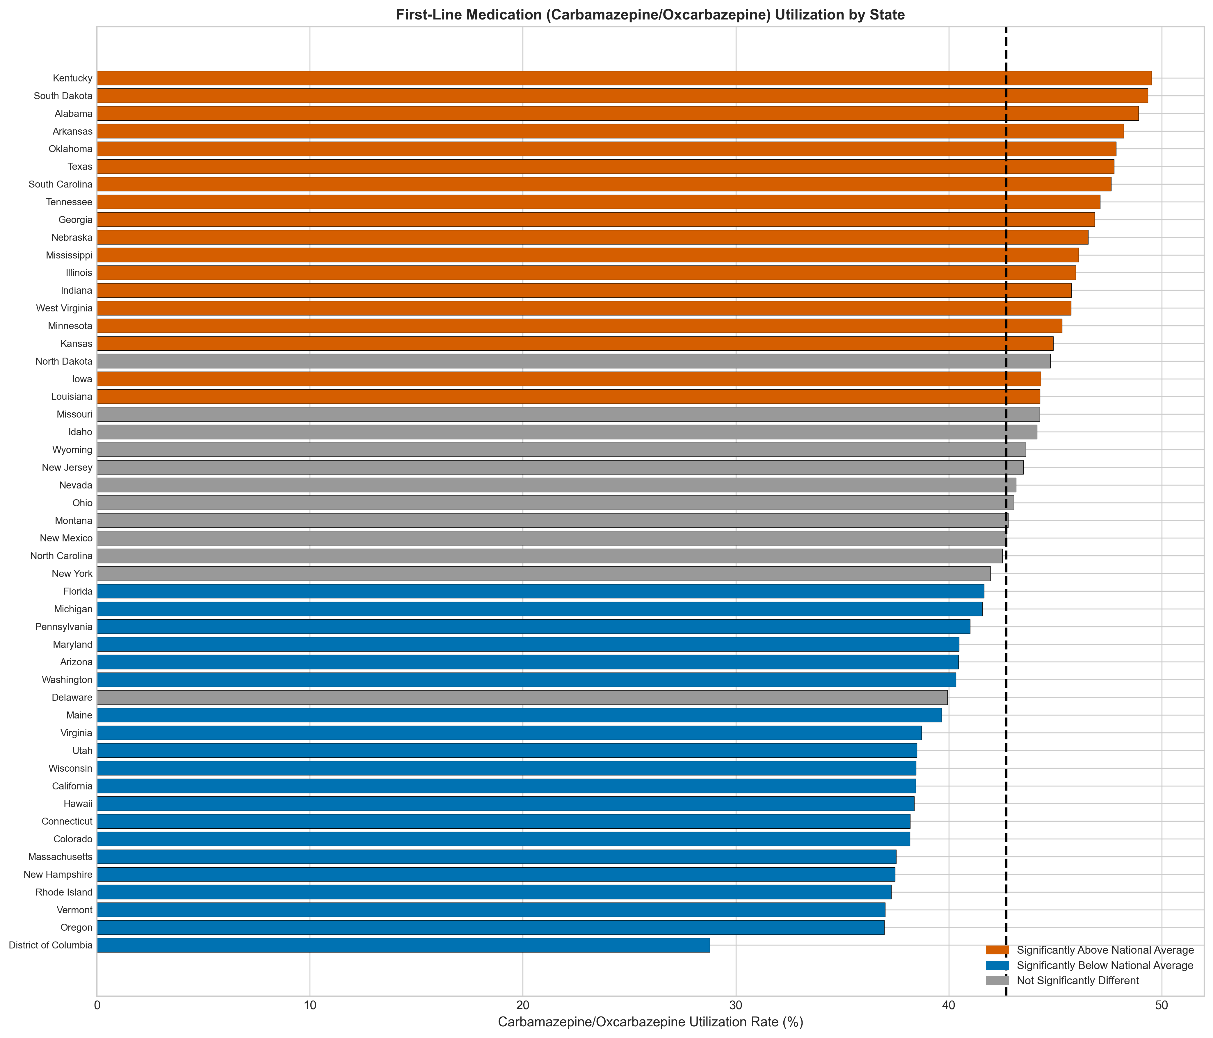
Bar chart showing carbamazepine/oxcarbazepine utilization rates by state. States colored red show significantly higher utilization than the national average (dashed line); states colored blue show significantly lower utilization. Gray indicates no significant difference from national average (two-tailed z-test, p < 0.05). Alaska excluded due to small sample size (n<10).

Figure S2. State-Level MVD Utilization (Bar Chart)
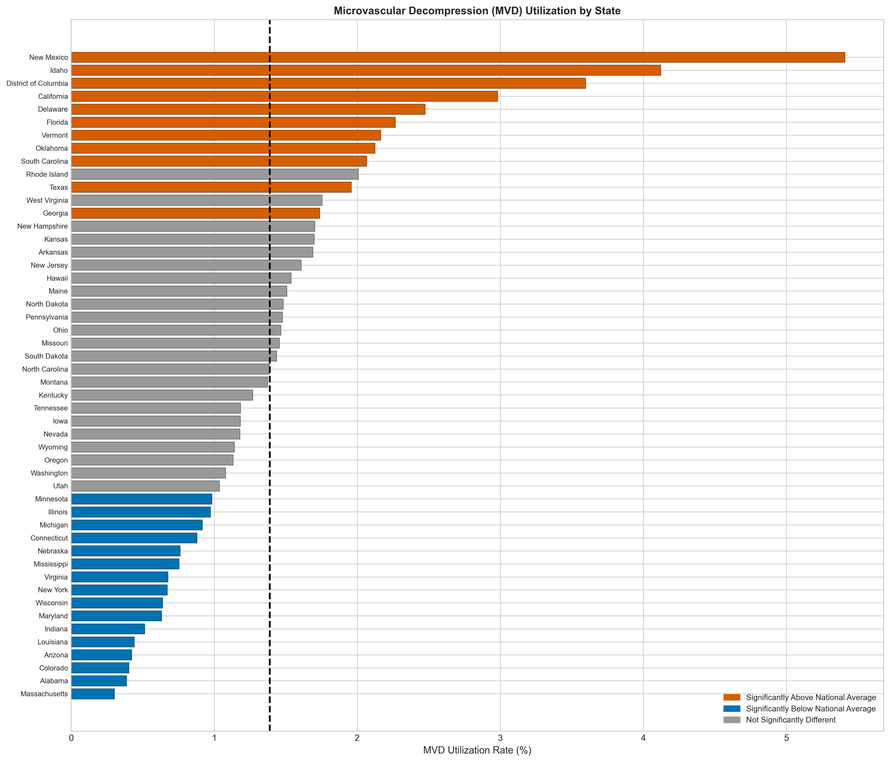
Bar chart showing microvascular decompression (MVD) utilization rates by state. States colored red show significantly higher utilization than the national average (dashed line); states colored blue show significantly lower utilization. Gray indicates no significant difference from national average (two-tailed z-test, p < 0.05). Alaska excluded due to small sample size (n<10).

