EEG FRONT-END DEVELOPMENT
Ideal System-Level Analog Front-End Implementation in LTspice
Stage-by-stage design, verification, and cross-verification report

Design stage | Ideal system-level EEG analog front end
Simulator | LTspice 24.x
Input stimulus | Reusable hierarchical EEG input model developed in the previous stage
Current chain | Differential gain -> HPF -> LPF -> post-gain
Next stage | ADC definition, then progressive CMOS replacement of ideal blocks

Purpose: establish a transparent behavioral reference system before transistor-level CMOS implementation.

1. Executive Summary
This report documents the second major phase of the EEG front-end project: transition from the previously completed literature-informed EEG stimulus model to an ideal analog front-end (AFE) system model in LTspice. The work intentionally separates system-level requirements from transistor-level circuit implementation. Each block is first represented by an ideal or passive behavioral element, tested independently, integrated with the realistic EEG/electrode stimulus, and then cross-verified using deliberately chosen test conditions.
The present ideal AFE contains a differential amplification stage with gain 20 V/V, a first-order high-pass section at approximately 0.48 Hz, a first-order low-pass section at approximately 40.8 Hz, and a post-amplification stage with gain 10 V/V. The nominal analog gain is therefore 200 V/V. The chain has been verified using both the completed dynamic EEG model and dedicated verification stimuli: a 50 uV, 10 Hz differential sine for amplifier verification, a temporary 50 mV DC offset for high-pass verification, a 1 mV, 200 Hz sine for low-pass verification, and zero-error algebraic traces for both gain stages.
The objective is not to copy a commercial AFE. The mentor-provided EEG front-end paper is used to understand the classical acquisition chain and required properties, while Texas Instruments ADS1299 literature will be used as a benchmark during the ADC/specification stage. The ideal chain developed here will later act as a reference against which CMOS implementations of the functional blocks can be compared.

2. System-Level Direction from the Mentor-Provided Literature
The paper "Front-end circuit design for electroencephalography (EEG) signal" describes a classical EEG acquisition path consisting of scalp electrodes, an instrumentation amplifier, filtering stages, post-amplification, and data acquisition. It emphasizes the need to amplify microvolt-level EEG signals while rejecting common-mode and power-line interference. It also identifies high input impedance, high common-mode rejection ratio (CMRR), low noise, low nonlinearity, interference robustness, suitable frequency response, and adequate dynamic range as important front-end properties [1].
The paper reports a practical implementation with a low-frequency high-pass corner, a low-pass filtering function, a notch stage, and post-amplification. The present work does not copy those exact circuits. Instead, it uses the paper to justify the order and purpose of the ideal blocks, while cutoff frequencies and gains are selected deliberately for the current learning-oriented EEG model.
Function in literature | Purpose in our ideal model | Current implementation
Instrumentation amplifier / preamplifier | Amplify the differential EEG while rejecting common-mode content | Ideal behavioral differential amplifier, G1 = 20
High-pass function | Remove DC and very-slow baseline drift | First-order RC HPF, fc ≈ 0.48 Hz
Low-pass function | Restrict signal bandwidth and suppress higher-frequency content | First-order RC LPF, fc ≈ 40.8 Hz
Post-amplifier | Raise filtered EEG to a more useful level | Ideal behavioral gain stage, G2 = 10
ADC / DAQ | Convert the conditioned analog signal to digital data | Next stage; ADS1299 used as benchmark, not copied directly

3. Design Methodology and Current Architecture
The design methodology is intentionally hierarchical and verification-driven. The completed EEG generator was converted into a reusable LTspice hierarchical block that exposes only the differential AFE interface nodes INP and INN. Internal nodes such as EEG_FINAL, the dynamic alpha/beta components, common-mode disturbance, and electrode-interface nodes remain hidden. This creates a professional separation between the stimulus model and the front-end under development.
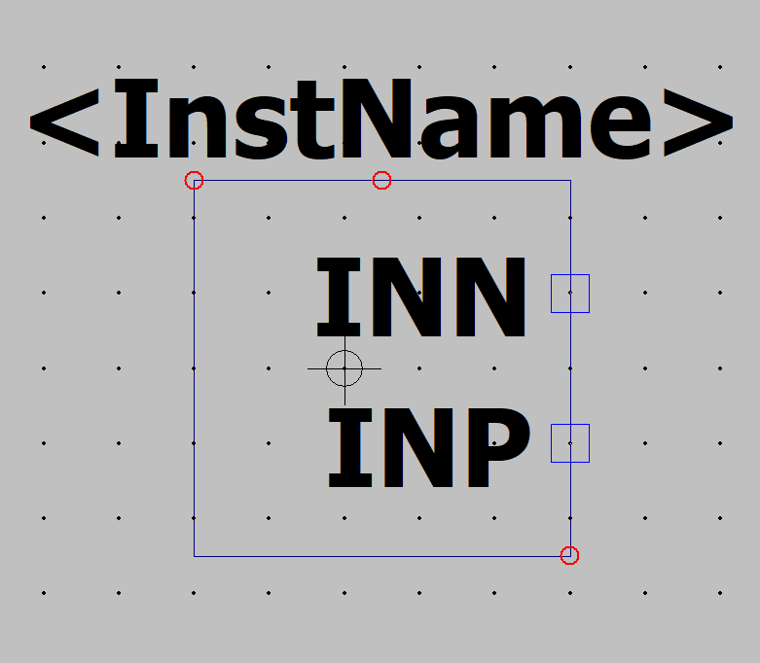
Figure 1. Hierarchical EEG_INPUT_MODEL symbol exposing only INP and INN to the top-level AFE schematic.
At the top level, the signal chain is currently:
EEG_INPUT_MODEL -> Differential Gain x20 -> HPF ~0.5 Hz -> LPF ~40 Hz -> Post Gain x10 -> AFE_OUT
The total nominal gain is
G_total = G1 x G2 = 20 x 10 = 200 V/V
This architecture is still ideal. Its role is to define what each functional block should do before introducing transistor limitations such as finite open-loop gain, input-referred noise, flicker noise, offset, CMRR, output swing, power, linearity, and PVT sensitivity.

4. Stage 1 - Ideal Differential Amplifier

4.1 Why this block is first
EEG is acquired as a small differential voltage in the presence of much larger common-mode components. Therefore the first ideal AFE function should respond to the difference between INP and INN rather than to either node individually. A moderate first-stage gain was chosen to avoid making the first block unrealistically aggressive before offset and dynamic-range constraints are fully studied.
V_AFE_AMP_OUT = 20 [ V(INP) - V(INN) ]
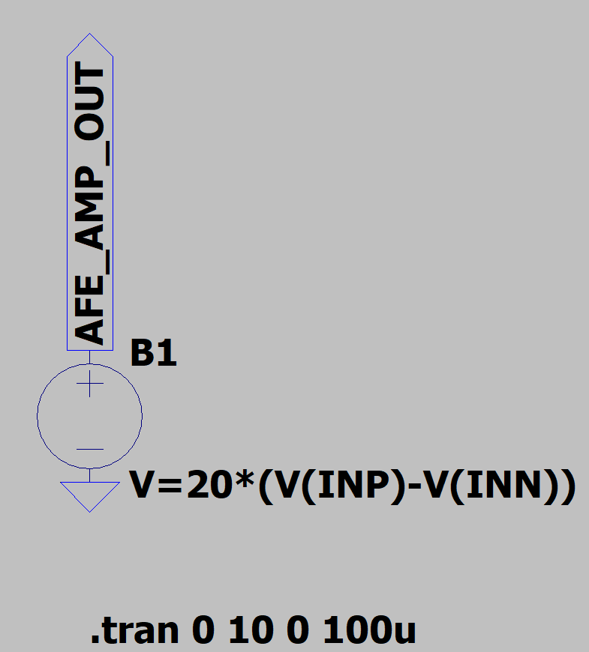
Figure 2. Initial ideal differential amplifier behavioral source used in the clean AFE schematic.

4.2 Standalone cross-verification before integration
Before connecting the completed EEG model, the amplifier was tested independently. INP was driven with a 50 uV peak, 10 Hz sine and INN was set to 0 V. This gives an exactly known differential input and an expected output amplitude of 1 mV peak:
50 uV x 20 = 1 mV
A second trace was used as an algebraic error monitor:
e_amp = V(AFE_AMP_OUT) - 20 [ V(INP) - V(INN) ]
If the ideal amplifier expression is implemented correctly, e_amp should be zero except for simulator numerical residue.
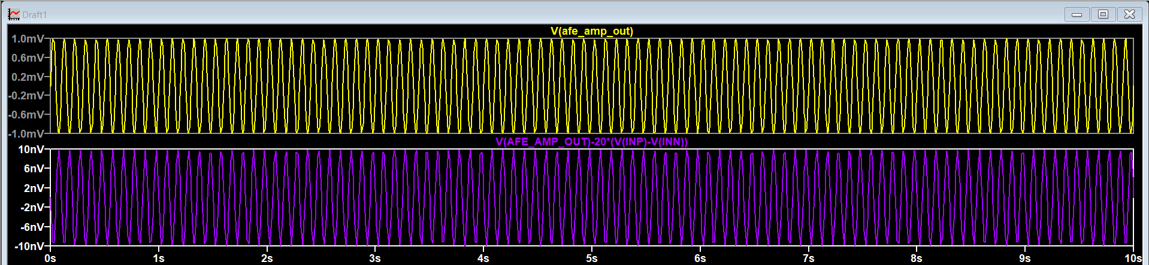
Figure 3. Standalone amplifier verification. The output reaches approximately ±1 mV and the algebraic error remains only at numerical-noise level.
Why this cross-verification matters: it separates amplifier-model correctness from the complexity of the EEG source. If a later integrated waveform looks wrong, this test provides evidence that the isolated gain block itself was correct.

4.3 Integration with the hierarchical EEG input model
After standalone verification, the temporary sine sources were removed and the professional hierarchical EEG_INPUT_MODEL was connected to the AFE. This block contains the final dynamic EEG stimulus, common-mode 50 Hz interference, and the frequency-dependent electrode interface developed previously.
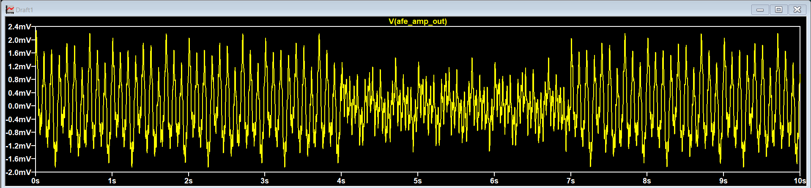
Figure 4. Ideal amplifier output after connection to the final hierarchical EEG/electrode stimulus model.
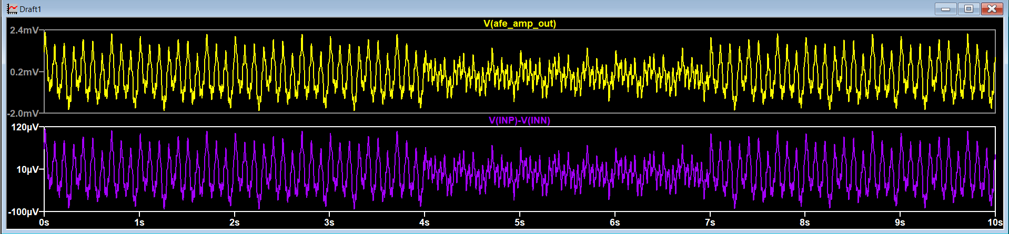
Figure 5. Cross-check of actual differential input V(INP)-V(INN) against the amplified output. The same time-domain structure is preserved while amplitude is scaled by 20.
The three-state EEG behavior remains visible after amplification: alpha-dominant activity before 4 s, reduced alpha / stronger faster content from 4 s to 7 s, and recovery after 7 s. This confirms that the first ideal AFE block does not alter the intended temporal behavior; it only scales the differential signal.

5. Stage 2 - High-Pass / DC-Removal Stage

5.1 Purpose and cutoff selection
A high-pass function is required to suppress DC and very-slow baseline drift before later gain stages. A target corner near 0.5 Hz was selected for this learning model. This value preserves the modeled EEG band while demonstrating the principle of baseline removal without copying the mentor paper's component values directly.
f_c = 1 / (2 pi R C)
Using R_HP = 1 Megohm and C_HP = 330 nF:
f_c,HP = 1 / [2 pi (1e6)(330e-9)] ≈ 0.482 Hz

5.2 Cross-verification using a deliberate DC offset
With the normal EEG waveform alone, HP_OUT can look very similar to the amplifier output because most modeled content is already above the high-pass corner. Therefore a controlled 50 mV DC offset was temporarily added to the amplifier output. This is a stronger test because the expected behavior is unambiguous: the input should remain centered near 50 mV, while the HPF output should settle around 0 V and preserve the AC EEG variation.
V_test = 50 mV + 20 [ V(INP) - V(INN) ]
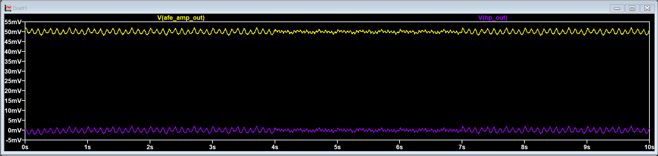
Figure 6. High-pass cross-verification using a temporary 50 mV DC offset. AFE_AMP_OUT remains centered near 50 mV while HP_OUT is centered near 0 V.
This test directly demonstrates the intended system function: DC rejection without removing the desired EEG variations. After the check, the temporary 50 mV term was removed and the normal amplifier expression restored.

6. Stage 3 - Low-Pass Band-Limiting Stage

6.1 Purpose and cutoff selection
The low-pass stage restricts the upper analog bandwidth and attenuates content well above the intended EEG band. A target near 40 Hz was chosen because the current EEG model focuses on delta, theta, alpha, and beta behavior and the earlier system target used approximately 0.5-40 Hz for basic EEG capture.
Using R_LP = 10 kohm and C_LP = 390 nF:
f_c,LP = 1 / [2 pi (10e3)(390e-9)] ≈ 40.81 Hz

6.2 Initial integrated observation
With the real EEG model, LP_OUT and HP_OUT remain similar because much of the desired content is below the cutoff. A small amplitude and phase difference is expected because a first-order low-pass filter already begins to affect components as they approach the corner frequency.
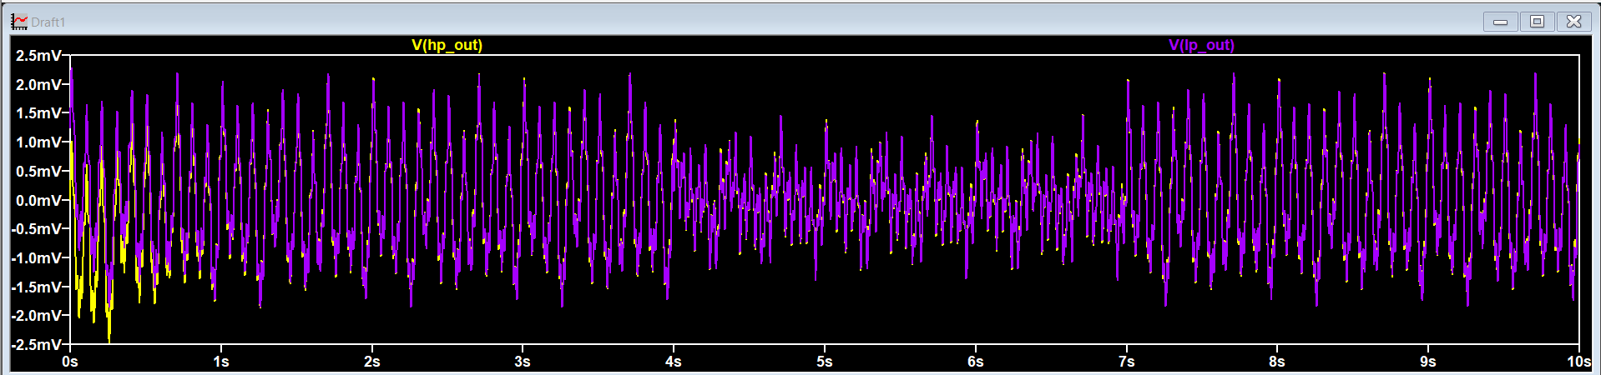
Figure 7. HP_OUT and LP_OUT with the normal EEG stimulus. The outputs are similar, with expected filtering-related amplitude/phase differences.

6.3 Dedicated 200 Hz cross-verification
A dedicated out-of-band stimulus was then used to prove that the LPF was actually providing attenuation. The normal EEG drive was temporarily replaced with a 1 mV peak, 200 Hz sine. Since 200 Hz is almost five times the filter corner, the expected first-order magnitude is approximately:
|H(f)| = 1 / sqrt[1 + (f/f_c)^2]
|H(200 Hz)| ≈ 0.200
Expected LP_OUT ≈ 1 mV x 0.200 ≈ 0.200 mV peak
The corrected verification plot shows approximately 1 mV peak at HP_OUT and approximately 0.2 mV peak at LP_OUT, in close agreement with the expected first-order attenuation.
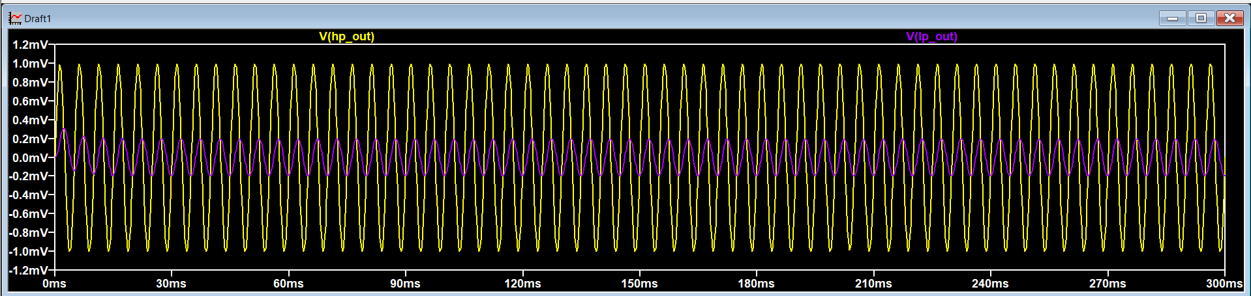
Figure 8. Dedicated 200 Hz LPF verification. The 200 Hz component is reduced from about 1 mV peak at HP_OUT to about 0.2 mV peak at LP_OUT.
Why this cross-verification matters: the normal EEG waveform is too broadband and visually dense to quantify the filter action reliably. A single known out-of-band tone converts the qualitative question "does the filter look different?" into a quantitative amplitude check.

7. Stage 4 - Post-Gain Amplification

7.1 Gain choice and role
After band-limiting, a second ideal gain stage of 10 V/V was introduced. This raises the conditioned EEG to a more convenient amplitude before the ADC stage while keeping the first-stage gain moderate.
V_AFE_OUT = 10 V(LP_OUT)
G_total = 20 x 10 = 200 V/V
As an order-of-magnitude example, 50 uV at the input corresponds to approximately 10 mV after the two gain stages, before considering filter attenuation at the specific signal frequency.
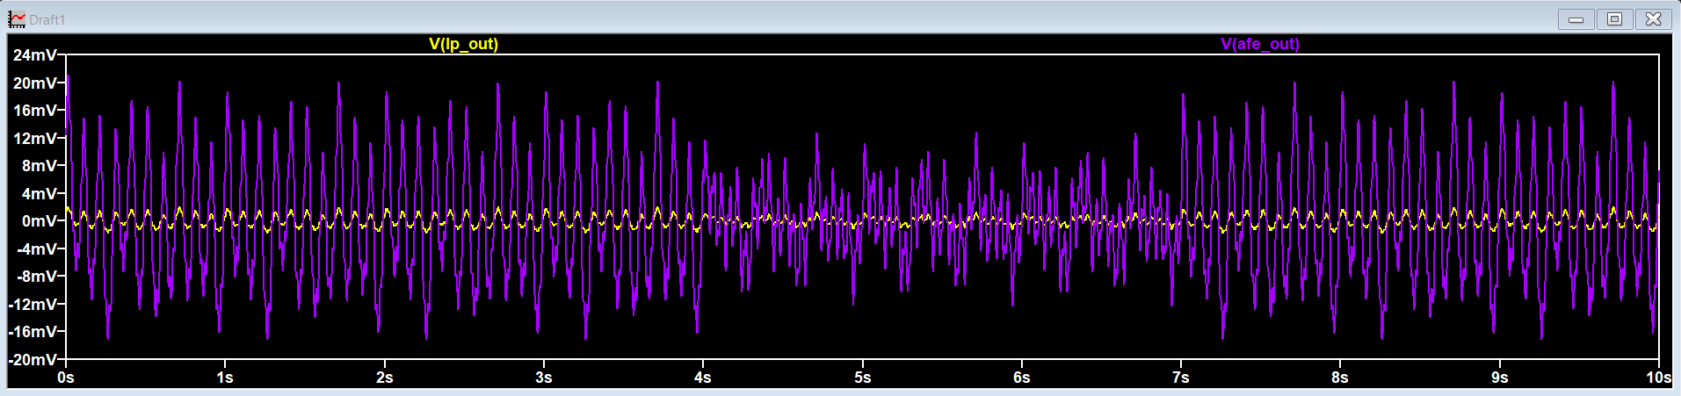
Figure 9. LP_OUT and AFE_OUT. The post-gain stage scales the filtered waveform by 10 while preserving its time-domain structure.

7.2 Algebraic zero-error cross-verification
The second gain stage was checked using the residual expression:
e_post = V(AFE_OUT) - 10 V(LP_OUT)
The residual remains essentially at zero, confirming that the behavioral post-gain source exactly implements the intended factor of 10 within numerical precision.
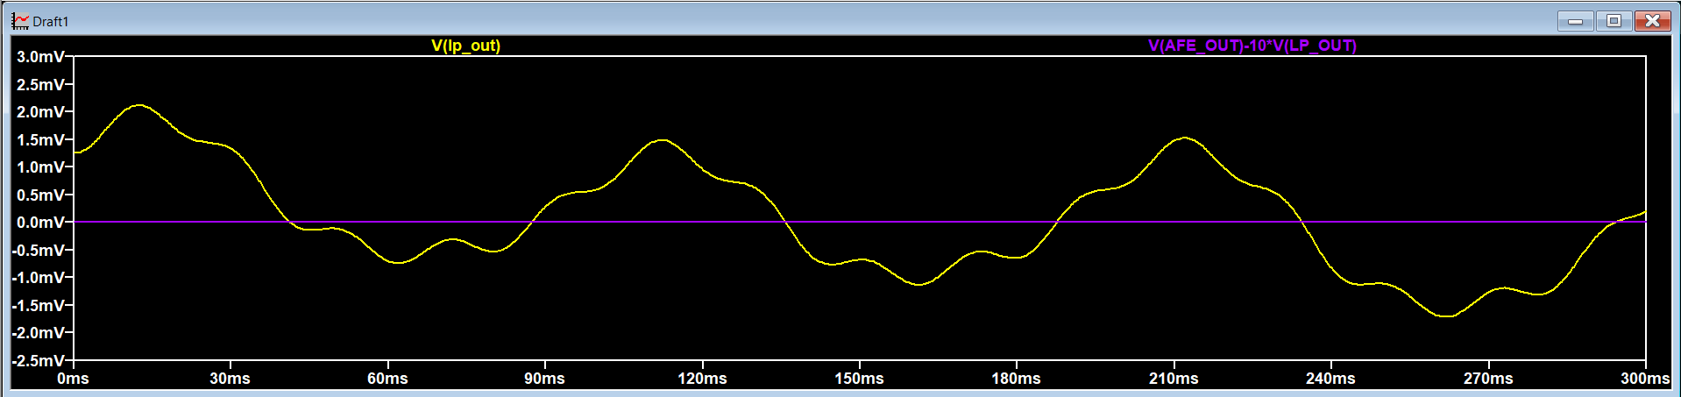
Figure 10. Post-gain cross-verification. The magenta residual V(AFE_OUT)-10·V(LP_OUT) is essentially zero.

8. Verification Matrix
Block | Nominal function | Verification stimulus / method | Expected result | Observed result
Differential amplifier | Gain = 20 | 50 uVpk, 10 Hz differential sine + zero-error expression | 1 mVpk output; residual ≈ 0 | Verified
Integrated amplifier | Gain = 20 on real EEG input | Compare V(INP)-V(INN) with AFE_AMP_OUT | Same waveform shape, x20 amplitude | Verified
High-pass | fc ≈ 0.482 Hz | Temporary +50 mV DC offset | DC removed; EEG AC retained | Verified
Low-pass | fc ≈ 40.81 Hz | 1 mVpk, 200 Hz dedicated tone | ~0.20 mVpk at LP_OUT | Verified
Post-gain | Gain = 10 | Compare LP_OUT and AFE_OUT + zero-error expression | x10 amplitude; residual ≈ 0 | Verified

9. Current Ideal AFE Specification Snapshot
Parameter | Current ideal target | Reason / status
Input representation | Differential INP/INN from hierarchical EEG/electrode model | Retains common-mode/electrode effects from stimulus stage
First-stage gain | 20 V/V | Moderate ideal preamplification
High-pass corner | ~0.48 Hz | DC / baseline-drift rejection
Low-pass corner | ~40.8 Hz | Band-limit current EEG model
Post-gain | 10 V/V | Raise conditioned signal before ADC
Total nominal gain | 200 V/V | 20 x 10
ADC | Not yet fixed | Next stage: choose full-scale, resolution, sample rate and interface assumptions
Commercial benchmark | ADS1299 literature | Reference for requirements/architecture; not directly instantiated

10. Engineering Interpretation and Why the Ideal Model Matters
The ideal chain is not intended to represent the final IC implementation. It is a behavioral reference model. This separation is valuable because it gives each later CMOS block a measurable target. For example, a CMOS low-noise amplifier can be compared against the ideal x20 stage for gain accuracy, bandwidth, input-referred noise, CMRR, offset, linearity, and power. A CMOS filter can be compared against the ideal high-pass/low-pass response. The ADC interface can be designed around the final analog output range rather than guessed before the analog chain is understood.
- The amplifier cross-checks establish the required differential transfer function before finite CMRR and noise are introduced.
- The HPF test establishes that the chain can reject large DC/baseline terms while preserving the desired signal.
- The LPF test establishes measurable attenuation of content well above the EEG band.
- The post-gain test establishes the final nominal scaling before ADC selection.
- The hierarchical EEG source keeps the AFE schematic clean and allows the same stimulus to be reused when ideal blocks are replaced by CMOS blocks.

11. Role of ADS1299 in the Next Stage
The Texas Instruments ADS1299 is not being inserted as a component into this ideal chain. Its role is to provide a well-documented professional EEG/biopotential AFE benchmark. During the next stage, its documentation can be used to guide decisions such as programmable gain philosophy, ADC architecture, input range, sampling rate, noise targets, common-mode/bias handling, and digital interface considerations. Our architecture remains our own; ADS1299 is a reference point for checking whether the chosen requirements are realistic.
This distinction is important for the project narrative: the work progresses from a literature-informed EEG stimulus, to an independently constructed ideal system model, to specification extraction, and finally to CMOS implementation and comparison.

12. Next Work Package
The next work package should define the ideal ADC interface before any transistor replacement begins. The recommended sequence is:
- Determine the useful AFE_OUT amplitude range under nominal EEG and worst-case stimulus conditions.
- Choose a provisional ADC input full-scale and common-mode convention.
- Choose a provisional resolution and sample rate using the EEG bandwidth and ADS1299 literature as references.
- Create an ideal ADC/quantizer model and verify that the dynamic EEG waveform is represented without clipping or excessive quantization error.
- Freeze the complete ideal end-to-end reference chain.
- Replace the first ideal analog block with a CMOS low-noise differential amplifier and compare it against the ideal reference.
- Continue block-by-block CMOS replacement while preserving the same hierarchical EEG stimulus and verification tests.

13. Conclusions
A verified ideal analog EEG front-end chain has been established in LTspice. The architecture currently provides differential gain of 20, baseline/DC rejection near 0.5 Hz, upper band limiting near 40 Hz, and post-gain of 10, for a nominal total gain of 200 V/V. Importantly, each functional block was not only simulated with the composite EEG waveform but also cross-verified with a deliberately simplified test stimulus that makes the expected behavior measurable.
This verification-first workflow significantly reduces ambiguity before CMOS design. The resulting behavioral model can now serve as a golden system-level reference for the ADC stage and for later transistor-level implementation of the AFE blocks.

References
[1] S. M. Salahuddin Morsalin and S.-C. Lai, “Front-end circuit design for electroencephalography (EEG) signal,” Indo–Taiwan 2nd International Conference on Computing, Analytics and Networks (Indo-Taiwan ICAN2020), 2020, pp. 170–175.
[2] Texas Instruments, ADS1299 documentation and application literature for EEG/biopotential acquisition. To be used as a benchmark during the ADC/specification stage rather than as a directly instantiated component in the present behavioral model.

Appendix A - Key LTspice Behavioral Expressions and Verification Traces
Purpose | LTspice expression
Ideal first-stage amplifier | V=20*(V(INP)-V(INN))
First-stage zero-error check | V(AFE_AMP_OUT)-20*(V(INP)-V(INN))
Temporary HPF DC-verification drive | V=50m+20*(V(INP)-V(INN))
Temporary LPF out-of-band test drive | V=1m*sin(2*pi*200*time)
Post-gain stage | V=10*V(LP_OUT)
Post-gain zero-error check | V(AFE_OUT)-10*V(LP_OUT)
Normal EEG transient | .tran 0 10 0 100u

