Development of a Literature-Informed EEG
Behavioral Stimulus in LTspice
Signal modeling, differential representation, common-mode interference,
electrode-interface effects, and dynamic alpha/beta behavior
Technical Report
Prepared as the input-signal development stage for a CMOS EEG front-end study
August 2026

Executive Summary
Objective. The goal of this work was to understand EEG from an analog/mixed-signal IC design perspective and to create a controlled LTspice stimulus that can later be used to derive and verify a CMOS analog front end (AFE). The model is intentionally engineering-oriented rather than a clinical EEG generator.
Progression. The work began with a deterministic four-band EEG source, verified each rhythm independently, converted the source into a differential signal, added 50 Hz common-mode interference, introduced unequal electrode impedances, demonstrated common-mode-to-differential conversion, extended the electrode interface to a frequency-dependent model, and finally added a literature-informed eyes-closed / eyes-open / eyes-closed alpha-beta transition.
Final outcome. The final EEG source (EEG_FINAL) is constructed from delta, theta, dynamic alpha, and dynamic beta components. Alpha is dominant from 0–4 s, suppressed from 4–7 s, and restored from 7–10 s, while beta is increased during the middle interval. A reconstruction-error check remains only in the picovolt range, confirming correct composition of the final behavioral source.
Scope boundary: The generated waveform is a literature-informed behavioral test stimulus for circuit development. It is not presented as a patient-specific or clinically validated EEG recording.

1. Background and Modeling Basis
The provided EEG reference material describes scalp EEG as a recording of brain electrical activity and classifies the principal rhythms by frequency and amplitude. It identifies alpha, beta, theta, and delta activity and relates them to different physiological states. The reference material also emphasizes electrode placement and electrode-impedance checking during EEG recording.
Rhythm | Reference frequency range | Qualitative association used in this work
Delta | about 2–4 Hz | slow / sleep-related
Theta | about 5–7 Hz | drowsiness / sleep-related
Alpha | 8–13 Hz | relaxed adult, eyes closed; occipital prominence
Beta | 14–30 Hz | mental activity / active state
Literature-informed dynamic behavior. The reference material states that alpha activity is characteristic of relaxed eyes-closed EEG, and that eye opening produces alpha blocking/desynchronization. It also associates beta activity with mental activity. These qualitative observations motivated the final state-dependent alpha and beta model.
Important distinction. Several numerical values used later in the LTspice testbench—such as 0.9 V common-mode bias, 100 mV 50 Hz interference, 100 MΩ input resistance, electrode-impedance mismatch values, and the exact alpha/beta scaling factors—are engineering choices made for controlled simulation and are not claimed to be fixed physiological constants.

2. Stage 1 – Initial Four-Band EEG Source
The first goal was to produce a simple and repeatable EEG-like waveform from four sinusoidal components. This provides a deterministic test signal that is easy to debug before introducing physiological state changes or electrode effects.
v_EEG(t) = v_δ(t) + v_θ(t) + v_α(t) + v_β(t)
Component | Frequency | Peak amplitude
Delta | 2 Hz | 20 µV
Theta | 6 Hz | 10 µV
Alpha | 10 Hz | 30 µV
Beta | 20 Hz | 5 µV
V=20u*sin(2*pi*2*time)+10u*sin(2*pi*6*time+0.4)+30u*sin(2*pi*10*time+1)+5u*sin(2*pi*20*time+0.2)
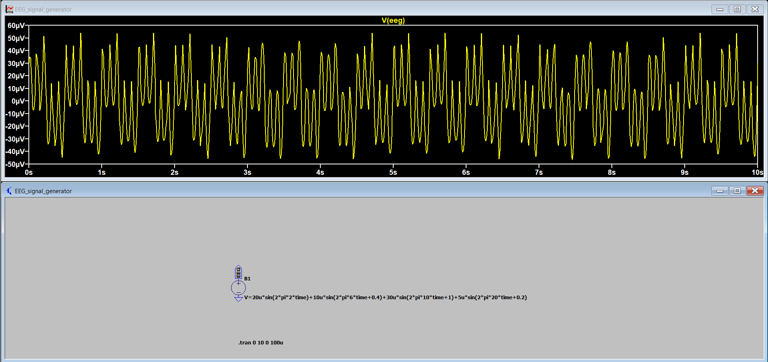
Figure 1. Initial composite EEG waveform generated in LTspice from delta, theta, alpha, and beta sinusoidal components.
Result: The composite waveform is centered near 0 V and reaches approximately −45 µV to +55 µV in the shown simulation. The irregular-looking envelope results from the superposition of components with different frequencies and phase offsets.

3. Stage 2 – Individual Rhythm Verification
Each rhythm was generated as an independent behavioral source to verify frequency and amplitude before relying on the composite signal.
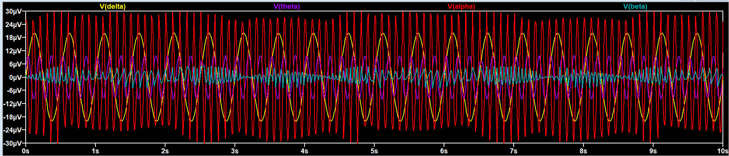
Figure 2. Individual delta, theta, alpha, and beta components used to construct the initial EEG source.
The plot confirms the intended ordering: delta is the slowest, theta and alpha are intermediate, and beta is the fastest. The amplitudes also match the defined behavioral-source values.
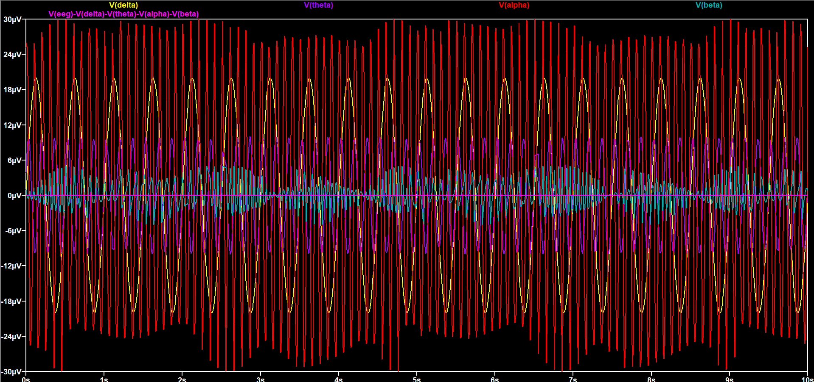
Figure 3. Initial composite-source reconstruction check. The residual after subtracting all four component sources lies essentially on the zero axis.
This numerical check verifies that the initial EEG source is exactly the sum of the four independently generated components, apart from simulator numerical precision.

4. Stage 3 – Differential EEG Representation
A CMOS biopotential front end receives a differential input rather than a single ground-referenced EEG source. The behavioral waveform was therefore split symmetrically around a testbench common-mode voltage of 0.9 V.
V_INP = V_CM + 0.5·V_EEG and V_INN = V_CM − 0.5·V_EEG
V_INP − V_INN = V_EEG
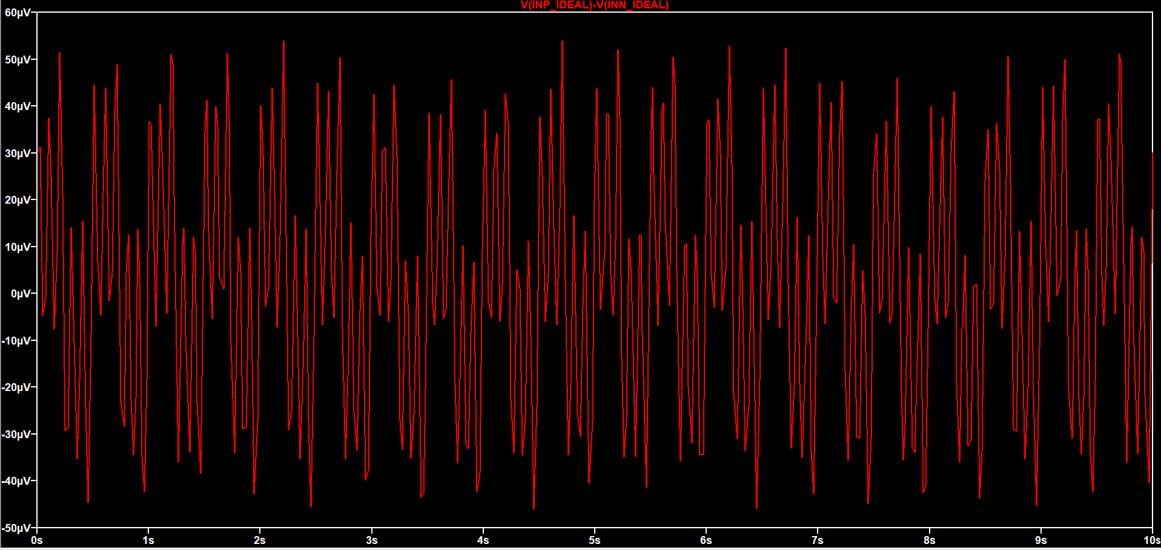
Figure 4. Differential EEG reconstruction, V(INP_IDEAL) − V(INN_IDEAL), after rescaling the LTspice waveform viewer to the microvolt range.
Result: The differential waveform reproduces the original EEG signal. The individual input nodes appear nearly flat at 0.9 V when displayed on a volt-scale plot because their EEG excursions are only tens of microvolts.

5. Stage 4 – 50 Hz Common-Mode Interference
To emulate a strong mains-related disturbance, a 50 Hz sinusoid with 100 mV peak amplitude was added to the common-mode signal while maintaining a 0.9 V DC operating point.
V=0.9+100m*sin(2*pi*50*time)
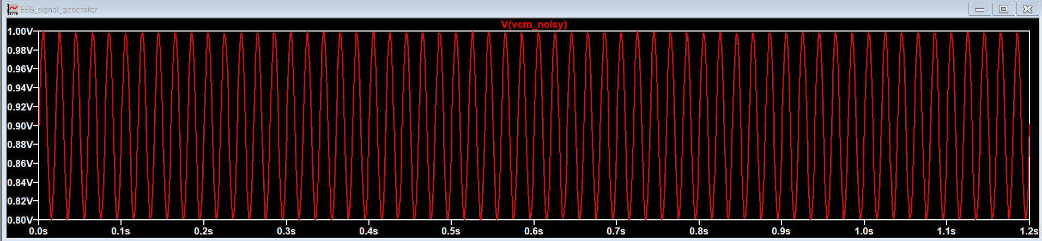
Figure 5. Noisy common-mode source V(VCM_NOISY), showing a 50 Hz waveform from approximately 0.8 V to 1.0 V.
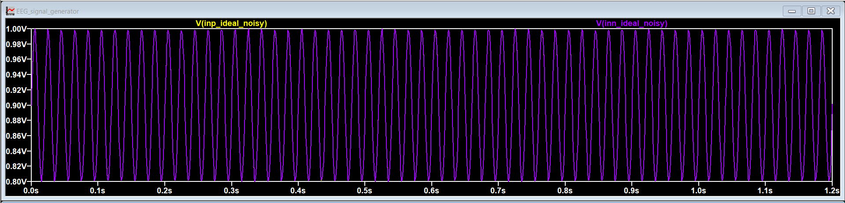
Figure 6. Positive and negative ideal input nodes with common-mode interference. The two traces visually overlap because the differential EEG is tiny compared with the 100 mV common-mode component.
In the ideal, perfectly symmetric input paths, the 50 Hz term cancels in differential subtraction. This stage therefore demonstrates the principle of common-mode rejection before source-impedance mismatch is introduced.

6. Stage 5 – Unequal Electrode Impedance and Common-Mode Conversion
The ideal common-mode cancellation is not representative of a real electrode interface because the two source impedances are rarely identical. An intentionally unequal resistive model was introduced: 50 kΩ on the positive path and 70 kΩ on the negative path, with 100 MΩ input-resistance paths to a clean 0.9 V bias reference.
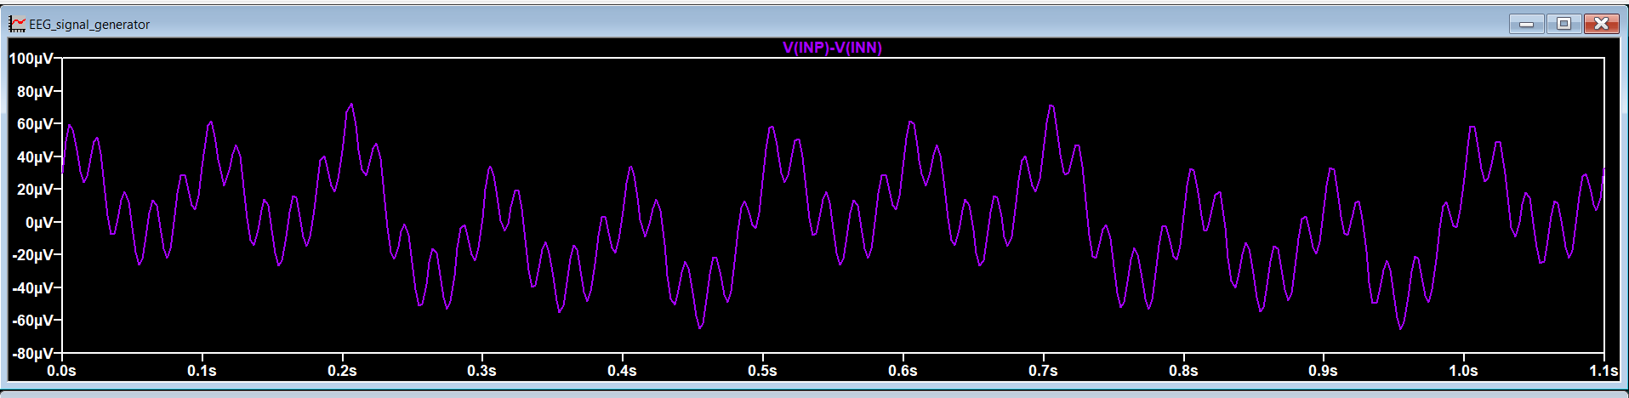
Figure 7. Differential signal V(INP) − V(INN) after introducing unequal 50 kΩ and 70 kΩ electrode paths.
Compared with the original EEG, the differential signal now includes a faster ripple and exhibits a larger peak excursion. This is the expected result of common-mode-to-differential conversion through unequal source impedances.
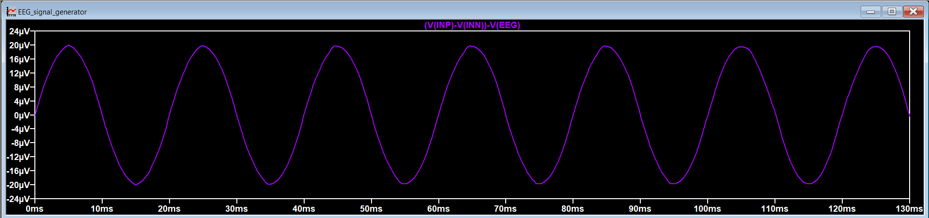
Figure 8. Isolated differential error, [V(INP) − V(INN)] − V(EEG). The residual is a clean approximately 50 Hz sinusoid with about ±20 µV peak amplitude.
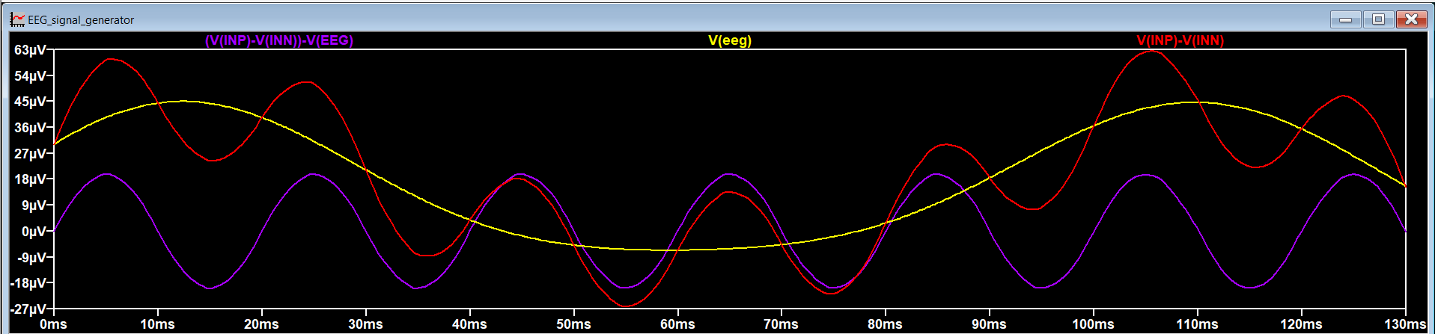
Figure 9. Comparison of the clean EEG, the electrode-mismatch error, and the resulting differential input seen by the front end.
Result: A common-mode disturbance of 100 mV is converted into a differential error of roughly 20 µV peak in this deliberately simplified resistive example. The magnitude is comparable with the EEG itself, clearly illustrating why source-impedance balance and very high AFE input impedance matter.

7. Stage 6 – Frequency-Dependent Electrode-Skin Interface
The purely resistive electrode model was then replaced by a first-order frequency-dependent interface of the form R_s + (R_ct ∥ C_dl). This introduces both frequency-dependent attenuation and phase shift.
Path | Series resistance | Charge-transfer resistance | Double-layer capacitance
Positive electrode | R_s = 10 kΩ | R_ct = 500 kΩ | C_dl = 100 nF
Negative electrode | R_s = 15 kΩ | R_ct = 700 kΩ | C_dl = 68 nF
These component values were selected as illustrative simulation parameters for learning. They are not asserted as a unique or universal physiological electrode model.
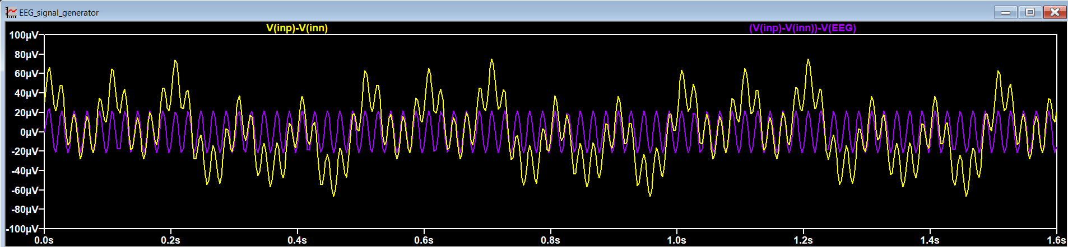
Figure 10. Differential signal and isolated error after replacing the simple resistors with frequency-dependent electrode-interface networks.
Result: The differential error remains dominated by the 50 Hz disturbance and is of the same order as the previous mismatch case, while the reactive interface adds frequency-dependent gain and phase behavior. This is a more useful input model for later AFE evaluation than a purely resistive source.

8. Stage 7 – Literature-Informed Dynamic Alpha/Beta Model
After the electrical input path was established, the EEG generator was upgraded from a permanently stationary four-sine source to a simple state-dependent behavioral source. The final scenario models eyes closed from 0–4 s, eyes open from 4–7 s, and eyes closed again from 7–10 s.
Component | Frequency | 0–4 s | 4–7 s | 7–10 s
Delta | 3 Hz | 15 µV | 15 µV | 15 µV
Theta | 6 Hz | 15 µV | 15 µV | 15 µV
Alpha | 10 Hz | 60 µV | 9 µV (15% of baseline) | 60 µV
Beta | 20 Hz | 10 µV | 25 µV (2.5× baseline) | 10 µV
The alpha suppression and beta increase are not intended to reproduce a unique clinical recording. They are controlled amplitude changes chosen to translate the qualitative alpha-block / higher-beta behavior from the reference material into a circuit-test stimulus.
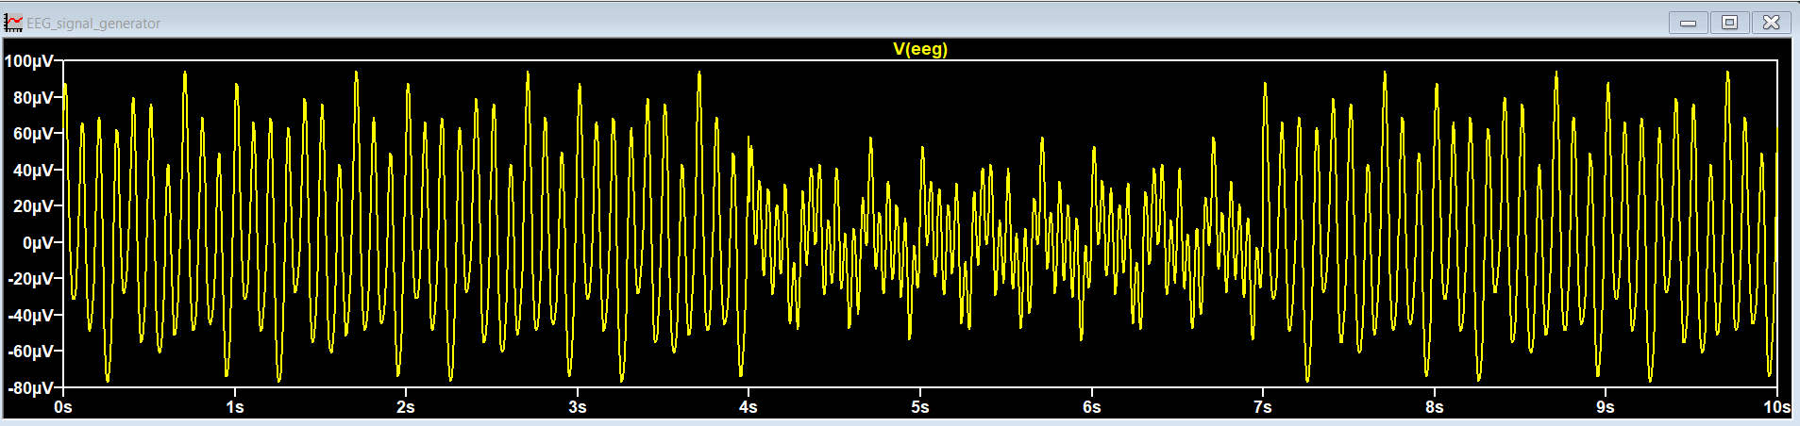
Figure 11. State-dependent EEG waveform. The signal is alpha-dominant from 0–4 s, lower-amplitude/faster during 4–7 s, and returns to the alpha-dominant state after 7 s.
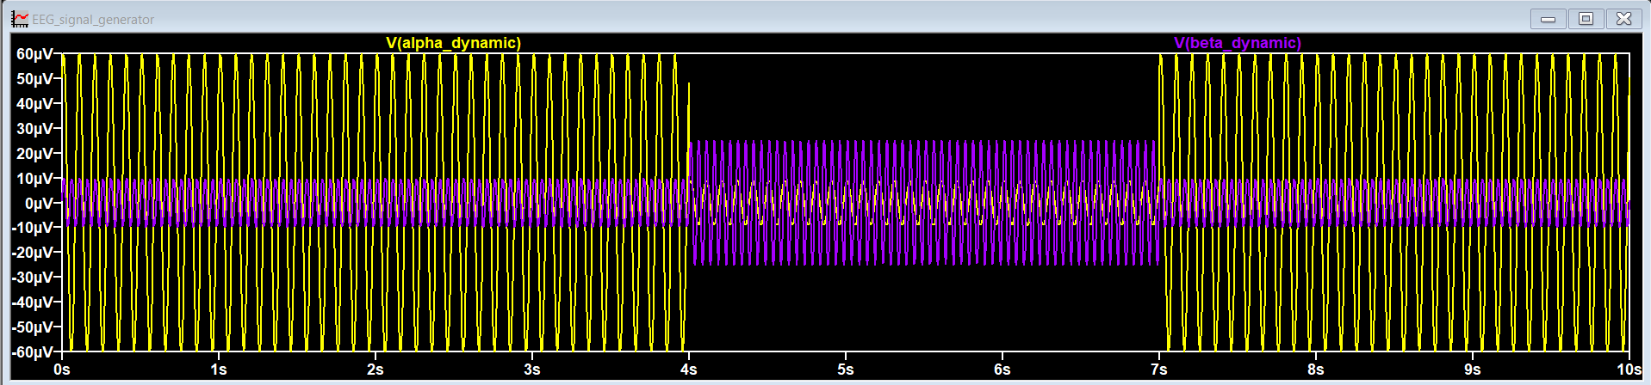
Figure 12. Dynamic alpha and beta components. Alpha falls from ±60 µV to approximately ±9 µV from 4–7 s, while beta rises from ±10 µV to approximately ±25 µV.

9. Final EEG_FINAL Source and Verification
For a clean final implementation, the behavioral source EEG_FINAL was constructed directly from the four component nodes instead of duplicating the full mathematical expression.
V=V(DELTA_DYNAMIC)+V(THETA_DYNAMIC)+V(ALPHA_DYNAMIC)+V(BETA_DYNAMIC)
V_EEG_FINAL = V_δ + V_θ + V_α,dynamic + V_β,dynamic
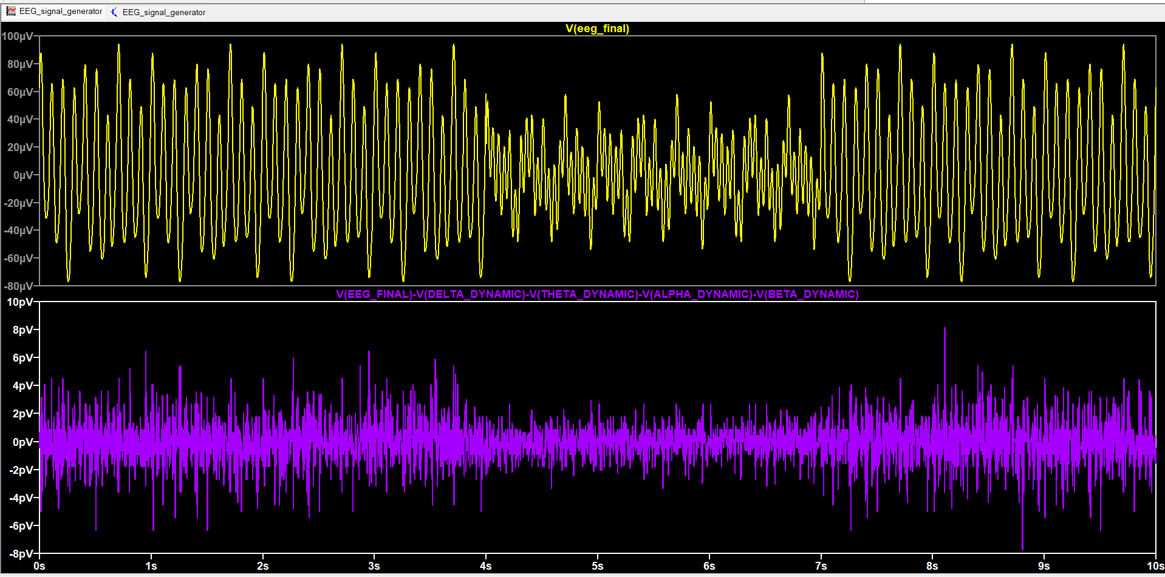
Figure 13. Final EEG_FINAL waveform (top) and reconstruction-error verification (bottom). The residual remains only in the picovolt range.
The reconstruction-error trace is defined as:
V(EEG_FINAL)-V(DELTA_DYNAMIC)-V(THETA_DYNAMIC)-V(ALPHA_DYNAMIC)-V(BETA_DYNAMIC)
Result: The error remains only a few picovolts across the 10 s transient analysis. Relative to EEG amplitudes in the tens of microvolts, this is numerical round-off and confirms that the final source is correctly assembled from the four components.

10. Final LTspice Model Organization
The LTspice workspace was deliberately organized as a progression rather than as a single opaque source. The static section contains the initial linear EEG, differential conversion, common-mode interference, and electrode-interface development. The dynamic section contains the state-dependent component sources and the final summed EEG_FINAL node.
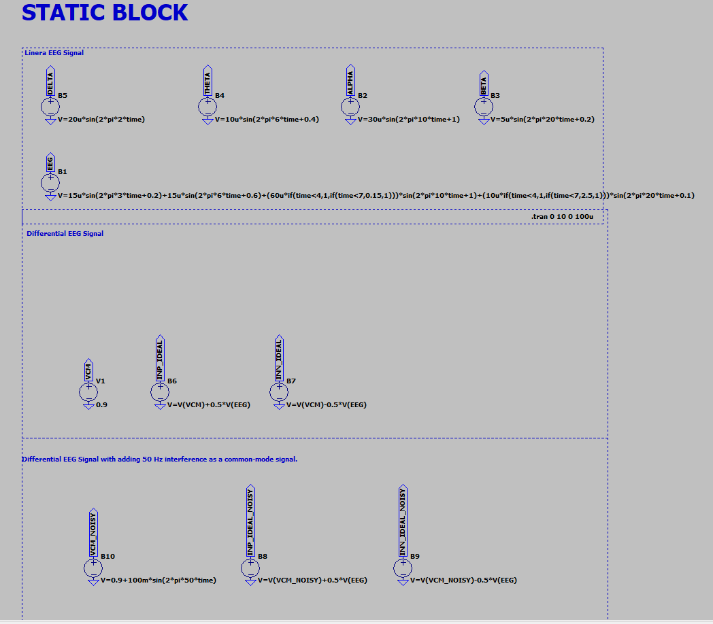
Figure 14. Static-block overview: initial EEG band sources, differential input generation, and 50 Hz common-mode injection.
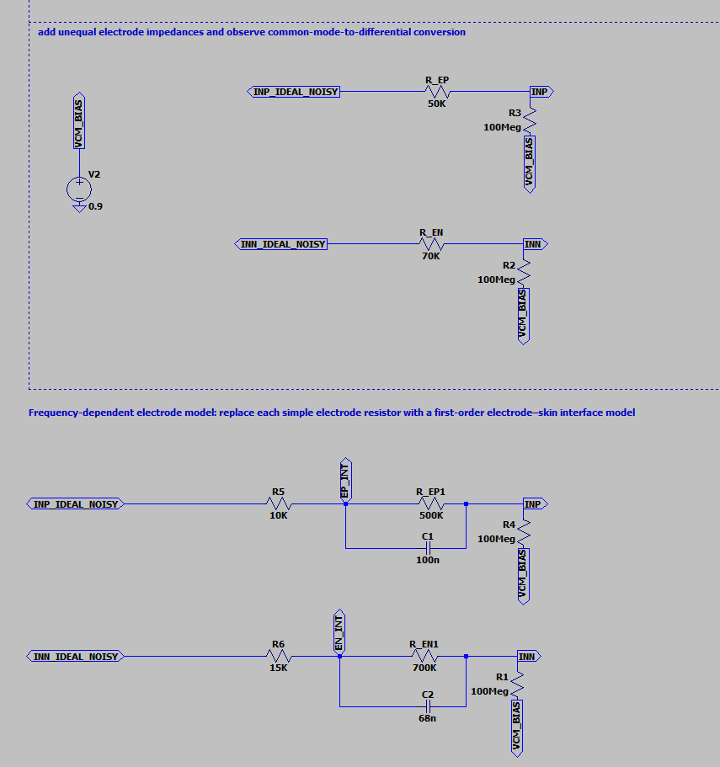
Figure 15. Electrode-interface progression: unequal resistive source impedances followed by the first-order frequency-dependent electrode-skin model.
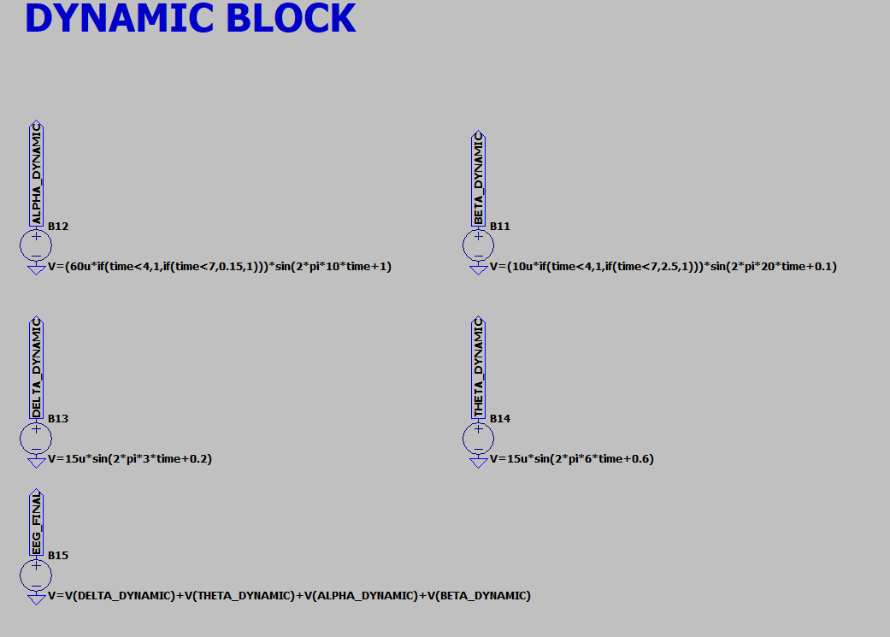
Figure 16. Dynamic block: delta, theta, dynamic alpha, dynamic beta, and EEG_FINAL behavioral sources.

11. Engineering Interpretation for the CMOS Front End
Observed input characteristic | Implication for later AFE design
Microvolt-level differential input | The wanted signal is small, so input-referred noise will be a primary AFE design metric.
Large common-mode disturbance relative to EEG | The testbench intentionally applies 100 mV of 50 Hz common-mode interference, demonstrating the importance of high CMRR.
Electrode/source-impedance mismatch | Even ideal differential subtraction cannot guarantee rejection when the source paths are unequal. High and balanced input impedance is therefore important.
Low-frequency content | Delta/theta components and slow state changes require careful high-pass/DC-servo selection so useful content is not removed.
State-dependent amplitude | The final source supplies more than a single sine-wave test: it provides a controlled change in spectral content that can later be propagated through the CMOS AFE.
Frequency-dependent interface | The R_s + (R_ct ∥ C_dl) network makes the AFE input environment reactive, which is more meaningful for stability, CMRR, and input-impedance studies.

12. Limitations and Scope of Claims
- The EEG waveform is deterministic and composed of a small number of sinusoidal components; it does not reproduce the stochastic spectrum of a measured EEG recording.
- The eyes-open transition is represented by chosen alpha/beta amplitude scaling rather than by fitting a measured subject dataset.
- The 100 mV, 50 Hz common-mode signal is a deliberate stress stimulus, not a universal measured interference level.
- The electrode-interface component values are illustrative and should later be parameterized or replaced by values extracted from the selected electrode type and measurement setup.
- No claim of clinical diagnostic validity is made. The model is intended for analog front-end development, verification, and learning.

13. Conclusion
A complete LTspice EEG input-development workflow was established. Starting from a transparent four-band model, the signal was verified component-by-component, converted to a differential representation, subjected to 50 Hz common-mode interference, passed through mismatched electrode paths, and extended with a frequency-dependent electrode interface. Finally, the EEG generator was upgraded with a literature-informed alpha/beta state transition and collected into a verified EEG_FINAL source.
This is an appropriate stopping point for the input-signal phase. The next stage should use EEG_FINAL and the electrode/interface model as the stimulus environment from which the CMOS front-end requirements—gain, bandwidth, input-referred noise, CMRR, input impedance, offset tolerance, and power—are derived.

Appendix A – Key LTspice Expressions
Transient analysis: .tran 0 10 0 100u
Initial EEG: V=20u*sin(2*pi*2*time)+10u*sin(2*pi*6*time+0.4)+30u*sin(2*pi*10*time+1)+5u*sin(2*pi*20*time+0.2)
Noisy common mode: V=0.9+100m*sin(2*pi*50*time)
Ideal positive input: V=V(VCM_NOISY)+0.5*V(EEG)
Ideal negative input: V=V(VCM_NOISY)-0.5*V(EEG)
Dynamic alpha: V=(60u*if(time<4,1,if(time<7,0.15,1)))*sin(2*pi*10*time+1)
Dynamic beta: V=(10u*if(time<4,1,if(time<7,2.5,1)))*sin(2*pi*20*time+0.1)
Dynamic delta: V=15u*sin(2*pi*3*time+0.2)
Dynamic theta: V=15u*sin(2*pi*6*time+0.6)
Final EEG: V=V(DELTA_DYNAMIC)+V(THETA_DYNAMIC)+V(ALPHA_DYNAMIC)+V(BETA_DYNAMIC)
Final reconstruction check: V(EEG_FINAL)-V(DELTA_DYNAMIC)-V(THETA_DYNAMIC)-V(ALPHA_DYNAMIC)-V(BETA_DYNAMIC)

Reference Material
[1] EEG.pdf, reference material provided for the project. Relevant sections used in this report include the EEG rhythm definitions and frequency ranges, normal-rhythm amplitude table, electrode-impedance guidance, bipolar/unipolar recording description, alpha-block behavior with eye opening, and beta association with thinking/mental activity (approximately pp. 9, 17, 21, 24, 31–33 of the provided PDF).

