# **Preparations**

**Open Windows Explorer (or file manager of your choice) and create a new folder**

Ideally choose a name that clearly indicates its contents, possibly containing the target program, the project name and creation date

**<DotDotIC>_<ProjectName>_<ECU>_<Date>**

example:

**DotDotIC_BMW iX3_HeadUnit_2021-08-12**

Note:

These are only naming examples, the name is only useful to identify the DotDotIC-folder as such, technically the name is of no relevance.

**Copy all required picture files to the newly created folder**

Use photo or file manager tool of your choice to identify good quality pictures of top and bottom of each PCB you would like to analyze in this project. Copy these files to your newly created folder.  
  
Note: Technically you could leave the pictures where they are, but it is good practice to copy the files to your new folder, so that others can use, process, and relocate the original pictures without messing up the DotDotIC project.

If you don’t want to move images around, you can save the project later as a “.pnts” file. This is a zip-like file containing all the information and images.

**Open DotDotIC**

Copy DotDotIC.exe to your local machine and Double-Click on the executable or a custom link to launch the program. No installation is required

**Add picture files**

Add required picture files by drag and drop or via the dialog box. Assign names to the ECUs and PCBs.

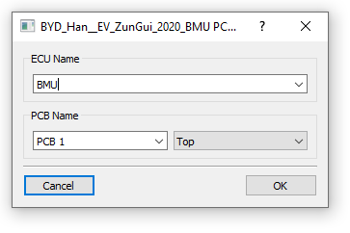

You can also add images through the File menu (“Add Image to project”) or by clicking the button on the bottom “Open Directory”.

# **UI**

4

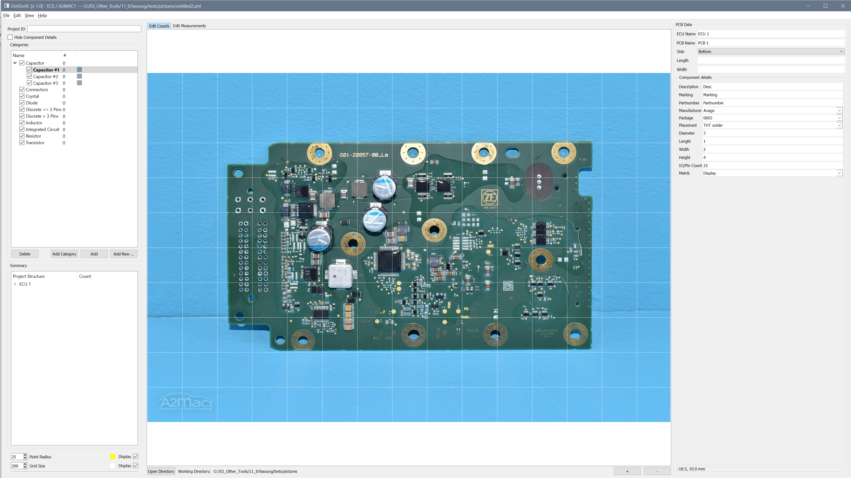

3

2

1

When opening DotDotIC you will see the UI similar as the picture above. The interface consists of 4 important panels:

1. Component and ECU Tree view
2. Graphics view
3. Component details
4. Toolbar

## **Component and ECU Tree View**

Here you will see a list of all components counted on the current PCB. Components are categorized by pre-defined categories.

### **Creating Categories Components**

You can add categories by clicking the button “Add Category” where you will be asked to input the name into a dialog.

In order to count you need to create a component. Select the category where you want to add a new component and click “Add New”. You will be asked for a component name.

By clicking “Add” you will skip the naming and add a component with the name of the category plus count such as “Capacitor #5”.

### **Deleting Categories and Components**

Select the category or component you want to delete and click the “Delete” button.

### **Renaming Components**

Right-click on a component or category and choose “Rename”.

### **Changing the color of components**

Click on the color besides the component name and choose any of your liking

### **Select PCB/ECU**

In order to change the current edited PCB/ECU, expand the tree in the lower end of the Component and ECU Tree View. Double click on “Top” or “Bottom” in the respective PCB/ECU to load the count and image.

### **Change Grid and Point Size**

The button on the bottom of panel 1 adjust the size of the grid and the point size. Checkboxes enable or disable grid and points

## **Graphics View**

In this pane the current image is displayed.

### **Counting**

Be sure that “Edit Counts” is selected in the Toolbar or in the “Edit” menu.

In order to count select a component in panel 1.

Hover the mouse over the image in press “CTRL” while clicking. This will add a count to the PCB.

### **Removing Counts**

Be sure that “Edit Counts” is selected in the Toolbar or in the “Edit” menu.

Hover the mouse over panel 2. Press “Shift” and drag the mouse over the counts you want to delete. The counts will be selected as visible by a thin red circle around them. Press “del” to delete.

### **General Controls**

Zoom by using the mouse wheel and drag the image by clicking and dragging.

See also in the help menu

## **Component Details**

In this pane you can edit component details which will be saved. You can also change the name and Top/Bottom assignment of the current PCB in the uppermost fields.

## **Toolbar**

Here you can change the edit modes “Edit Counts” and “Edit Measures”.

“Edit Counts” is the default mode and works as described in the Graphics View Chapter.

In “Edit Measures” you can measure the dimensions of components

For this click on “Edit Measures”

Click on the image while holding “C”. Drag the mouse so that the resulting rectangle covers the PCB. Release the mouse and a dialog will pop up, asking for the width of the selected region in mm. Now the image is calibrated. To measure click again on the image and hold “M”. Drag the mouse over the area you want to measure and release the drag. A new rectangle will be drawn also showing the dimensions.

Rectangles can be removed by the same procedure as counts.

# **Exporting, Saving, Preview and Loading of Projects**

In the “File” you can save the current project.

NOTE: The save file must be in the same folder as the images when saving as “.pnt” (old format). Use “.pnts” as file extension if you don’t want to keep track of the files by yourself

You can export the current project to a “Kalk-BOM” like table with “Export Counts…” (See View->BOM View for a preview)

You can export detail images via “Export detail images”

You can reset the current project with “Reset”

You can load an old project through the “Recently Used” interface, by loading it explicitly or by drag&drop over the Graphics View.

Under the “View” Menu you can generate a preview table, which will be exported under “Export Counts”

# **Errors & Issues**

If the app breaks feel free to contact gs@ecs-network.com