Relocalisation Process from a Current Frame
Assumptions:
- ORB keypoints of all keyframes and frames have been computed
- Bag of words (BoW) have been computed
- Feature vector have been computed from BoW
- Descriptors for each keypoints have been computed from feature vector

- Find relocalisation candidates. This is done by searching all keyframes that share a word with current frame
- Filter candidates and fit the best fit. Not all candidates are fit for computing pose, as shown in these two examples:

Frame | Keyframe
Case 1 (only 1 candidate found)
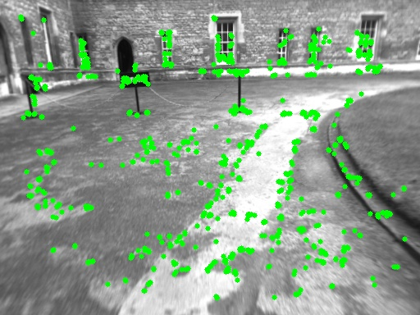 | 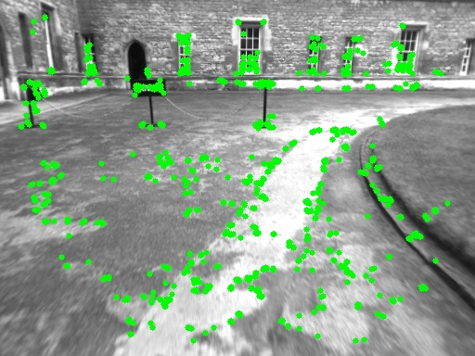
Case 2 (2 candidates found)
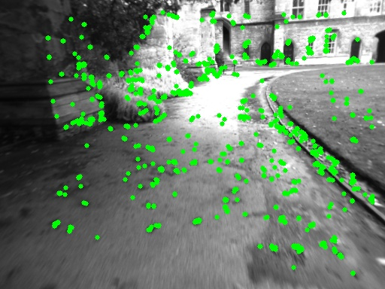 | 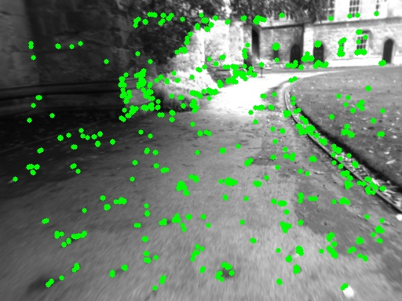
 | 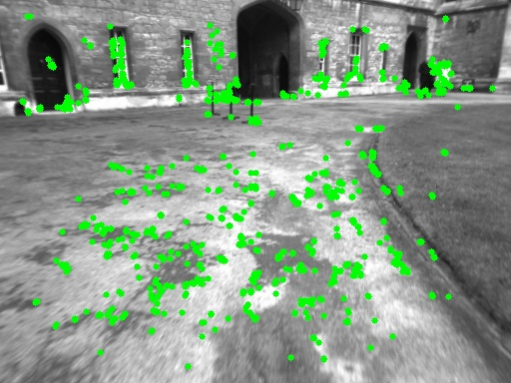

Candidate filtering is done by matching each keypoint in particular keyframe with keypoints in current frame, and enumerate the matches. Two keypoints are considered as matching if their descriptors have distances less than a threshold (computed by counting bits set). A keyframe will be included in next process if it contains at least 15 match keypoints.

- For each candidate:
  - Estimate pose camera using Perspective-n-Point from matching 3D points in the candidate keyframe and its projection in the frame, using RANSAC scheme. If RANSAC reaches maximum 5 iterations, no pose is computed and discard candidate keyframe. These are examples of failed pose estimation:
Frame | Keyframe
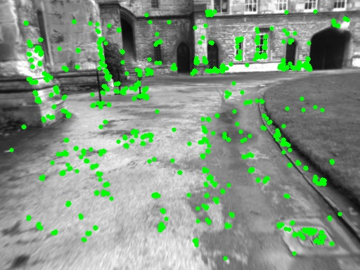 | 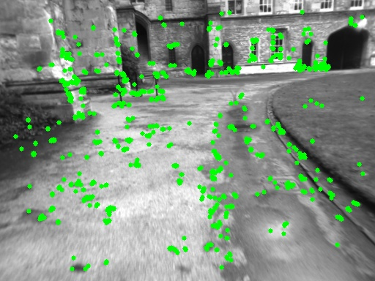
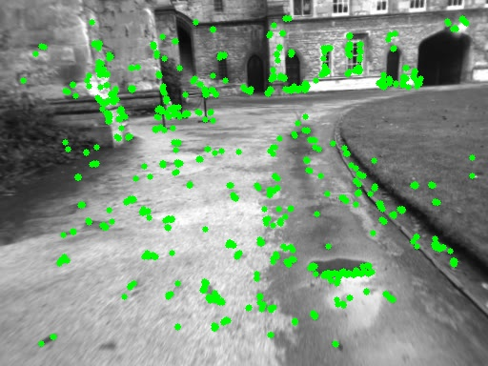 | 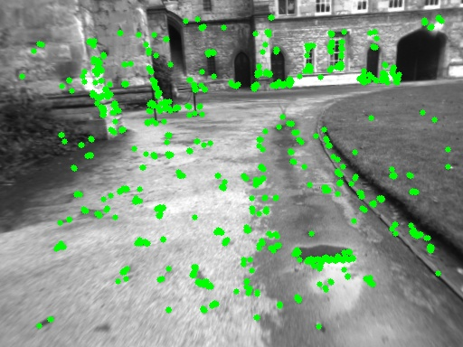

  - If particular pose can be computed, optimize. Pose must be supported by at least 50 map point inliers.
- Send result of pose estimation to Map Publisher

