**Practice Activity #1 (PA1): Using XAML Controls**

Mobapp

**Patrick A. Pangilinan**

**C3A - BSCS**

**USER REQUIREMENTS:**

1. Create a new project and name it **pa1_<section>-<lastname>.**
2. Design a UI for a simple registration system. See the sample layout below.

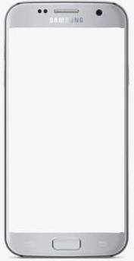

Name:

Proceed

REGISTRATION

Company Logo

Age:

Male

Female

Submit

Controls: Image, Label, Button Label, RadioButton, Button, Entry

1. You may add more information that you want to get from the user and add three more controls that are not yet used in the interface provided.
2. Provide a screen shot of your output.
3. List down five things you learned in doing this activity.

**Initial Login Page** **Register Page**

Controls: Image, Label, Button Added controls: Checkbox, Slider, Switch

**Five Things I learned:**

* Xaml is very similar to HTML coding, but it’s more functional and uses C# as the backend.
* Xaml has many formatting capabilities that you’d find in other mobile applications
* In order to have better performance with the mobile emulators, I learned that I needed to install HAXM for intel drivers.
* XAML is good in parsing large data because it can iterate over the elements without loading the whole content in memory.
* I found it surprising how easy to read XAML code is especially coming from HTML in Webdev