Student Name: Pang Wai Kye

Matriculation Number: A0197283R

Github Repo: <https://github.com/pangpuncake/CS3219_OTOT_A1>

**A1.1**

Instructions on creating and running docker container:

1. cd ./app
2. Create the Dockerfile
3. docker build -t cs3219_a1.1 .
4. docker run -p 3000:8080 cs3219_a1.1

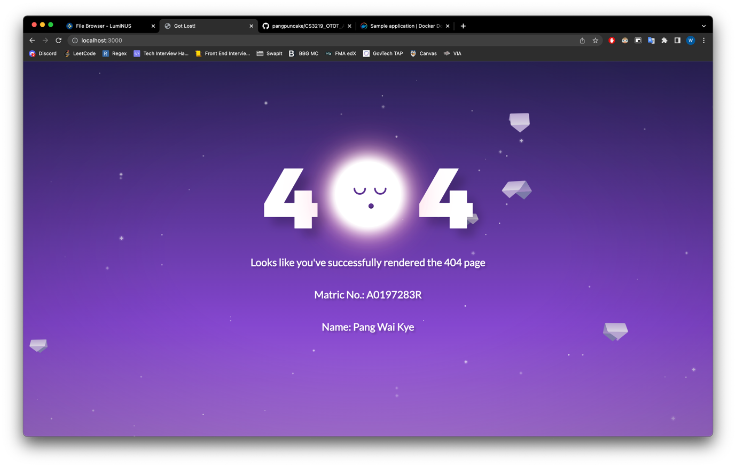

**A1.2**

Instructions on creating and running docker container:

1. cd ./nginx-sample
2. Create the Dockerfile
3. Create the nginx.conf
4. docker build -t cs3219_a1.2 .
5. docker run -p 3000:80 cs3219_a1.2

**A1.3**

Instructions on creating and running docker container:

1. cd ./nginx
2. Create the Dockerfile
3. Create the nginx.conf
4. cd ../
5. Create the docker-compose.yml
6. docker compose run --rm -p 3000:80 backend

