Student Name: Pang Wai Kye

Matriculation Number: A0197283R

Github Repo: <https://github.com/pangpuncake/CS3219_OTOT_A2_A3>

**A2.1**

Create and verify cluster:

1. kind create cluster --name kind-1 --config k8s/kind/cluster-config.yaml
2. Inspect node containers:   
   docker ps
3. See available nodes through kubectl:   
   kubectl get nodes
4. See cluster info:   
   kubectl cluster-info

**A2.2**

Create and verify deployment:

1. Create the frontend-deployment.yaml manifest
2. Apply the manifest:   
   kubectl apply -f frontend-deployment.yaml
3. See the deployment:   
   kubectl get deployment
4. The READY column should show 3/3
5. See the pods:   
   kubectl get pods
6. The READY column for each pod should be 1/1
7. See the ReplicaSet:   
   kubectl get rs
8. The DESIRED should be equal to the CURRENT and READY

Create and verify service:

1. Create the frontend-service.yaml manifest
2. Apply the manifest:   
   kubectl apply -f frontend-service.yaml
3. See the service:   
   kubectl get svc  
   
4. Check the service is connecting to the webapp pod:  
   kubectl port-forward svc/frontend 3000:3000  
   Text

   Description automatically generated
5. The web app should be displayed on localhost:3000

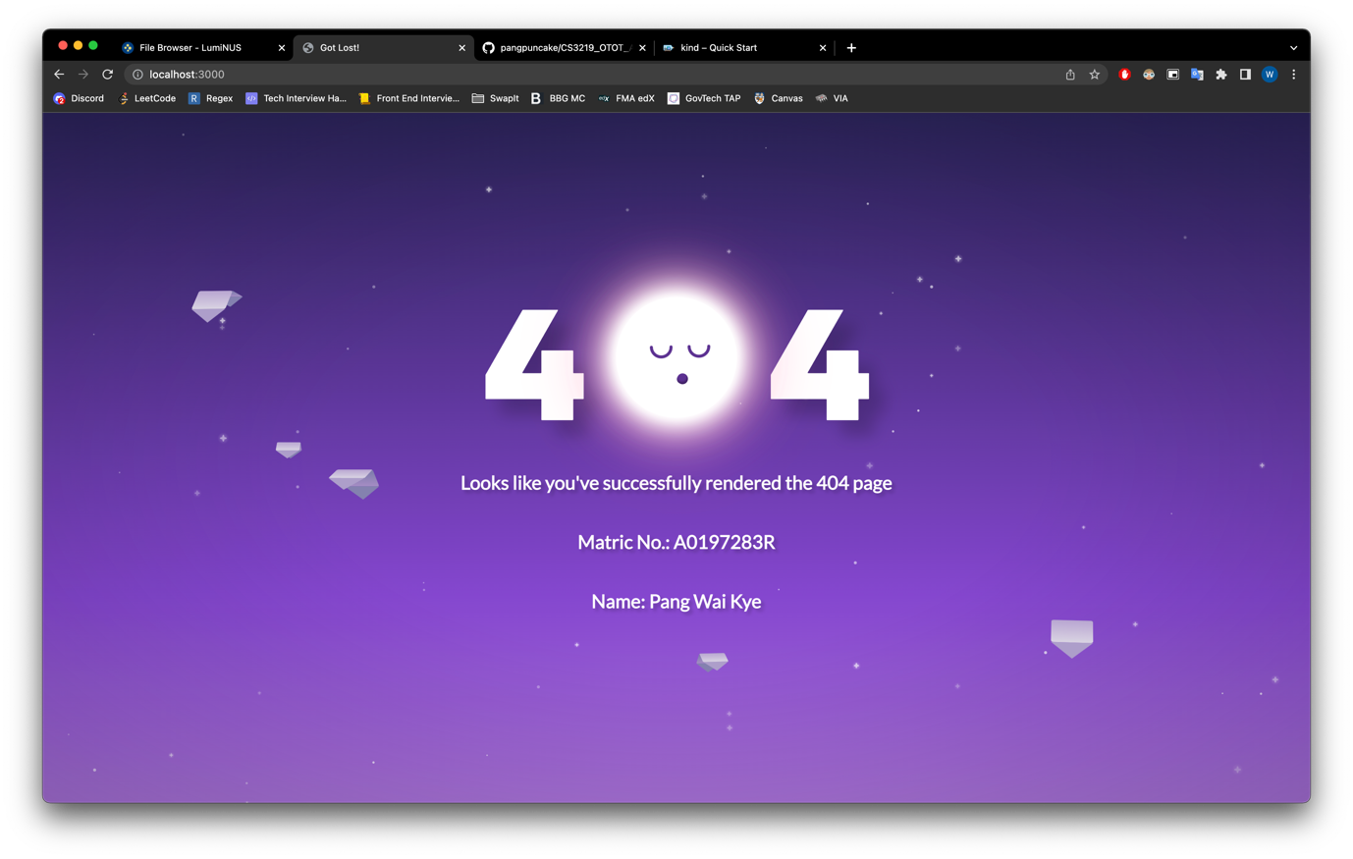

**A2.3**

Setting up ingress and verifying it works:

1. kubectl apply -f <https://raw.githubusercontent.com/kubernetes/ingress-nginx/main/deploy/static/provider/kind/deploy.yaml>
2. Check the ingress deployment has been created:  
   kubectl get deploy -n ingress-nginx  
   
3. The READY column should show 1/1
4. Check the ingress controller:   
   kubectl get pod -l app.kubernetes.io/component=controller -n ingress-nginx  
   
5. The READY column should show 1/1
6. Create the ingress.yaml manifest
7. Apply the manifest:   
   kubectl apply -f ingress.yaml
8. Check the ingress object:  
   kubectl get ingress  
   
9. Visit localhost/app

