Submission for Task B1 and B2

Student Name: Pang Wai Kye

Matriculation Number: A0197283R

Github Repo: <https://github.com/pangpuncake/CS3219_OTOT_B>

**B1**

Postman Collection: <https://www.getpostman.com/collections/494050758f6151e8379e>

**B2.1**

Local testing

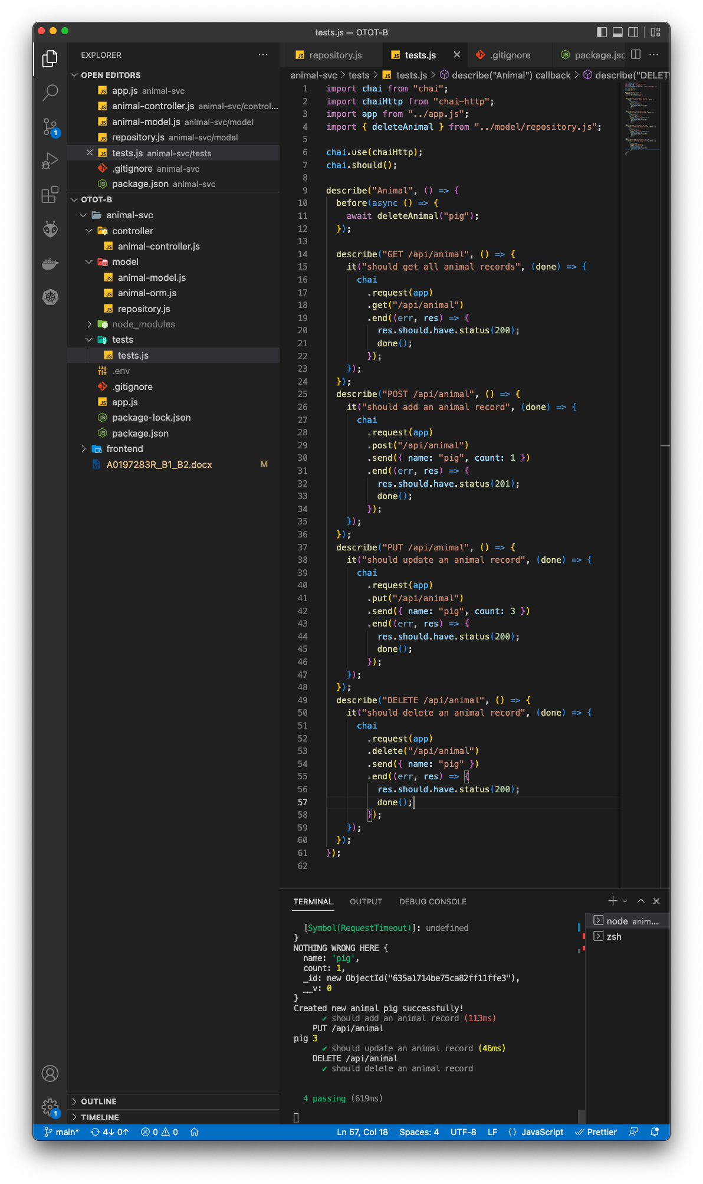

Automated testing:

**B2.2**