Submission for Task D

Student Name: Pang Wai Kye

Matriculation Number: A0197283R

Github Repo: <https://github.com/pangpuncake/CS3219_OTOT_D>

**D**

Please refer to the README.md for more the commands or the screenshots provided.

**Setup cluster**

**Create topic**

**Describe topic**

**Write (left) / Read (right) topic**

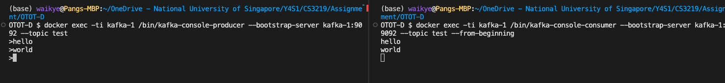

**Kill Leader**

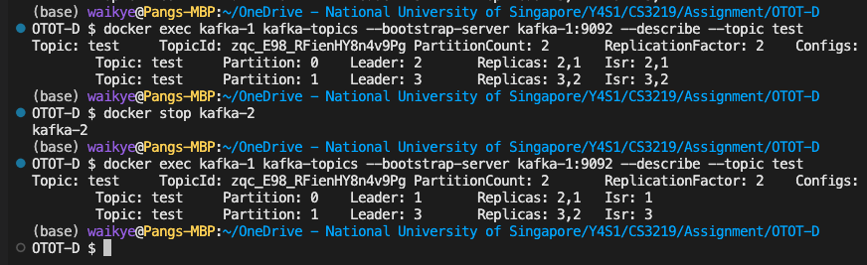

Partition 0 - leader kafka-2 killed, kafka-1 took over.

Write from kafka-1



Write from kafka-3

The topic still contains all the messages despite the leader being deleted due to the replication done on the other kafka instances.