LaTeX最强大的功能就是显示美丽的数学公式，下面我们来看这些公式是怎么实现的。

1、数学公式的前后要加上 $ 或 \( 和 \)，比如：$f(x) = 3x + 7$ 和 \(f(x) = 3x + 7\) 效果是一样的；  
如果用 \[ 和 \]，或者使用 $$ 和 $$，则改公式独占一行；  
如果用 \begin{equation} 和 \end{equation}，则公式除了独占一行还会自动被添加序号， 如何公式不想编号则使用 \begin{equation\*} 和 \end{equation\*}.

2、字符  
普通字符在数学公式中含义一样，除了  
# $ % & ~ \_ ^ \ { }  
若要在数学环境中表示这些符号# $ % & \_ { }，需要分别表示为\# \$ \% \& \\_ \{ \}，即在个字符前加上\。

3、上标和下标  
用 ^ 来表示上标，用 \_ 来表示下标，看一简单例子：

$$\sum\_{i=1}^n a\_i=0$$  
$$f(x)=x^{x^x}$$

效果:

[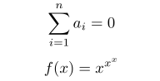](http://photo.blog.sina.com.cn/showpic.html#blogid=5e16f1770100fs38&url=http://s15.sinaimg.cn/orignal/5e16f177gaf02882dc5be)

这里有更多的[LaTeX上标下标的设置](http://blog.sina.com.cn/s/blog_5e16f1770100fs7f.html" \t "_blank)

4、希腊字母  
更多请参见[这里](http://hepg.sdu.edu.cn/Service/tips/latex/doc2/MathSymb.html)

5、数学函数

6、在公式中插入文本可以通过 \mbox{text} 在公式中添加text，比如：

\documentclass{article}  
\usepackage{CJK}  
\begin{CJK\*}{GBK}{song}  
\begin{document}  
$$\mbox{对任意的$x>0$}, \mbox{有 }f(x)>0. $$  
\end{CJK\*}  
\end{document}

效果:

[LaTeX技巧10：LaTeX数学公式输入初级入门](http://photo.blog.sina.com.cn/showpic.html#blogid=5e16f1770100fs38&url=http://s12.sinaimg.cn/orignal/5e16f177gaf02890d2bfb)

7、分数及开方  
\frac{numerator}{denominator} \sqrt{expression\_r\_r\_r}表示开平方，  
\sqrt[n]{expression\_r\_r\_r} 表示开 n 次方.

8、省略号（3个点）  
\ldots 表示跟文本底线对齐的省略号；\cdots 表示跟文本中线对齐的省略号，

比如：

[LaTeX技巧10：LaTeX数学公式输入初级入门](http://photo.blog.sina.com.cn/showpic.html#blogid=5e16f1770100fs38&url=http://s14.sinaimg.cn/orignal/5e16f177gaf0291b1d46d)

表示为 $$f(x\_1,x\_x,\ldots,x\_n) = x\_1^2 + x\_2^2 + \cdots + x\_n^2 $$

9、括号和分隔符  
() 和 [ ] 和 ｜ 对应于自己；  
{} 对应于 \{ \}；  
|| 对应于 \|。  
当要显示大号的括号或分隔符时，要对应用 \left 和 \right，如：

\[f(x,y,z) = 3y^2 z \left( 3 + \frac{7x+5}{1 + y^2} \right).\]对应于

[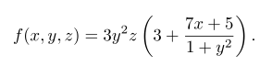](http://photo.blog.sina.com.cn/showpic.html#blogid=5e16f1770100fs38&url=http://s1.sinaimg.cn/orignal/5e16f177g77e6a89f5790)

\left. 和 \right. 只用与匹配，本身是不显示的，比如，要输出：

[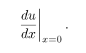](http://photo.blog.sina.com.cn/showpic.html#blogid=5e16f1770100fs38&url=http://s16.sinaimg.cn/orignal/5e16f177gaf029961372f)

则用 $$\left. \frac{du}{dx} \right|\_{x=0}.$$

10、多行的数学公式

[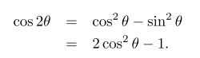](http://photo.blog.sina.com.cn/showpic.html#blogid=5e16f1770100fs38&url=http://s7.sinaimg.cn/orignal/5e16f177gaf029d9cfa16)

可以表示为：

\begin{eqnarray\*}  
\cos 2\theta & = & \cos^2 \theta - \sin^2 \theta \\  
& = & 2 \cos^2 \theta - 1.  
\end{eqnarray\*}

其中&是对其点，表示在此对齐。  
\*使latex不自动显示序号，如果想让latex自动标上序号，则把\*去掉

11、矩阵

[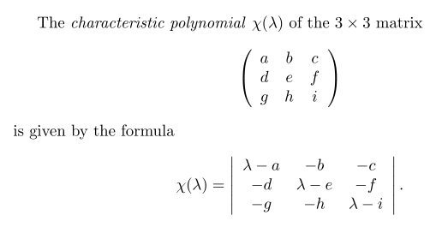](http://photo.blog.sina.com.cn/showpic.html#blogid=5e16f1770100fs38&url=http://s2.sinaimg.cn/orignal/5e16f177gaf02a18f7d11)

表示为：

The \emph{characteristic polynomial} $\chi(\lambda)$ of the  
$3 \times 3$~matrix  
\[ \left( \begin{array}{ccc}  
a & b & c \\  
d & e & f \\  
g & h & i \end{array} \right)\]  
is given by the formula  
\[ \chi(\lambda) = \left| \begin{array}{ccc}  
\lambda - a & -b & -c \\  
-d & \lambda - e & -f \\  
-g & -h & \lambda - i \end{array} \right|.\]

c表示向中对齐，l表示向左对齐，r表示向右对齐。

12、导数、极限、求和、积分(Derivatives, Limits, Sums and Integrals)

**The expression\_r\_r\_rs**

[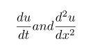](http://photo.blog.sina.com.cn/showpic.html#blogid=5e16f1770100fs38&url=http://s9.sinaimg.cn/orignal/5e16f177gaf02aae723d8)

are obtained in LaTeX by typing

\frac{du}{dt} and \frac{d^2 u}{dx^2}

respectively. The mathematical symbol [LaTeX技巧10：LaTeX数学公式输入初级入门](http://photo.blog.sina.com.cn/showpic.html#blogid=5e16f1770100fs38&url=http://s10.sinaimg.cn/orignal/5e16f177g77e6ab8d4819) is produced using \partial. Thus the Heat Equation

[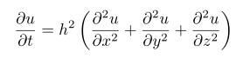](http://photo.blog.sina.com.cn/showpic.html#blogid=5e16f1770100fs38&url=http://s8.sinaimg.cn/orignal/5e16f177gaf02b6a09837)

is obtained in LaTeX by typing

\[ \frac{\partial u}{\partial t}  
= h^2 \left( \frac{\partial^2 u}{\partial x^2}  
+ \frac{\partial^2 u}{\partial y^2}  
+ \frac{\partial^2 u}{\partial z^2}\right)\]

To obtain mathematical **expression\_r\_r\_rs** such as

[LaTeX技巧10：LaTeX数学公式输入初级入门](http://photo.blog.sina.com.cn/showpic.html#blogid=5e16f1770100fs38&url=http://s10.sinaimg.cn/orignal/5e16f177gaf02bdae8dd9)

in displayed equations we type \lim\_{x \to +\infty}, \inf\_{x > s} and \sup\_K respectively. Thus to obtain

[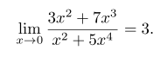](http://photo.blog.sina.com.cn/showpic.html#blogid=5e16f1770100fs38&url=http://s12.sinaimg.cn/orignal/5e16f177gaf02c1a5162b)

(in LaTeX) we type

\[ \lim\_{x \to 0} \frac{3x^2 +7x^3}{x^2 +5x^4} = 3.\]

To obtain a summation sign such as

[LaTeX技巧10：LaTeX数学公式输入初级入门](http://photo.blog.sina.com.cn/showpic.html#blogid=5e16f1770100fs38&url=http://s13.sinaimg.cn/orignal/5e16f177gaf02c6bd3f6c)

we type \sum\_{i=1}^{2n}. Thus

[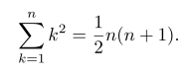](http://photo.blog.sina.com.cn/showpic.html#blogid=5e16f1770100fs38&url=http://s12.sinaimg.cn/orignal/5e16f177gaf02c77e2e3b)

is obtained by typing

\[ \sum\_{k=1}^n k^2 = \frac{1}{2} n (n+1).\]

We now discuss how to obtain integrals in mathematical documents. A typical integral is the following:

[LaTeX技巧10：LaTeX数学公式输入初级入门](http://photo.blog.sina.com.cn/showpic.html#blogid=5e16f1770100fs38&url=http://s12.sinaimg.cn/orignal/5e16f177gaf02ca6d817b)

This is typeset using

\[ \int\_a^b f(x)\,dx.\]

The integral sign is typeset using the control sequence \int, and the limits of integration (in this case a and b are treated as a subscript and a superscript on the integral sign.  
Most integrals occurring in mathematical documents begin with an integral sign and contain one or more instances of d followed by another (Latin or Greek) letter, as in dx, dy and dt. To obtain the correct appearance one should put extra space before the d, using \,. Thus

[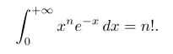](http://photo.blog.sina.com.cn/showpic.html#blogid=5e16f1770100fs38&url=http://s12.sinaimg.cn/orignal/5e16f177gaf02cf06e7bb)

[LaTeX技巧10：LaTeX数学公式输入初级入门](http://photo.blog.sina.com.cn/showpic.html#blogid=5e16f1770100fs38&url=http://s13.sinaimg.cn/orignal/5e16f177gaf02d0eac3dc)

[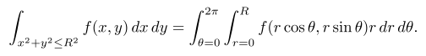](http://photo.blog.sina.com.cn/showpic.html#blogid=5e16f1770100fs38&url=http://s14.sinaimg.cn/orignal/5e16f177gaf02d31bce9d)

and

[LaTeX技巧10：LaTeX数学公式输入初级入门](http://photo.blog.sina.com.cn/showpic.html#blogid=5e16f1770100fs38&url=http://s16.sinaimg.cn/orignal/5e16f177gaf02d4f2e15f)

are obtained by typing

\[ \int\_0^{+\infty} x^n e^{-x} \,dx = n!.\]  
  
\[ \int \cos \theta \,d\theta = \sin \theta.\]  
  
\[ \int\_{x^2 + y^2 \leq R^2} f(x,y)\,dx\,dy  
= \int\_{\theta=0}^{2\pi} \int\_{r=0}^R  
f(r\cos\theta,r\sin\theta) r\,dr\,d\theta.\]

and

\[ \int\_0^R \frac{2x\,dx}{1+x^2} = \log(1+R^2).\]

respectively.

In some multiple integrals (i.e., integrals containing more than one integral sign) one finds that LaTeX puts too much space between the integral signs. The way to improve the appearance of of the integral is to use the control sequence \! to remove a thin strip of unwanted space. Thus, for example, the multiple integral

[LaTeX技巧10：LaTeX数学公式输入初级入门](http://photo.blog.sina.com.cn/showpic.html#blogid=5e16f1770100fs38&url=http://s10.sinaimg.cn/orignal/5e16f177gaf02dde4b8d9)

is obtained by typing

\[ \int\_0^1 \! \int\_0^1 x^2 y^2\,dx\,dy.\]

Had we typed

\[ \int\_0^1 \int\_0^1 x^2 y^2\,dx\,dy.\]

we would have obtained

[LaTeX技巧10：LaTeX数学公式输入初级入门](http://photo.blog.sina.com.cn/showpic.html#blogid=5e16f1770100fs38&url=http://s9.sinaimg.cn/orignal/5e16f177gaf02de4b50c8)

A particularly noteworthy example comes when we are typesetting a multiple integral such as

[LaTeX技巧10：LaTeX数学公式输入初级入门](http://photo.blog.sina.com.cn/showpic.html#blogid=5e16f1770100fs38&url=http://s7.sinaimg.cn/orignal/5e16f177gaf02e4b499c6)

Here we use \! three times to obtain suitable spacing between the integral signs. We typeset this integral using

\[ \int \!\!\! \int\_D f(x,y)\,dx\,dy.\]

Had we typed

\[ \int \int\_D f(x,y)\,dx\,dy.\]

we would have obtained

[LaTeX技巧10：LaTeX数学公式输入初级入门](http://photo.blog.sina.com.cn/showpic.html#blogid=5e16f1770100fs38&url=http://s5.sinaimg.cn/orignal/5e16f177gaf02e5365e74)

The following (reasonably complicated) passage exhibits a number of the features which we have been discussing:

[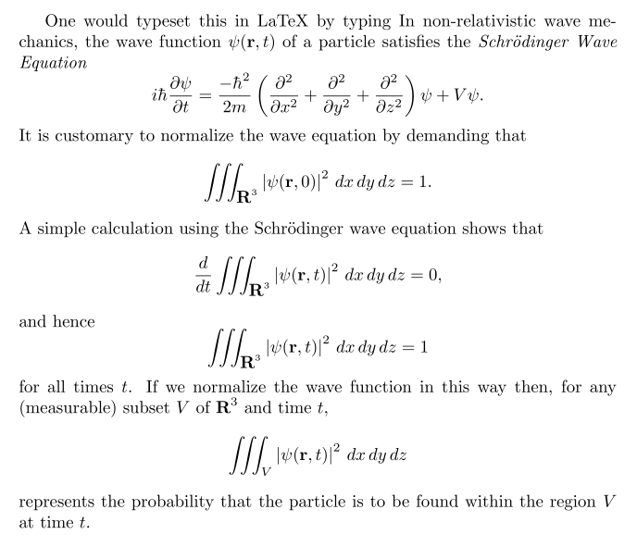](http://photo.blog.sina.com.cn/showpic.html#blogid=5e16f1770100fs38&url=http://s6.sinaimg.cn/orignal/5e16f177gaf02f3b558d5)

One would typeset this in LaTeX by typing In non-relativistic wave mechanics, the wave function  
$\psi(\mathbf{r},t)$ of a particle satisfies the  
\emph{Schr\"{o}dinger Wave Equation}  
\[ i\hbar\frac{\partial \psi}{\partial t}  
= \frac{-\hbar^2}{2m} \left(  
\frac{\partial^2}{\partial x^2}  
+ \frac{\partial^2}{\partial y^2}  
+ \frac{\partial^2}{\partial z^2}  
\right) \psi + V \psi.\]  
It is customary to normalize the wave equation by  
demanding that  
\[ \int \!\!\! \int \!\!\! \int\_{\textbf{R}^3}  
\left| \psi(\mathbf{r},0) \right|^2\,dx\,dy\,dz = 1.\]  
A simple calculation using the Schr\"{o}dinger wave  
equation shows that  
\[ \frac{d}{dt} \int \!\!\! \int \!\!\! \int\_{\textbf{R}^3}  
\left| \psi(\mathbf{r},t) \right|^2\,dx\,dy\,dz = 0,\]  
and hence  
\[ \int \!\!\! \int \!\!\! \int\_{\textbf{R}^3}  
\left| \psi(\mathbf{r},t) \right|^2\,dx\,dy\,dz = 1\]  
for all times~$t$. If we normalize the wave function in this  
way then, for any (measurable) subset~$V$ of $\textbf{R}^3$  
and time~$t$,  
\[ \int \!\!\! \int \!\!\! \int\_V  
\left| \psi(\mathbf{r},t) \right|^2\,dx\,dy\,dz\]  
represents the probability that the particle is to be found  
within the region~$V$ at time~$t$.