© Li Wei and Eamonn Keogh, 2006
Function timeseries2symbol takes in a time series and convert it to string(s). Its input and output are shown in Table 1. One requirement of the function is that N/n must be an integer. Otherwise the program will give a warning, and abort.
Table 1: Input and output of the Function timeseries2symbol
Input:
data | the raw time series
N | the length of sliding window (use the length of the raw time series instead if you don't want to have sliding windows)
n | the number of symbols in the low dimensional approximation of the sub sequence
alphabet_size | the number of discrete symbols (2 <= alphabet_size <= 10)
Output:
symbolic_data | matrix of symbolic data (no-repetition). If consecutive subsequences have the same string, then only the first occurrence is recorded, with a pointer to its location stored in "pointers"
pointers | location of the first occurrences of the strings

The new version of Function timeseries2symbol does exactly the same thing as the old version. The only difference is that it can handle the situation when N/n is not an integer.
If N is not dividable by n, there will be some points in the time series that we are not sure which segment to put them. For example, in Figure 1 A), we are dividing 10 data points into 5 segments. And it is obvious that point 1, 2 should be in segment 1, point 3, 4 should be in segment 2, so on and so forth. While in Figure 1 B), we are dividing 10 data points into 3 segments. And we are not clear which segment point 4 should go, segment 1 or segment 2. Same problem holds for point 7. The solution is simple. Instead of putting the whole point into a segment, we can put part of it. For example, in Figure 1 B), point 4 contributes its 1/3 to segment 1 and its 2/3 to segment 2, and point 7 contributes its 2/3 to segment 2 and its 1/3 to segment 3. This makes each segment contains exactly 3.3 data points and solves the undividable problem.
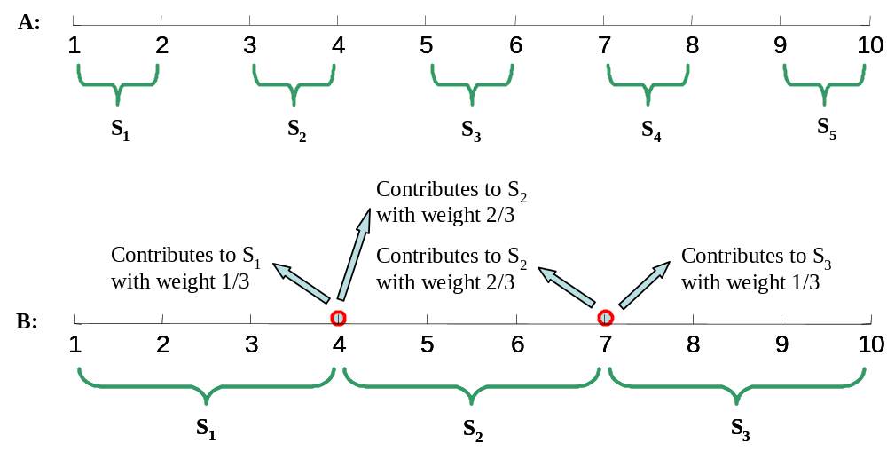
Figure 1: A) 10 data points are divided into 5 segments. B) 10 data points are divided into 3 segments. The data points marked with circles contribute to two adjacent segments at the same time

