## **1. koa**

[koajs](http://koajs.com/) Koa2是现在最流行的基于Node.js平台的web开发框架

## **2.安装**

npm i koa

## **2.应用程序**

Koa 应用程序是一个包含一组中间件函数的对象，它是按照类似堆栈的方式组织和执行的。

**const** Koa = require('koa');**const** app = **new** Koa();

app.use(**async** ctx => {

ctx.body = 'Hello World';

});

app.on('error', err => {

log.error('server error', err)

});

app.listen(3000);//app.callback()//http.createServer(app.callback()).listen(3000);//https.createServer(app.callback()).listen(3000);

## **3.级联中间件**

Koa 中间件以更传统的方式级联

app.use(**function**)

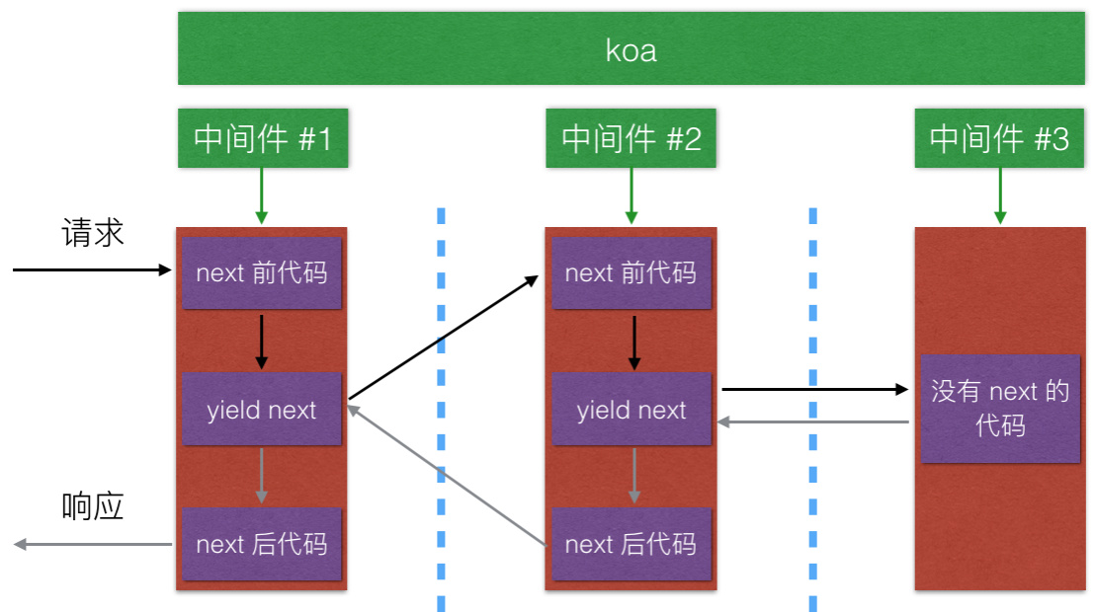

**const** Koa = require('koa');**const** app = **new** Koa();

// x-response-time

app.use(**async** (ctx, next) => {

**const** start = Date.now();

**await** next();

**const** ms = Date.now() - start;

ctx.set('X-Response-Time', `${ms}ms`);

});

// logger

app.use(**async** (ctx, next) => {

**const** start = Date.now();

**await** next();

**const** ms = Date.now() - start;

console.log(`${ctx.method} ${ctx.url} - ${ms}`);

});

// response

app.use(**async** ctx => {

ctx.body = 'Hello World';

});

app.listen(3000);

### **4. 上下文(Context)**

Koa Context 将 node 的 request 和 response 对象封装到单个对象中，为编写 Web 应用程序和 API 提供了许多有用的方法

* ctx.request; // 这是 koa Request
* ctx.response; // 这是 koa Response
* ctrx.req //原始的http请求对象
* ctx.res //原始的http响应对象
* ctx.app 应用程序实例引用
* ctx.request是Koa2中context经过封装的请求对象

绕过 Koa 的 response 处理是 不被支持的

## **5.获取请求参数**

**const** Koa = require('koa');**const** app = **new** Koa();

app.use(**async** (ctx) => {

console.log(ctx.method); //获取请求方法

console.log(ctx.url); //获取请求URL

console.log(ctx.query); //获取解析的查询字符串对象

console.log(ctx.querystring); //根据 ? 获取原始查询字符串.

console.log(ctx.headers);//获取请求头对象

ctx.body = ctx.url;

});

app.listen(3000, () => {

console.log('server is starting at port 3000');

});

## **6.获取请求体**

**const** Koa = require('koa');**const** querystring = require('querystring');**const** app = **new** Koa();

app.use(**async** (ctx) => {

**if** (ctx.method == 'GET') {

ctx.set('Content-Type', 'text/html;charset=utf-8');

ctx.body = (

`

<form method="POST">

<input name="username" >

<input type="submit">

</form>

`

);

} **else** **if** (ctx.method == 'POST') {

ctx.set('Content-Type', 'application/json');

ctx.body = **await** parseBody(ctx);

} **else** {

ctx.body = 'Not Allowed';

}

});**function** **parseBody**(ctx) {

**return** **new** Promise(**function** (resolve, reject) {

**let** buffers = [];

ctx.req.on('data', **function** (data) {

buffers.push(data);

});

ctx.req.on('end', **function** (data) {

**let** body = buffers.toString();

body = querystring.parse(body);

resolve(body);

});

ctx.req.on('error', **function** (errdata) {

reject(err);

});

});

}

app.listen(3000, () => {

console.log('server is starting at port 3000');

});

## **7.使用中间件获取普通请求体**

npm i koa-bodyparser -S

[koa-bodyparser](https://npmjs.org/package/koa-bodyparser)

const Koa = require('koa');

const querystring = require('querystring');

const bodyParser = require('koa-bodyparser');

const app = new Koa();

app.use(bodyParser());

app.use(async (ctx) => {

if (ctx.method == 'GET') {

ctx.set('Content-Type', 'text/html;charset=utf-8');

ctx.body = (

`

<form method="POST">

<input name="username" >

<input type="submit">

</form>

`

);

} else if (ctx.method == 'POST') {

ctx.set('Content-Type', 'application/json');

ctx.body = ctx.request.body;

} else {

ctx.body = 'Not Allowed';

}

});

app.listen(3000, () => {

console.log('server is starting at port 3000');

});

## **8.使用中间件获取包含文件的请求体**

[koa-better-body](https://www.npmjs.com/package/koa-better-body)

npm i koa-better-body -S

**const** Koa = require('koa');**const** querystring = require('querystring');**const** path = require('path');**const** convert = require('koa-convert');**const** bodyParser = require('koa-better-body');**const** app = **new** Koa();

app.use(convert(bodyParser({

uploadDir: path.join(__dirname, 'uploads'),

keepExtensions: true

})));

app.use(**async** (ctx) => {

**if** (ctx.method == 'GET') {

ctx.set('Content-Type', 'text/html;charset=utf-8');

ctx.body = (

`

<form method="POST" enctype="multipart/form-data">

<input name="username" >

<input name="avatar" type="file" >

<input type="submit">

</form>

`

);

} **else** **if** (ctx.method == 'POST') {

ctx.set('Content-Type', 'application/json');

console.log(ctx.request.fields);

ctx.body = ctx.request.body;

} **else** {

ctx.body = 'Not Allowed';

}

});

app.listen(3000, () => {

console.log('server is starting at port 3000');

});

{

username: 'zfpx',

avatar: [File {

domain: null,

_events: {},

_eventsCount: 0,

_maxListeners: undefined,

size: 78540,

path: '\%uploads\%upload_b631c6cbae762214afbe18b6e18d9f68.png',

name: 'mm.png',

type: 'image/png',

hash: null,

lastModifiedDate: 2018 - 03 - 09 T09: 12: 20.679 Z,

_writeStream: [WriteStream]

}]

}

## **9. 路由中间件**

npm install --save koa-router

单级路由

**const** Koa = require('koa');**const** Router = require('koa-router');**const** app = **new** Koa();

**let** user = **new** Router();

user.get('/user', **function** (ctx) {

ctx.body = 'get user ';

}).get('/query/:id', **function** (ctx) {

ctx.body = ctx.params;

}).post('/user', **function** (ctx) {

ctx.body = 'post user ';

}).get('/home', **function** (ctx) {

ctx.body = 'get home ';

});

app.use(user.routes());

app.listen(3000, () => {

console.log('server is starting at port 3000');

});

多级路由

**let** user = **new** Router();

user.get('/add', **function** (ctx) {

ctx.body = 'get user add ';

});

**let** article = **new** Router();

article.get('/add', **function** (ctx) {

ctx.body = 'get article add ';

});

**let** router = **new** Router();

router.use('/user', user.routes());

router.use('/article', article.routes());

app.use(router.routes());

## **10.cookie**

* ctx.cookies.get(name,[optins]):读取上下文请求中的cookie。
* ctx.cookies.set(name,value,[options])：在上下文中写入cookie。
  + domain：写入cookie所在的域名
  + path：写入cookie所在的路径
  + maxAge：Cookie最大有效时长
  + expires：cookie失效时间
  + httpOnly:是否只用http请求中获得
  + overwirte：是否允许重写

app.use(**async** (ctx, next) => {

console.log(ctx.url);

**if** (ctx.url == '/write') {

ctx.cookies.set('name', 'zfpx');

ctx.body = 'write';

} **else** {

next();

}

});

app.use(**async** (ctx) => {

**if** (ctx.url == '/read') {

ctx.body = ctx.cookies.get('name');

}

});

## **11.session**

[koa-session](https://www.npmjs.com/package/koa-session)

$ npm install koa-session

**const** Koa = require('koa');**const** session = require('koa-session');**const** app = **new** Koa();

app.keys = ['zfpx'];

app.use(session({}, app));

app.use(**async** (ctx) => {

**let** visit = ctx.session.visit;

**if** (visit) {

visit = visit + 1;

} **else** {

visit = 1;

}

ctx.session.visit = visit;

ctx.body = `这是你的第${visit}次访问`;

});

app.listen(3000);

## **12. 模板引擎**

npm i koa-views ejs -S

**const** Koa = require('koa');**const** views = require('koa-views');**const** path = require('path');**const** app = **new** Koa();

app.use(views(path.join(__dirname, './views'), {

extension: 'ejs'

}));

app.use(**async** ctx => {

**await** ctx.render('index', { name: '珠峰培训' });

});

app.listen(3000, () => {

console.log('server is starting at port 3000');

});

## **13. 静态资源中间件**

npm install --save koa-**static**

**const** **static** = require('koa-static')**const** app = **new** Koa()

app.use(**static**(path.join( __dirname, 'public')))

app.use( **async** ( ctx ) => {

ctx.body = 'Not Found'

})

## **14. koa实现**

**const** Koa = require('./koa');**const** app = **new** Koa();

app.use(**async** (**async**, next) => {

console.log(1);

**await** next();

console.log(2);

});

app.use(**async** (ctx, next) => {

console.log(3);

**await** next();

console.log(4);

});

app.use(**async** (ctx, next) => {

console.log(5);

});

app.listen(3000);

**let** http = require('http');**class** **Koa** {

**constructor**() {

**this**.middleware = [];

}

use(fn) {

**this**.middleware.push(fn);

}

listen(port) {

**let** middleware = **this**.middleware;

**let** server = http.createServer((req, res) => {

**let** ctx = { req, res }

**function** **dispatch**(idx) {

middleware[idx](ctx, () => dispatch(idx + 1));

}

dispatch(0);

});

server.listen(port);

}

}

module.exports = Koa;

## **15. generator**

[koa-generator](https://github.com/17koa/koa-generator)

$ npm install -g koa-generator

$ koa /tmp/foo && cd /tmp/foo

$ npm install

$ npm start

## **16. form-data**

**const** Koa = require('koa');**const** views = require('koa-views');**const** fs = require('fs');**let** querystring = require('querystring');**let** path = require('path');**let** uuid = require('uuid');**const** app = **new** Koa();

app.use(**async** (ctx, next) => {

**if** (ctx.method == 'GET') {

ctx.set('Content-Type', 'text/html;charset=utf8');

ctx.body = (

`

<form id="userform" method="POST" enctype="multipart/form-data">

用户名:<input type="text" name="username">

密码<input type="text" name="password">

头像<input type="file" name="avatar">

<input type="submit">

</form>

`

);

} **else** **if** (ctx.method == 'POST') {

**let** buffers = [];

ctx.req.on('data', **function** (data) {

buffers.push(data);

});

ctx.req.on('end', **function** () {

**let** result = Buffer.concat(buffers);

**let** type = ctx.headers['content-type'];

**let** matched = type.match(/\bboundary=(.+)\b/);

**if** (matched) {

**let** seperator = '--' + matched[1];

**let** body = process(seperator, result);

ctx.body = body;

} **else** {

next();

}

});

ctx.body = 'hello';

} **else** {

next();

}

});

app.listen(3000);

Buffer.prototype.split = Buffer.prototype.split || **function** (sep) {

**let** len = Buffer.byteLength(sep);

**let** parts = [];

**let** offset = 0;

**let** pos = -1;

**while** (-1 != (pos = **this**.indexOf(sep, offset))) {

parts.push(**this**.slice(offset, pos));

offset = pos + len;

}

parts.push(**this**.slice(offset));

**return** parts;

}**function** **process**(seperator, result) {

**let** lines = result.split(seperator);

lines = lines.slice(1, -1);

**let** body = {};

**let** files = [];

lines.forEach(**function** (line) {

**let** [desc, val] = line.split('\r\n\r\n');

desc = desc.toString();

val = val.slice(0, -2);

**if** (desc.includes('filename')) {//如果是文件的话

**let** [, line1, line2] = desc.split('\r\n');

**let** obj1 = querystring.parse(line1, '; ');

**let** obj2 = querystring.parse(line2, '; ');

**let** filepath = path.join(__dirname, 'uploads', uuid.v4());

fs.writeFileSync(filepath, val);

files.push({

...obj1, filepath

});

} **else** {

**let** matched = desc.match(/\bname=(.+)\b/);

**if** (matched)

body[matched[1]] = val.toString();

}

});

**return** { body, files };

}