1.初始化项目
create-react-app zhufeng_react5
cd zhufeng_react5
cnpm i jquery -S
npm start

2. 渲染文本

2.1 渲染效果
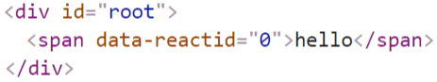

2.2 实现

2.2.1 index.js
src\index.js
import React from './react';
React.render('hello',document.getElementById('root'));

2.2.2 react.js
src\react.js
import $ from 'jquery';let React = {
rootIndex:0,
render
}function render(element,container){
container.innerHTML = `<span data-reactid="${React.rootIndex}">${element}</span>`;
}
export default React;

3. 重构

3.2 类图
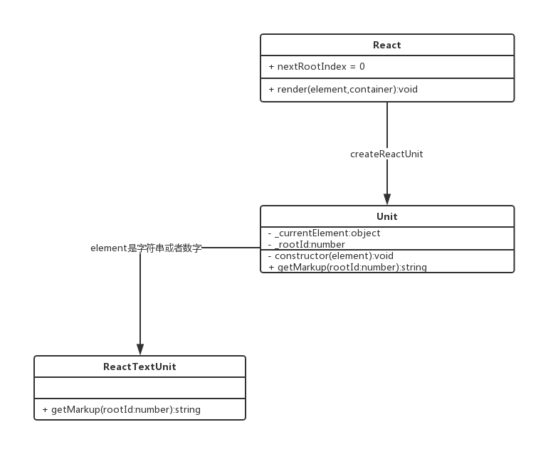

3.3 实现

3.3.1 index.js
src\index.js
import React from './react';
React.render('hello',document.getElementById('root'));

3.3.2 react\index.js
src\react\index.js
import $ from 'jquery';import {createUnit} from './unit';let React = {
rootIndex:0,
render
}function render(element,container){
let unit = createUnit(element);
let markup = unit.getMarkUp(React.rootIndex);
$(container).html(markup);
$(document).trigger('mounted');//componentDidMount
}
export default React;

3.3.3 react\unit.js
src\react\unit.js
class Unit {
constructor(element){
this._currentElement = element;
}
getMarkUp(){
throw new Error('不能调用此方法');
}
}class TextUnit extends Unit{
getMarkUp(reactid){
this._reactid = reactid;//保存记录rootId
//返回文本节点对应的HTML字符串
return `<span data-reactid="${reactid}">${this._currentElement}</span>`;
}
}
function createUnit(element){
if(typeof element =='string' || typeof element =='number'){
return new TextUnit(element);
}
}
export {
createUnit
}

4. 渲染原生DOM组件
- babeljs

4.1 渲染效果
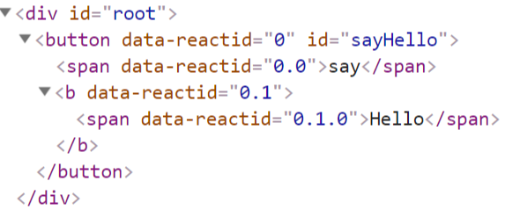

4.2 类图
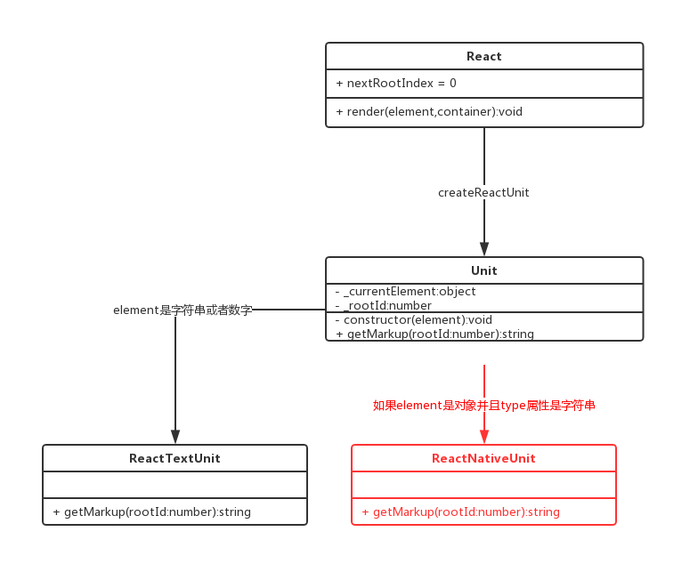

4.3 JSX语法
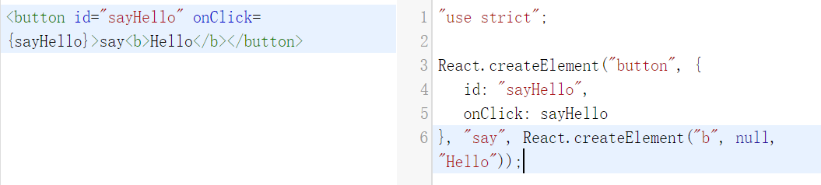

4.3.1 JSX
<button id="sayHello" onClick={sayHello}>say<b style={{color:'red'}}>Hello</b></button>

4.3.2 JavaScript
let element = React.createElement("button", {
id: "sayHello",
onClick: sayHello
}, "say", React.createElement("b", {style:{color:'red'}}, "Hello"));

4.4 实现

4.4.1 index.js
src/index.js
import React from './react';function sayHello(){
alert('hello');
}let element = React.createElement(
'button',{id:'sayHello',onClick:sayHello},
'say',
React.createElement('b',{style:{color:'green'}},'hello'),
);
React.render(element,document.getElementById('root'));

4.4.2 react/index.js
src/react/index.js
import $ from 'jquery';
import {createUnit} from './unit';+import {createElement} from './element';
let React = {
rootIndex:0,
render,+ createElement
}
function render(element,container){
let unit = createUnit(element);
let markup = unit.getMarkUp(React.rootIndex);
$(container).html(markup);
$(document).trigger('mounted');//componentDidMount
}

export default React;

4.4.3 react/element.js
src/react/element.js
class Element{
constructor(type,props){
this.type = type;
this.props = props;
}
}function createElement(type,props,...children){
props=props||{};
props.children = children;
return new Element(type,props);
}
export {
createElement
}

4.4.4 react/unit.js
src/react/unit.js
+import {Element} from './element';+import $ from 'jquery';
class Unit {
constructor(element){
this._currentElement = element;
}
getMarkUp(){
throw new Error('不能调用此方法');
}
}
class TextUnit extends Unit{
getMarkUp(reactid){
this._reactid = reactid;//保存记录reactid
//返回文本节点对应的HTML字符串
return `<span data-reactid="${reactid}">${this._currentElement}</span>`;
}
}+class NativeUnit extends Unit {+ getMarkUp(reactid){+ this._reactid = reactid;//保存记录reactid+ //返回文本节点对应的HTML字符串+ let {type,props} = this._currentElement;+ let tagOpen = `<${type} data-reactid="${reactid}" `;+ let tagClose = `</$type>`;+ let content = '';+ for(let propName in props){+ if(/^on[A-Z]/.test(propName)){+ let eventName = propName.slice(2).toLowerCase();+ $(document).delegate(`[data-reactid="${reactid}"]`,`${eventName}.${reactid}`,props[propName]);+ }else if(propName === 'style'){+ let styleObj = props[propName];+ let styles = Object.keys(styleObj).map(attr=>`${attr}:${styleObj[attr]}`).join(';');+ tagOpen += (` style="${styles}" `);+ }else if (propName === 'children'){+ let children = props.children||[];+ children.map((child,index)=>{+ let childUnit = createUnit(child);+ let childMarkUp = childUnit.getMarkUp(`${reactid}.${index}`);+ content += childMarkUp;+ });+ }else{+ tagOpen += ` ${propName}=${props[propName]} `;+ }+ }+ return tagOpen + '>' + content + tagClose;+ }+}
function createUnit(element){
if(typeof element =='string' || typeof element =='number'){
return new TextUnit(element);
}+ if(element instanceof Element && typeof element.type === 'string'){+ return new NativeUnit(element);+ }
}

export {
createUnit
}

5. 渲染自定义组件

5.1 渲染效果
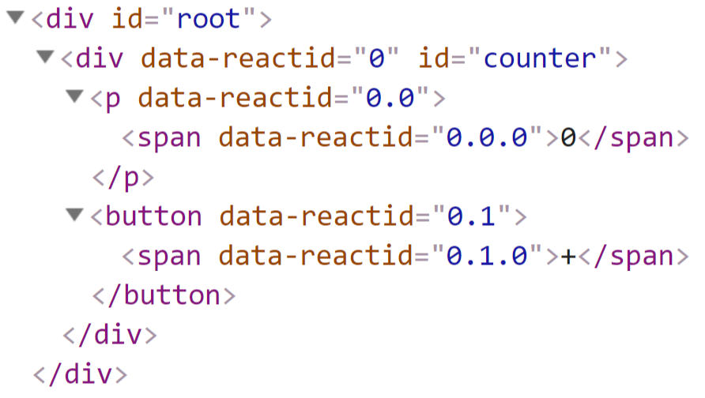

5.2 类图
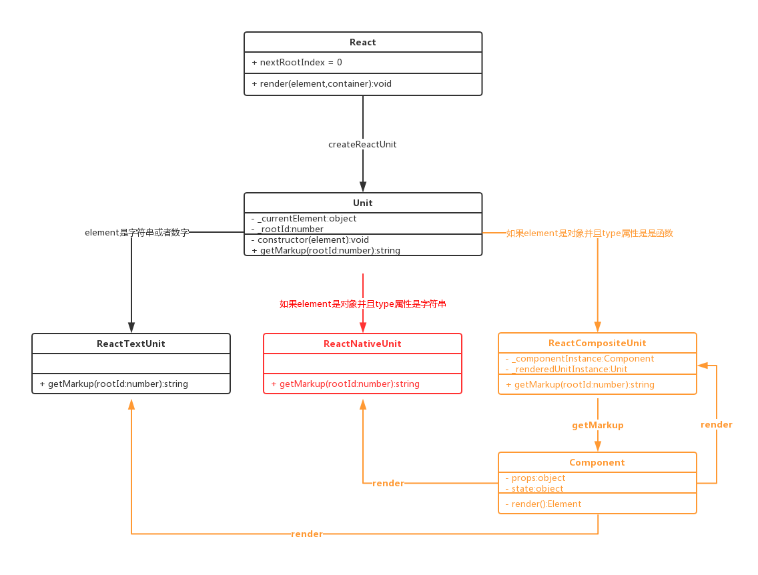

5.3 实现

5.3.1 src/index.js
import React from './react';class Counter extends React.Component{
constructor(props){
super(props);
this.state = {number:0};
}
componentWillMount(){
console.log('Counter componentWillMount')
}
componentDidMount() {
console.log('Counter componentDidMount')
}
handleClick = ()=>{
this.setState({number:this.state.number+1});
}
render(){
let p = React.createElement('p',{style:{color:'red'}},this.state.number);
let button = React.createElement('button',{onClick:this.handleClick},'+');
return React.createElement('div',{id:'counter'},p,button);
}
}let element = React.createElement(Counter);
React.render(element,document.getElementById('root'));

5.3.2 react/index.js
src/react/index.js
import $ from 'jquery';
import {createUnit} from './unit';
import {createElement} from './element';+import {Component} from './component';
let React = {
rootIndex:0,
render,
createElement,+ Component
}
function render(element,container){
let unit = createUnit(element);
let markup = unit.getMarkUp(React.rootIndex);
$(container).html(markup);
$(document).trigger('mounted');//componentDidMount
}

export default React;

5.3.3 react/component.js
src/react/component.js
class Component{
constructor(props){
this.props = props;
}
}export {Component}

5.3.4 react/unit.js
src/react/unit.js
import {Element} from './element';
import $ from 'jquery';
class Unit {
constructor(element){
this._currentElement = element;
}
getMarkUp(){
throw new Error('不能调用此方法');
}
}
class TextUnit extends Unit{
getMarkUp(reactid){
this._reactid = reactid;//保存记录reactid
//返回文本节点对应的HTML字符串
return `<span data-reactid="${reactid}">${this._currentElement}</span>`;
}
}
class NativeUnit extends Unit {
getMarkUp(reactid){
this._reactid = reactid;//保存记录reactid
//返回文本节点对应的HTML字符串
let {type,props} = this._currentElement;
let tagOpen = `<${type} data-reactid="${reactid}" `;
let tagClose = `</$type>`;
let content = '';
for(let propName in props){
if(/^on[A-Z]/.test(propName)){
let eventName = propName.slice(2).toLowerCase();
$(document).delegate(`[data-reactid="${reactid}"]`,`${eventName}.${reactid}`,props[propName]);
}else if(propName === 'style'){
let styleObj = props[propName];
let styles = Object.keys(styleObj).map(attr=>`${attr}:${styleObj[attr]}`).join(';');
tagOpen += (` style="${styles}" `);
}else if (propName === 'children'){
let children = props.children||[];
children.map((child,index)=>{
let childUnit = createUnit(child);
let childMarkUp = childUnit.getMarkUp(`${reactid}.${index}`);
content += childMarkUp;
});
}else{
tagOpen += ` ${propName}=${props[propName]} `;
}
}
return tagOpen + '>' + content + tagClose;
}
}
+class CompositeUnit extends Unit{+ getMarkUp(reactid){+ this._reactid = reactid;+ //type是一个自定义组件的类的定义+ let {type:Component,props} = this._currentElement;+ //创建Component类的实例+ let componentInstance = new Component(props);+ //组件将要渲染+ componentInstance.componentWillMount&&componentInstance.componentWillMount();+ //执行render方法获得虚拟DOM元素实例+ let renderedElement = componentInstance.render();+ //根据虚拟DOM元素得到unit,可能是TextUnit NativeUnit CompositeUnit+ let renderedUnitInstance = this._renderedUnitInstance= createUnit(renderedElement);+ //获得此unit的HTML标记字符串+ let renderedMarkUp = renderedUnitInstance.getMarkUp(reactid);+ //注册挂载完成的监听，越底层的组件越先监听，越先执行+ $(document).on('mounted',()=>componentInstance.componentDidMount&&componentInstance.componentDidMount());+ return renderedMarkUp;+ }+}

function createUnit(element){
if(typeof element =='string' || typeof element =='number'){
return new TextUnit(element);
}
if(element instanceof Element && typeof element.type === 'string'){
return new NativeUnit(element);
}+ if(element instanceof Element && typeof element.type === 'function'){+ return new CompositeUnit(element);+ }
}

export {
createUnit
}

6. 实现setState

6.1 src/index.js
import React from './react';class Counter extends React.Component{
constructor(props){
super(props);
this.state = {number:0};
}
componentWillMount(){
console.log('Counter componentWillMount')
}
componentDidMount() {
setInterval(() => {
this.setState({number:this.state.number+1});
}, 1000);
}
render(){
return this.state.number;
}
}let element = React.createElement(Counter);
React.render(element,document.getElementById('root'));

6.2 react/component.js
src/react/component.js
class Component{
constructor(props){
this.props = props;
}
setState(partialState){
this._currentUnit.update(null,partialState);
}
}export {Component}

6.3 react/unit.js
src/react/unit.js
import {Element} from './element';
import $ from 'jquery';
class Unit {
constructor(element){
this._currentElement = element;
}
getMarkUp(){
throw new Error('不能调用此方法');
}
}
class TextUnit extends Unit{
getMarkUp(reactid){
this._reactid = reactid;//保存记录reactid
//返回文本节点对应的HTML字符串
return `<span data-reactid="${reactid}">${this._currentElement}</span>`;
}+ update(nextElement){+ if(this._currentElement != nextElement){+ this._currentElement = nextElement;+ $(`[data-reactid="${this._reactid}"]`).html(this._currentElement);+ }+ }
}
class NativeUnit extends Unit {
getMarkUp(reactid){
this._reactid = reactid;//保存记录reactid
//返回文本节点对应的HTML字符串
let {type,props} = this._currentElement;
let tagOpen = `<${type} data-reactid="${reactid}" `;
let tagClose = `</$type>`;
let content = '';
for(let propName in props){
if(/^on[A-Z]/.test(propName)){
let eventName = propName.slice(2).toLowerCase();
$(document).delegate(`[data-reactid="${reactid}"]`,`${eventName}.${reactid}`,props[propName]);
}else if(propName === 'style'){
let styleObj = props[propName];
let styles = Object.keys(styleObj).map(attr=>`${attr}:${styleObj[attr]}`).join(';');
tagOpen += (` style="${styles}" `);
}else if (propName === 'children'){
let children = props.children||[];
children.map((child,index)=>{
let childUnit = createUnit(child);
let childMarkUp = childUnit.getMarkUp(`${reactid}.${index}`);
content += childMarkUp;
});
}else{
tagOpen += ` ${propName}=${props[propName]} `;
}
}
return tagOpen + '>' + content + tagClose;
}
}

class CompositeUnit extends Unit{
//接收到新的更新，自定义组件传第二个参数，原生组件和text传处一个参数+ update(nextElement,partialState){+ //如果传过来了新的元素，则使用新的元素+ this._currentElement = nextElement||this._currentElement;+ //获取新的状态对象和属性对象+ let nextState = this._componentInstance.state= Object.assign(this._componentInstance.state,partialState);+ let nextProps = this._currentElement.props;+ //如果shouldComponentUpdate返回了false则不需要继续更新+ if(this._componentInstance.shouldComponentUpdate&&this._componentInstance.shouldComponentUpdate(nextProps,nextState)===false){return;}+ //获得上次渲染出来的unit实例 + let prevRenderedUnitInstance = this._renderedUnitInstance;+ //从unit实例中获取+ let prevRenderedElement = prevRenderedUnitInstance._currentElement;+ //获取新的虚拟DOM+ let nextRenderElement = this._componentInstance.render();+ //进行domdiff对比+ if(shouldDeepCompare(prevRenderedElement,nextRenderElement)){+ //如果需要更新，则继续调用子节点的upate方法进行更新,传入新的element更新子节点+ prevRenderedUnitInstance.update(nextRenderElement);+ this._componentInstance.componentDidUpdate&&this._componentInstance.componentDidUpdate();+ }else{+ //如果发现不需要对比，干脆重新渲染+ this._renderedUnitInstance = createUnit(nextRenderElement);+ let nextMarkUp = this._renderedUnitInstance.getMarkUp(this._reactid);+ //替换整个节点+ $(`[data-reactid="${this._reactid}"]`).replaceWith(nextMarkUp);+ }

}
getMarkUp(reactid){
this._reactid = reactid;
//type是一个自定义组件的类的定义
let {type:Component,props} = this._currentElement;
//创建Component类的实例+ let componentInstance = this._componentInstance = new Component(props);
//组件实例关联上自己的unit实例+ componentInstance._currentUnit = this;
//组件将要渲染
componentInstance.componentWillMount&&componentInstance.componentWillMount();
//执行render方法获得虚拟DOM元素实例
let renderedElement = componentInstance.render();
//根据虚拟DOM元素得到unit,可能是TextUnit NativeUnit CompositeUnit
let renderedUnitInstance = this._renderedUnitInstance= createUnit(renderedElement);
//获得此unit的HTML标记字符串
let renderedMarkUp = renderedUnitInstance.getMarkUp(reactid);
//注册挂载完成的监听，越底层的组件越先监听，越先执行
$(document).on('mounted',()=>componentInstance.componentDidMount&&componentInstance.componentDidMount());
return renderedMarkUp;
}
}
+function shouldDeepCompare(prevElement,nextElement){+ if(prevElement!==null && nextElement!=null){+ let prevType = typeof prevElement;+ let nextType = typeof nextElement;+ //如果新老节点都是文本可以进行比较+ if((prevType === 'string' ||prevType === 'number')&&(nextType === 'string' ||nextType === 'number')){+ return true;+ }+ if(prevElement instanceof Element && nextElement instanceof Element){+ return prevElement.type === nextElement.type;+ }+ } + return false;+}
function createUnit(element){
if(typeof element =='string' || typeof element =='number'){
return new TextUnit(element);
}
if(element instanceof Element && typeof element.type === 'string'){
return new NativeUnit(element);
}
if(element instanceof Element && typeof element.type === 'function'){
return new CompositeUnit(element);
}
}

export {
createUnit
}

6.4 react/element.js
src/react/element.js
class Element{
constructor(type,props){
this.type = type;+ this.key = props.key;
this.props = props;
}
}

7. 对比属性
- 实现点击加1功能

7.1 src/index.js
src/index.js
import React from './react';class Counter extends React.Component{
constructor(props){
super(props);
this.state = {number:0};
}
componentWillMount(){
console.log('Counter componentWillMount')
}
componentDidMount() {
console.log('Counter componentDidMount')
}
handleClick= ()=>{
this.setState({number:this.state.number+1});
}
render(){
let p = React.createElement('p',{},this.state.number);
let button = React.createElement('button',{onClick:this.handleClick},'+');
return React.createElement('div',{id:'counter',style:{color:this.state.number%2===0?'red':'green',backgroundColor:this.state.number%2===0?'green':'red'}},p,button);
}
}let element = React.createElement(Counter);
React.render(element,document.getElementById('root'));

7.2 react/unit.js
src/react/unit.js
import {Element} from './element';
import $ from 'jquery';
class Unit {
constructor(element){
this._currentElement = element;
}
getMarkUp(){
throw new Error('不能调用此方法');
}
}
class TextUnit extends Unit{
getMarkUp(reactid){
this._reactid = reactid;//保存记录reactid
//返回文本节点对应的HTML字符串
return `<span data-reactid="${reactid}">${this._currentElement}</span>`;
}
update(nextElement){
if(this._currentElement != nextElement){
this._currentElement = nextElement;
$(`[data-reactid="${this._reactid}"]`).html(this._currentElement);
}
}

}
class NativeUnit extends Unit {
getMarkUp(reactid){
this._reactid = reactid;//保存记录reactid
//返回文本节点对应的HTML字符串
let {type,props} = this._currentElement;
let tagOpen = `<${type} data-reactid="${reactid}" `;
let tagClose = `</$type>`;
let content = '';
for(let propName in props){
if(/^on[A-Z]/.test(propName)){
let eventName = propName.slice(2).toLowerCase();
$(document).delegate(`[data-reactid="${reactid}"]`,`${eventName}.${reactid}`,props[propName]);
}else if(propName === 'style'){+ let styleObj = props[propName];+ let styles = Object.keys(styleObj).map(attr=>{+ let attrName = attr.replace(/([A-Z])/g,function(matched,group){+ return `-${group.toLowerCase()}`;+ })+ return `${attrName}:${styleObj[attr]}`;+ }).join(';');+ tagOpen += (` style="${styles}" `);
}else if (propName === 'children'){
let children = props.children||[];
children.map((child,index)=>{
let childUnit = createUnit(child);
let childMarkUp = childUnit.getMarkUp(`${reactid}.${index}`);
content += childMarkUp;
});
}else{
tagOpen += ` ${propName}=${props[propName]} `;
}
}
return tagOpen + '>' + content + tagClose;
}+ update(nextElement){+ let oldProps = this._currentElement.props;+ let newProps = nextElement.props;+ this.updateDOMproperties(oldProps,newProps);+ //this.updateDOMChildren(nextElement.props.children);+ }+ updateDOMproperties(oldProps,newProps){+ let propName;+ //把新属性对象上没有属性给删除掉+ for(propName in oldProps){+ if(!newProps.hasOwnProperty(propName)){+ $(`[data-reactid="${this._reactid}"]`).removeAttr(propName);+ }+ if(/^on[A-Z]/.test(propName)){+ $(document).undelegate(`.${this.reactid}`);+ }+ }+ for(propName in newProps){+ if(propName == 'children'){+ + }else if(/^on[A-Z]/.test(propName)){+ let eventName = propName.slice(2).toLowerCase();+ $(document).delegate(`[data-reactid="${this._reactid}"]`,`${eventName}.${this._reactid}`,newProps[propName]);+ }else if(propName === 'style'){+ let styleObj = newProps[propName];+ Object.entries(styleObj).forEach(([attr,value])=>{+ $(`[data-reactid="${this._reactid}"]`).css(attr,value);+ })+ }else{+ $(`[data-reactid="${this._reactid}"]`).prop(propName,newProps[propName]);+ }+ }+ }+}

class CompositeUnit extends Unit{
//接收到新的更新，自定义组件传第二个参数，原生组件和text传处一个参数
update(nextElement,partialState){
//如果传过来了新的元素，则使用新的元素
this._currentElement = nextElement||this._currentElement;
//获取新的状态对象和属性对象
let nextState = this._componentInstance.state= Object.assign(this._componentInstance.state,partialState);
let nextProps = this._currentElement.props;
//如果shouldComponentUpdate返回了false则不需要继续更新
if(this._componentInstance.shouldComponentUpdate&&this._componentInstance.shouldComponentUpdate(nextProps,nextState)===false){return;}
//获得上次渲染出来的unit实例
let prevRenderedUnitInstance = this._renderedUnitInstance;
//从unit实例中获取
let prevRenderedElement = prevRenderedUnitInstance._currentElement;
//获取新的虚拟DOM
let nextRenderElement = this._componentInstance.render();
//进行domdiff对比
if(shouldDeepCompare(prevRenderedElement,nextRenderElement)){
//如果需要更新，则继续调用子节点的upate方法进行更新,传入新的element更新子节点
prevRenderedUnitInstance.update(nextRenderElement);
this._componentInstance.componentDidUpdate&&this._componentInstance.componentDidUpdate();
}else{
//如果发现不需要对比，干脆重新渲染
this._renderedUnitInstance = createUnit(nextRenderElement);
let nextMarkUp = this._renderedUnitInstance.getMarkUp(this._reactid);
//替换整个节点
$(`[data-reactid="${this._reactid}"]`).replaceWith(nextMarkUp);
}

}
getMarkUp(reactid){
this._reactid = reactid;
//type是一个自定义组件的类的定义
let {type:Component,props} = this._currentElement;
//创建Component类的实例
let componentInstance = this._componentInstance = new Component(props);
//组件实例关联上自己的unit实例
componentInstance._currentUnit = this;
//组件将要渲染
componentInstance.componentWillMount&&componentInstance.componentWillMount();
//执行render方法获得虚拟DOM元素实例
let renderedElement = componentInstance.render();
//根据虚拟DOM元素得到unit,可能是TextUnit NativeUnit CompositeUnit
let renderedUnitInstance = this._renderedUnitInstance= createUnit(renderedElement);
//获得此unit的HTML标记字符串
let renderedMarkUp = renderedUnitInstance.getMarkUp(reactid);
//注册挂载完成的监听，越底层的组件越先监听，越先执行
$(document).on('mounted',()=>componentInstance.componentDidMount&&componentInstance.componentDidMount());
return renderedMarkUp;
}
}

function shouldDeepCompare(prevElement,nextElement){
if(prevElement!==null && nextElement!=null){
let prevType = typeof prevElement;
let nextType = typeof nextElement;
//如果新老节点都是文本可以进行比较
if((prevType === 'string' ||prevType === 'number')&&(nextType === 'string' ||nextType === 'number')){
return true;
}
if(prevElement instanceof Element && nextElement instanceof Element){
return prevElement.type === nextElement.type;
}
}
return false;
}
function createUnit(element){
if(typeof element =='string' || typeof element =='number'){
return new TextUnit(element);
}
if(element instanceof Element && typeof element.type === 'string'){
return new NativeUnit(element);
}
if(element instanceof Element && typeof element.type === 'function'){
return new CompositeUnit(element);
}
}

export {
createUnit
}

8. 对比子元素

8.1 src/unit.js
src\unit.js
import {Element} from './element';
import $ from 'jquery';+ let diffQueue = [];
class Unit {
constructor(element){
this._currentElement = element;
}
getMarkUp(){
throw new Error('不能调用此方法');
}
}
class TextUnit extends Unit{
getMarkUp(reactid){
this._reactid = reactid;//保存记录reactid
//返回文本节点对应的HTML字符串
return `<span data-reactid="${reactid}">${this._currentElement}</span>`;
}
update(nextElement){
if(this._currentElement != nextElement){
this._currentElement = nextElement;
$(`[data-reactid="${this._reactid}"]`).html(this._currentElement);
}
}

}
class NativeUnit extends Unit {
getMarkUp(reactid){
this._reactid = reactid;//保存记录reactid
//返回文本节点对应的HTML字符串
let {type,props} = this._currentElement;
let tagOpen = `<${type} data-reactid="${reactid}" `;
let tagClose = `</$type>`;
let content = '';+ let renderedChildUnits=[];
for(let propName in props){
if(/^on[A-Z]/.test(propName)){
let eventName = propName.slice(2).toLowerCase();
$(document).delegate(`[data-reactid="${reactid}"]`,`${eventName}.${reactid}`,props[propName]);
}else if(propName === 'style'){
let styleObj = props[propName];
let styles = Object.keys(styleObj).map(attr=>{
let attrName = attr.replace(/([A-Z])/g,function(matched,group){
return `-${group.toLowerCase()}`;
})
return `${attrName}:${styleObj[attr]}`;
}).join(';');
tagOpen += (` style="${styles}" `);
}else if (propName === 'children'){
let children = props.children||[];
children.map((child,index)=>{
let childUnit = createUnit(child);+ renderedChildUnits.push(childUnit);
let childMarkUp = childUnit.getMarkUp(`${reactid}.${index}`);
content += childMarkUp;
});
}else{
tagOpen += ` ${propName}=${props[propName]} `;
}
}+ this._renderedChildUnits = renderedChildUnits;
return tagOpen + '>' + content + tagClose;
}
update(nextElement){
let oldProps = this._currentElement.props;
let newProps = nextElement.props;
this.updateDOMproperties(oldProps,newProps);+ this.updateDOMChildren(nextElement.props.children);
}+ //对比子元素+ updateDOMChildren(newChildrenElements){+ this.diff(diffQueue,newChildrenElements);+ }+ diff(diffQueue,newChildrenElements){+ let oldChildUnitsMap = this.getChildrenMap(this._renderedChildUnits);+ let newChildren = this.getNewChildren(oldChildUnitsMap,newChildrenElements);+ }+ getNewChildren(oldChildUnitsMap,newChildrenElements){+ let newChildren = [];+ newChildrenElements.forEach((newElement,index)=>{+ let newKey = newElement.key||index.toString();+ let oldUnit = oldChildUnitsMap[newKey];//获得老的unit+ let oldElement = oldUnit&&oldUnit._currentElement;//获得老的element+ if(shouldDeepCompare(oldElement,newElement)){//如果可以更进一步深比较+ oldUnit.update(newElement);+ newChildren.push(oldUnit);+ }else{+ let newChildUnit = createUnit(newElement);//如果不需要深比较则直接创建新的unit+ newChildren.push(newChildUnit);+ }+ });+ return newChildren;+ }+ getChildrenMap(childUnits=[]){+ let map = {};+ for(let i=0;i<childUnits.length;i++){+ let key = childUnits[i].key||i.toString();+ map[key]=childUnits[i];+ }+ return map;+ }
updateDOMproperties(oldProps,newProps){
let propName;
//把新属性对象上没有属性给删除掉
for(propName in oldProps){
if(!newProps.hasOwnProperty(propName)){
$(`[data-reactid="${this._reactid}"]`).removeAttr(propName);
}
if(/^on[A-Z]/.test(propName)){
$(document).undelegate(`.${this._reactid}`);
}
}
for(propName in newProps){
if(propName == 'children'){

}else if(/^on[A-Z]/.test(propName)){
let eventName = propName.slice(2).toLowerCase();
$(document).undelegate(`.${this._reactid}`);
$(document).delegate(`[data-reactid="${this._reactid}"]`,`${eventName}.${this._reactid}`,newProps[propName]);
}else if(propName === 'style'){
let styleObj = newProps[propName];
Object.entries(styleObj).forEach(([attr,value])=>{
$(`[data-reactid="${this._reactid}"]`).css(attr,value);
})
}else{
$(`[data-reactid="${this._reactid}"]`).prop(propName,newProps[propName]);
}
}
}
}

class CompositeUnit extends Unit{
//接收到新的更新，自定义组件传第二个参数，原生组件和text传处一个参数
update(nextElement,partialState){
//如果传过来了新的元素，则使用新的元素
this._currentElement = nextElement||this._currentElement;
//获取新的状态对象和属性对象
let nextState = this._componentInstance.state= Object.assign(this._componentInstance.state,partialState);
let nextProps = this._currentElement.props;
//如果shouldComponentUpdate返回了false则不需要继续更新
if(this._componentInstance.shouldComponentUpdate&&this._componentInstance.shouldComponentUpdate(nextProps,nextState)===false){return;}
//获得上次渲染出来的unit实例
let prevRenderedUnitInstance = this._renderedUnitInstance;
//从unit实例中获取
let prevRenderedElement = prevRenderedUnitInstance._currentElement;
//获取新的虚拟DOM
let nextRenderElement = this._componentInstance.render();
//进行domdiff对比
if(shouldDeepCompare(prevRenderedElement,nextRenderElement)){
//如果需要更新，则继续调用子节点的upate方法进行更新,传入新的element更新子节点
prevRenderedUnitInstance.update(nextRenderElement);
this._componentInstance.componentDidUpdate&&this._componentInstance.componentDidUpdate();
}else{
//如果发现不需要对比，干脆重新渲染
this._renderedUnitInstance = createUnit(nextRenderElement);
let nextMarkUp = this._renderedUnitInstance.getMarkUp(this._reactid);
//替换整个节点
$(`[data-reactid="${this._reactid}"]`).replaceWith(nextMarkUp);
}

}
getMarkUp(reactid){
this._reactid = reactid;
//type是一个自定义组件的类的定义
let {type:Component,props} = this._currentElement;
//创建Component类的实例
let componentInstance = this._componentInstance = new Component(props);
//组件实例关联上自己的unit实例
componentInstance._currentUnit = this;
//组件将要渲染
componentInstance.componentWillMount&&componentInstance.componentWillMount();
//执行render方法获得虚拟DOM元素实例
let renderedElement = componentInstance.render();
//根据虚拟DOM元素得到unit,可能是TextUnit NativeUnit CompositeUnit
let renderedUnitInstance = this._renderedUnitInstance= createUnit(renderedElement);
//获得此unit的HTML标记字符串
let renderedMarkUp = renderedUnitInstance.getMarkUp(reactid);
//注册挂载完成的监听，越底层的组件越先监听，越先执行
$(document).on('mounted',()=>componentInstance.componentDidMount&&componentInstance.componentDidMount());
return renderedMarkUp;
}
}

function shouldDeepCompare(prevElement,nextElement){
if(prevElement!==null && nextElement!=null){
let prevType = typeof prevElement;
let nextType = typeof nextElement;
//如果新老节点都是文本可以进行比较
if((prevType === 'string' ||prevType === 'number')&&(nextType === 'string' ||nextType === 'number')){
return true;
}
if(prevElement instanceof Element && nextElement instanceof Element){
return prevElement.type === nextElement.type;
}
}
return false;
}
function createUnit(element){
if(typeof element =='string' || typeof element =='number'){
return new TextUnit(element);
}
if(element instanceof Element && typeof element.type === 'string'){
return new NativeUnit(element);
}
if(element instanceof Element && typeof element.type === 'function'){
return new CompositeUnit(element);
}
}

export {
createUnit
}

9. 获得补丁数组
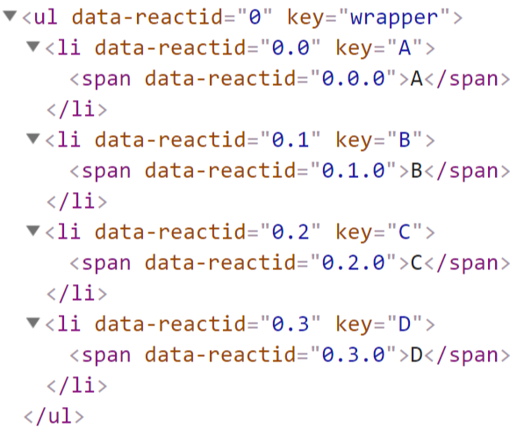
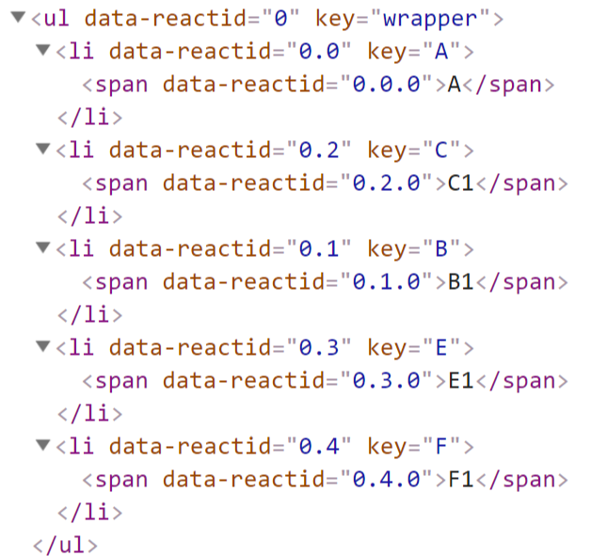
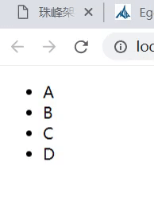

9.1 src/index.js
src/index.js
import React from './react';class Counter extends React.Component{
constructor(props){
super(props);
this.state = {odd:true};
}
componentDidMount(){
setTimeout(()=>{
this.setState({odd:!this.state.odd});
},1000);
}
render(){
if(this.state.odd){
return React.createElement('ul',{key:'wrapper'},
React.createElement('li',{key:'A'},'A'),
React.createElement('li',{key:'B'},'B'),
React.createElement('li',{key:'C'},'C'),
React.createElement('li',{key:'D'},'D'),
);
}
return React.createElement('ul',{key:'wrapper'},
React.createElement('li',{key:'A'},'A1'),
React.createElement('li',{key:'C'},'C1'),
React.createElement('li',{key:'B'},'B1'),
React.createElement('li',{key:'E'},'E1'),
React.createElement('li',{key:'F'},'F1')
);
}
}let element = React.createElement(Counter);
React.render(element,document.getElementById('root'));

9.2 src/react/unit.js
src/react/unit.js
import {Element} from './element';
import $ from 'jquery';+import types from './types';+let diffQueue = [];+let updateDepth=0;
class Unit {
constructor(element){
this._currentElement = element;
}
getMarkUp(){
throw new Error('不能调用此方法');
}
}
class TextUnit extends Unit{
getMarkUp(reactid){
this._reactid = reactid;//保存记录reactid
//返回文本节点对应的HTML字符串
return `<span data-reactid="${reactid}">${this._currentElement}</span>`;
}
update(nextElement){
if(this._currentElement != nextElement){
this._currentElement = nextElement;
$(`[data-reactid="${this._reactid}"]`).html(this._currentElement);
}
}

}
class NativeUnit extends Unit {
getMarkUp(reactid){
this._reactid = reactid;//保存记录reactid
//返回文本节点对应的HTML字符串
let {type,props} = this._currentElement;
let tagOpen = `<${type} data-reactid="${reactid}" `;
let tagClose = `</$type>`;
let content = '';
let renderedChildUnits=[];
for(let propName in props){
if(/^on[A-Z]/.test(propName)){
let eventName = propName.slice(2).toLowerCase();
$(document).delegate(`[data-reactid="${reactid}"]`,`${eventName}.${reactid}`,props[propName]);
}else if(propName === 'style'){
let styleObj = props[propName];
let styles = Object.keys(styleObj).map(attr=>{
let attrName = attr.replace(/([A-Z])/g,function(matched,group){
return `-${group.toLowerCase()}`;
})
return `${attrName}:${styleObj[attr]}`;
}).join(';');
tagOpen += (` style="${styles}" `);
}else if (propName === 'children'){
let children = props.children||[];
children.map((child,index)=>{
let childUnit = createUnit(child);
childUnit._mountIndex = index;
renderedChildUnits.push(childUnit);
let childMarkUp = childUnit.getMarkUp(`${reactid}.${index}`);
content += childMarkUp;
});
}else{
tagOpen += ` ${propName}=${props[propName]} `;
}
}
this._renderedChildUnits = renderedChildUnits;
return tagOpen + '>' + content + tagClose;
}
update(nextElement){
let oldProps = this._currentElement.props;
let newProps = nextElement.props;
this.updateDOMproperties(oldProps,newProps);
this.updateDOMChildren(nextElement.props.children);
}
//对比子元素+ updateDOMChildren(newChildrenElements){+ updateDepth++;+ this.diff(diffQueue,newChildrenElements);+ updateDepth--;+ if(updateDepth===0){+ console.log('diffQueue',diffQueue);+ diffQueue=[];+ }+ }+ diff(diffQueue,newChildrenElements){+ let oldChildUnitsMap = this.getChildrenMap(this._renderedChildUnits);+ let {newChildrenMap,newChildren} = this.getNewChildren(oldChildUnitsMap,newChildrenElements);+ // lastIndex里存放着被复用的子元素的最大索引+ let lastIndex = 0;+ for(let i=0;i<newChildren.length;i++){+ let newChild = newChildren[i];//取得新元素+ let newKey = (newChild._currentElement.props&&newChild._currentElement.key)||i.toString();//取得新key+ let oldChild = oldChildUnitsMap[newKey];+ if(oldChild === newChild){+ if(oldChild._mountIndex < lastIndex){+ diffQueue.push({+ parentId:this._reactid,+ parentNode:$(`[data-reactid="${this._reactid}"]`),+ type:types.MOVE,+ fromIndex:oldChild._mountIndex,+ toIndex:i+ });+ }+ lastIndex = Math.max(oldChild._mountIndex,lastIndex);+ //否则根本不用移动，直接修改挂载索引为新索引i即可+ }else{+ if(oldChild){+ diffQueue.push({+ parentId:this._reactid,+ parentNode:$(`[data-reactid="${this._reactid}"]`),+ type:types.REMOVE,+ fromIndex:oldChild._mountIndex+ });+ $(document).undelegate(`.${oldChild._reactid}`);+ }+ diffQueue.push({+ parentId:this._reactid,+ parentNode:$(`[data-reactid="${this._reactid}"]`),+ type:types.INSERT,+ toIndex:i,+ markUp:newChild.getMarkUp(`${this._reactid}.${i}`)+ });+ }+ newChild._mountIndex = i;+ }+ for(let oldKey in oldChildUnitsMap){+ if(!newChildrenMap.hasOwnProperty(oldKey)){+ let oldChild = oldChildUnitsMap[oldKey];+ diffQueue.push({+ parentId:this._reactid,+ parentNode:$(`[data-reactid="${this._reactid}"]`),+ type:types.REMOVE,+ fromIndex:oldChild._mountIndex+ });+ }+ }+ }+ getNewChildren(oldChildUnitsMap,newChildrenElements){+ let newChildren = [];+ let newChildrenMap={};+ newChildrenElements.forEach((newElement,index)=>{+ let newKey = newElement.key||index.toString();+ let oldUnit = oldChildUnitsMap[newKey];//获得老的unit+ let oldElement = oldUnit&&oldUnit._currentElement;//获得老的element+ if(shouldDeepCompare(oldElement,newElement)){//如果可以更进一步深比较+ oldUnit.update(newElement);+ newChildren.push(oldUnit);+ newChildrenMap[newKey]=oldUnit;+ }else{+ let newChildUnit = createUnit(newElement);//如果不需要深比较则直接创建新的unit+ newChildren.push(newChildUnit);+ newChildrenMap[newKey]=newChildUnit;+ }+ });+ return {newChildrenMap,newChildren};+ }+ getChildrenMap(childUnits=[]){+ let map = {};+ for(let i=0;i<childUnits.length;i++){+ let key = (childUnits[i]._currentElement.props&&childUnits[i]._currentElement.props.key)||i.toString();+ map[key]=childUnits[i];+ }+ return map;+ }+ updateDOMproperties(oldProps,newProps){+ let propName;+ //把新属性对象上没有属性给删除掉+ for(propName in oldProps){+ if(!newProps.hasOwnProperty(propName)){+ $(`[data-reactid="${this._reactid}"]`).removeAttr(propName);+ }+ if(/^on[A-Z]/.test(propName)){+ $(document).undelegate(`.${this._reactid}`);+ }+ }+ for(propName in newProps){+ if(propName == 'children'){+ + }else if(/^on[A-Z]/.test(propName)){+ let eventName = propName.slice(2).toLowerCase();+ $(document).undelegate(`.${this._reactid}`);+ $(document).delegate(`[data-reactid="${this._reactid}"]`,`${eventName}.${this._reactid}`,newProps[propName]);+ }else if(propName === 'style'){+ let styleObj = newProps[propName];+ Object.entries(styleObj).forEach(([attr,value])=>{+ $(`[data-reactid="${this._reactid}"]`).css(attr,value);+ })+ }else{+ $(`[data-reactid="${this._reactid}"]`).prop(propName,newProps[propName]);+ }+ }+ }+}

class CompositeUnit extends Unit{
//接收到新的更新，自定义组件传第二个参数，原生组件和text传处一个参数
update(nextElement,partialState){
//如果传过来了新的元素，则使用新的元素
this._currentElement = nextElement||this._currentElement;
//获取新的状态对象和属性对象
let nextState = this._componentInstance.state= Object.assign(this._componentInstance.state,partialState);
let nextProps = this._currentElement.props;
//如果shouldComponentUpdate返回了false则不需要继续更新
if(this._componentInstance.shouldComponentUpdate&&this._componentInstance.shouldComponentUpdate(nextProps,nextState)===false){return;}
//获得上次渲染出来的unit实例
let prevRenderedUnitInstance = this._renderedUnitInstance;
//从unit实例中获取
let prevRenderedElement = prevRenderedUnitInstance._currentElement;
//获取新的虚拟DOM
let nextRenderElement = this._componentInstance.render();
//进行domdiff对比
if(shouldDeepCompare(prevRenderedElement,nextRenderElement)){
//如果需要更新，则继续调用子节点的upate方法进行更新,传入新的element更新子节点
prevRenderedUnitInstance.update(nextRenderElement);
this._componentInstance.componentDidUpdate&&this._componentInstance.componentDidUpdate();
}else{
//如果发现不需要对比，干脆重新渲染
this._renderedUnitInstance = createUnit(nextRenderElement);
let nextMarkUp = this._renderedUnitInstance.getMarkUp(this._reactid);
//替换整个节点
$(`[data-reactid="${this._reactid}"]`).replaceWith(nextMarkUp);
}

}
getMarkUp(reactid){
this._reactid = reactid;
//type是一个自定义组件的类的定义
let {type:Component,props} = this._currentElement;
//创建Component类的实例
let componentInstance = this._componentInstance = new Component(props);
//组件实例关联上自己的unit实例
componentInstance._currentUnit = this;
//组件将要渲染
componentInstance.componentWillMount&&componentInstance.componentWillMount();
//执行render方法获得虚拟DOM元素实例
let renderedElement = componentInstance.render();
//根据虚拟DOM元素得到unit,可能是TextUnit NativeUnit CompositeUnit
let renderedUnitInstance = this._renderedUnitInstance= createUnit(renderedElement);
//获得此unit的HTML标记字符串
let renderedMarkUp = renderedUnitInstance.getMarkUp(reactid);
//注册挂载完成的监听，越底层的组件越先监听，越先执行
$(document).on('mounted',()=>componentInstance.componentDidMount&&componentInstance.componentDidMount());
return renderedMarkUp;
}
}

function shouldDeepCompare(prevElement,nextElement){
if(prevElement!==null && nextElement!=null){
let prevType = typeof prevElement;
let nextType = typeof nextElement;
//如果新老节点都是文本可以进行比较
if((prevType === 'string' ||prevType === 'number')&&(nextType === 'string' ||nextType === 'number')){
return true;
}
if(prevElement instanceof Element && nextElement instanceof Element){
return prevElement.type === nextElement.type;
}
}
return false;
}
function createUnit(element){
if(typeof element =='string' || typeof element =='number'){
return new TextUnit(element);
}
if(element instanceof Element && typeof element.type === 'string'){
return new NativeUnit(element);
}
if(element instanceof Element && typeof element.type === 'function'){
return new CompositeUnit(element);
}
}

export {
createUnit
}

9.3 types.js
src\types.js
export default {
MOVE:'MOVE',
INSERT:"INSERT",
REMOVE:"REMOVE"
}

10. 打补丁

10.1 src/index.js
src/index.js
import React from './react';class Counter extends React.Component{
constructor(props){
super(props);
this.state = {odd:true};
}
componentDidMount(){
setTimeout(()=>{
this.setState({odd:!this.state.odd});
},5000);
}
render(){
if(this.state.odd){
return React.createElement('ul',{key:'wrapper'},
React.createElement('li',{key:'A'},'A'),
React.createElement('li',{key:'B'},'B'),
React.createElement('li',{key:'C'},'C'),
React.createElement('li',{key:'D'},'D'),
);
}
return React.createElement('ul',{key:'wrapper'},
React.createElement('li',{key:'A'},'A'),
React.createElement('li',{key:'C'},'C1'),
React.createElement('li',{key:'B'},'B1'),
React.createElement('li',{key:'E'},'E1'),
React.createElement('li',{key:'F'},'F1')
);
}
}let element = React.createElement(Counter);
React.render(element,document.getElementById('root'));

10.2 react/unit.js
src/react/unit.js
import {Element} from './element';
import $ from 'jquery';
import types from './types';
let diffQueue = [];
let updateDepth=0;
class Unit {
constructor(element){
this._currentElement = element;
}
getMarkUp(){
throw new Error('不能调用此方法');
}
}
class TextUnit extends Unit{
getMarkUp(reactid){
this._reactid = reactid;//保存记录reactid
//返回文本节点对应的HTML字符串
return `<span data-reactid="${reactid}">${this._currentElement}</span>`;
}
update(nextElement){
if(this._currentElement != nextElement){
this._currentElement = nextElement;
$(`[data-reactid="${this._reactid}"]`).html(this._currentElement);
}
}

}
class NativeUnit extends Unit {
getMarkUp(reactid){
this._reactid = reactid;//保存记录reactid
//返回文本节点对应的HTML字符串
let {type,props} = this._currentElement;
let tagOpen = `<${type} data-reactid="${reactid}" `;
let tagClose = `</$type>`;
let content = '';
let renderedChildUnits=[];
for(let propName in props){
if(/^on[A-Z]/.test(propName)){
let eventName = propName.slice(2).toLowerCase();
$(document).delegate(`[data-reactid="${reactid}"]`,`${eventName}.${reactid}`,props[propName]);
}else if(propName === 'style'){
let styleObj = props[propName];
let styles = Object.keys(styleObj).map(attr=>{
let attrName = attr.replace(/([A-Z])/g,function(matched,group){
return `-${group.toLowerCase()}`;
})
return `${attrName}:${styleObj[attr]}`;
}).join(';');
tagOpen += (` style="${styles}" `);
}else if (propName === 'children'){
let children = props.children||[];
children.map((child,index)=>{
let childUnit = createUnit(child);
childUnit._mountIndex = index;
renderedChildUnits.push(childUnit);
let childMarkUp = childUnit.getMarkUp(`${reactid}.${index}`);
content += childMarkUp;
});
}else{
tagOpen += ` ${propName}=${props[propName]} `;
}
}
this._renderedChildUnits = renderedChildUnits;
return tagOpen + '>' + content + tagClose;
}
update(nextElement){
let oldProps = this._currentElement.props;
let newProps = nextElement.props;
this.updateDOMproperties(oldProps,newProps);
this.updateDOMChildren(nextElement.props.children);
}
//对比子元素
updateDOMChildren(newChildrenElements){
updateDepth++;
this.diff(diffQueue,newChildrenElements);
updateDepth--;
if(updateDepth===0){
console.log('diffQueue',diffQueue);+ this.patch(diffQueue);
diffQueue=[];
}
}+ patch(diffQueue){+ let deleteChildren = [];+ let deleteMap={};+ for(let i=0;i<diffQueue.length;i++){+ let difference = diffQueue[i];+ if(difference.type===types.MOVE || difference.type===types.REMOVE){+ let fromIndex = difference.fromIndex;+ let oldChild = $(difference.parentNode.children().get(fromIndex));+ deleteMap[fromIndex]=oldChild;+ deleteChildren.push(oldChild);+ }+ }+ $.each(deleteChildren,(idx,child)=>{+ $(child).remove();+ });
+ for(let k=0;k<diffQueue.length;k++){+ let difference = diffQueue[k];+ switch(difference.type){+ case types.INSERT:+ this.insertChildAt(difference.parentNode,$(difference.markUp),difference.toIndex);+ break;+ case types.MOVE:+ this.insertChildAt(difference.parentNode,deleteMap[difference.fromIndex],difference.toIndex);+ break;+ default:+ break; + }+ }+ }+ insertChildAt(parentNode,childNode,index){+ let oldChild = parentNode.children().get(index);+ oldChild?childNode.insertBefore(oldChild):childNode.appendTo(parentNode);+ }
diff(diffQueue,newChildrenElements){
let oldChildUnitsMap = this.getChildrenMap(this._renderedChildUnits);
let {newChildrenMap,newChildren} = this.getNewChildren(oldChildUnitsMap,newChildrenElements);
// lastIndex里存放着被复用的子元素的最大索引
let lastIndex = 0;
for(let i=0;i<newChildren.length;i++){
let newChild = newChildren[i];//取得新元素
let newKey = (newChild._currentElement.props&&newChild._currentElement.key)||i.toString();//取得新key
let oldChild = oldChildUnitsMap[newKey];
if(oldChild === newChild){
if(oldChild._mountIndex < lastIndex){
diffQueue.push({
parentId:this._reactid,
parentNode:$(`[data-reactid="${this._reactid}"]`),
type:types.MOVE,
fromIndex:oldChild._mountIndex,
toIndex:i
});
}
lastIndex = Math.max(oldChild._mountIndex,lastIndex);
//否则根本不用移动，直接修改挂载索引为新索引i即可
}else{
if(oldChild){
diffQueue.push({
parentId:this._reactid,
parentNode:$(`[data-reactid="${this._reactid}"]`),
type:types.REMOVE,
fromIndex:oldChild._mountIndex
});
$(document).undelegate(`.${oldChild._reactid}`);
}
diffQueue.push({
parentId:this._reactid,
parentNode:$(`[data-reactid="${this._reactid}"]`),
type:types.INSERT,
toIndex:i,
markUp:newChild.getMarkUp(`${this._reactid}.${i}`)
});
}
newChild._mountIndex = i;
}
for(let oldKey in oldChildUnitsMap){
if(!newChildrenMap.hasOwnProperty(oldKey)){
let oldChild = oldChildUnitsMap[oldKey];
diffQueue.push({
parentId:this._reactid,
parentNode:$(`[data-reactid="${this._reactid}"]`),
type:types.REMOVE,
fromIndex:oldChild._mountIndex
});
}
}
}
getNewChildren(oldChildUnitsMap,newChildrenElements){
let newChildren = [];
let newChildrenMap={};
newChildrenElements.forEach((newElement,index)=>{
let newKey = newElement.key||index.toString();
let oldUnit = oldChildUnitsMap[newKey];//获得老的unit
let oldElement = oldUnit&&oldUnit._currentElement;//获得老的element
if(shouldDeepCompare(oldElement,newElement)){//如果可以更进一步深比较
oldUnit.update(newElement);
newChildren.push(oldUnit);
newChildrenMap[newKey]=oldUnit;
}else{
let newChildUnit = createUnit(newElement);//如果不需要深比较则直接创建新的unit
newChildren.push(newChildUnit);
newChildrenMap[newKey]=newChildUnit;
}
});
return {newChildrenMap,newChildren};
}
getChildrenMap(childUnits=[]){
let map = {};
for(let i=0;i<childUnits.length;i++){
let key = (childUnits[i]._currentElement.props&&childUnits[i]._currentElement.props.key)||i.toString();
map[key]=childUnits[i];
}
return map;
}
updateDOMproperties(oldProps,newProps){
let propName;
//把新属性对象上没有属性给删除掉
for(propName in oldProps){
if(!newProps.hasOwnProperty(propName)){
$(`[data-reactid="${this._reactid}"]`).removeAttr(propName);
}
if(/^on[A-Z]/.test(propName)){
$(document).undelegate(`.${this._reactid}`);
}
}
for(propName in newProps){
if(propName == 'children'){

}else if(/^on[A-Z]/.test(propName)){
let eventName = propName.slice(2).toLowerCase();
$(document).undelegate(`.${this._reactid}`);
$(document).delegate(`[data-reactid="${this._reactid}"]`,`${eventName}.${this._reactid}`,newProps[propName]);
}else if(propName === 'style'){
let styleObj = newProps[propName];
Object.entries(styleObj).forEach(([attr,value])=>{
$(`[data-reactid="${this._reactid}"]`).css(attr,value);
})
}else{
$(`[data-reactid="${this._reactid}"]`).prop(propName,newProps[propName]);
}
}
}
}

class CompositeUnit extends Unit{
//接收到新的更新，自定义组件传第二个参数，原生组件和text传处一个参数
update(nextElement,partialState){
//如果传过来了新的元素，则使用新的元素
this._currentElement = nextElement||this._currentElement;
//获取新的状态对象和属性对象
let nextState = this._componentInstance.state= Object.assign(this._componentInstance.state,partialState);
let nextProps = this._currentElement.props;
//如果shouldComponentUpdate返回了false则不需要继续更新
if(this._componentInstance.shouldComponentUpdate&&this._componentInstance.shouldComponentUpdate(nextProps,nextState)===false){return;}
//获得上次渲染出来的unit实例
let prevRenderedUnitInstance = this._renderedUnitInstance;
//从unit实例中获取
let prevRenderedElement = prevRenderedUnitInstance._currentElement;
//获取新的虚拟DOM
let nextRenderElement = this._componentInstance.render();
//进行domdiff对比
if(shouldDeepCompare(prevRenderedElement,nextRenderElement)){
//如果需要更新，则继续调用子节点的upate方法进行更新,传入新的element更新子节点
prevRenderedUnitInstance.update(nextRenderElement);
this._componentInstance.componentDidUpdate&&this._componentInstance.componentDidUpdate();
}else{
//如果发现不需要对比，干脆重新渲染
this._renderedUnitInstance = createUnit(nextRenderElement);
let nextMarkUp = this._renderedUnitInstance.getMarkUp(this._reactid);
//替换整个节点
$(`[data-reactid="${this._reactid}"]`).replaceWith(nextMarkUp);
}

}
getMarkUp(reactid){
this._reactid = reactid;
//type是一个自定义组件的类的定义
let {type:Component,props} = this._currentElement;
//创建Component类的实例
let componentInstance = this._componentInstance = new Component(props);
//组件实例关联上自己的unit实例
componentInstance._currentUnit = this;
//组件将要渲染
componentInstance.componentWillMount&&componentInstance.componentWillMount();
//执行render方法获得虚拟DOM元素实例
let renderedElement = componentInstance.render();
//根据虚拟DOM元素得到unit,可能是TextUnit NativeUnit CompositeUnit
let renderedUnitInstance = this._renderedUnitInstance= createUnit(renderedElement);
//获得此unit的HTML标记字符串
let renderedMarkUp = renderedUnitInstance.getMarkUp(reactid);
//注册挂载完成的监听，越底层的组件越先监听，越先执行
$(document).on('mounted',()=>componentInstance.componentDidMount&&componentInstance.componentDidMount());
return renderedMarkUp;
}
}

function shouldDeepCompare(prevElement,nextElement){
if(prevElement!==null && nextElement!=null){
let prevType = typeof prevElement;
let nextType = typeof nextElement;
//如果新老节点都是文本可以进行比较
if((prevType === 'string' ||prevType === 'number')&&(nextType === 'string' ||nextType === 'number')){
return true;
}
if(prevElement instanceof Element && nextElement instanceof Element){
return prevElement.type === nextElement.type;
}
}
return false;
}
function createUnit(element){
if(typeof element =='string' || typeof element =='number'){
return new TextUnit(element);
}
if(element instanceof Element && typeof element.type === 'string'){
return new NativeUnit(element);
}
if(element instanceof Element && typeof element.type === 'function'){
return new CompositeUnit(element);
}
}

export {
createUnit
}

11. todos
commit

11.1 src/index.js
src/index.js
import React from './react';class Todos extends React.Component{
constructor(props){
super(props);
this.state = {list:[],text:''};
}
add(){
if(this.state.text && this.state.text.length>0){
this.setState({list:[...this.state.list,this.state.text],text:''});
}
}
onChange(event) {
this.setState({text: event.target.value});
}
onDel(index) {
this.state.list.splice(index,1);
this.setState({list: this.state.list});
}
render(){
var createItem = (itemText,index)=> {
return React.createElement("div", {}, itemText,React.createElement('button',{onClick: this.onDel.bind(this,index)},'X'));
};

var lists = this.state.list.map(createItem);
var input = React.createElement("input", {onKeyup: this.onChange.bind(this),value: this.state.text});
var button = React.createElement("button", {onClick: this.add.bind(this)}, 'Add')
return React.createElement('div',{},input,button,...lists);
}
}let todos = React.createElement(Todos);
React.render(todos,document.getElementById('root'));

11.2 react/unit.js
src/react/unit.js
import {Element} from './element';
import $ from 'jquery';
import types from './types';
let diffQueue = [];
let updateDepth=0;
class Unit {
constructor(element){
this._currentElement = element;
}
getMarkUp(){
throw new Error('不能调用此方法');
}
}
class TextUnit extends Unit{
getMarkUp(reactid){
this._reactid = reactid;//保存记录reactid
//返回文本节点对应的HTML字符串
return `<span data-reactid="${reactid}">${this._currentElement}</span>`;
}
update(nextElement){
if(this._currentElement != nextElement){
this._currentElement = nextElement;
$(`[data-reactid="${this._reactid}"]`).html(this._currentElement);
}
}

}
class NativeUnit extends Unit {
getMarkUp(reactid){
this._reactid = reactid;//保存记录reactid
//返回文本节点对应的HTML字符串
let {type,props} = this._currentElement;
let tagOpen = `<${type} data-reactid="${reactid}" `;
let tagClose = `</$type>`;
let content = '';
let renderedChildUnits=[];
for(let propName in props){
if(/^on[A-Z]/.test(propName)){
let eventName = propName.slice(2).toLowerCase();
$(document).delegate(`[data-reactid="${reactid}"]`,`${eventName}.${reactid}`,props[propName]);
}else if(propName === 'style'){
let styleObj = props[propName];
let styles = Object.keys(styleObj).map(attr=>{
let attrName = attr.replace(/([A-Z])/g,function(matched,group){
return `-${group.toLowerCase()}`;
})
return `${attrName}:${styleObj[attr]}`;
}).join(';');
tagOpen += (` style="${styles}" `);
}else if (propName === 'children'){
let children = props.children||[];
children.map((child,index)=>{
let childUnit = createUnit(child);
childUnit._mountIndex = index;
renderedChildUnits.push(childUnit);
let childMarkUp = childUnit.getMarkUp(`${reactid}.${index}`);
content += childMarkUp;
});
}else{
tagOpen += ` ${propName}=${props[propName]} `;
}
}
this._renderedChildUnits = renderedChildUnits;
return tagOpen + '>' + content + tagClose;
}
update(nextElement){
let oldProps = this._currentElement.props;
let newProps = nextElement.props;
this.updateDOMproperties(oldProps,newProps);
this.updateDOMChildren(nextElement.props.children);
}
//对比子元素
updateDOMChildren(newChildrenElements){
updateDepth++;
this.diff(diffQueue,newChildrenElements);
updateDepth--;
if(updateDepth===0){
console.log('diffQueue',diffQueue);
this.patch(diffQueue);
diffQueue=[];
}
}
patch(diffQueue){
let deleteChildren = [];
let deleteMap={};
for(let i=0;i<diffQueue.length;i++){
let difference = diffQueue[i];
if(difference.type===types.MOVE || difference.type===types.REMOVE){
let fromIndex = difference.fromIndex;+ let parentId = difference.parentId;+ let oldChild = $(difference.parentNode.children().get(fromIndex));+ deleteMap[parentId]={};+ deleteMap[parentId][fromIndex]=oldChild;
deleteChildren.push(oldChild);
}
}
$.each(deleteChildren,(idx,child)=>{
$(child).remove();
});

for(let k=0;k<diffQueue.length;k++){
let difference = diffQueue[k];
switch(difference.type){
case types.INSERT:
this.insertChildAt(difference.parentNode,$(difference.markUp),difference.toIndex);
break;
case types.MOVE:+ this.insertChildAt(difference.parentNode,deleteMap[difference.parentId][difference.fromIndex],difference.toIndex);
break;
default:
break;
}
}
}
insertChildAt(parentNode,childNode,index){
let oldChild = parentNode.children().get(index);
oldChild?childNode.insertBefore(oldChild):childNode.appendTo(parentNode);
}
diff(diffQueue,newChildrenElements){
let oldChildUnitsMap = this.getChildrenMap(this._renderedChildUnits);
let {newChildrenMap,newChildren} = this.getNewChildren(oldChildUnitsMap,newChildrenElements);
// lastIndex里存放着被复用的子元素的最大索引
let lastIndex = 0;
for(let i=0;i<newChildren.length;i++){
let newChild = newChildren[i];//取得新元素
let newKey = (newChild._currentElement.props&&newChild._currentElement.key)||i.toString();//取得新key
let oldChild = oldChildUnitsMap[newKey];
if(oldChild === newChild){
if(oldChild._mountIndex < lastIndex){
diffQueue.push({
parentId:this._reactid,
parentNode:$(`[data-reactid="${this._reactid}"]`),
type:types.MOVE,
fromIndex:oldChild._mountIndex,
toIndex:i
});
}
lastIndex = Math.max(oldChild._mountIndex,lastIndex);
//否则根本不用移动，直接修改挂载索引为新索引i即可
}else{
if(oldChild){
diffQueue.push({
parentId:this._reactid,
parentNode:$(`[data-reactid="${this._reactid}"]`),
type:types.REMOVE,
fromIndex:oldChild._mountIndex
});
$(document).undelegate(`.${oldChild._reactid}`);
}
diffQueue.push({
parentId:this._reactid,
parentNode:$(`[data-reactid="${this._reactid}"]`),
type:types.INSERT,
toIndex:i,
markUp:newChild.getMarkUp(`${this._reactid}.${i}`)
});
}
newChild._mountIndex = i;
}
for(let oldKey in oldChildUnitsMap){
if(!newChildrenMap.hasOwnProperty(oldKey)){
let oldChild = oldChildUnitsMap[oldKey];
diffQueue.push({
parentId:this._reactid,
parentNode:$(`[data-reactid="${this._reactid}"]`),
type:types.REMOVE,
fromIndex:oldChild._mountIndex
});+ this._renderedChildUnits = this._renderedChildUnits.filter(item=>item != oldChild);+ $(document).undelegate(`.${oldChild._reactid}`);
}
}
}
getNewChildren(oldChildUnitsMap,newChildrenElements){
let newChildren = [];
let newChildrenMap={};
newChildrenElements.forEach((newElement,index)=>{
let newKey = newElement.key||index.toString();
let oldUnit = oldChildUnitsMap[newKey];//获得老的unit
let oldElement = oldUnit&&oldUnit._currentElement;//获得老的element
if(shouldDeepCompare(oldElement,newElement)){//如果可以更进一步深比较
oldUnit.update(newElement);
newChildren.push(oldUnit);
newChildrenMap[newKey]=oldUnit;
}else{
let newChildUnit = createUnit(newElement);//如果不需要深比较则直接创建新的unit
newChildren.push(newChildUnit);
newChildrenMap[newKey]=newChildUnit;
this._renderedChildUnits[index]=newChildUnit;
}
});
return {newChildrenMap,newChildren};
}
getChildrenMap(childUnits=[]){
let map = {};
for(let i=0;i<childUnits.length;i++){
let key = (childUnits[i]._currentElement.props&&childUnits[i]._currentElement.props.key)||i.toString();
map[key]=childUnits[i];
}
return map;
}
updateDOMproperties(oldProps,newProps){
let propName;
//把新属性对象上没有属性给删除掉
for(propName in oldProps){
if(!newProps.hasOwnProperty(propName)){
$(`[data-reactid="${this._reactid}"]`).removeAttr(propName);
}
if(/^on[A-Z]/.test(propName)){
$(document).undelegate(`.${this._reactid}`);
}
}
for(propName in newProps){
if(propName == 'children'){

}else if(/^on[A-Z]/.test(propName)){
let eventName = propName.slice(2).toLowerCase();
$(document).undelegate(`.${this._reactid}`);
$(document).delegate(`[data-reactid="${this._reactid}"]`,`${eventName}.${this._reactid}`,newProps[propName]);
}else if(propName === 'style'){
let styleObj = newProps[propName];
Object.entries(styleObj).forEach(([attr,value])=>{
$(`[data-reactid="${this._reactid}"]`).css(attr,value);
})
}else{
$(`[data-reactid="${this._reactid}"]`).prop(propName,newProps[propName]);
}
}
}
}

class CompositeUnit extends Unit{
//接收到新的更新，自定义组件传第二个参数，原生组件和text传处一个参数
update(nextElement,partialState){
//如果传过来了新的元素，则使用新的元素
this._currentElement = nextElement||this._currentElement;
//获取新的状态对象和属性对象
let nextState = this._componentInstance.state= Object.assign(this._componentInstance.state,partialState);
let nextProps = this._currentElement.props;
//如果shouldComponentUpdate返回了false则不需要继续更新
if(this._componentInstance.shouldComponentUpdate&&this._componentInstance.shouldComponentUpdate(nextProps,nextState)===false){return;}
//获得上次渲染出来的unit实例
let prevRenderedUnitInstance = this._renderedUnitInstance;
//从unit实例中获取
let prevRenderedElement = prevRenderedUnitInstance._currentElement;
//获取新的虚拟DOM
let nextRenderElement = this._componentInstance.render();
//进行domdiff对比
if(shouldDeepCompare(prevRenderedElement,nextRenderElement)){
//如果需要更新，则继续调用子节点的upate方法进行更新,传入新的element更新子节点
prevRenderedUnitInstance.update(nextRenderElement);
this._componentInstance.componentDidUpdate&&this._componentInstance.componentDidUpdate();
}else{
//如果发现不需要对比，干脆重新渲染
this._renderedUnitInstance = createUnit(nextRenderElement);
let nextMarkUp = this._renderedUnitInstance.getMarkUp(this._reactid);
//替换整个节点
$(`[data-reactid="${this._reactid}"]`).replaceWith(nextMarkUp);
}

}
getMarkUp(reactid){
this._reactid = reactid;
//type是一个自定义组件的类的定义
let {type:Component,props} = this._currentElement;
//创建Component类的实例
let componentInstance = this._componentInstance = new Component(props);
//组件实例关联上自己的unit实例
componentInstance._currentUnit = this;
//组件将要渲染
componentInstance.componentWillMount&&componentInstance.componentWillMount();
//执行render方法获得虚拟DOM元素实例
let renderedElement = componentInstance.render();
//根据虚拟DOM元素得到unit,可能是TextUnit NativeUnit CompositeUnit
let renderedUnitInstance = this._renderedUnitInstance= createUnit(renderedElement);
//获得此unit的HTML标记字符串
let renderedMarkUp = renderedUnitInstance.getMarkUp(reactid);
//注册挂载完成的监听，越底层的组件越先监听，越先执行
$(document).on('mounted',()=>componentInstance.componentDidMount&&componentInstance.componentDidMount());
return renderedMarkUp;
}
}

function shouldDeepCompare(prevElement,nextElement){
if(prevElement!==null && nextElement!=null){
let prevType = typeof prevElement;
let nextType = typeof nextElement;
//如果新老节点都是文本可以进行比较
if((prevType === 'string' ||prevType === 'number')&&(nextType === 'string' ||nextType === 'number')){
return true;
}
if(prevElement instanceof Element && nextElement instanceof Element){
return prevElement.type === nextElement.type;
}
}
return false;
}
function createUnit(element){
if(typeof element =='string' || typeof element =='number'){
return new TextUnit(element);
}
if(element instanceof Element && typeof element.type === 'string'){
return new NativeUnit(element);
}
if(element instanceof Element && typeof element.type === 'function'){
return new CompositeUnit(element);
}
}

export {
createUnit
}

10. diff 策略
- Web UI 中 DOM 节点跨层级的移动操作特别少，可以忽略不计。
- 拥有相同类的两个组件将会生成相似的树形结构，拥有不同类的两个组件将会生成不同的树形结构。
- 对于同一层级的一组子节点，它们可以通过唯一key进行区分。

10.1 tree diff
- React 对树的算法进行了简洁明了的优化，即对树进行分层比较，两棵树只会对同一层次的节点进行比较
- 当出现节点跨层级移动时，并不会出现想象中的移动操作，而是以 A 为根节点的树被整个重新创建
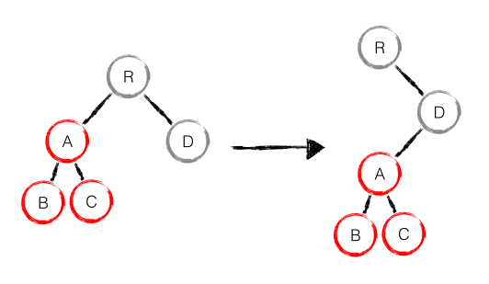

10.2 component diff
- 如果是同一类型的组件，按照原策略继续比较 virtual DOM tree
- 如果不是，则将该组件判断为dirty component,从而替换整个组件下的所有子节点
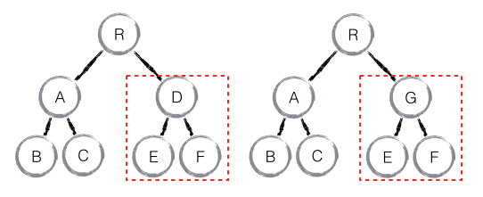

10.3 element diff
- 当节点处于同一层级时，React diff 提供了三种节点操作,分别为：INSERT(插入)、MOVE(移动)和 REMOVE(删除)
- INSERT 新的 component 类型不在老集合里， 即是全新的节点，需要对新节点执行插入操作
- MOVE 在老集合有新 component 类型，就需要做移动操作，可以复用以前的 DOM 节点
- REMOVE 老 component 不在新集合里的，也需要执行删除操作

10.4 key
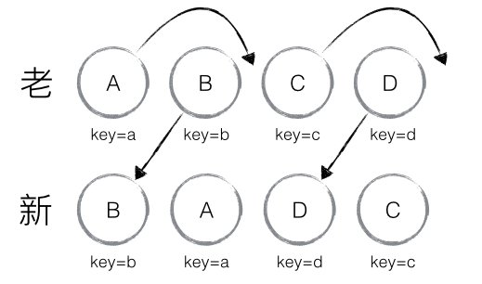
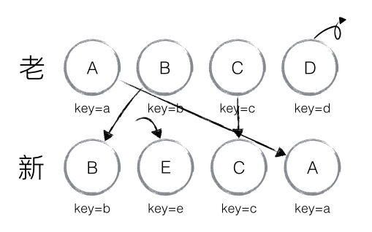
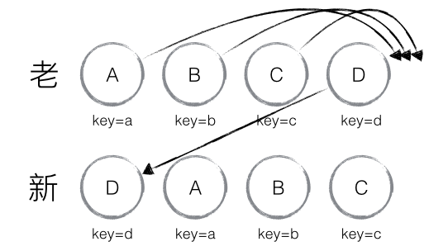

11.delegate
- delegate() 方法为指定的元素(属于被选元素的子元素)添加一个或多个事件处理程序，并规定当这些事件发生时运行的函数，使用 delegate() 方法的事件处理程序适用于当前或未来的元素(比如由脚本创建的新元素)
参数名称 | 参数含义
childSelector | 必需,规定要附加事件处理程序的一个或多个子元素
event | 必需,规定附加到元素的一个或多个事件,由空格分隔多个事件值。必须是有效的事件
data | 可选,规定传递到函数的额外数据
function | 必需,规定当事件发生时运行的函数
- delegate

undelegate

参数events还支持为事件类型附加额外的命名空间

- 当为同一元素绑定多个相同类型的事件处理函数时。使用命名空间，可以在触发事件、移除事件时限定触发或移除的范围。
var $document = $(document);//为#btn1元素绑定click事件，定义在foo和bar两个命名空间下
$document.delegate("#btn1", "click.foo.bar", function(event){
alert("click-1");
});//为#btn1元素绑定click事件，定义在test命名空间下
$document.delegate("#btn1", "click.test", function(event){
alert("click-2");
});//为#btn1元素绑定click事件，定义在test和foo两个命名空间下
$document.delegate("#btn1", "click.test.foo", function(event){
alert("click-3");
});

// 触发所有click事件
$btn1.trigger("click"); // 触发A和B (event.namespace = "")// 触发定义在foo命名空间下的click事件
$btn1.trigger("click.foo"); // 触发A (event.namespace = "foo")// 触发定义在bar命名空间下的click事件
$btn1.trigger("click.bar"); // 触发A (event.namespace = "bar")// 移除所有btn1元素定义在foo命名空间下的click事件处理函数
$btn1.undelegate( "click.foo" ); // 移除A
// $document.undelegate(".test"); // 移除click-2、click-3
// $document.undelegate(".foo"); // 移除click-1、click-3
// $document.undelegate(".foo.bar"); // 移除click-1

