1.Redux应用场景
- 在React中，数据在组件中是单向流动的
- 数据通过props从父组件流向子组件
- 两个兄弟组件之间的通信就比较麻烦
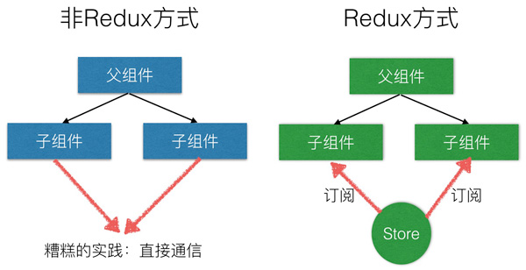

2.Redux设计思想
- Redux是将整个应用状态存储到到一个地方，称为store
- 里面保存一棵状态树state tree
- 组件可以派发dispatch action给store,而不是直接通知其它组件
- 其它组件可以通过订阅store中的状态(state)来刷新自己的视图
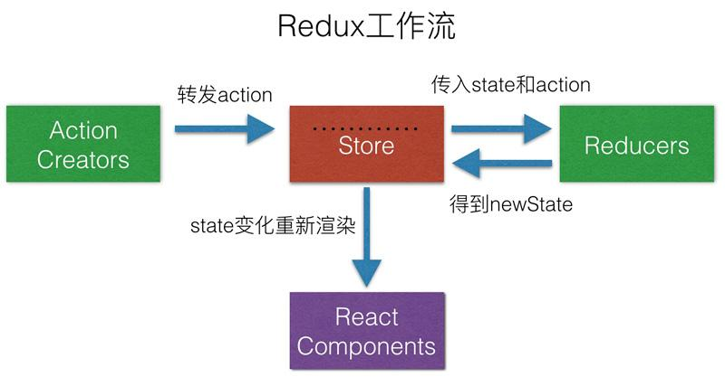

3.预备知识

3.1 redux全家桶
- redux是 JavaScript 状态容器， 提供可预测化的状态管理
- redux-logger可以打印状态变化前后的日志
- redux-thunk可以让store可以dispatch函数
- redux-promise可以让store可以派发promise
- react-redux可以实现React组件和Redux的连接，让组件自动订阅仓库中的状态变化事件，并状态发生变化的时候自动更新

3.2 Context(上下文)
- 在某些场景下，你想在整个组件树中传递数据，但却不想手动地在每一层传递属性。你可以直接在 React 中使用强大的contextAPI解决上述问题
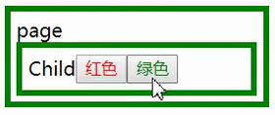
import React,{Component} from 'react';import ReactDOM from 'react-dom';let ThemeContext = React.createContext('theme');class Child extends Component {
render() {
return (
<ThemeContext.Consumer>
{
value => (
<div style={{ border: `5px solid ${value.color}`, padding: 5 }}>
Child
<button onClick={() =>value.changeColor('red')} style={{color:'red'}}>红色</button>
<button onClick={() => value.changeColor('green')} style={{color:'green'}}>绿色</button>
</div>
)
}
</ThemeContext.Consumer>
)
}
}
class Father extends Component {
constructor() {
super();
this.state = { color: 'red' };
}
changeColor = (color) => {
this.setState({ color })
}
render() {
let contextVal = {changeColor: this.changeColor,color:this.state.color };
return (
<ThemeContext.Provider value={contextVal}>
<div style={{margin:'10px', border: `5px solid ${this.state.color}`, padding: 5, width: 200 }}>
page
<Child />
</div>
</ThemeContext.Provider>

)
}
}
ReactDOM.render(<Father />, document.querySelector('#root'));

3.3 useReducer
- 接收一个形如 (state, action) => newState 的 reducer，并返回当前的 state 以及与其配套的 dispatch 方法
const [state, dispatch] = useReducer(reducer, initialArg);
import React,{useReducer} from 'react';import ReactDOM from 'react-dom';const initialState = {number:0};const INCREMENT = 'INCREMENT';const DECREMENT = 'DECREMENT';function reducer(state, action) {
switch (action.type) {
case INCREMENT:
return {number: state.number + 1};
case DECREMENT:
return {number: state.number - 1};
default:
throw new Error();
}
}function Counter(){
const [state, dispatch] = useReducer(reducer, initialState);
return (
<>
Count: {state.number}
<button onClick={() => dispatch({type: INCREMENT})}>+</button>
<button onClick={() => dispatch({type: DECREMENT})}>-</button>
</>
)
}
ReactDOM.render(<Counter />, document.querySelector('#root'));

3.4 compose
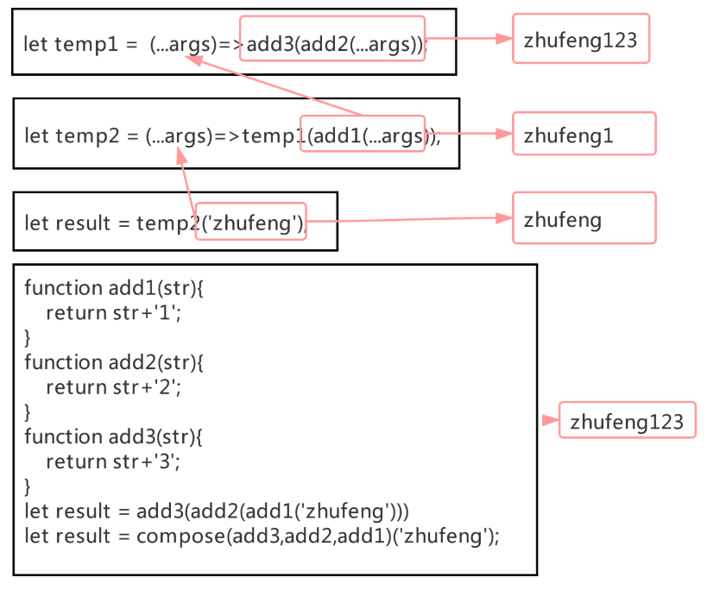
function add1(str){
return '1'+str;
}function add2(str){
return '2'+str;
}function add3(str){
return '3'+str;
}
function compose(...funcs){
return funcs.reduce((a,b)=>(...args)=>a(b(...args)));
}
let result = compose(add3,add2,add1)('zfpx');console.log(result);

4.原版redux
import React,{Component,useReducer} from 'react';import ReactDOM from 'react-dom';import {createStore} from 'redux';import {Provider,connect} from 'react-redux';const initialState = { number: 0 };const INCREMENT = "INCREMENT";const DECREMENT = "DECREMENT";function reducer(state = initialState, action) {
switch (action.type) {
case INCREMENT:
return { number: state.number + 1 };
case DECREMENT:
return { number: state.number - 1 };
default:
return state;
}
}let store = createStore(reducer);function Counter(props) {
return (
<>
<p>{props.number}</p>
<button onClick={props.add}>+</button>
</>
);
}let mapStateToProps = state => state;let mapDispatchToProps = dispatch => ({
add() {
dispatch({ type: INCREMENT });
},
minus() {
dispatch({ type: DECREMENT });
}
});let ConnectedCounter = connect(
mapStateToProps,
mapDispatchToProps
)(Counter);

ReactDOM.render(
<Provider store={store}>
<ConnectedCounter />
</Provider>,
document.querySelector("#root")
);

5.hooks版redux

5.1 index.js
import React,{Component,useReducer} from 'react';
import ReactDOM from 'react-dom';- import {createStore} from 'redux';- import {Provider,connect} from 'react-redux';+ import { createStore } from "./redux";
const initialState = { number: 0 };
const INCREMENT = "INCREMENT";
const DECREMENT = "DECREMENT";
function reducer(state = initialState, action) {
switch (action.type) {
case INCREMENT:
return { number: state.number + 1 };
case DECREMENT:
return { number: state.number - 1 };
default:
return state;
}
}- let store = createStore(reducer);+ let { store, Provider, connect } = createStore(reducer, initialState);
function Counter(props) {
return (
<>
<p>{props.number}</p>
<button onClick={props.add}>+</button>
</>
);
}
let mapStateToProps = state => state;
let mapDispatchToProps = dispatch => ({
add() {
dispatch({ type: INCREMENT });
},
minus() {
dispatch({ type: DECREMENT });
}
});
let ConnectedCounter = connect(
mapStateToProps,
mapDispatchToProps
)(Counter);

ReactDOM.render(
<Provider store={store}>
<ConnectedCounter />
</Provider>,
document.querySelector("#root")
);

5.2 index.js
src\redux\index.js
import React from "react";const Context = React.createContext();export function createStore(reducer, initialState) {
let store = {};
const Provider = props => {
const [state, dispatch] = React.useReducer(reducer, initialState);
store.getState = () => {
return state;
};
store.dispatch = dispatch;
return (
<Context.Provider value={state}>
{React.cloneElement(props.children)}
</Context.Provider>
);
};

function connect(mapStatetoProps,mapDispatchToProps) {
return function(Component) {
let state = initialState;
let actions ={};
return props => {
if (store.getState) state = mapStatetoProps(store.getState());
actions = mapDispatchToProps(store.dispatch);
return <Component {...state} {...props} dispatch={store.dispatch} {...actions}/>;
};
};
}
return { store, connect, Provider };
}

6.hooks版中间件

6.1 index.js
import React, { Component, useReducer } from "react";
import ReactDOM from "react-dom";
/* import {createStore} from 'redux';
import {Provider,connect} from 'react-redux'; */
import { createStore,applyMiddleware } from "./redux";
const initialState = { number: 0 };
const INCREMENT = "INCREMENT";
const DECREMENT = "DECREMENT";
function reducer(state = initialState, action) {
switch (action.type) {
case INCREMENT:
return { number: state.number + 1 };
case DECREMENT:
return { number: state.number - 1 };
default:
return state;
}
}+ let logger = store=>next=>action=>{+ console.log(`%c prev state`,`color: #a3a3a3; font-weight: bold`,store.getState());+ console.log(`%c action`,`color: #7fbedf; font-weight: bold`,store.getState());+ next(action);+ console.log(`%c next state`,`color: #9cd69b; font-weight: bold`,store.getState());+ }+ let thunk = store=>next=>action=>{+ if(typeof action === 'function'){+ return action(store.dispatch,store.getState);+ }+ return next(action);+ }+ let promise = store=>next=>action=>{+ if(action.then){+ return action.then(store.dispatch);+ }+ return next(action);+ }+ //let { store, Provider, connect } = createStore(reducer, initialState);+ let { store, Provider, connect } = applyMiddleware(thunk,promise,logger)(createStore)(reducer, initialState);
function Counter(props) {
return (
<>
<p>{props.number}</p>
<button onClick={props.add}>+</button>+ <button onClick={()=>store.dispatch(function(dispatch,getState){+ setTimeout(() => {+ dispatch({type:INCREMENT});+ }, 1000);+ })}>异步+1</button>+ <button onClick={()=>store.dispatch(new Promise(function(resolve,reject){+ setTimeout(() => {+ resolve({type:INCREMENT});+ }, 1000);+ }))}>Promise+1</button>+ </>+ );
}
let mapStateToProps = state => state;
let mapDispatchToProps = dispatch => ({
add() {
dispatch({ type: INCREMENT });
},
minus() {
dispatch({ type: DECREMENT });
}
});
let ConnectedCounter = connect(
mapStateToProps,
mapDispatchToProps
)(Counter);

ReactDOM.render(
<Provider store={store}>
<ConnectedCounter />
</Provider>,
document.querySelector("#root")
);

6.2 redux
import React from "react";
const Context = React.createContext();+ function compose(...funcs) {+ return funcs.reduce((a, b) => (...args) => a(b(...args)));+ }+ export function applyMiddleware(...middlewares){+ return createStore => (...args)=>{+ const { store, connect, Provider } = createStore(...args);+ let dispatch;+ const middlewareAPI= {+ getState:()=>store.getState(),+ dispatch:(...args)=>dispatch(...args)+ }+ const chain = middlewares.map(middleware=>middleware(middlewareAPI));+ dispatch = compose(...chain)((...args)=>store._dispatch(...args));+ store.dispatch = dispatch;+ return {+ store, connect, Provider+ }+ }+ }
export function createStore(reducer, initialState) {
let store = {};
const Provider = props => {
const [state, dispatch] = React.useReducer(reducer, initialState);
store.getState = () => {
return state;
};+ store._dispatch = dispatch;
return (
<Context.Provider value={state}>
{React.cloneElement(props.children)}
</Context.Provider>
);
};

function connect(mapStatetoProps,mapDispatchToProps) {
return function(Component) {
let state = initialState;
let actions ={};+ return props => {+ if (store.getState) state = mapStatetoProps(store.getState());+ actions = mapDispatchToProps(store.dispatch);+ return <Component {...state} {...props} dispatch={store.dispatch} {...actions}/>;+ };
};
}
return { store, connect, Provider };
}

