1.本课学习目标
- 学习如何获取专业权威的一手知识
- 学习如何阅读RFC标准文档
- 学习扩展的巴科斯范式(ABNF)定义的通信协议语言
- 学习HTTP协议的实现和解析细节

1.1 TCP/IP参考模型
- TCP/IP协议被称为传输控制协议/互联网协议，又称网络通讯协议
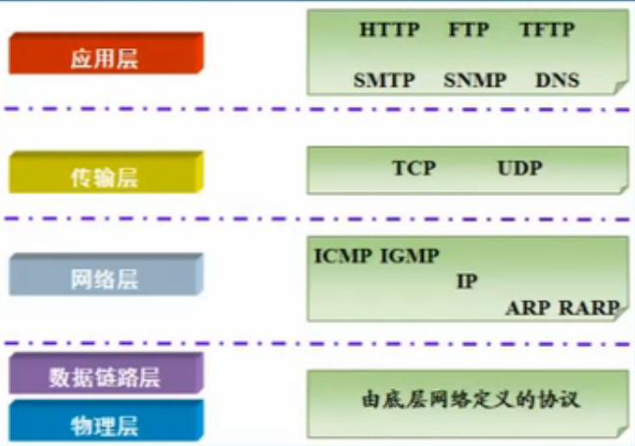

2.GET

2.1 使用

2.1.1 http-server.js
const http = require('http');const fs = require('fs');const path = require('path');const server = http.createServer(function(req,res){
if(['/get.html'].includes(req.url)){
res.writeHead(200,{'Context-type':"text-html"});
res.end(fs.readFileSync(path.join(__dirname,'static',req.url.slice(1))));
}else if(req.url === '/get'){
res.writeHead(200,{'Context-type':"text-plain"});
res.end('get');
}
});
server.listen(8080);

2.1.2 static\get.html
<!DOCTYPE html><html lang="en"><head>
<meta charset="UTF-8">
<meta name="viewport" content="width=device-width, initial-scale=1.0">
<title>get</title></head><body>
<script>
let xhr = new XMLHttpRequest();
xhr.onreadystatechange = ()=>{
console.log('onreadystatechange',xhr.readyState);
}
xhr.open("GET", "http://127.0.0.1:8080/get");
xhr.responseType="text";
xhr.setRequestHeader('name', 'zhufeng');
xhr.setRequestHeader('age', '10');
xhr.onload = () => {
console.log('readyState',xhr.readyState);
console.log('status',xhr.status);
console.log('statusText',xhr.statusText);
console.log('getAllResponseHeaders',xhr.getAllResponseHeaders());
console.log('response',xhr.response);
};
xhr.send();
</script></body></html>

2.1.3 请求响应格式
- 一个请求消息是从客户端到服务器端的,在消息首行里包含方法,资源指标符,协议版本
Request=Request-Line;
*((general-header|request-header|entity-header)CRLF)
CRLF
[message-body]

2.1.3.1 请求
GET /get HTTP/1.1
Host: 127.0.0.1:8080
Connection: keep-alive
name: zhufeng
age: 10
User-Agent: Mozilla/5.0 (Windows NT 10.0; Win64; x64) AppleWebKit/537.36 (KHTML, like Gecko) Chrome/84.0.4147.89 Safari/537.36
Accept: */*
Accept-Encoding: gzip, deflate, br
Accept-Language: zh-CN,zh;q=0.9
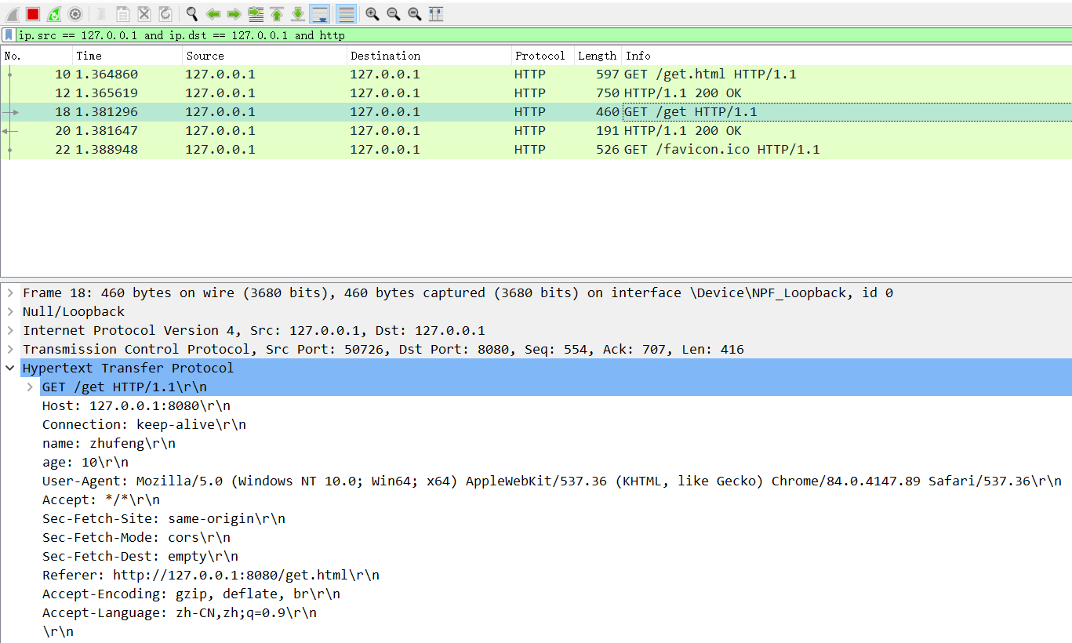

2.1.3.2 响应
Response=Status-Line;
*((general-header|response-header|entity-header)CRLF)
CRLF
[message-body]
HTTP/1.1 200 OK
Context-type: text-plainDate: Fri, 14 Aug 2020 03:58:41 GMTConnection: keep-alive
Transfer-Encoding: chunked
3get
0
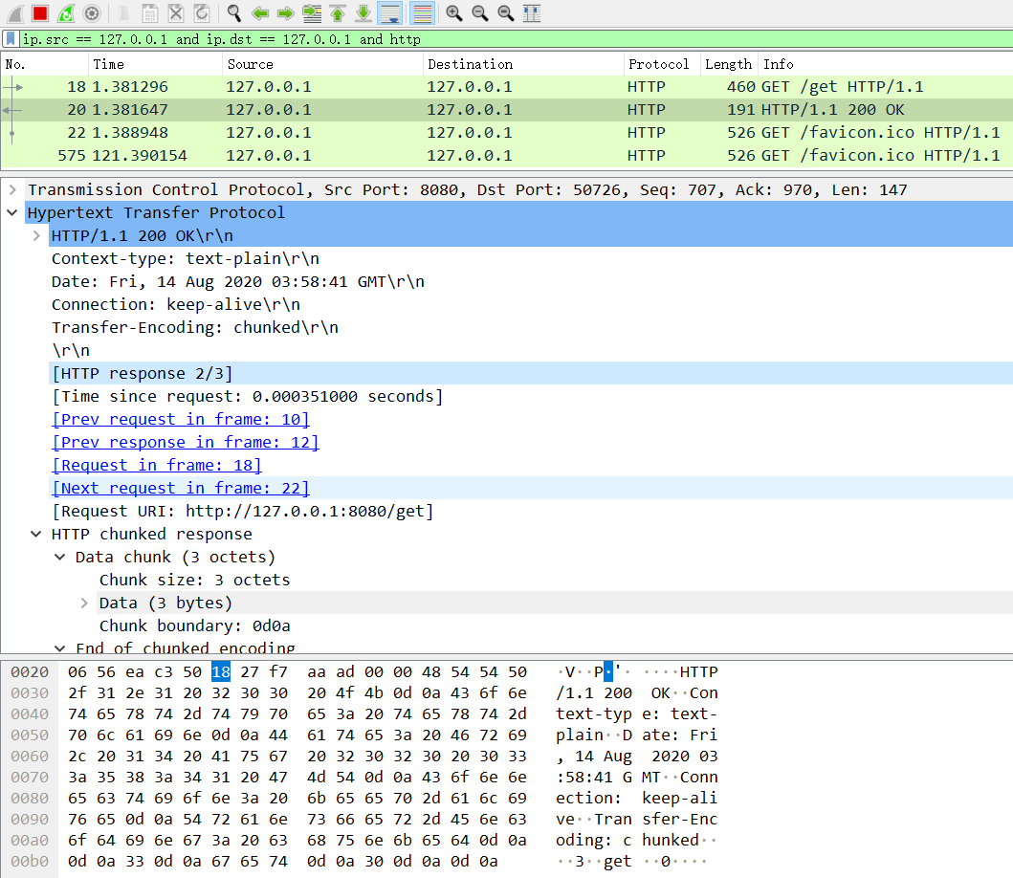

2.2 实现

2.2.1 tcp-get-client.js
- readyState
tcp-get-client.js
let net = require('net');const ReadyState = {
UNSENT:0,//（代理被创建，但尚未调用 open() 方法。
OPENED:1,//open() 方法已经被调用
HEADERS_RECEIVED:2,//send() 方法已经被调用，并且头部和状态已经可获得。
LOADING:3,//（交互）正在解析响应内容
DONE:4 //（完成）响应内容解析完成，可以在客户端调用了
}class XMLHttpRequest {
constructor(){
this.readyState = ReadyState.UNSENT;
this.headers = {};
}
open(method, url) {
this.method = method||'GET';
this.url = url;
let {hostname,port,path} = require('url').parse(url);
this.hostname = hostname;
this.port = port;
this.path = path;
this.headers.Host=`${hostname}:${port}`;
const socket = this.socket = net.createConnection({port: this.port,hostname:this.hostname},()=>{
socket.on('data', (data) => {
data = data.toString();
let [response,bodyRows] = data.split('\r\n\r\n');
let [statusLine,...headerRows] = response.split('\r\n');
let [,status,statusText] = statusLine.split(' ');
this.status = status;
this.statusText = statusText;
this.responseHeaders = headerRows.reduce((memo,row)=>{
let [key,value] = row.split(': ');
memo[key]= value;
return memo;
},{});
this.readyState = ReadyState.HEADERS_RECEIVED;
xhr.onreadystatechange&&xhr.onreadystatechange();
this.readyState = ReadyState.LOADING;
xhr.onreadystatechange&&xhr.onreadystatechange();
let [,body,] = bodyRows.split('\r\n');
this.response = this.responseText = body;
this.readyState = ReadyState.DONE;
xhr.onreadystatechange&&xhr.onreadystatechange();
this.onload&&this.onload();
});
socket.on('error', (err) => {
this.onerror&&this.onerror(err);
});
});
this.readyState = ReadyState.OPENED;
xhr.onreadystatechange&&xhr.onreadystatechange();
}
getAllResponseHeaders(){
let allResponseHeaders='';
for(let key in this.responseHeaders){
allResponseHeaders+=`${key}: ${this.responseHeaders[key]}\r\n`;
}
return allResponseHeaders;
}
setRequestHeader(header,value){
this.headers[header]= value;
}
send() {
let rows = [];
rows.push(`${this.method} ${this.path} HTTP/1.1`);
rows.push(...Object.keys(this.headers).map(key=>`${key}: ${this.headers[key]}`));
this.socket.write(rows.join('\r\n')+'\r\n\r\n');
}
}
let xhr = new XMLHttpRequest();
xhr.onreadystatechange = ()=>{
console.log('onreadystatechange',xhr.readyState);
}
xhr.open("GET", "http://127.0.0.1:8080/get");
xhr.responseType="text";
xhr.setRequestHeader('name', 'zhufeng');
xhr.setRequestHeader('age', '10');
xhr.onload = () => {
console.log('readyState',xhr.readyState);
console.log('status',xhr.status);
console.log('statusText',xhr.statusText);
console.log('getAllResponseHeaders',xhr.getAllResponseHeaders());
console.log('response',xhr.response);
};
xhr.send();

2.2.2 tcp-get-sever
tcp-get-sever.js
const net = require('net');const server = net.createServer((socket) => {
socket.on('data',(data)=>{
let request = data.toString();
let [requestLine,...headerRows] = request.split('\r\n');
let [method,path] = requestLine.split(' ');
let headers = headerRows.slice(0,-2).reduce((memo,row)=>{
let [key,value] = row.split(': ');
memo[key] = value;
return memo;
},{});
console.log('method',method);
console.log('path',path);
console.log('headers',headers);

let rows = [];
rows.push(`HTTP/1.1 200 OK`);
rows.push(`Context-type: text-plain`);
rows.push(`Date: ${new Date().toGMTString()}`);
rows.push(`Connection: keep-alive`);
rows.push(`Transfer-Encoding: chunked`);
let responseBody = 'get';
rows.push(`\r\n${Buffer.byteLength(responseBody).toString(16)}\r\n${responseBody}\r\n0`);
let response = rows.join('\r\n');
socket.end(response);
});
})
server.on('error', (err) => {
console.error(err);
});

server.listen(8080,() => {
console.log('服务器已经启动', server.address());
});

5.POST方法

5.1 实战

5.1.1 请求和响应

5.1.1.1 请求
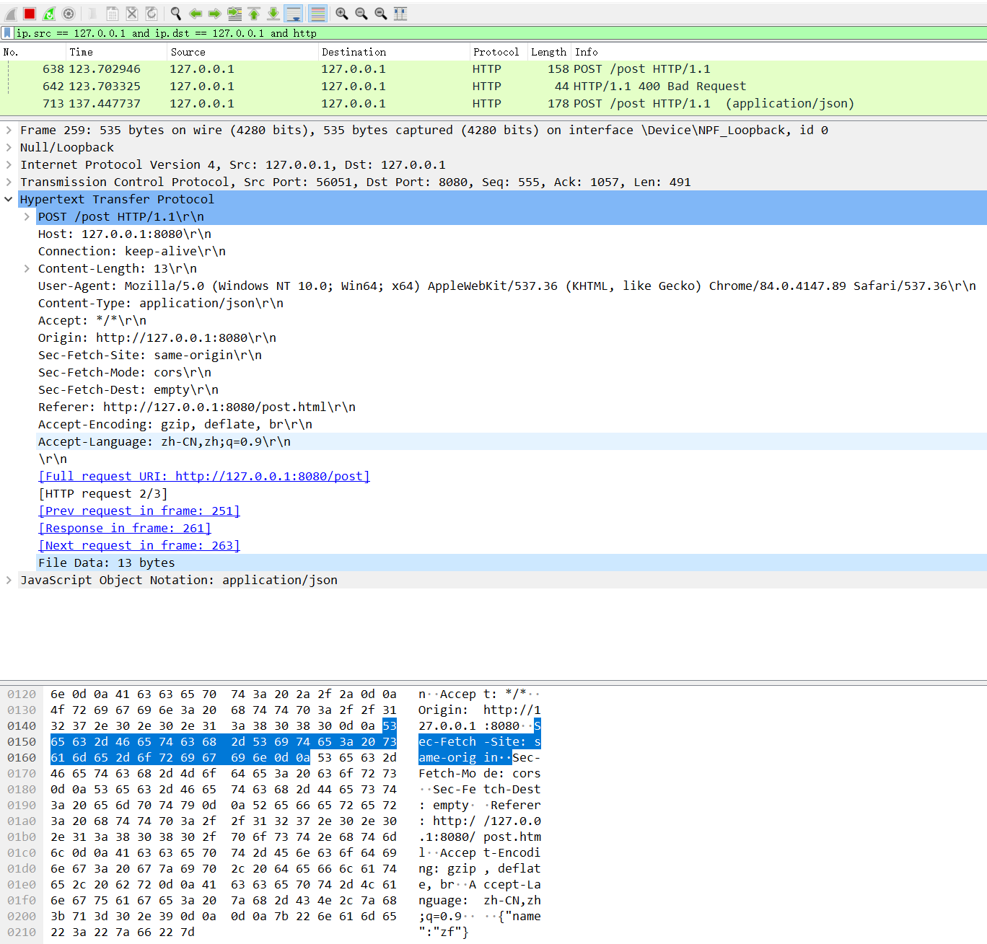

5.1.1.2 响应
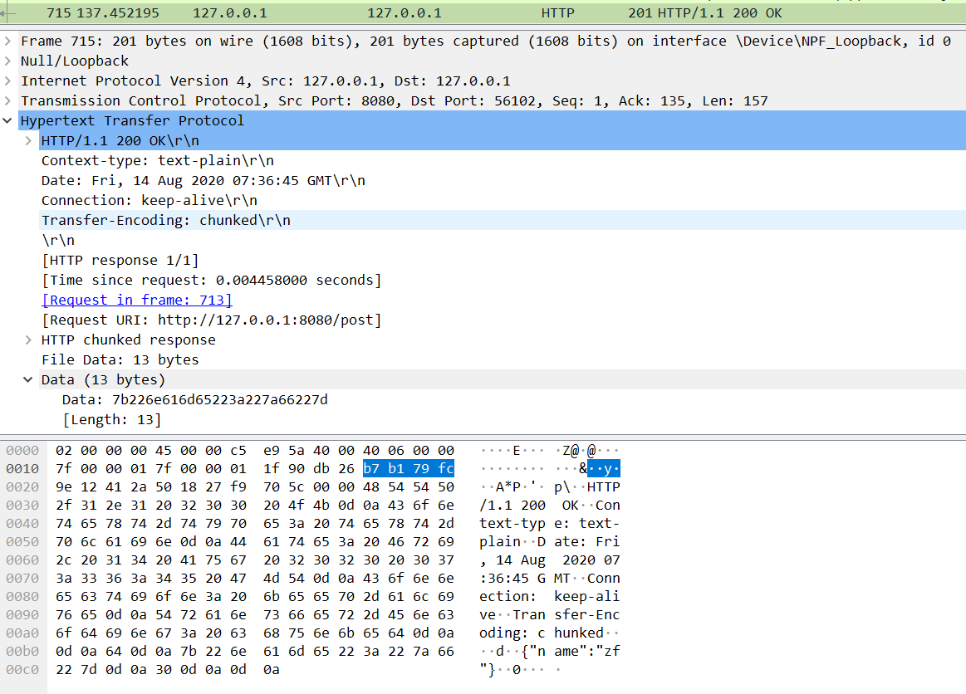

5.1.2 http-server.js
http-server.js
const http = require('http');
const fs = require('fs');
const path = require('path');
const server = http.createServer(function(req,res){+ if(['/get.html','/post.html'].includes(req.url)){
res.writeHead(200,{'Context-type':"text-html"});
res.end(fs.readFileSync(path.join(__dirname,'static',req.url.slice(1))));
}else if(req.url === '/get'){
res.writeHead(200,{'Context-type':"text-plain"});
res.end('get');+ }else if(req.url === '/post'){+ let buffers = [];+ req.on('data',(data)=>{+ buffers.push(data);+ });+ req.on('end',()=>{+ console.log('method',req.method);+ console.log('url',req.url);+ console.log('headers',req.headers);+ let body = Buffer.concat(buffers);+ console.log('body',body.toString());+ res.statusCode = 200;+ res.setHeader('Context-type',"text-plain");+ res.write(body);+ res.end();+ });
}
});
server.listen(8080);

5.1.3 static\post.html
static\post.html
<!DOCTYPE html>
<html lang="en">
<head>
<meta charset="UTF-8">
<meta name="viewport" content="width=device-width, initial-scale=1.0">
<title>get</title>
</head>
<body>
<script>
let xhr = new XMLHttpRequest();
xhr.onreadystatechange = ()=>{
console.log('onreadystatechange',xhr.readyState);
}+ xhr.open("POST", "http://127.0.0.1:8080/post");
xhr.responseType="text";+ xhr.setRequestHeader('Content-Type','application/json');
xhr.onload = () => {
console.log('readyState',xhr.readyState);
console.log('status',xhr.status);
console.log('statusText',xhr.statusText);
console.log('getAllResponseHeaders',xhr.getAllResponseHeaders());
console.log('response',xhr.response);
};+ xhr.send(JSON.stringify({name:'zhufeng',age:10}));
</script>
</body>
</html>

5.2 实现

5.2.1 tcp-post-client.js
tcp-post-client.js
let net = require('net');
const ReadyState = {
UNSENT:0,//（代理被创建，但尚未调用 open() 方法。
OPENED:1,//open() 方法已经被调用
HEADERS_RECEIVED:2,//send() 方法已经被调用，并且头部和状态已经可获得。
LOADING:3,//（交互）正在解析响应内容
DONE:4 //（完成）响应内容解析完成，可以在客户端调用了
}
class XMLHttpRequest {
constructor(){
this.readyState = ReadyState.UNSENT;
this.headers = {};
}
open(method, url) {
this.method = method||'GET';
this.url = url;
let {hostname,port,path} = require('url').parse(url);
this.hostname = hostname;
this.port = port;
this.path = path;
this.headers.Host=`${hostname}:${port}`;+ this.headers.Connection=`keep-alive`;
const socket = this.socket = net.createConnection({port: this.port,hostname:this.hostname},()=>{
socket.on('data', (data) => {
data = data.toString();
console.log(data);
let [response,bodyRows] = data.split('\r\n\r\n');
let [statusLine,...headerRows] = response.split('\r\n');
let [,status,statusText] = statusLine.split(' ');
this.status = status;
this.statusText = statusText;
this.responseHeaders = headerRows.reduce((memo,row)=>{
let [key,value] = row.split(': ');
memo[key]= value;
return memo;
},{});
this.readyState = ReadyState.HEADERS_RECEIVED;
xhr.onreadystatechange&&xhr.onreadystatechange();
this.readyState = ReadyState.LOADING;
xhr.onreadystatechange&&xhr.onreadystatechange();
let [,body,] = bodyRows.split('\r\n');
this.response = this.responseText = body;
this.readyState = ReadyState.DONE;
xhr.onreadystatechange&&xhr.onreadystatechange();
this.onload&&this.onload();
});
socket.on('error', (err) => {
this.onerror&&this.onerror(err);
});
});
this.readyState = ReadyState.OPENED;
xhr.onreadystatechange&&xhr.onreadystatechange();
}
getAllResponseHeaders(){
let allResponseHeaders='';
for(let key in this.responseHeaders){
allResponseHeaders+=`${key}: ${this.responseHeaders[key]}\r\n`;
}
return allResponseHeaders;
}
setRequestHeader(header,value){
this.headers[header]= value;
}
send(body) {
let rows = [];
rows.push(`${this.method} ${this.path} HTTP/1.1`);+ this.headers["Content-Length"]=Buffer.byteLength(body);
rows.push(...Object.keys(this.headers).map(key=>`${key}: ${this.headers[key]}`));+ let request = rows.join('\r\n')+'\r\n\r\n'+body;
console.log(request);
this.socket.write(request);
}
}

let xhr = new XMLHttpRequest();
xhr.onreadystatechange = ()=>{
console.log('onreadystatechange',xhr.readyState);
}
xhr.open("POST", "http://127.0.0.1:8080/post");
xhr.responseType="text";
xhr.setRequestHeader('Content-Type','application/json');
xhr.onload = () => {
console.log('readyState',xhr.readyState);
console.log('status',xhr.status);
console.log('statusText',xhr.statusText);
console.log('getAllResponseHeaders',xhr.getAllResponseHeaders());
console.log('response',xhr.response);
};
xhr.send(`{"name":"zf"}`);

5.2.2 tcp-post-server.js
const net = require('net');
const Parer = require('./Parser');
const server = net.createServer((socket) => {
socket.on('data',(data)=>{+ let parser = new Parer();+ let {method,url,headers,body} = parser.parse(data);+ console.log('method',method);+ console.log('url',url);+ console.log('headers',headers);+ console.log('body',body);
let rows = [];
rows.push(`HTTP/1.1 200 OK`);
rows.push(`Context-type: text-plain`);
rows.push(`Date: ${new Date().toGMTString()}`);
rows.push(`Connection: keep-alive`);
rows.push(`Transfer-Encoding: chunked`);
rows.push(`\r\n${Buffer.byteLength(body).toString(16)}\r\n${body}\r\n0`);
let response = rows.join('\r\n');
socket.end(response);
});
})
server.on('error', (err) => {
console.error(err);
});

server.listen(8080,() => {
console.log('服务器已经启动', server.address());
});

5.2.3 Parser.js
let LF = 10,//换行 line feed
CR = 13,//回车 carriage return
SPACE = 32,//空格
COLON = 58;//冒号let PARSER_UNINITIALIZED=0,//未解析
START=1,//开始解析
REQUEST_LINE=2,
HEADER_FIELD_START=3,
HEADER_FIELD=4,
HEADER_VALUE_START=5,
HEADER_VALUE=6,
READING_BODY=7;class Parser {
constructor(){
this.state = PARSER_UNINITIALIZED;
}
parse(buffer) {
let self =this,
requestLine='',
headers = {},
body='',
i=0,
char,
state = START,//开始解析
headerField='',
headerValue='';
console.log(buffer.toString());
for (i = 0; i < buffer.length; i++) {
char = buffer[i];
switch (state) {
case START:
state = REQUEST_LINE;
self['requestLineMark']=i;
case REQUEST_LINE:
if (char == CR) {//换行
requestLine=buffer.toString('utf8', self['requestLineMark'], i);
break;
}else if(char == LF){//回车
state = HEADER_FIELD_START;
}
break;
case HEADER_FIELD_START:
if(char === CR){
state = READING_BODY;
self['bodyMark'] = i+2;
break;
}else{
state = HEADER_FIELD;
self['headerFieldMark'] = i;
}
case HEADER_FIELD:
if (char == COLON) {
headerField=buffer.toString('utf8', self['headerFieldMark'], i);
state = HEADER_VALUE_START;
}
break;
case HEADER_VALUE_START:
if (char == SPACE) {
break;
}
self['headerValueMark'] = i;
state = HEADER_VALUE;
case HEADER_VALUE:
if (char === CR) {
headerValue=buffer.toString('utf8', self['headerValueMark'], i);
headers[headerField] = headerValue;
headerField = '';
headerValue = '';
}else if(char === LF){
state = HEADER_FIELD_START;
}
break;
default:
break;
}
}
let [method,url] =requestLine.split(' ');
body=buffer.toString('utf8', self['bodyMark'], i);
return {method,url,headers,body};
}
}module.exports = Parser;

6.文件上传

6.1 实战

6.1.1 请求和响应

6.1.1.1 请求
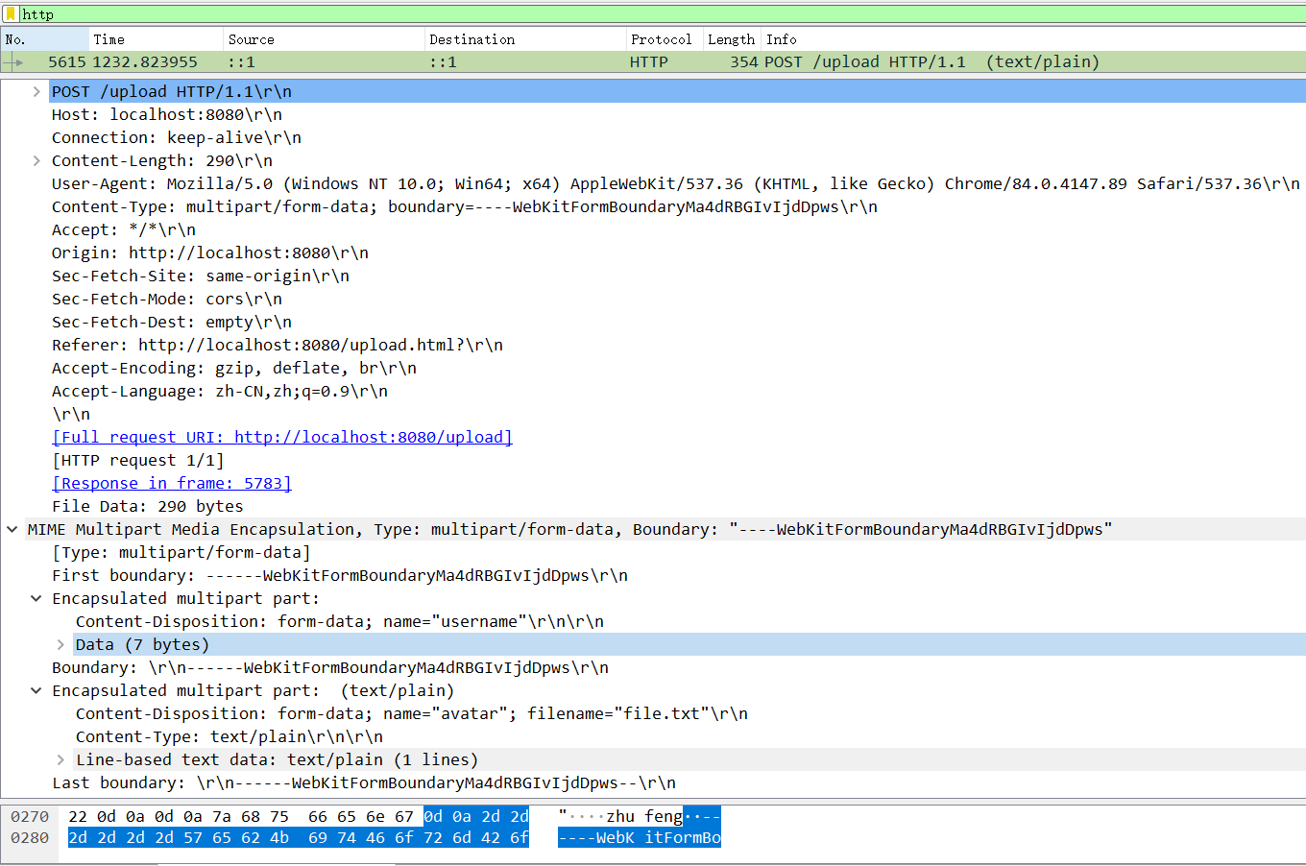

6.1.1.2 响应
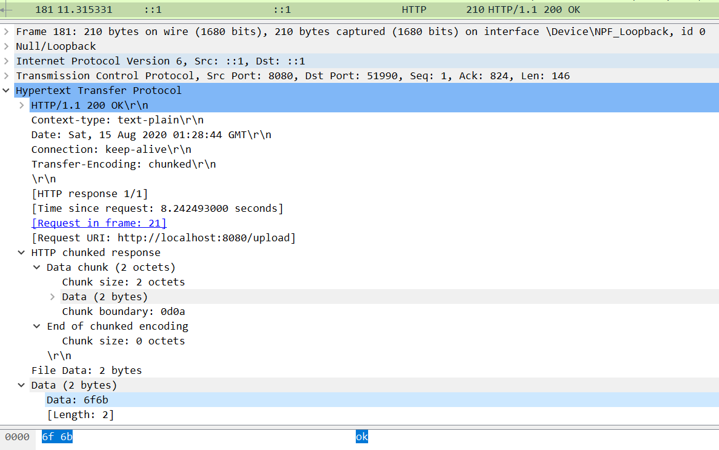

6.1.2 http-server.js
const http = require('http');
const fs = require('fs');
const path = require('path');
const formidable = require('formidable');
const url = require('url');
const server = http.createServer(function(req,res){
const {pathname} = url.parse(req.url);
if(['/get.html','/post.html','/upload.html'].includes(pathname)){
res.writeHead(200,{'Context-type':"text-html"});
res.end(fs.readFileSync(path.join(__dirname,'static',pathname.slice(1))));
}else if(pathname === '/get'){
res.writeHead(200,{'Context-type':"text-plain"});
res.end('get');
}else if(pathname === '/post'){
let buffers = [];
req.on('data',(data)=>{
buffers.push(data);
});
req.on('end',()=>{
console.log('method',req.method);
console.log('url',req.url);
console.log('headers',req.headers);
let body = Buffer.concat(buffers);
console.log('body',body.toString());
res.statusCode = 200;
res.setHeader('Context-type',"text-plain");
res.write(body);
res.end();
});
}else if(req.url === '/upload'){+ const form = formidable();+ form.parse(req, (err, fields, files) => {+ console.log('fields',fields);+ console.log('files',files);+ let avatar = files.avatar;+ let filePath = path.join(__dirname,'static',avatar.name);+ fs.writeFileSync(filePath,fs.readFileSync(avatar.path));+ res.statusCode = 200;+ res.setHeader('Context-type',"text-plain");+ res.write(JSON.stringify({...fields,avatar:filePath}));+ res.end();+ });
}else{
res.statusCode = 404;
res.end();
}
});
server.listen(8080);

6.1.3 static\upload.html
static\upload.html
<!DOCTYPE html><html lang="en"><head>
<meta charset="UTF-8">
<meta name="viewport" content="width=device-width, initial-scale=1.0">
<title>get</title></head><body>
<form onsubmit="upload(event)">
<input type="text" id="username"/>
<input type="file" id="file"/>
<input type="submit"/>
</form>
<script>
function upload(event){
event.preventDefault();
let username= document.getElementById('username').value;
let file= document.getElementById('file').files[0];
let xhr = new XMLHttpRequest();
xhr.open("POST", "http://localhost:8080/upload");
var formData=new FormData();
formData.append("username",username);
formData.append("file",file);
xhr.responseType="text";
xhr.onload = () => {
console.log(xhr.response);
};
xhr.send(formData);
}
</script></body></html>

6.1.4 tcp-upload-client.js
tcp-upload-client.js
let net = require('net');
let fs = require('fs');
let path = require('path');
const ReadyState = {
UNSENT:0,//（代理被创建，但尚未调用 open() 方法。
OPENED:1,//open() 方法已经被调用
HEADERS_RECEIVED:2,//send() 方法已经被调用，并且头部和状态已经可获得。
LOADING:3,//（交互）正在解析响应内容
DONE:4 //（完成）响应内容解析完成，可以在客户端调用了
}
class XMLHttpRequest {
constructor(){
this.readyState = ReadyState.UNSENT;
this.headers = {};
}
open(method, url) {
this.method = method||'GET';
this.url = url;
let {hostname,port,path} = require('url').parse(url);
this.hostname = hostname;
this.port = port;
this.path = path;
this.headers.Host=`${hostname}:${port}`;
this.headers.Connection=`keep-alive`;
const socket = this.socket = net.createConnection({port: this.port,hostname:this.hostname},()=>{
socket.on('data', (data) => {
data = data.toString();
console.log(data);
let [response,bodyRows] = data.split('\r\n\r\n');
let [statusLine,...headerRows] = response.split('\r\n');
let [,status,statusText] = statusLine.split(' ');
this.status = status;
this.statusText = statusText;
this.responseHeaders = headerRows.reduce((memo,row)=>{
let [key,value] = row.split(': ');
memo[key]= value;
return memo;
},{});
this.readyState = ReadyState.HEADERS_RECEIVED;
xhr.onreadystatechange&&xhr.onreadystatechange();
this.readyState = ReadyState.LOADING;
xhr.onreadystatechange&&xhr.onreadystatechange();
let [,body,] = bodyRows.split('\r\n');
this.response = this.responseText = body;
this.readyState = ReadyState.DONE;
xhr.onreadystatechange&&xhr.onreadystatechange();
this.onload&&this.onload();
});
socket.on('error', (err) => {
this.onerror&&this.onerror(err);
});
});
this.readyState = ReadyState.OPENED;
xhr.onreadystatechange&&xhr.onreadystatechange();
}
getAllResponseHeaders(){
let allResponseHeaders='';
for(let key in this.responseHeaders){
allResponseHeaders+=`${key}: ${this.responseHeaders[key]}\r\n`;
}
return allResponseHeaders;
}
setRequestHeader(header,value){
this.headers[header]= value;
}+ send(formData) {+ let rows = [];+ let boundary = '----WebKitFormBoundaryF5odcsAPqFAB2mkm';+ this.headers['Content-Type']= `multipart/form-data; boundary=${boundary}`;+ let parts = [];+ for(let key in formData){+ let value = formData[key];+ if(typeof value === 'string'){+ let rows = [];+ rows.push(`Content-Disposition: form-data; name="${key}"\r\n`);+ rows.push(value);+ parts.push(rows.join('\r\n'));+ }else{+ let rows = [];+ rows.push(`Content-Disposition: form-data; name="${value.name}"; filename="${value.filename}"`);+ rows.push(`Content-Type: ${value.contentType}\r\n`);+ rows.push(value.content);+ parts.push(rows.join('\r\n'));+ }+ }+ let body = parts.join('\r\n'+'--'+boundary+'\r\n');+ body = '--'+boundary+'\r\n'+body+'\r\n--'+boundary+'--';+ this.headers["Content-Length"]=Buffer.byteLength(body);+ rows.push(`${this.method} ${this.path} HTTP/1.1`);+ rows.push(...Object.keys(this.headers).map(key=>`${key}: ${this.headers[key]}`));+ let request = rows.join('\r\n');+ request += '\r\n\r\n';+ let buffers = [Buffer.from(request)];+ buffers.push(Buffer.from(body));+ this.socket.write(Buffer.concat(buffers));
}
}+class FormData{+ append(key,value){+ this[key]=value;+ }+}
let xhr = new XMLHttpRequest();
xhr.onreadystatechange = ()=>{
console.log('onreadystatechange',xhr.readyState);
}+xhr.open("POST", "http://127.0.0.1:8080/upload");
xhr.responseType="text";+let formData=new FormData();+formData.append("username",'zhufeng');+let file = fs.readFileSync(path.join(__dirname,'file.txt'));+formData.append("avatar",{name:'file',filename:'file.txt',contentType:'text/plain',content:file});
xhr.onload = () => {
console.log('readyState',xhr.readyState);
console.log('status',xhr.status);
console.log('statusText',xhr.statusText);
console.log('getAllResponseHeaders',xhr.getAllResponseHeaders());
console.log('response',xhr.response);
};+xhr.send(formData);

6.1.5 tcp-upload-server.js
tcp-upload-server.js
const net = require('net');
const path = require('path');
const fs = require('fs');
const Parer = require('./Parser');
const server = net.createServer((socket) => {
socket.on('data',(data)=>{
let parser = new Parer();
let {method,url,headers,body} = parser.parse(data);
console.log('method',method);
console.log('url',url);
console.log('headers',headers);
console.log('body',body);+ let [,boundary] = headers['Content-Type'].match(/boundary=([^;]+)/i);+ let parts = body.split('--'+boundary).slice(1,-1);+ parts= parts.map(item=>item.slice(2,-2));+ let fields = {};+ let files = {};+ for(let i=0;i<parts.length;i++){+ let part = parts[i];+ let rows = part.split('\r\n');+ if(rows.length==3){+ let [key,,value] = rows;+ let [,name] = key.toString().match(/name="([^"]+?)"/);+ fields[name]= value.toString();+ }else if(rows.length==4){+ let [key,type,,value] = rows;+ let [,name,filename] = key.toString().match(/name="([^"]+?)"; filename="([^"]+?)"/);+ let filePath = path.join(__dirname,'static',filename);+ fs.writeFileSync(filePath,value);+ files[name]={name,filename,path:filePath};+ }+ }+ console.log(fields);+ console.log(files);
let rows = [];
rows.push(`HTTP/1.1 200 OK`);
rows.push(`Context-type: text-plain`);
rows.push(`Date: ${new Date().toGMTString()}`);
rows.push(`Connection: keep-alive`);
rows.push(`Transfer-Encoding: chunked`);+ let responseBody = JSON.stringify({...fields,...files});+ rows.push(`\r\n${Buffer.byteLength(responseBody).toString(16)}\r\n${responseBody}\r\n0`);
let response = rows.join('\r\n');
socket.end(response);
});
})
server.on('error', (err) => {
console.error(err);
});

server.listen(8080,() => {
console.log('服务器已经启动', server.address());
});
Powered by idoc. De

