## **1.项目仓库**

* 前端技术栈为 React + craco
* 后端技术栈为 MySQL + eggjs
* [cicd-frontend](https://gitee.com/zhufengpeixun/cicd-frontend)
* [cicd-backend](https://gitee.com/zhufengpeixun/cicd-backend)

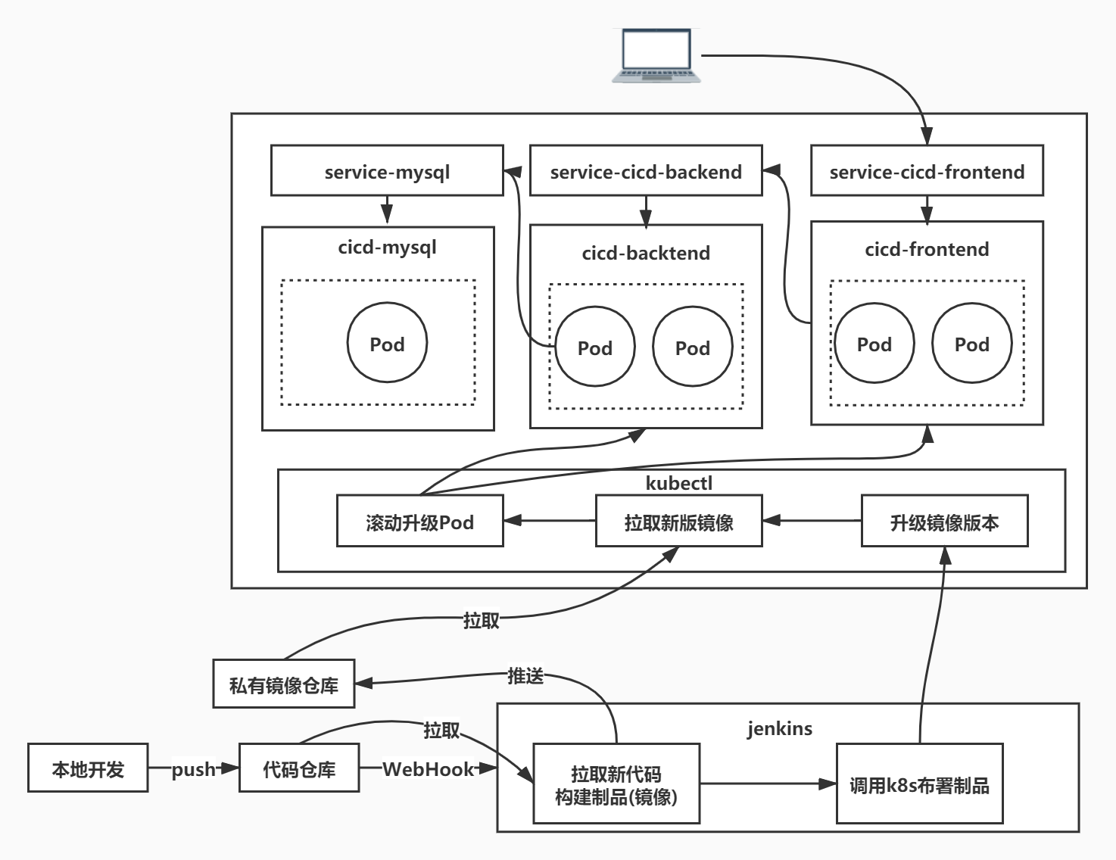

## **2.添加一个节点**

* 增加一个node2的节点

## **2 布署MSYQL**

### **2.1 设置污点**

* Node2节点机器只用于部署MySQL服务
* 可以给节点加污点，只用来布署MySQL服务
* node1增加webserver的污点
* node2增加mysql的污点

kubectl taint nodes node1 webserver:NoSchedule

kubectl taint nodes node2 mysql=true:NoSchedule

### **2.2 创建数据目录**

* 在本地创建MYSQL数据文件夹然后挂载进MySQL容器
* 以方便MySQL 数据可以持久化
* 在node2上创建mysql数据文件夹
* 此文件夹要为空，不然启动MYSQL会失败

mkdir /**var**/lib/mysql

* 将root密码存入 secret 内保存

kubectl create secret generic mysql-auth --**from**-literal=username=root --**from**-literal=password=root

vi deployment-cicd-mysql.yaml

apiVersion: apps/v1kind: Deploymentmetadata:

name: cicd-mysqlspec:

replicas: 1

selector:

matchLabels:

app: cicd-mysql

template:

metadata:

labels:

app: cicd-mysql

spec:

tolerations:

- key: "mysql"

operator: "Equal"

value: "true"

effect: "NoSchedule"

containers:

- name: cicd-mysql

image: mysql:5.7

imagePullPolicy: IfNotPresent

args:

- "--ignore-db-dir=lost+found"

ports:

- containerPort: 3306

volumeMounts:

- name: mysql-data

mountPath: "/var/lib/mysql"

env:

- name: MYSQL_ROOT_PASSWORD

valueFrom:

secretKeyRef:

name: mysql-auth

key: password

volumes:

- name: mysql-data

hostPath:

path: /var/lib/mysql

type: Directory

[root@master project]# kubectl apply -f deployment-cicd-mysql.yaml

deployment.apps/cicd-mysql created

//查看容器内的日志 方便查看报错

kubectl get pods

kubectl describe pods cicd-mysql-bcb77c759-bdrd8

kubectl logs cicd-mysql-6cbd4f95-g64hh

vi service-cicd-mysql.yaml

apiVersion: v1kind: Servicemetadata:

name: service-cicd-mysqlspec:

selector:

app: cicd-mysql

ports:

- protocol: TCP

port: 3306

targetPort: 3306

type: NodePort

让配置文件生效

kubectl apply -f service-cicd-mysql.yaml

连接数据库初始化数据

* -h 为任意节点的公网或内网IP

mysql -h172.31.178.169 -P32636 -uroot -proot

mysql -h118.190.156.138 -P32636 -uroot -proot

**create** **database** cicd;**use** cicd;**CREATE** **TABLE** `users` (

`id` int(11) **NOT** NULL AUTO_INCREMENT **COMMENT** 'ID',

`name` varchar(255) **NOT** NULL **COMMENT** '姓名',

`age` int(11) **NOT** NULL **COMMENT** '年龄',

`sex` varchar(255) **NOT** NULL **COMMENT** '性别；1男 2女',

PRIMARY **KEY** (`id`)

) **ENGINE**=**InnoDB** AUTO_INCREMENT=9 **DEFAULT** **CHARSET**=utf8;

## **3 布署后端**

### **3.1 新建jenkins项目**

* cicd-backend
* 设置git源码地址
* 配置git私钥
* 配置DOCKER_LOGIN_USERNAME和DOCKER_LOGIN_PASSWORD

### **3.2 添加构建布署**

#!/bin/bash

time=$(date "+%Y%m%d%H%M%S")

npm install --registry=https://registry.npm.taobao.org

docker build -t 115.28.139.92:8082/cicd-backend:$time .

docker login -u $DOCKER_LOGIN_USERNAME -p $DOCKER_LOGIN_PASSWORD 115.28.139.92:8082

docker push 115.28.139.92:8082/cicd-backend:$time

### **3.3 配置信息**

#### **3.3.1 数据库地址**

vi mysql.config.yaml

apiVersion: v1kind: ConfigMapmetadata:

name: mysql-configdata:

host: "service-cicd-mysql"

port: "3306"

database: "cicd"

kubectl apply -f mysql.config.yaml

#### **3.3.2 数据库账号**

vi mysql-auth.yaml

apiVersion: v1kind: Secretmetadata:

name: mysql-authstringData:

username: root

password: roottype: Opaque

kubectl apply -f mysql.config.yaml

#### **3.3.3 私有仓库认证**

kubectl create secret docker-registry private-registry \

--docker-username=admin \

--docker-password=admin123 \

--docker-email=admin@example.org \

--docker-server=115.28.139.92:8082

#### **3.3.4 后台Deployment**

vi cicd-backend.yaml

apiVersion: apps/v1kind: Deploymentmetadata:

name: cicd-backendspec:

selector:

matchLabels:

app: cicd-backend

replicas: 1

template:

metadata:

labels:

app: cicd-backend

spec:

imagePullSecrets:

- name: private-registry

containers:

- name: cicd-backend

imagePullPolicy: Always

image: "115.28.139.92:8082/cicd-backend:20210321202052"

ports:

- containerPort: 7001

env:

- name: MYSQL_HOST

valueFrom:

configMapKeyRef:

name: mysql-config

key: host

- name: MYSQL_PORT

valueFrom:

configMapKeyRef:

name: mysql-config

key: port

- name: MYSQL_DATABASE

valueFrom:

configMapKeyRef:

name: mysql-config

key: database

- name: MYSQL_USER

valueFrom:

secretKeyRef:

name: mysql-auth

key: username

- name: MYSQL_PASSWORD

valueFrom:

secretKeyRef:

name: mysql-auth

key: password

kubectl apply -f cicd-backend.yaml

#### **3.3.5 后台Service**

* vi service-cicd-backend.yaml

apiVersion: v1kind: Servicemetadata:

name: service-cicd-backendspec:

selector:

app: cicd-backend

ports:

- protocol: TCP

port: 7001

targetPort: 7001

type: NodePort

kubectl apply -f service-cicd-backend.yaml

curl http://172.31.178.169:31300/user/list

## **4 布署前端**

### **4.1 安装编译器**

yum -y install gcc gcc-c++ kernel-devel

### **4.1 新建jenkins项目**

* cicd-frontend
* 设置git源码地址
* 配置git私钥
* 配置DOCKER_LOGIN_USERNAME和DOCKER_LOGIN_PASSWORD

### **4.1 配置构建步骤**

#!/bin/sh -l

time=$(date "+%Y%m%d%H%M%S")

npm install --registry=https://registry.npm.taobao.org

npm run build

docker build -t 115.28.139.92:8082/cicd-frontend:$time .

docker login -u $DOCKER_LOGIN_USERNAME -p $DOCKER_LOGIN_PASSWORD 115.28.139.92:8082

docker push 115.28.139.92:8082/cicd-frontend:$time

### **4.2 配置构建步骤**

vi cicd-frontend.yaml

apiVersion: apps/v1kind: Deploymentmetadata:

name: cicd-frontendspec:

selector:

matchLabels:

app: cicd-frontend

replicas: 1

template:

metadata:

labels:

app: cicd-frontend

spec:

imagePullSecrets:

- name: private-registry

containers:

- name: cicd-frontend

image: 115.28.139.92:8082/cicd-frontend:20210321204724

kubectl apply -f cicd-frontend.yaml

vi service-cicd-frontend.yaml

apiVersion: v1kind: Servicemetadata:

name: service-cicd-frontendspec:

selector:

app: cicd-frontend

ports:

- protocol: TCP

port: 80

targetPort: 80

type: NodePort

kubectl apply -f service-cicd-frontend.yaml

kubectl **get** svc

http://118.190.156.138:31753/

## **5.集成jenkins**

### **5.1 添加全局配置文件**

* 系统管理=>Managed files=>Add a new Config=>Custom file
* Name设置为k8s-config
* 把master上的~/.kube/config拷贝到Content中

### **5.2 安装kubectl**

cat <<EOF > /etc/yum.repos.d/kubernetes.repo

[kubernetes]

name=Kubernetes

baseurl=http://mirrors.aliyun.com/kubernetes/yum/repos/kubernetes-el7-x86_64

enabled=1

gpgcheck=0

repo_gpgcheck=0

gpgkey=http://mirrors.aliyun.com/kubernetes/yum/doc/yum-key.gpg

http://mirrors.aliyun.com/kubernetes/yum/doc/rpm-package-key.gpg

EOF

yum install -y kubectl

### **5.3 绑定配置文件**

* 打开项目配置
* 选择绑定=>Provide Configuration files=>Target选择k8s-config=>Target输入k8s-config.yaml

### **5.4 shell**

* 使用 kubectl set image 命令快速设置镜像地址版本
* 格式为：kubectl set image deployment/[deployment名称] [容器名称]=[镜像版本]

#!/bin/bash

time=$(date "+%Y%m%d%H%M%S")

npm install --registry=https://registry.npm.taobao.org

docker build -t 115.28.139.92:8082/cicd-backend:$time .

docker login -u $DOCKER_LOGIN_USERNAME -p $DOCKER_LOGIN_PASSWORD 115.28.139.92:8082

docker push 115.28.139.92:8082/cicd-backend:$time+kubectl --kubeconfig=k8s-config.yaml set image deployment/cicd-backend cicd-backend=115.28.139.92:8082/cicd-backend:$time

deployment.apps/cicd-backend image updated表示更新成功

## **6.推送触发构建**

### **6.1 安装插件**

* publish over ssh(方便操作远程的服务器)
* gitee
* Last Changes(可视化查看git文件变化)

### **6.2 构建触发器**

* Gitee webhook触发构建,并记录webhook URL地址
* 生成 Gitee WebHook 密码

## **6.3 配置WebHooks [#](https://zhufeng-document.vercel.app/html/125.16.k8s.html" \l "t276.3 %E9%85%8D%E7%BD%AEWebHooks)**

* 打开项目的WebHooks管理页面
* 配置webhookURL和WebHook 密码

## **6.参考**

* 强行删除pod

kubectl **delete** pod cicd-mysql-84795bc9d7-fpjmp --force --grace-period=0