## **1.生成项目**

npx create-react-app zaxios --typescript

cd create-react-app

yarn add axios @types/axios qs @types/qs parse-headers

yarn add express body-parser

yarn start

## **2. get请求**

* [axios](https://github.com/axios/axios)

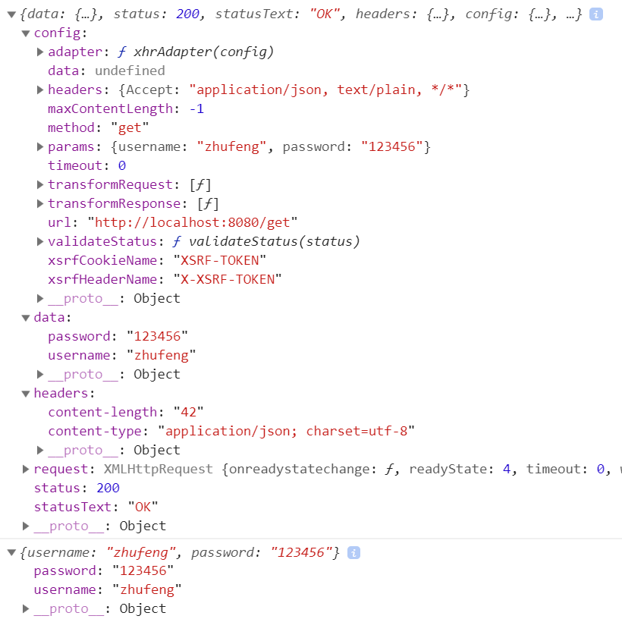

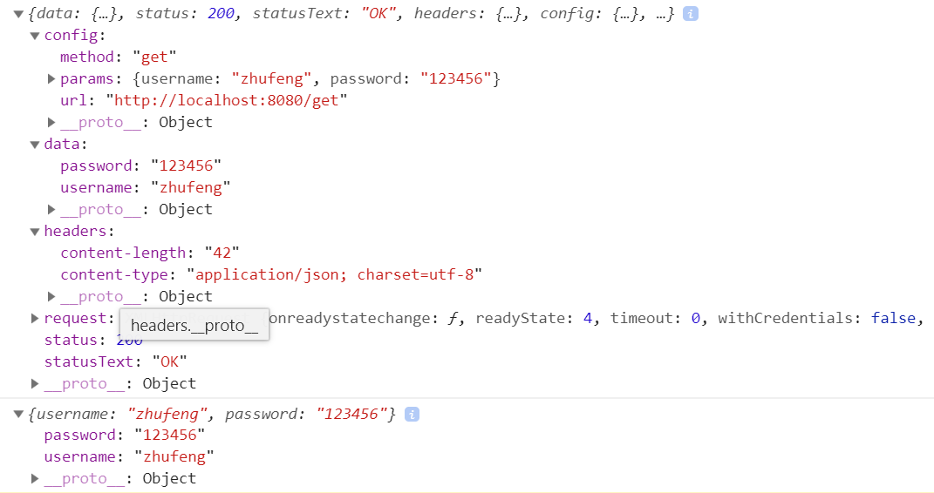

### **2.1 src\index.tsx**

src\index.tsx

import axios, { AxiosResponse } from './axios';

const baseURL = 'http://localhost:8080';

export interface User {

username: string;

password: string;

}

let user: User = {

username: 'zhufeng',

password: '123456'

};

axios({

method: 'get',

url: baseURL + '/get',

params: user

}).then((response: AxiosResponse) => {

console.log(response);

return response.data;

}).then((data: User) => {

console.log(data);

}).catch(function (error: any) {

console.log(error);

});

### **2.2 axios\index.tsx**

src\axios\index.tsx

import Axios from './Axios';

import { AxiosInstance } from './types';

function createInstance(): AxiosInstance {

let context = new Axios();

let instance = Axios.prototype.request.bind(context);

instance = Object.assign(instance, Axios.prototype, context);

return instance as AxiosInstance;

}

var axios = createInstance();

export default axios;

export * from './types';

### **2.2 axios\Axios.tsx**

src\axios\Axios.tsx

import { AxiosRequestConfig, AxiosResponse } from './types';

import qs from 'qs';

import parse from 'parse-headers';

class Axios {

request(config: AxiosRequestConfig): Promise {

return this.dispatchRequest(config);

}

dispatchRequest(config: AxiosRequestConfig): Promise {

return new Promise((resolve, reject) => {

let { method = 'get', url, params } = config;

let request: XMLHttpRequest = new XMLHttpRequest();

if (params) {

let paramsString = qs.stringify(params);

url = url + (url.indexOf('?') == -1 ? '?' : '&') + paramsString;

}

request.open(method, url, true);

request.responseType = 'json';

request.onreadystatechange = () => {

if (request.readyState === 4) {

if (request.status >= 200 && request.status < 300) {

let response: AxiosResponse = {

data: request.response,

status: request.status,

statusText: request.statusText,

headers: parse(request.getAllResponseHeaders()),

config: config,

request

}

resolve(response);

} else {

reject('请求失败');

}

}

}

request.send();

});

}

}

export default Axios;

### **2.3 axios\types.tsx**

src\axios\types.tsx

export type Methods = 'GET' | 'get' | 'POST' | 'post' | 'PUT' | 'put' | 'DELETE' | 'delete';

export interface AxiosInstance {

(config: AxiosRequestConfig): Promise<axiosresponse>

}

export interface AxiosRequestConfig {

url: string;

method?: Methods;

params?: Record<string, any="" style="box-sizing: border-box;">

}

export interface AxiosResponse {

data: T;

status: number;

statusText: string;

headers: any;

config: AxiosRequestConfig;

request?: any;

}

## **3. POST请求**

### **3.1 src\index.tsx**

import axios, { AxiosResponse } from './axios';

const baseURL = 'http://localhost:8080';

export interface User {

username: string;

password: string;

}

let user: User = {

username: 'zhufeng',

password: '123456'

};

axios({+ method: 'post',+ url: baseURL + '/post',+ headers: { 'Content-Type': 'application/json' },+ data: user,

}).then((response: AxiosResponse) => {

console.log(response);

return response.data;

}).then((data: User) => {

console.log(data);

}).catch(function (error: any) {

console.log(error);

});

### **3.2 axios\types.tsx**

src\axios\types.tsx

export type Methods = 'GET' | 'get' | 'POST' | 'post' | 'PUT' | 'put' | 'DELETE' | 'delete';

export interface AxiosInstance {

<T = any>(config: AxiosRequestConfig): Promise<AxiosResponse<T>>

}

export interface AxiosRequestConfig {

url: string;

method?: Methods;

params?: Record<string, any>;+ data?: Record<string, any>;+ headers?: Record<string, any>;

}

export interface AxiosResponse<T = any> {

data: T;

status: number;

statusText: string;

headers: any;

config: AxiosRequestConfig;

request?: any;

}

### **3.3 axios\Axios.tsx**

src\axios\Axios.tsx

import { AxiosRequestConfig, AxiosResponse } from './types';

import qs from 'qs';

import parse from 'parse-headers';

class Axios {

request(config: AxiosRequestConfig): Promise<AxiosResponse> {

return this.dispatchRequest(config);

}

dispatchRequest(config: AxiosRequestConfig): Promise<AxiosResponse> {

return new Promise((resolve, reject) => {+ let { method = 'get', url, params, headers, data } = config;

let request: XMLHttpRequest = new XMLHttpRequest();

if (params) {

let paramsString = qs.stringify(params);

url = url + (url.indexOf('?') == -1 ? '?' : '&') + paramsString;

}

request.open(method, url, true);

request.responseType = 'json';

request.onreadystatechange = () => {

if (request.readyState === 4) {

if (request.status >= 200 && request.status < 300) {

let response: AxiosResponse = {

data: request.response,

status: request.status,

statusText: request.statusText,

headers: parse(request.getAllResponseHeaders()),

config: config,

request

}

resolve(response);

} else {

reject('请求失败');

}

}

}+ if (headers) {+ for (let key in headers) {+ request.setRequestHeader(key, headers[key]);+ }+ }+ let body: string | null = null;+ if (data && typeof data == 'object') {+ body = JSON.stringify(data);+ }+ request.send(body);

});

}

}

export default Axios;

## **4. 错误处理**

* 网络异常
* 超时异常
* 错误状态码

### **4.1 axios\Axios.tsx**

src\axios\Axios.tsx

import { AxiosRequestConfig, AxiosResponse } from './types';

import qs from 'qs';

import parse from 'parse-headers';

class Axios {

request(config: AxiosRequestConfig): Promise<AxiosResponse> {

return this.dispatchRequest(config);

}

dispatchRequest(config: AxiosRequestConfig): Promise<AxiosResponse> {

return new Promise((resolve, reject) => {+ let { method = 'get', url, params, headers, data, timeout } = config;

let request: XMLHttpRequest = new XMLHttpRequest();

if (params) {

let paramsString = qs.stringify(params);

url = url + (url.indexOf('?') == -1 ? '?' : '&') + paramsString;

}

request.open(method, url, true);

request.responseType = 'json';

request.onreadystatechange = () => {+ if (request.readyState === 4 && request.status !== 0) {

if (request.status >= 200 && request.status < 300) {

let response: AxiosResponse = {

data: request.response,

status: request.status,

statusText: request.statusText,

headers: parse(request.getAllResponseHeaders()),

config: config,

request

}

resolve(response);

} else {+ reject(new Error(`Request failed with status code ${request.status}`));

}

}

}

if (headers) {

for (let key in headers) {

request.setRequestHeader(key, headers[key]);

}

}

let body: string | null = null;

if (data && typeof data == 'object') {

body = JSON.stringify(data);

}+ request.onerror = () => { //网络异常+ reject(new Error('Network Error'));+ }+ if (timeout) {+ request.timeout = timeout;+ request.ontimeout = () => { //超时异常+ reject(new Error(`timeout of ${timeout}ms exceeded`));+ }+ }

request.send(body);

});

}

}

export default Axios;

### **4.2 src\index.tsx**

#### **4.2.1 网络错误**

+setTimeout(() => {

axios({

method: 'post',

url: baseURL + '/post',

headers: { 'Content-Type': 'application/json' },

data: user,

}).then((response: AxiosResponse) => {

console.log(response);

return response.data;

}).then((data: User) => {

console.log(data);

}).catch(function (error: any) {

console.log(error);

});+}, 5000);

#### **4.2.2 超时**

axios({

method: 'post',+ url: baseURL + '/post_timeout?timeout=3000',

headers: { 'Content-Type': 'application/json' },+ timeout: 1000,

data: user,

}).then((response: AxiosResponse) => {

console.log(response);

return response.data;

}).then((data: User) => {

console.log(data);

}).catch(function (error: any) {

console.log(error);

});

#### **4.2.3 错误状态码**

axios({

method: 'post',+ url: baseURL + '/post_status?code=300',

headers: { 'Content-Type': 'application/json' },

timeout: 1000,

data: user,

}).then((response: AxiosResponse) => {

console.log(response);

return response.data;

}).then((data: User) => {

console.log(data);

}).catch(function (error: any) {

console.log(error);

});

## **5. 拦截器功能**

### **5.1 src\index.tsx**

src\index.tsx

import axios from './axios'

import { AxiosResponse, AxiosRequestConfig } from './axios';

const baseURL = 'http://localhost:8080';

interface User {

username: string;

password: string;

}

let user: User = {

username: 'zhufeng',

password: '123456'

};+console.time('cost');+axios.interceptors.request.use((config: AxiosRequestConfig) => {+ console.timeEnd('cost');+ config.headers!.name += '1';+ return config;+ //return Promise.reject('在1处失败了!');+})+let request_interceptor = axios.interceptors.request.use((config: AxiosRequestConfig) => {+ config.headers!.name += '2';+ return config;+})+axios.interceptors.request.use((config: AxiosRequestConfig) => {+ return new Promise<AxiosRequestConfig>(function (resolve) {+ setTimeout(function () {+ config.headers!.name += '3';+ resolve(config);+ }, 3000);+ });+})+axios.interceptors.request.eject(request_interceptor);+axios.interceptors.response.use((response: AxiosResponse) => {+ response.data.username += '1'+ return response;+})+let response_interceptor = axios.interceptors.response.use((response: AxiosResponse) => {+ response.data.username += '2'+ return response;+})+axios.interceptors.response.use((response: AxiosResponse) => {+ response.data.username += '3';+ return response;+ //return Promise.reject('失败了');+})

+axios.interceptors.response.eject(response_interceptor);

axios<User>({

method: 'post',+ url: baseURL + '/post',+ headers: { 'Content-Type': 'application/json', name: 'name' },

data: user,+}).then((response: AxiosRequestConfig | AxiosResponse<User>) => {

console.log(response);

console.timeEnd('cost');+ return response.data as User;

}).then((data: User) => {

console.log(data);

}).catch(function (error: any) {

console.log('error', error);

});

### **5.2 src\axios\types.tsx**

src\axios\types.tsx

+import AxiosInterceptorManager from './AxiosInterceptorManager';

export type Methods = 'GET' | 'get' | 'POST' | 'post' | 'PUT' | 'put' | 'DELETE' | 'delete';

export interface AxiosInstance {

<T = any>(config: AxiosRequestConfig): Promise<AxiosResponse<T>>;+ interceptors: {+ request: AxiosInterceptorManager<AxiosRequestConfig>;+ response: AxiosInterceptorManager<AxiosResponse>;+ };

}

export interface AxiosRequestConfig {

url: string;

method?: Methods;

params?: Record<string, any>;

data?: Record<string, any>;

headers?: Record<string, any>;

timeout?: number;

}

export interface AxiosResponse<T = any> {

data: T;

status: number;

statusText: string;

headers: any;

config: AxiosRequestConfig;

request?: any;

}

### **5.3 AxiosInterceptorManager.ts**

src\axios\AxiosInterceptorManager.ts

**export** interface OnFulfilledFn<V> {

(value: V): V | Promise<V>

}

**export** interface OnRejectedFn {

(error: any): any

}**export** interface Interceptor<T = any> {

onFulfilled: OnFulfilledFn<T>

onRejected?: OnRejectedFn

}

**export** **default** **class** **InterceptorManager**<**V**> {

private interceptors: Array<Interceptor<V> | null> = []

use(onFulfilled: OnFulfilledFn<V>, onRejected?: OnRejectedFn): number {

**this**.interceptors.push({

onFulfilled,

onRejected

})

**return** **this**.interceptors.length - 1;

}

eject(id: number): **void** {

**if** (**this**.interceptors[id]) {

**this**.interceptors[id] = null;

}

}

}

### **5.3 src\axios\Axios.tsx**

src\axios\Axios.tsx

import { AxiosRequestConfig, AxiosResponse } from './types';+import AxiosInterceptorManager, { Interceptor } from './AxiosInterceptorManager';

import qs from 'qs';

import parse from 'parse-headers';+interface Interceptors {+ request: AxiosInterceptorManager<AxiosRequestConfig>;+ response: AxiosInterceptorManager<AxiosResponse>;+}

class Axios {+ public interceptors: Interceptors = {+ request: new AxiosInterceptorManager<AxiosRequestConfig>(),+ response: new AxiosInterceptorManager<AxiosResponse>()+ }+ request<T>(config: AxiosRequestConfig): Promise<AxiosRequestConfig | AxiosResponse<T>> {- return this.dispatchRequest(config);+ const chain: Interceptor[] = [+ {+ onFulfilled: this.dispatchRequest,+ onRejected: undefined+ }+ ]+ this.interceptors.request.interceptors.forEach((interceptor: Interceptor<AxiosRequestConfig> | null) => {+ interceptor && chain.unshift(interceptor);+ })

+ this.interceptors.response.interceptors.forEach((interceptor: Interceptor<AxiosResponse<T>> | null) => {+ interceptor && chain.push(interceptor)+ })+ let promise: Promise<AxiosRequestConfig | AxiosResponse<T>> = Promise.resolve(config);

+ while (chain.length) {+ const { onFulfilled, onRejected } = chain.shift()!;+ promise = promise.then(onFulfilled, onRejected);+ }+ return promise;+ }+ dispatchRequest<T>(config: AxiosRequestConfig): Promise<AxiosResponse<T>> {+ return new Promise<AxiosResponse<T>>((resolve, reject) => {

let { method = 'get', url, params, headers, data, timeout } = config;

let request: XMLHttpRequest = new XMLHttpRequest();

if (params) {

let paramsString = qs.stringify(params);

url = url + (url.indexOf('?') == -1 ? '?' : '&') + paramsString;

}

request.open(method, url, true);

request.responseType = 'json';

request.onreadystatechange = () => {

if (request.readyState === 4 && request.status !== 0) {

if (request.status >= 200 && request.status < 300) {

let response: AxiosResponse = {

data: request.response,

status: request.status,

statusText: request.statusText,

headers: parse(request.getAllResponseHeaders()),

config: config,

request

}

resolve(response);

} else {

reject(new Error(`Request failed with status code ${request.status}`));

}

}

}

if (headers) {

for (let key in headers) {

request.setRequestHeader(key, headers[key]);

}

}

let body: string | null = null;

if (data && typeof data == 'object') {

body = JSON.stringify(data);

}

request.onerror = () => { //网络异常

reject(new Error('Network Error'));

}

if (timeout) {

request.timeout = timeout;

request.ontimeout = () => { //超时异常

reject(new Error(`timeout of ${timeout}ms exceeded`));

}

}

request.send(body);

});

}

}

export default Axios;

## **6. 合并配置**

### **6.1 axios\types.tsx**

src\axios\types.tsx

export interface AxiosRequestConfig extends Record<string, any> {+ url?: string;

method?: Methods;

params?: Record<string, any>;

data?: Record<string, any>;

headers?: Record<string, any>;

timeout?: number;

}

### **6.2 Axios.tsx**

src\axios\Axios.tsx

import { AxiosRequestConfig, AxiosResponse } from './types';

import AxiosInterceptorManager, { Interceptor } from './AxiosInterceptorManager';

import qs from 'qs';

import parse from 'parse-headers';

interface Interceptors {

request: AxiosInterceptorManager<AxiosRequestConfig>;

response: AxiosInterceptorManager<AxiosResponse>;

}+let defaults: AxiosRequestConfig = {+ method: 'get',+ timeout: 0,+ headers: {+ common: {+ accept: 'application/json'+ }+ }+}+let getStyleMethods = ['get', 'head', 'delete', 'options'];+getStyleMethods.forEach((method: string) => {+ defaults.headers![method] = {};+});

+let postStyleMethods = ['put', 'post', 'patch'];+postStyleMethods.forEach((method: string) => {+ defaults.headers![method] = {};+});+let allMethods = [...getStyleMethods, ...postStyleMethods];

class Axios {+ public defaults: AxiosRequestConfig = defaults;

public interceptors: Interceptors = {

request: new AxiosInterceptorManager<AxiosRequestConfig>(),

response: new AxiosInterceptorManager<AxiosResponse>()

}

request<T>(config: AxiosRequestConfig): Promise<AxiosRequestConfig | AxiosResponse<T>> {

//return this.dispatchRequest(config);+ config.headers = Object.assign(this.defaults.headers, config.headers);

const chain: Interceptor[] = [

{

onFulfilled: this.dispatchRequest,

onRejected: undefined

}

]

this.interceptors.request.interceptors.forEach((interceptor: Interceptor<AxiosRequestConfig> | null) => {

interceptor && chain.unshift(interceptor);

})

this.interceptors.response.interceptors.forEach((interceptor: Interceptor<AxiosResponse<T>> | null) => {

interceptor && chain.push(interceptor)

})

let promise: Promise<AxiosRequestConfig | AxiosResponse<T>> = Promise.resolve(config);

while (chain.length) {

const { onFulfilled, onRejected } = chain.shift()!;

promise = promise.then(onFulfilled, onRejected);

}

return promise;

}

dispatchRequest<T>(config: AxiosRequestConfig): Promise<AxiosResponse<T>> {

return new Promise<AxiosResponse<T>>((resolve, reject) => {

let { method = 'get', url, params, headers, data, timeout } = config;

let request: XMLHttpRequest = new XMLHttpRequest();

if (params) {

let paramsString = qs.stringify(params);+ url = url + (url!.indexOf('?') == -1 ? '?' : '&') + paramsString;

}+ request.open(method, url!, true);

request.responseType = 'json';

request.onreadystatechange = () => {

if (request.readyState === 4 && request.status !== 0) {

if (request.status >= 200 && request.status < 300) {

let response: AxiosResponse = {

data: request.response,

status: request.status,

statusText: request.statusText,

headers: parse(request.getAllResponseHeaders()),

config: config,

request

}

resolve(response);

} else {

reject(new Error(`Request failed with status code ${request.status}`));

}

}

}+ if (headers) {+ for (let key in headers) {+ if (key === 'common' || allMethods.includes(key)) {+ for (let key2 in headers[key]) {+ request.setRequestHeader(key2, headers[key][key2]);+ }+ } else {+ request.setRequestHeader(key, headers[key]);+ }+ }+ }

let body: string | null = null;

if (data && typeof data == 'object') {

body = JSON.stringify(data);

}

request.onerror = () => { //网络异常

reject(new Error('Network Error'));

}

if (timeout) {

request.timeout = timeout;

request.ontimeout = () => { //超时异常

reject(new Error(`timeout of ${timeout}ms exceeded`));

}

}

request.send(body);

});

}

}

export default Axios;

## **7.转换请求与响应**

### **7.1 axios\types.tsx**

src\axios\types.tsx

export interface AxiosRequestConfig extends Record<string, any> {

url?: string;

method?: Methods;

params?: Record<string, any>;

data?: Record<string, any>;

headers?: Record<string, any>;

timeout?: number;+ transformRequest?: (data: Record<string, any>, headers: Record<string, any>) => any;+ transformResponse?: (data: any) => any;

}

### **7.2 axios\Axios.tsx**

src\axios\Axios.tsx

import { AxiosRequestConfig, AxiosResponse } from './types';

import AxiosInterceptorManager, { Interceptor } from './AxiosInterceptorManager';

import qs from 'qs';

import parse from 'parse-headers';

interface Interceptors {

request: AxiosInterceptorManager<AxiosRequestConfig>;

response: AxiosInterceptorManager<AxiosResponse>;

}

let defaults: AxiosRequestConfig = {

method: 'get',

timeout: 0,

headers: {

common: {

accept: 'application/json'

}

},+ transformRequest: function (data: Record<string, any>, headers: Record<string, any>) {+ headers['content-type'] = 'application/x-www-form-urlencoded';+ return qs.stringify(data);+ },+ transformResponse(data: any) {+ if (typeof data == 'string')+ data = JSON.parse(data);+ return data;+ },

}

let getStyleMethods = ['get', 'head', 'delete', 'options'];

getStyleMethods.forEach((method: string) => {

defaults.headers![method] = {};

});

let postStyleMethods = ['put', 'post', 'patch'];

postStyleMethods.forEach((method: string) => {

defaults.headers![method] = {};

});

let allMethods = [...getStyleMethods, ...postStyleMethods];

class Axios {

public defaults: AxiosRequestConfig = defaults;

public interceptors: Interceptors = {

request: new AxiosInterceptorManager<AxiosRequestConfig>(),

response: new AxiosInterceptorManager<AxiosResponse>()

}

request<T>(config: AxiosRequestConfig): Promise<AxiosRequestConfig | AxiosResponse<T>> {

//return this.dispatchRequest(config);+ if (config.transformRequest && config.data)+ config.data = config.transformRequest(config.data, config.headers = {});

config.headers = Object.assign(this.defaults.headers, config.headers);

const chain: Interceptor[] = [

{

onFulfilled: this.dispatchRequest,

onRejected: undefined

}

]

this.interceptors.request.interceptors.forEach((interceptor: Interceptor<AxiosRequestConfig> | null) => {

interceptor && chain.unshift(interceptor);

})

this.interceptors.response.interceptors.forEach((interceptor: Interceptor<AxiosResponse<T>> | null) => {

interceptor && chain.push(interceptor)

})

let promise: Promise<AxiosRequestConfig | AxiosResponse<T>> = Promise.resolve(config);

while (chain.length) {

const { onFulfilled, onRejected } = chain.shift()!;

promise = promise.then(onFulfilled, onRejected);

}

return promise;

}

dispatchRequest<T>(config: AxiosRequestConfig): Promise<AxiosResponse<T>> {

return new Promise<AxiosResponse<T>>((resolve, reject) => {

let { method = 'get', url, params, headers, data, timeout } = config;

let request: XMLHttpRequest = new XMLHttpRequest();

if (params) {

let paramsString = qs.stringify(params);

url = url + (url!.indexOf('?') == -1 ? '?' : '&') + paramsString;

}

request.open(method, url!, true);

request.responseType = 'json';

request.onreadystatechange = () => {

if (request.readyState === 4 && request.status !== 0) {

if (request.status >= 200 && request.status < 300) {

let response: AxiosResponse = {

data: request.response,

status: request.status,

statusText: request.statusText,

headers: parse(request.getAllResponseHeaders()),

config: config,

request

}+ if (config.transformResponse) {+ response.data = config.transformResponse(response.data);+ }

resolve(response);

} else {

reject(new Error(`Request failed with status code ${request.status}`));

}

}

}

if (headers) {

for (let key in headers) {

if (key === 'common' || allMethods.includes(key)) {

for (let key2 in headers[key]) {

request.setRequestHeader(key2, headers[key][key2]);

}

} else {

request.setRequestHeader(key, headers[key]);

}

}

}

let body: string | null = null;

if (data && typeof data == 'object') {

body = JSON.stringify(data);

}

request.onerror = () => { //网络异常

reject(new Error('Network Error'));

}

if (timeout) {

request.timeout = timeout;

request.ontimeout = () => { //超时异常

reject(new Error(`timeout of ${timeout}ms exceeded`));

}

}

request.send(body);

});

}

}

export default Axios;

## **8.任务取消**

### **8.1 src\index.tsx**

src\index.tsx

**import** axios **from** './axios'**import** { AxiosResponse, AxiosRequestConfig } **from** './axios';

interface User {

username: string;

password: string;

}**const** CancelToken = axios.CancelToken;**const** source = CancelToken.source();

axios({

method: 'post',

baseURL: 'http://localhost:8080',

url: '/post_timeout?timeout=2000',

timeout: 3000,

cancelToken: source.token

}).then((response: AxiosRequestConfig | AxiosResponse<User>) => {

console.log(response);

**return** response.data **as** User;

}).then((data: User) => {

console.log(data);

}).catch(**function** (error: any) {

**if** (axios.isCancel(error)) {

console.log('请求取消', error);

} **else** {

console.log('error', error);

}

});

source.cancel('用户取消请求');

### **8.2 axios\types.tsx**

src\axios\types.tsx

export interface AxiosInstance {

<T = any>(config: AxiosRequestConfig): Promise<AxiosResponse<T>>;

interceptors: {

request: AxiosInterceptorManager<AxiosRequestConfig>;

response: AxiosInterceptorManager<AxiosResponse>;

};+ CancelToken: any;+ isCancel: any

}

### **8.3 axios\cancel.tsx**

src\axios\cancel.tsx

**export** **class** **Cancel** {

**constructor**(public reason: string) { }

}**export** **function** **isCancel**(error: any) {

**return** error **instanceof** Cancel;

}**export** **class** **CancelToken** {

public resolve: any;

source() {

**return** {

token: **new** Promise((resolve) => {

**this**.resolve = resolve;

}),

cancel: (reason: string) => {

**this**.resolve(**new** Cancel(reason));

}

}

}

}

### **8.4 axios\index.tsx**

src\axios\index.tsx

import Axios from './Axios';

import { AxiosInstance } from './types';+import { CancelToken, isCancel } from './cancel';

function createInstance(): AxiosInstance {

let context = new Axios();

let instance = Axios.prototype.request.bind(context);

instance = Object.assign(instance, Axios.prototype, context);

return instance as AxiosInstance;

}

var axios = createInstance();+axios.CancelToken = new CancelToken();+axios.isCancel = isCancel;

export default axios;

export * from './types';

### **8.5 axios\Axios.tsx**

src\axios\Axios.tsx

import { AxiosRequestConfig, AxiosResponse } from './types';

import AxiosInterceptorManager, { Interceptor } from './AxiosInterceptorManager';

import qs from 'qs';

import parse from 'parse-headers';

interface Interceptors {

request: AxiosInterceptorManager<AxiosRequestConfig>;

response: AxiosInterceptorManager<AxiosResponse>;

}

let defaults: AxiosRequestConfig = {

method: 'get',

timeout: 0,

headers: {

common: {

accept: 'application/json'

}

},

transformRequest: function (data: Record<string, any>, headers: Record<string, any>) {

headers['content-type'] = 'application/x-www-form-urlencoded';

return qs.stringify(data);

},

transformResponse(data: any) {

if (typeof data == 'string')

data = JSON.parse(data);

return data;

},

}

let getStyleMethods = ['get', 'head', 'delete', 'options'];

getStyleMethods.forEach((method: string) => {

defaults.headers![method] = {};

});

let postStyleMethods = ['put', 'post', 'patch'];

postStyleMethods.forEach((method: string) => {

defaults.headers![method] = {};

});

let allMethods = [...getStyleMethods, ...postStyleMethods];

class Axios {

public defaults: AxiosRequestConfig = defaults;

public interceptors: Interceptors = {

request: new AxiosInterceptorManager<AxiosRequestConfig>(),

response: new AxiosInterceptorManager<AxiosResponse>()

}

request<T>(config: AxiosRequestConfig): Promise<AxiosRequestConfig | AxiosResponse<T>> {

//return this.dispatchRequest(config);

if (config.transformRequest && config.data)

config.data = config.transformRequest(config.data, config.headers = {});

config.headers = Object.assign(this.defaults.headers, config.headers);

config = Object.assign(this.defaults, config);

if (!config.url!.startsWith('http') && config.baseURL) {

config.url = config.baseURL + config.url;

}

const chain: Interceptor[] = [

{

onFulfilled: this.dispatchRequest,

onRejected: undefined

}

]

this.interceptors.request.interceptors.forEach((interceptor: Interceptor<AxiosRequestConfig> | null) => {

interceptor && chain.unshift(interceptor);

})

this.interceptors.response.interceptors.forEach((interceptor: Interceptor<AxiosResponse<T>> | null) => {

interceptor && chain.push(interceptor)

})

let promise: Promise<AxiosRequestConfig | AxiosResponse<T>> = Promise.resolve(config);

while (chain.length) {

const { onFulfilled, onRejected } = chain.shift()!;

promise = promise.then(onFulfilled, onRejected);

}

return promise;

}

dispatchRequest<T>(config: AxiosRequestConfig): Promise<AxiosResponse<T>> {

return new Promise<AxiosResponse<T>>((resolve, reject) => {

let { method = 'get', url, params, headers, data, timeout } = config;

let request: XMLHttpRequest = new XMLHttpRequest();

if (params) {

let paramsString = qs.stringify(params);

url = url + (url!.indexOf('?') === -1 ? '?' : '&') + paramsString;

}

request.open(method, url!, true);

request.responseType = 'json';

request.onreadystatechange = () => {

if (request.readyState === 4 && request.status !== 0) {

if (request.status >= 200 && request.status < 300) {

let response: AxiosResponse = {

data: request.response,

status: request.status,

statusText: request.statusText,

headers: parse(request.getAllResponseHeaders()),

config: config,

request

}

if (config.transformResponse) {

response.data = config.transformResponse(response.data);

}

resolve(response);

} else {

reject(new Error(`Request failed with status code ${request.status}`));

}

}

}

if (headers) {

for (let key in headers) {

if (key === 'common' || allMethods.includes(key)) {

for (let key2 in headers[key]) {

request.setRequestHeader(key2, headers[key][key2]);

}

} else {

request.setRequestHeader(key, headers[key]);

}

}

}

let body: string | null = null;

if (data && typeof data == 'object') {

body = JSON.stringify(data);

}

request.onerror = () => { //网络异常

reject(new Error('Network Error'));

}+ if (config.cancelToken) {+ config.cancelToken.then((reason: string) => {+ request.abort();+ reject(reason);+ });+ }

if (timeout) {

request.timeout = timeout;

request.ontimeout = () => { //超时异常

reject(new Error(`timeout of ${timeout}ms exceeded`));

}

}

request.send(body);

});

}

}

export default Axios;

## **9.后端接口**

**let** express = require('express');**let** bodyParser = require('body-parser');**let** app = express();

app.use(bodyParser.json());

app.use(bodyParser.urlencoded({ extended: true }));

app.use(**function** (req, res, next) {

res.set({

'Access-Control-Allow-Origin': 'http://localhost:3000',

'Access-Control-Allow-Credentials': true,

'Access-Control-Allow-Methods': 'GET,POST, PUT, DELETE, OPTIONS',

'Access-Control-Allow-Headers': 'Content-Type,name'

});

**if** (req.method === 'OPTIONS') {

**return** res.sendStatus(200);

}

next();

});

app.get('/get', **function** (req, res) {

res.json(req.query);

});

app.post('/post', **function** (req, res) {

res.json(req.body);

});

app.post('/post_timeout', **function** (req, res) {

**let** { timeout } = req.query;

console.log(req.query);

**if** (timeout) {

timeout = parseInt(timeout);

} **else** {

timeout = 0;

}

setTimeout(**function** () {

res.json(req.body);

}, timeout);

});

app.post('/post_status', **function** (req, res) {

**let** { code } = req.query;

**if** (code) {

code = parseInt(code);

} **else** {

code = 200;

}

res.statusCode = code;

res.json(req.body);

});

app.listen(8080);