## **1. Redux中间件**

* 如果没有中间件的运用,redux 的工作流程是这样 action -> reducer，这是相当于同步操作，由dispatch 触发action后，直接去reducer执行相应的动作
* 但是在某些比较复杂的业务逻辑中，这种同步的实现方式并不能很好的解决我们的问题。比如我们有一个这样的需求，点击按钮 -> 获取服务器数据 -> 渲染视图，因为获取服务器数据是需要异步实现，所以这时候我就需要引入中间件改变redux同步执行的流程，形成异步流程来实现我们所要的逻辑，有了中间件，redux 的工作流程就变成这样 action -> middlewares -> reducer，点击按钮就相当于dispatch 触发action，接下去获取服务器数据 middlewares 的执行，当 middlewares 成功获取到服务器就去触发reducer对应的动作，更新需要渲染视图的数据
* 中间件的机制可以让我们改变数据流，实现如异步 action ，action 过滤，日志输出，异常报告等功能。

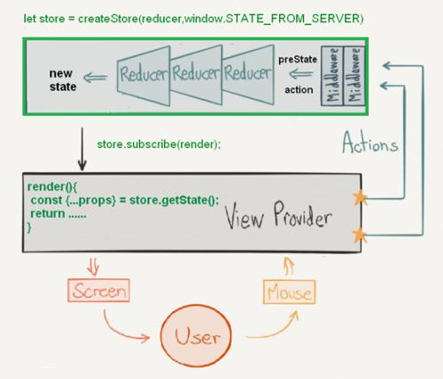

## **2. 日志中间件**

* 我们改写了dispatch方法,实现了在更改状态时打印前后的状态
* 但是这种方案并不好。所以我们可以采用中间的方式

### **2.1 实现日志**

src\store\index.tsx

**import** { createStore, Store, AnyAction } **from** '../redux';**import** reducer **from** './reducers';**import** { CombinedState } **from** './reducers';**const** store: Store<CombinedState, AnyAction> = createStore<CombinedState, AnyAction, {}, {}>(reducer, { counter1: { number: 0 }, counter2: { number: 0 } });**let** dispatch = store.dispatch;

store.dispatch = **function** (action: AnyAction): **AnyAction** {

console.log(store.getState());

dispatch(action);

console.log(store.getState());

**return** action;

};**export** **default** store;

### **2.2 实现异步**

src\store\index.tsx

**import** { createStore, Store, AnyAction } **from** '../redux';**import** reducer **from** './reducers';**import** { CombinedState } **from** './reducers';**const** store: Store<CombinedState, AnyAction> = createStore<CombinedState, AnyAction, {}, {}>(reducer, { counter1: { number: 0 }, counter2: { number: 0 } });**let** dispatch = store.dispatch;

store.dispatch = **function** (action: AnyAction): **AnyAction** {

setTimeout(() => {

dispatch(action);

}, 1000);

**return** action;

};**export** **default** store;

## **3. 日志中间件**

### **3.1 store\index.tsx**

src\store\index.tsx

+import { createStore, Store, AnyAction, Middleware, MiddlewareAPI, StoreEnhancer, StoreEnhancerStoreCreator, applyMiddleware } from '../redux';

import reducer from './reducers';

import { CombinedState } from './reducers';+//const store: Store<CombinedState, AnyAction> = createStore<CombinedState, AnyAction, {}, {}>(reducer, { counter1: { number: 0 }, counter2: { number: 0 } });+let logger: Middleware = (api: MiddlewareAPI) => (next: any) => (action: any) => {+ console.log(api.getState());+ next(action);+ console.log(api.getState());+ return action;+};+let storeEnhancer: StoreEnhancer = applyMiddleware(logger);+let storeEnhancerStoreCreator: StoreEnhancerStoreCreator = storeEnhancer(createStore);+let store: Store = storeEnhancerStoreCreator(reducer);+export default store;

### **3.2 redux\types.tsx**

src\redux\types.tsx

export interface Action<T = any> {

type: T

}

export interface AnyAction extends Action {

[extraProps: string]: any

}

export type Reducer<S = any, A extends Action = AnyAction> = (

state: S | undefined,

action: A

) => S

+export interface Dispatch<A extends Action = AnyAction> {+ <T extends A>(action: T): T+}

export interface Unsubscribe {

(): void

}

export interface Store<S = any, A extends Action = AnyAction> {

dispatch: Dispatch<A>;

getState(): S;

subscribe(listener: () => void): Unsubscribe;

}

+export interface Middleware<+ DispatchExt = {},+ S = any,+ D extends Dispatch = Dispatch+ > {+ (api: MiddlewareAPI<D, S>): (+ next: Dispatch<AnyAction>+ ) => (action: any) => any+}

+export interface MiddlewareAPI<D extends Dispatch = Dispatch, S = any> {+ dispatch: D+ getState(): S+}

+export type StoreEnhancer = (+ next: StoreEnhancerStoreCreator+) => StoreEnhancerStoreCreator+export type StoreEnhancerStoreCreator = <+ S = any,+ A extends Action = AnyAction+ >(+ reducer: Reducer<S, A>,+ preloadedState?: S+) => Store<S, A>

### **3.3 redux\index.tsx**

src\redux\index.tsx

import createStore from './createStore';

import bindActionCreators from './bindActionCreators';

import combineReducers from './combineReducers';+import applyMiddleware from './applyMiddleware'

export {

createStore,

bindActionCreators,

combineReducers,+ applyMiddleware

}

export * from './types';

export * from './bindActionCreators';

export * from './combineReducers';+export * from './applyMiddleware';

### **3.4 redux\compose.tsx**

src\redux\compose.tsx

* [compose](https://github.com/reduxjs/redux/blob/master/src/compose.ts)

**function** **add1**(str){

**return** '1'+str;

}**function** **add2**(str){

**return** '2'+str;

}**function** **add3**(str){

**return** '3'+str;

}

**function** **compose**(...funcs){

**return** funcs.reduce((a,b)=>(...args)=>a(b(...args)));

}

**let** result = compose(add3,add2,add1)('zhufeng');console.log(result);

**export** **default** **function** **compose**(...funcs: Function[]) {

**return** funcs.reduce((a, b) => (...args: any) => a(b(...args)))

}

### **3.5 applyMiddleware.tsx**

src\redux\applyMiddleware.tsx

**import** compose **from** './compose';**import** { Middleware, Store, StoreEnhancer, Dispatch, MiddlewareAPI, StoreCreator, Action, AnyAction, Reducer } **from** './'**export** **function** **applyMiddleware**(

...middlewares: Middleware[]): **StoreEnhancerexport** **default** **function** **applyMiddleware**(

...middlewares: Middleware[]): **StoreEnhancer** {

**return** (createStore: StoreCreator) => <S, A extends Action>(

reducer: Reducer<S, A>

): Store<S, A> => {

const store = createStore(reducer)

let dispatch: Dispatch;

const middlewareAPI: MiddlewareAPI = {

getState: store.getState,

dispatch: (action) => dispatch(action)

}

const chain = middlewares.map(middleware => middleware(middlewareAPI))

dispatch = compose(...chain)(store.dispatch)

return {

...store,

dispatch

}

}

}

函数兼容性判断

**let** x: string | number;**let** y: string;

y = x;

x = y;

==========================

**export** interface Action {

type: string

}**export** interface NameAction extends Action {

name: string;

}**export** interface AgeAction extends Action {

age: number;

}**export** interface AllAction extends Action {

name: string;

age: number;

}**export** interface Dispatch<A extends Action> {

<T extends A>(action: T): T

}**let** dispatchNameAction: Dispatch<NameAction> = null;**let** dispatchAgeAction: Dispatch<AgeAction> = null;**let** dispatchAllAction: Dispatch<AllAction> = null;

dispatchNameAction = dispatchAgeAction;//处理少的能赋值给处理多的

dispatchAgeAction = dispatchNameAction;//处理多的不能赋值给处理少的

dispatchAllAction = dispatchNameAction;

dispatchAllAction = dispatchAgeAction;

## **4. 级联中间件**

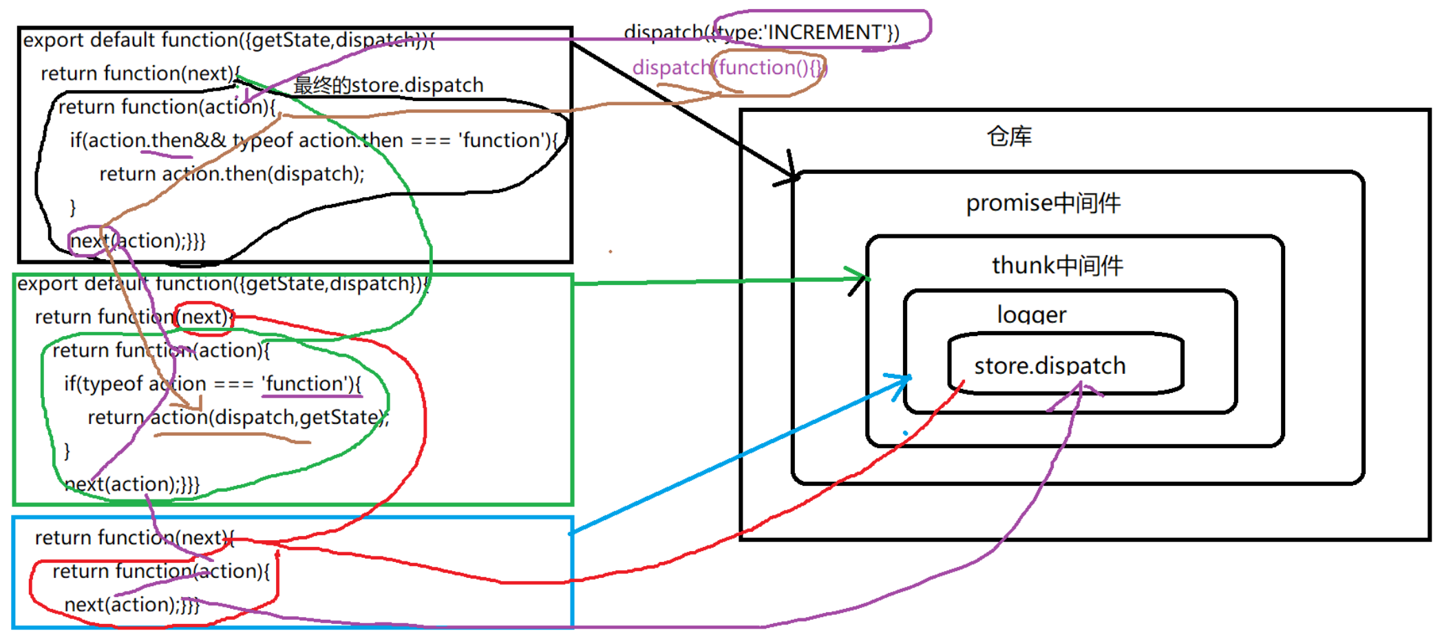

### **4.1 store\index.tsx**

src\store\index.tsx

import { createStore, Store, AnyAction, Middleware, MiddlewareAPI, StoreEnhancer, StoreEnhancerStoreCreator, applyMiddleware } from '../redux';

import reducer from './reducers';

import { CombinedState } from './reducers';

//const store: Store<CombinedState, AnyAction> = createStore<CombinedState, AnyAction, {}, {}>(reducer, { counter1: { number: 0 }, counter2: { number: 0 } });

let logger: Middleware = (api: MiddlewareAPI) => (next: any) => (action: any) => {

console.log(api.getState());

next(action);

console.log(api.getState());

return action;

};+let thunk: Middleware = (api: MiddlewareAPI) => (next: any) => (action: any) => {+ if (typeof action == 'function') {+ return action(api.dispatch, api.getState);+ }+ return next(action);+};+function isPromise(obj: any) {+ return !!obj && (typeof obj === 'object' || typeof obj === 'function') && typeof obj.then === 'function';+}+let promise: Middleware = (api: MiddlewareAPI) => (next: any) => (action: any) => {+ return isPromise(action.payload)+ ? action.payload+ .then((result: any) => api.dispatch({ ...action, payload: result }))+ .catch((error: any) => {+ api.dispatch({ ...action, payload: error, error: true });+ return Promise.reject(error);+ })+ : next(action);+};+let storeEnhancer: StoreEnhancer = applyMiddleware(thunk, promise, logger);

let storeEnhancerStoreCreator: StoreEnhancerStoreCreator = storeEnhancer(createStore);

let store: Store = storeEnhancerStoreCreator(reducer);

export default store;

### **4.2 actions\counter1.tsx**

src\store\actions\counter1.tsx

import * as types from '../action-types';+import { AnyAction, Dispatch } from '../../redux';

const actions = {

increment1(): AnyAction {

return { type: types.INCREMENT1 };

},+ increment1Async() {+ return function (dispatch: Dispatch) {+ setTimeout(() => {+ dispatch({ type: types.INCREMENT1 });+ }, 1000);+ }+ },+ increment1Promise() {+ return {+ type: types.INCREMENT1,+ payload: new Promise((resolve: any, reject: any) => {+ setTimeout(() => {+ let result = Math.random();+ if (result > .5) {+ resolve(result);+ } else {+ reject(result);+ }+ }, 1000);+ })+ }+ },

decrement1(): AnyAction {

return { type: types.DECREMENT1 };

}

}

export default actions;

### **4.3 Counter1.tsx**

src\components\Counter1.tsx

import React, { Component } from 'react';

import actions from '../store/actions/counter1';

import { CombinedState } from '../store/reducers';

import { Counter1State } from '../store/reducers/counter1';

import { connect } from '../react-redux';+import { ActionCreatorsMapObject, AnyAction } from '../redux';

type Props = Counter1State & typeof actions;

class Counter1 extends Component<Props> {

render() {

let { number, increment1, decrement1 } = this.props;

return (

<div>

<p>{number}</p>

<button onClick={increment1}>+</button>+ <button onClick={this.props.increment1Async}>异步+1</button>+ <button onClick={this.props.increment1Promise}>promise异步+1</button>

</div>

)

}

}

let mapStateToProps = (state: CombinedState): Counter1State => state.counter1;+export default connect<any>(

mapStateToProps,

actions

)(Counter1)

### **4.4 connect.tsx**

src\react-redux\connect.tsx

import React from "react";

import { bindActionCreators, Unsubscribe, AnyAction, ActionCreatorsMapObject } from "../redux";

import ReactReduxContext from "./context";

import { CombinedState } from '../store/reducers';

import { ContextValue } from './types';

interface MapStateToProps {

(state: CombinedState): any;

}

interface MapDispatchToProps {

[method: string]: void

}+export default function <Action = AnyAction>(mapStateToProps: MapStateToProps, mapDispatchToProps: ActionCreatorsMapObject<Action>) {

return function wrapWithConnect(WrappedComponent: React.ComponentType<any>) {

return class extends React.Component {

static contextType = ReactReduxContext;

unsubscribe: Unsubscribe;

constructor(props: any, context: ContextValue) {

super(props);

this.state = mapStateToProps(context.store.getState());

}

componentDidMount() {

this.unsubscribe = this.context.store.subscribe(() =>

this.setState(mapStateToProps(this.context.store.getState()))

);

}

shouldComponentUpdate() {

if (this.state === mapStateToProps(this.context.store.getState())) {

return false;

}

return true;

}

componentWillUnmount() {

this.unsubscribe();

}

render() {+ let actions = bindActionCreators<Action, ActionCreatorsMapObject<Action>>(

mapDispatchToProps,

this.context.store.dispatch

);

return <WrappedComponent {...this.state} {...actions} />;

}

};

};

}

### **4.5 bindActionCreators.tsx**

src\redux\bindActionCreators.tsx

import { Dispatch, AnyAction } from './';+export interface ActionCreator<A> {

(...args: any[]): A

}+export interface ActionCreatorsMapObject<A> {

[key: string]: ActionCreator<A>

}+export default function bindActionCreators<A, M extends ActionCreatorsMapObject<A>>(

actionCreators: M,

dispatch: Dispatch<A>

): M+export default function bindActionCreators<A, M extends ActionCreatorsMapObject<A>>(

actionCreators: M,+ dispatch: Dispatch<A>

): M {+ const boundActionCreators: ActionCreatorsMapObject<A> = {};

for (const key in actionCreators) {

const actionCreator = actionCreators[key]

if (typeof actionCreator === 'function') {

boundActionCreators[key] = bindActionCreator<A>(actionCreator, dispatch)

}

}

return boundActionCreators as M;

}+function bindActionCreator<A>(

actionCreator: ActionCreator<A>,+ dispatch: Dispatch<A>

) {

return function (this: any, ...args: any[]) {

return dispatch(actionCreator.apply(this, args));

}

}

### **4.6 redux\types.tsx**

src\redux\types.tsx

+export interface Dispatch<A = AnyAction> {

<T extends A>(action: T): T

}