## **1. React路由**

* 不同的路径渲染不同的组件
* 有两种实现方式
  + HashRouter:利用hash实现路由切换
  + BrowserRouter:实现h5 Api实现路由的切换

### **1.1 HashRouter**

* 利用hash实现路由切换

<a href="#/a">去a</a>

<a href="#/b">去b</a>

<script>

window.addEventListener('hashchange',()=>{

console.log(window.location.hash);

});

</script>

### **1.2 BrowserRouter**

* 利用h5 Api实现路由的切换

#### **1.2.1 history**

* [history](https://developer.mozilla.org/zh-CN/docs/Web/API/Window/history)对象提供了操作浏览器会话历史的接口。
* historylength 属性声明了浏览器历史列表中的元素数量
* [pushState](https://developer.mozilla.org/zh-CN/docs/Web/API/History_API) HTML5引入了 history.pushState() 和 history.replaceState() 方法，它们分别可以添加和修改历史记录条目。这些方法通常与window.onpopstate 配合使用
* [onpopstate](https://developer.mozilla.org/zh-CN/docs/Web/API/Window/onpopstate) window.onpopstate是popstate事件在window对象上的事件处理程序

#### **1.2.2 pushState**

* pushState会往History中写入一个对象，他造成的结果便是,History length +1、url 改变、该索引History对应有一个State对象,这个时候若是点击浏览器的后退，便会触发popstate事件，将刚刚的存入数据对象读出
* pushState 会改变History
* 每次使用时候会为该索引的State加入我们自定义数据
* 每次我们会根据State的信息还原当前的view，于是用户点击后退便有了与浏览器后退前进一致的感受
* pushState() 需要三个参数: 一个状态对象, 一个标题 (目前被忽略), 和 (可选的) 一个URL
* 调用history.pushState()或者history.replaceState()不会触发popstate事件. popstate事件只会在浏览器某些行为下触发, 比如点击后退、前进按钮(或者在JavaScript中调用history.back()、history.forward()、history.go()方法)

<script>

window.onpopstate = (event) => {

console.log({state:event.state,pathname:window.location.pathname,type:'popstate'});

};

window.onpushstate = (event) => {

console.log(event);

};

(function (history) {

var pushState = history.pushState;

history.pushState = function (state,title,pathname) {

if (typeof window.onpushstate == "function") {

window.onpushstate({state,pathname,type:'pushstate'});

}

return pushState.apply(history, arguments);

};

})(window.history);

//绑定事件处理函数.

setTimeout(()=>{

history.pushState({page: 1}, "title 1", "/page1");

},1000);

setTimeout(()=>{

history.pushState({page: 2}, "title 2", "/page2");

},2000);

setTimeout(()=>{

history.replaceState({page: 3}, "title 3", "/page3");

},3000);

setTimeout(()=>{

history.back();

},4000);

setTimeout(()=>{

history.go(1);

},5000);

</script>

## **2. 跑通路由**

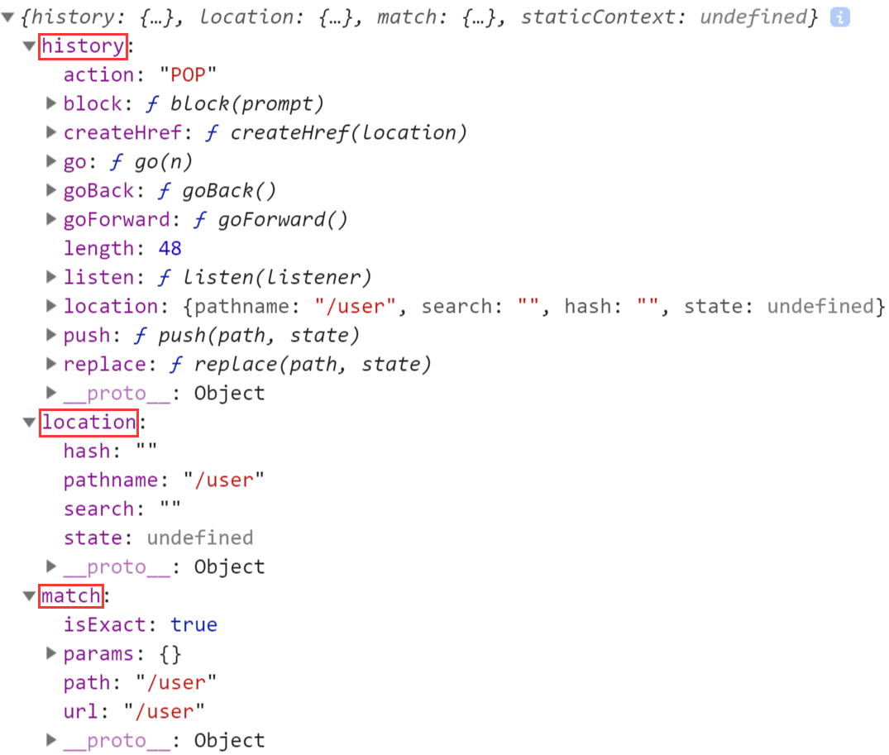

### **2.1 src\index.js**

**import** React **from** 'react';**import** ReactDOM **from** 'react-dom';**import** {HashRouter **as** Router,Route} **from** 'react-router-dom';**import** Home **from** './components/Home';**import** User **from** './components/User';**import** Profile **from** './components/Profile';

ReactDOM.render(

<Router>

<div>

<Route path="/" component={Home} />

<Route path="/user" component={User} />

<Route path="/profile" component={Profile}/>

</div>

</Router>

,document.getElementById('root'));

### **2.2 components\Home.js**

src\components\Home.js

**import** React,{Component} **from** 'react';**export** **default** **class** **Home** **extends** **Component**{

render() {

**return** (

<div>Home</div>

)

}

}

### **2.3 components\User.js**

src\components\User.js

**import** React,{Component} **from** 'react';**export** **default** **class** **User** **extends** **Component**{

render() {

console.log(JSON.stringify(**this**.props));

**return** (

<div>User</div>

)

}

}

/**

{

"history": {

"length": 4,

"action": "POP",

"location": {

"pathname": "/user",

"search": "?name=zfpx",

"hash": "#top"

}

},

"location": {

"pathname": "/user",

"search": "?name=zfpx",

"hash": "#top"

},

"match": {

"path": "/user",

"url": "/user",

"isExact": true,

"params": {}

}

}

*/

### **2.4 components\Profile.js**

src\components\Profile.js

**import** React,{Component} **from** 'react';**export** **default** **class** **Profile** **extends** **Component**{

render() {

**return** (

<div>Profile</div>

)

}

}

## **3. 实现路由**

### **3.1 index.js**

src\react-router-dom\index.js

**import** HashRouter **from** './HashRouter';**import** Route **from** './Route';**export** {

HashRouter,

Route

}

### **3.2 HashRouter.js**

src\react-router-dom\HashRouter.js

**import** React, { Component } **from** 'react'**import** Context **from** './context';**export** **default** **class** **HashRouter** **extends** **Component** {

state = {

location:{pathname:window.location.hash.slice(1)}

}

componentWillMount(){

window.addEventListener('hashchange',()=>{

**this**.setState({

location:{

...this.state.location,

pathname:window.location.hash.slice(1) || '/'

}

});

});

window.location.hash = window.location.hash || '/';

}

render() {

**let** value = {

location:**this**.state.location

}

**return** (

<Context.Provider value={value}>

{this.props.children}

</Context.Provider>

)

}

}

### **3.4 Route.js**

src\react-router-dom\Route.js

**import** React,{Component} **from** 'react';**import** Context **from** './context';**export** **default** **class** **Route** **extends** **Component**{

**static** contextType = Context;

render() {

**let** {path,component: Component}=**this**.props;

**let** pathname = **this**.context.location.pathname;

**if** (path == pathname) {

**return** <Component/>

} **else** {

**return** null;

}

}

}

### **3.4 context.js**

src\react-router-dom\context.js

**import** {createContext} **from** 'react';**export** **default** createContext();

## **4.path-to-regexp**

* [path-to-regexp](https://www.npmjs.com/package/path-to-regexp)
* [regulex](https://jex.im/regulex)

### **4.1 /home结束**

**let** pathToRegExp = require('path-to-regexp');**let** regx = pathToRegExp('/home',[],{end:true});console.log(regx);// /^\/home\/?$/iconsole.log(regx.test('/home'));console.log(regx.test('/home/2'));

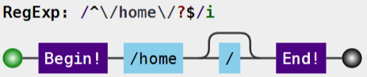

### **4.2 /home非结束**

**let** pathToRegExp = require('path-to-regexp');**let** regx2 = pathToRegExp('/home',[],{end:false});console.log(regx2);// /^\/home\/?(?=\/|$)/iconsole.log(regx2.test('/home'));console.log(regx2.test('/home/'));console.log(regx2.test('/home//'));console.log(regx2.test('/home/2'));

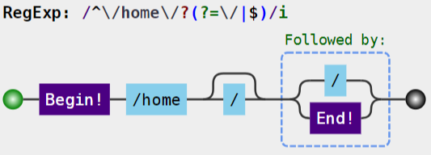

### **4.3 路径参数**

**let** params = [];**let** regx3 = pathToRegExp('/user/:id',params,{end:true});console.log(regx3,params);/**

/^\/user\/(?:([^\/]+?))\/?$/i

[ { name: 'id', optional: false, offset: 7 } ]

**/

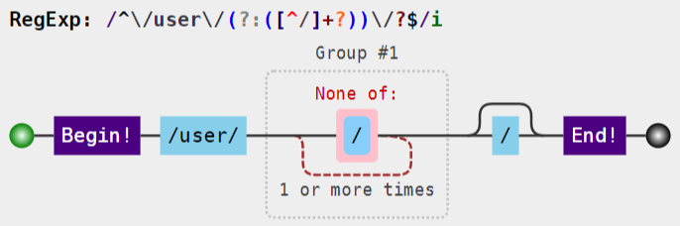

### **4.4 正则匹配**

| **表达式** | **含义** |
| --- | --- |
| () | 表示捕获分组，()会把每个分组里的匹配的值保存起来，使用$n(n是一个数字，表示第n个捕获组的内容) |
| (?:) | 表示非捕获分组，和捕获分组唯一的区别在于，非捕获分组匹配的值不会保存起来 |

* 正则匹配的前瞻就是给正则匹配的选项定义一个断言，或者说是一个条件比如：我要匹配一个字母，但是我的需求是字母后面必须是跟着一个数字的情况，那么这种场景是怎么实现了，就是用到前瞻的概念，那么我想要他的前面也要是一个数字怎么办了，这就是后顾

| **表达式** | **含义** |
| --- | --- |
| (?=pattern) | 正向肯定查找(前瞻),后面必须跟着什么 |
| (?!pattern) | 正向否定查找(前瞻)，后面不能跟着什么 |
| (?<=pattern) | 反向肯定条件查找(后顾),不捕获 |
| (?<!pattern) | 反向否定条件查找（后顾） |

console.log('1a'.match(/\d(?=[a-z])/));console.log('1@'.match(/\d(?![a-z])/));console.log('a1'.match(/(?<=[a-z])\d/));console.log('$1'.match(/(?<![a-z])\d/));

## **5.正则匹配**

### **5.1 Route.js**

src\react-router-dom\Route.js

**import** React, { Component } **from** 'react'**import** Context **from** './context';**import** pathToRegexp **from** 'path-to-regexp';**export** **default** **class** **Route** **extends** **Component** {

**static** contextType = Context;

render() {

**let** {path,component:Component,exact=false} = **this**.props;

**let** pathname = **this**.context.location.pathname;

**let** regxp = pathToRegexp(path,[],{end:exact});

**let** result = pathname.match(regxp);

console.log('regxp,pathname,result',regxp,pathname,result);

**if**(result){

**return** <Component/>;

}

**return** null;

}

}

## **6. 实现Link**

### **6.1 src/index.js**

src/index.js

import React from 'react';

import ReactDOM from 'react-dom';

import {HashRouter as Router,Route,Link} from './react-router-dom';

import Home from './components/Home';

import User from './components/User';

import Profile from './components/Profile';

ReactDOM.render(

<Router>

<>

<Link to="/">Home</Link><Link to="/user">User</Link><Link to="/profile">Profile</Link>

<Route path="/" exact component={Home} />

<Route path="/user" component={User} />

<Route path="/profile" component={Profile}/>

</>

</Router>

,document.getElementById('root'));

### **6.2 Link.js**

src/react-router-dom/Link.js

**import** React, { Component } **from** 'react'**import** Context **from** './context';**export** **default** **class** **Link** **extends** **Component** {

**static** contextType = Context;

render() {

**return** (

<a onClick={()=>this.context.history.push(this.props.to)}>{this.props.children}</a>

)

}

}

### **6.3 index.js**

src/react-router-dom/index.js

**import** HashRouter **from** './HashRouter';**import** Route **from** './Route';**import** Link **from** './Link';**export** {

HashRouter,

Route,

Link

}

### **6.4 HashRouter.js**

src/react-router-dom/HashRouter.js

**import** React, { Component } **from** 'react'**import** Context **from** './context';**export** **default** **class** **HashRouter** **extends** **Component** {

state = {

location:{pathname:window.location.hash.slice(1) || '/'},

}

componentDidMount(){

window.location.hash = window.location.hash || '/';

window.addEventListener('hashchange',()=>{

**this**.setState({

location:{

...this.state.location,

pathname:window.location.hash.slice(1) || '/'

}

});

});

}

render() {

**let** value={

location: **this**.state.location,

history: {

push(to) {

window.location.hash=to;

}

}

}

**return** (

<Context.Provider value={value}>

{this.props.children}

</Context.Provider>

)

}

}

## **7. 引入bootstrap**

### **7.1 src\index.js**

src\index.js

import React from 'react';

import ReactDOM from 'react-dom';

import {HashRouter as Router,Route,Link} from './react-router-dom';

import Home from './components/Home';

import User from './components/User';

import Profile from './components/Profile';

import 'bootstrap/dist/css/bootstrap.css';

ReactDOM.render(

<Router>

<>

<div className="navbar navbar-inverse">

<div className="container-fluid">

<div className="navbar-heading">

<div className="navbar-brand">珠峰架构</div>

</div>

<ul className="nav navbar-nav">

<li><Link to="/">Home</Link></li>

<li><Link to="/user">User</Link></li>

<li><Link to="/profile">Profile</Link></li>

</ul>

</div>

</div>

<div className="container">

<div className="row">

<div className="col-md-12">

<Route path="/" exact component={Home} />

<Route path="/user" component={User} />

<Route path="/profile" component={Profile}/>

</div>

</div>

</div>

</>

</Router>

,document.getElementById('root'));

## **8. Redirect&Switch**

### **8.1 src\index.js**

src\index.js

import React from 'react';

import ReactDOM from 'react-dom';

import {HashRouter as Router,Route,Link,Redirect,Switch} from './react-router-dom';

import Home from './components/Home';

import User from './components/User';

import Profile from './components/Profile';

import 'bootstrap/dist/css/bootstrap.css';

ReactDOM.render(

<Router>

<>

<div className="navbar navbar-inverse">

<div className="container-fluid">

<div className="navbar-heading">

<div className="navbar-brand">珠峰架构</div>

</div>

<ul className="nav navbar-nav">

<li><Link to="/">Home</Link></li>

<li><Link to="/user">User</Link></li>

<li><Link to="/profile">Profile</Link></li>

</ul>

</div>

</div>

<div className="container">

<div className="row">

<div className="col-md-12">

<Switch>

<Route path="/" exact component={Home} />

<Route path="/user" component={User} />

<Route path="/profile" component={Profile}/>

<Redirect to="/" />

</Switch>

</div>

</div>

</div>

</>

</Router>

,document.getElementById('root'));

### **8.2 index.js**

src/react-router-dom/index.js

**import** HashRouter **from** './HashRouter';**import** Route **from** './Route';**import** Link **from** './Link';**import** Redirect **from** './Redirect';**import** Switch **from** './Switch';**export** {

HashRouter,

Route,

Link,

Redirect,

Switch

}

### **8.3 Link.js**

src/react-router-dom/Link.js

**import** React, { Component } **from** 'react'**import** Context **from** './context';**export** **default** **class** **Link** **extends** **Component** {

**static** contextType = Context;

render() {

**return** (

<a onClick={()=>this.context.history.push(this.props.to)}>{this.props.children}</a>

)

}

}

### **8.4 Route.js**

src/react-router-dom/Route.js

**import** React, { Component } **from** 'react'**import** Context **from** './context';**import** pathToRegexp **from** 'path-to-regexp';**export** **default** **class** **Route** **extends** **Component** {

**static** contextType = Context;

render() {

**let** {path,component:Component,exact=false} = **this**.props;

**let** pathname = **this**.context.location.pathname;

**let** regxp = pathToRegexp(path,[],{end:exact});

**let** result = pathname.match(regxp);

**if**(result){

**return** <Component {...this.context}/>;

}

**return** null;

}

}

### **8.5 Redirect.js**

src/react-router-dom/Redirect.js

**import** React, { Component } **from** 'react'**import** Context **from** './context';**export** **default** **class** **Link** **extends** **Component** {

**static** contextType = Context;

render() {

**this**.context.history.push(**this**.props.to);

**return** null;

}

}

### **8.6 Switch.js**

src/react-router-dom/Switch.js

**import** React, { Component } **from** 'react'**import** Context **from** './context';**import** pathToRegexp **from** 'path-to-regexp';**export** **default** **class** **Switch** **extends** **Component** {

**static** contextType = Context;

render() {

**let** pathname = **this**.context.location.pathname;

**for**(**let** i=0;i<**this**.props.children.length;i++){

**let** child = **this**.props.children[i];

**let** {path='/',component:Component,exact=false} = child.props;

**let** regxp = pathToRegexp(path,[],{end:exact});

**let** result = pathname.match(regxp);

**if**(result){

**return** child;

}

}

**return** null;

}

}

## **9. 路径参数**

### **9.1 User.js**

src/components/User.js

**import** React,{Component} **from** 'react';**import** {Link,Route} **from** '../react-router-dom';**import** UserAdd **from** './UserAdd';**import** UserDetail **from** './UserDetail';**import** UserList **from** './UserList';**export** **default** **class** **User** **extends** **Component**{

render() {

**return** (

<div className="row">

<div className="col-md-2">

<ul className="nav nav-stack">

<li><Link to="/user/list">用户列表</Link></li>

<li><Link to="/user/add">添加用户</Link></li>

</ul>

</div>

<div className="col-md-10">

<Route path="/user/add" component={UserAdd}/>

<Route path="/user/list" component={UserList}/>

<Route path="/user/detail/:id" component={UserDetail}/>

</div>

</div>

)

}

}

### **9.2 UserAdd.js**

src/components/UserAdd.js

**import** React, { Component } **from** 'react'

**export** **default** **class** **UserAdd** **extends** **Component** {

**constructor**(){

**super**();

**this**.usernameRef = React.createRef();

}

handleSubmit = (event)=>{

event.preventDefault();

**let** username = **this**.usernameRef.current.value;

**let** usersStr = localStorage.getItem('users');

**let** users = usersStr?JSON.parse(usersStr):[];

users.push({id:Date.now()+'',username});

localStorage.setItem('users',JSON.stringify(users));

**this**.props.history.push('/user/list');

}

render() {

**return** (

<form onSubmit={this.handleSubmit}>

<input className="form-control" type="text" ref={this.usernameRef}/>

<button type="submit" className="btn btn-primary">提交</button>

</form>

)

}

}

### **9.3 UserList.js**

src/components/UserList.js

**import** React, { Component } **from** 'react'**import** {Link} **from** '../react-router-dom';**export** **default** **class** **UserList** **extends** **Component** {

state = {

users:[]

}

componentDidMount(){

**let** usersStr = localStorage.getItem('users');

**let** users = usersStr?JSON.parse(usersStr):[];

**this**.setState({users});

}

render() {

**return** (

<div>

UserList

<ul className="list-group">

{

this.state.users.map((user,index)=>(

<li className="list-group-item" key={index}>

<Link to={{pathname:`/user/detail/${user.id}`,state :user}}>{user.username}</Link>

</li>

))

}

</ul>

</div>

)

}

}

### **9.3 UserDetail.js**

src/components/UserDetail.js

**import** React, { Component } **from** 'react'

**export** **default** **class** **UserDetail** **extends** **Component** {

state = {

user:{}

}

componentDidMount(){

**let** user = **this**.props.location.state;

**if**(!user){

**let** usersStr = localStorage.getItem('users');

**let** users = usersStr?JSON.parse(usersStr):[];

**let** id = **this**.props.match.params.id;

user = users.find(user=>user.id === id);

}

**if**(user) **this**.setState({user});

}

render() {

**let** user = **this**.state.user;

**return** (

<div>

{user.id}:{user.username}

</div>

)

}

}

### **9.4 HashRouter.js**

src/react-router-dom/HashRouter.js

**import** React, { Component } **from** 'react'**import** Context **from** './context';**export** **default** **class** **HashRouter** **extends** **Component** {

state = {

location:{pathname:window.location.hash.slice(1) || '/'}

}

locationState=undefined

componentDidMount(){

window.location.hash = window.location.hash || '/';

window.addEventListener('hashchange',()=>{

**this**.setState({

location:{

...this.state.location,

pathname:window.location.hash.slice(1) || '/',

state:**this**.locationState

}

});

});

}

render() {

**let** that = **this**;

**let** value = {

location:that.state.location,

history:{

push(to){

**if**(**typeof** to === 'object'){

**let** {pathname,state}= to;

that.locationState = state;

window.location.hash = pathname;

}**else**{

window.location.hash = to;

}

}

}

}

**return** (

<Context.Provider value={value}>

{this.props.children}

</Context.Provider>

)

}

}

### **9.5 Route.js**

src/react-router-dom/Route.js

**import** React, { Component } **from** 'react'**import** Context **from** './context';**import** pathToRegexp **from** 'path-to-regexp';**export** **default** **class** **Route** **extends** **Component** {

**static** contextType = Context;

render() {

**let** { path, component: Component, exact = false } = **this**.props;

**let** pathname = **this**.context.location.pathname;

**let** keys = [];

**let** regxp = pathToRegexp(path, keys, { end: exact });

**let** result = pathname.match(regxp);

**if** (result) {

**let** [url, ...values] = result;

keys = keys.map(item=>item.name);

**let** params = values.reduce((memo, val, index) => {

memo[keys[index]] = val;

**return** memo;

}, {});

**let** match = {

url:pathname,

isExact:pathname===url,

path,

params

}

**let** props = {

location: **this**.context.location,

history: **this**.context.history,

match

}

**return** <Component {...props} />;

}

**return** null;

}

}

### **9.6 Switch.js**

src/react-router-dom/Switch.js

**import** React, { Component } **from** 'react'**import** Context **from** './context';**import** pathToRegexp **from** 'path-to-regexp';**export** **default** **class** **Switch** **extends** **Component** {

**static** contextType = Context;

render() {

**let** pathname = **this**.context.location.pathname;

**let** children = Array.isArray(**this**.props.children)?**this**.props.children:[**this**.props.children]

**for**(**let** i=0;i<children.length;i++){

**let** child = children[i];

**let** {path='/',exact=false} = child.props;

**let** regxp = pathToRegexp(path,[],{end:exact});

**let** result = pathname.match(regxp);

**if**(result){

**return** child;

}

}

**return** null;

}

}

## **10. 受保护的路由**

### **10.1 src/index.js**

src/index.js

import React from 'react';

import ReactDOM from 'react-dom';

import {HashRouter as Router,Route,Link,Redirect,Switch} from './react-router-dom';

import Home from './components/Home';

import User from './components/User';

import Profile from './components/Profile';

import Protected from './components/Protected';

import Login from './components/Login';

import 'bootstrap/dist/css/bootstrap.css';

ReactDOM.render(

<Router>

<>

<div className="navbar navbar-inverse">

<div className="container-fluid">

<div className="navbar-heading">

<div className="navbar-brand">珠峰架构</div>

</div>

<ul className="nav navbar-nav">

<li><Link to="/">Home</Link></li>

<li><Link to="/user">User</Link></li>

<li><Link to="/profile">Profile</Link></li>

</ul>

</div>

</div>

<div className="container">

<div className="row">

<div className="col-md-12">

<Switch>

<Route path="/" exact component={Home} />

<Route path="/user" component={User} />

<Route path="/login" component={Login} />

<Protected path="/profile" component={Profile}/>

<Redirect to="/" />

</Switch>

</div>

</div>

</div>

</>

</Router>

,document.getElementById('root'));

### **10.2 Route.js**

src/react-router-dom/Route.js

**let** props = {

location: **this**.context.location,

history: **this**.context.history,

match

}

**if**(Component){

**return** <Component {...props} />;

}**else** **if**(render){

**return** render(props);

}**else**{

**return** null;

}

### **10.3 Protected.js**

src/components/Protected.js

**import** React, { Component } **from** 'react'**import** {Route,Redirect} **from** '../react-router-dom';**export** **default** ({component:Component,...rest})=>(

<Route {...rest} render={

props => (

localStorage.getItem('logined')?<Component {...props}/>:<Redirect to={{pathname:'/login',state:{from:props.location.pathname}}}/>

)

}/>

)

### **10.4 Login.js**

src/components/Login.js

**import** React, { Component } **from** 'react'

**export** **default** **class** **Login** **extends** **Component** {

handleClick = ()=>{

localStorage.setItem('logined','true');

**if**(**this**.props.location.state)

**this**.props.history.push(**this**.props.location.state.from);

}

render() {

**return** (

<button className="btn btn-primary" onClick={this.handleClick}>登录</button>

)

}

}

## **11. 自定义导航**

### **11.1 index.js**

src/index.js

<ul className="nav navbar-nav">+ <li><MenuLink exact to="/">Home</MenuLink></li>+ <li><MenuLink to="/user">User</MenuLink></li>+ <li><MenuLink to="/profile">Profile</MenuLink></li>

</ul>

### **11.2 MenuLink.js**

src/components/MenuLink.js

**import** React **from** 'react'**import** {Route,Link} **from** '../react-router-dom';**import** './MenuLink.css'**export** **default** ({to,exact,children}) => (

<Route

path={to}

exact={exact}

children={

props => (

<Link className={props.match?'active':''} to={to}>{children}</Link>

)

}

/>

)

### **11.3 MenuLink.css**

src/components/MenuLink.css

.navbar-inverse .navbar-nav > li > .active{

background-color: green!important;

color:red!important;

}

### **11.4 Link.js**

src\react-router-dom\Link.js

import React, { Component } from 'react'

import Context from './context';

export default class Link extends Component {

static contextType = Context;

render() {

return (+ <a {...this.props} onClick={()=>this.context.history.push(this.props.to)}>{this.props.children}</a>

)

}

}

### **11.5 Route.js**

src/react-router-dom/Route.js

import React, { Component } from 'react'

import Context from './context';

import pathToRegexp from 'path-to-regexp';

export default class Route extends Component {

static contextType = Context;

render() {

let { path='/', component: Component, exact = false,render,children } = this.props;

let pathname = this.context.location.pathname;

let keys = [];

let regxp = pathToRegexp(path, keys, { end: exact });

let result = pathname.match(regxp);+ let props = {+ location: this.context.location,+ history: this.context.history+ }

if (result) {

let [url, ...values] = result;

keys = keys.map(item=>item.name);

let params = values.reduce((memo, val, index) => {

memo[keys[index]] = val;

return memo;

}, {});

let match = {

url:pathname,

isExact:pathname===url,

path,

params

}+ props.match = match;

if(Component){

return <Component {...props} />;

}else if(render){

return render(props);+ }else if(children){+ return children(props);+ }else{+ return null;+ }+ }else if(children){+ return children(props);+ }else{+ return null;+ }

}

}

## **12. withRouter**

### **12.1 src/index.js**

+import NavHeader from './components/NavHeader';

<div className="navbar navbar-inverse">

<div className="container-fluid">+ <NavHeader/>

<ul className="nav navbar-nav">

<MenuLink exact to="/">Home</MenuLink>

<MenuLink to="/user">User</MenuLink>

<MenuLink to="/profile">Profile</MenuLink>

</ul>

</div>

### **12.2 NavHeader.js**

src/components/NavHeader.js

**import** React, { Component } **from** 'react'**import** {withRouter} **from** '../react-router-dom';**class** **NavHeader** **extends** **Component** {

render() {

**return** (

<div className="navbar-heading">

<div className="navbar-brand" onClick={()=>this.props.history.push('/')}>珠峰架构</div>

</div>

)

}

}**export** **default** withRouter(NavHeader)

### **12.3 withRouter.js**

src/react-router-dom/withRouter.js

**import** React **from** 'react'**import** {Route} **from** '../react-router-dom';**export** **default** **function** (Component) {

**return** props=>(

<Route render={routeProps=><Component {...routeProps}>}/>

)

}

### **12.4 index.js**

src/react-router-dom/index.js

**import** withRouter **from** './withRouter';**export** {

HashRouter,

Route,

Link,

Redirect,

Switch,

withRouter

}

## **13. 阻止跳转**

### **13.1 UserAdd.js**

src/components/UserAdd.js

**import** React, { Component } **from** 'react'**import** {Prompt} **from** '../react-router-dom';**export** **default** **class** **UserAdd** **extends** **Component** {

**constructor**(){

**super**();

**this**.usernameRef = React.createRef();

}

state = {

isBlocking:false

}

handleSubmit = (event)=>{

event.preventDefault();

**this**.setState({

isBlocking:false

},()=>{

**let** username = **this**.usernameRef.current.value;

**let** usersStr = localStorage.getItem('users');

**let** users = usersStr?JSON.parse(usersStr):[];

users.push({id:Date.now()+'',username});

localStorage.setItem('users',JSON.stringify(users));

**this**.props.history.push('/user/list');

})

}

render() {

**let** {isBlocking}=**this**.state;

**return** (

<form onSubmit={this.handleSubmit}>

<Prompt

when={isBlocking}

message={location=>`你确定要跳转到${location.pathname}吗？`}

/>

<input className="form-control" type="text"

onChange={event => {

this.setState({isBlocking:event.target.value.length>0});

}}

ref={this.usernameRef}/>

<button type="submit" className="btn btn-primary">提交</button>

</form>

)

}

}

### **13.2 HashRouter.js**

src/react-router-dom/HashRouter.js

**import** React, { Component } **from** 'react'**import** Context **from** './context';**export** **default** **class** **HashRouter** **extends** **Component** {

state = {

location: { pathname: window.location.hash.slice(1) || '/' }

}

locationState = undefined

getMessage=null

componentDidMount() {

window.location.hash = window.location.hash || '/';

window.addEventListener('hashchange', () => {

**this**.setState({

location: {

...this.state.location,

pathname: window.location.hash.slice(1) || '/',

state: **this**.locationState

}

});

});

}

render() {

**let** that = **this**;

**let** value = {

location: that.state.location,

history: {

push(to) {

**if** (that.getMessage) {

**let** allow=window.confirm(that.getMessage(that.state.location)+`，并且跳转到${**typeof** to === 'object'?to.pathname:to}吗?`);

**if** (!allow) **return**;

}

**if** (**typeof** to === 'object') {

**let** { pathname, state } = to;

that.locationState = state;

window.location.hash = pathname;

} **else** {

window.location.hash = to;

}

},

block(message) {

that.getMessage=message;

},

unblock() {

that.getMessage=null;

}

}

}

**return** (

<Context.Provider value={value}>

{this.props.children}

</Context.Provider>

)

}

}

### **13.3 index.js**

src/react-router-dom/index.js

**import** HashRouter **from** './HashRouter';**import** Route **from** './Route';**import** Link **from** './Link';**import** Redirect **from** './Redirect';**import** Switch **from** './Switch';**import** withRouter **from** './withRouter';**import** Prompt **from** './Prompt';**export** {

HashRouter,

Route,

Link,

Redirect,

Switch,

withRouter,

Prompt

}

### **13.4 Prompt.js**

src/react-router-dom/Prompt.js

**import** React **from** 'react'**import** Context **from** './context';**export** **default** **class** **Prompt** **extends** **React**.**Component**{

**static** contextType = Context;

componentWillUnmount() {

**this**.history.unblock();

}

render() {

**this**.history=**this**.context.history;

**const** {when,message}=**this**.props;

**if** (when) {

**this**.history.block(message);

} **else** {

**this**.history.block(null);

}

**return** null;

}

}

## **14. BrowserRouter**

### **14.1 index.js**

src/index.js

**import** {BrowserRouter **as** Router,Route,Redirect,Switch} **from** './react-router-dom';

### **14.2 BrowserRouter.js**

src/react-router-dom/BrowserRouter.js

**import** React, { Component } **from** 'react'**import** Context **from** './context';

(**function** (history) {

**var** pushState = history.pushState;

history.pushState = **function** (state,title,pathname) {

**if** (**typeof** window.onpushstate == "function") {

window.onpushstate(state,pathname);

}

**return** pushState.apply(history, arguments);

};

})(window.history);**export** **default** **class** **BrowserRouter** **extends** **Component** {

state = {

location: { pathname: '/' }

}

getMessage = null

componentDidMount() {

window.onpopstate = (event) => {

**this**.setState({

location: {

...this.state.location,

pathname:document.location.pathname,

state:event.state

}

});

};

window.onpushstate = (state,pathname) => {

**this**.setState({

location: {

...this.state.location,

pathname,

state

}

});

};

}

render() {

**let** that = **this**;

**let** value = {

location: that.state.location,

history: {

push(to) {

**if** (that.block) {

**let** allow = window.confirm(that.getMessage(that.state.location));

**if** (!allow) **return**;

}

**if** (**typeof** to === 'object') {

**let** { pathname, state } = to;

window.history.pushState(state, '', pathname);

} **else** {

window.history.pushState('', '', to);

}

},

block(getMessage) {

that.block = getMessage;

},

unblock() {

that.block = null;

}

}

}

**return** (

<Context.Provider value={value}>

{this.props.children}

</Context.Provider>

)

}

}

### **14.3 index.js**

src/react-router-dom/index.js

**import** HashRouter **from** './HashRouter';**import** Route **from** './Route';**import** Link **from** './Link';**import** Redirect **from** './Redirect';**import** Switch **from** './Switch';**import** withRouter **from** './withRouter';**import** Prompt **from** './Prompt';**import** BrowserRouter **from** './BrowserRouter';

**export** {

HashRouter,

Route,

Link,

Redirect,

Switch,

withRouter,

Prompt,

BrowserRouter

}