## **1. React Hooks**

* Hook可以让你在不编写 class组件 的情况下使用 state

## **2. 搭建项目**

npx create-react-app zhufeng_hooks

cd zhufeng_hooks

yarn start

## **3. useState**

* useState 会返回一对值: 当前状态和一个让你更新它的函数
* useState 唯一的参数就是初始 state

**const** [state, setState] = useState(initialState);

### **3.1 使用**

**import** React **from** 'react';**import** ReactDOM **from** 'react-dom';**function** **Counter**(){

**const** [number,setNumber] = React.useState(0);

**return** (

<>

<p>{number}</p>

<button onClick={()=>setNumber(number+1)}>+</button>

</>

)

}**function** **render**(){

ReactDOM.render(<Counter/>,document.getElementById('root'));

}

render();

### **3.2 实现**

import React from 'react';

import ReactDOM from 'react-dom';+let lastState;+function useState(initialState){+ lastState = lastState||initialState;+ function setState(newState){+ lastState = newState;+ render();+ }+ return [lastState,setState];+}

function Counter(){

const [number,setNumber] = useState(0);

return (

<>

<p>{number}</p>

<button onClick={()=>setNumber(number+1)}>+</button>

</>

)

}

function render(){

ReactDOM.render(<Counter/>,document.getElementById('root'));

}

render();

## **4. 多useState**

### **4.1 使用**

**import** React **from** 'react';**import** ReactDOM **from** 'react-dom';**function** **Counter**(){

**const** [number1,setNumber1] = React.useState(0);

**const** [number2,setNumber2] = React.useState(0);

**return** (

<>

<p>{number1}</p>

<button onClick={()=>setNumber1(number1+1)}>+</button>

<hr/>

<p>{number2}</p>

<button onClick={()=>setNumber2(number2+1)}>+</button>

</>

)

}**function** **render**(){

ReactDOM.render(<Counter/>,document.getElementById('root'));

}

render();

### **4.2 实现**

**import** React **from** 'react';**import** ReactDOM **from** 'react-dom';**let** hookStates = [];**let** hookIndex = 0;**function** **useState**(initialState){

//如果有老值取老值,没有取默认值

hookStates[hookIndex]=hookStates[hookIndex]||initialState;

//暂存索引

**let** currentIndex = hookIndex;

**function** **setState**(newState){

hookStates[currentIndex]=newState;

render();

}

**return** [hookStates[hookIndex++],setState];

} **function** **Counter**(){

**const** [number1,setNumber1] = useState(0);

**const** [number2,setNumber2] = useState(0);

**return** (

<>

<p>{number1}</p>

<button onClick={()=>setNumber1(number1+1)}>+</button>

<hr/>

<p>{number2}</p>

<button onClick={()=>setNumber2(number2+1)}>+</button>

</>

)

}**function** **render**(){

hookIndex =0;

ReactDOM.render(<Counter/>,document.getElementById('root'));

}

render();

## **5. 优化**

* 我们可以使用useMemo和useCallback来减少渲染

### **5.1 使用**

**import** React **from** 'react';**import** ReactDOM **from** 'react-dom';**let** Child = ({ onButtonClick, data }) => {

console.log("Child render");

**return** <button onClick={onButtonClick}>{data.number}</button>;

}

Child = React.memo(Child);

**function** **App**() {

**const** [number, setNumber] = React.useState(0);

**const** [name, setName] = React.useState("zhufeng");

**const** addClick = React.useCallback(() => setNumber(number + 1), [number]);

**const** data = React.useMemo(() => ({ number }), [number]);

**return** (

<div>

<input value={name} onChange={(e) => setName(e.target.value)} />

<Child onButtonClick={addClick} data={data} />

</div>

);

}**function** **render**(){

ReactDOM.render(<App />,document.getElementById('root'));

}

render();

### **5.2 实现**

import React from 'react';

import ReactDOM from 'react-dom';+let hookStates = [];//放着此组件的所有的hooks数据+let hookIndex = 0;//代表当前的hooks的索引+function useState(initialState){+ //如果有老值取老值,没有取默认值+ hookStates[hookIndex]=hookStates[hookIndex]||initialState;+ //暂存索引+ let currentIndex = hookIndex;+ function setState(newState){+ hookStates[currentIndex]=newState;+ render();+ }+ return [hookStates[hookIndex++],setState];+} +function useCallback(callback,dependencies){+ if(hookStates[hookIndex]){+ let [lastCallback,lastCallbackDeps] = hookStates[hookIndex];+ let same = dependencies.every((item,index)=>item === lastCallbackDeps[index]);+ if(same){//如果老依赖和新的依赖都相同,则直接返回老的,如果不一相同,则返回新的+ hookIndex++;+ return lastCallback;+ }else{+ hookStates[hookIndex++]=[callback,dependencies];+ return callback;+ }+ }else{+ hookStates[hookIndex++]=[callback,dependencies];+ return callback;+ }+}++function useMemo(factory,dependencies){+ if(hookStates[hookIndex]){+ let [memo,lastDeps] = hookStates[hookIndex];+ let same = dependencies.every((item,index)=>item === lastDeps[index]);+ if(same){//如果老依赖和新的依赖都相同,则直接返回老的,如果不一相同,则返回新的+ hookIndex++;+ return memo;+ }else{+ let newMemo = factory();+ hookStates[hookIndex++]=[newMemo,dependencies];+ return newMemo;+ }+ }else{+ let newMemo = factory();+ hookStates[hookIndex++]=[newMemo,dependencies];+ return newMemo;+ }+}

let Child = ({ onButtonClick, data }) => {

console.log("Child render");

return <button onClick={onButtonClick}>{data.number}</button>;

}

Child = React.memo(Child);

function App() {

const [number, setNumber] = useState(0);

const [name, setName] = useState("zhufeng");

const addClick = useCallback(() => setNumber(number + 1), [number]);

const data = useMemo(() => ({ number }), [number]);

return (

<div>

<input value={name} onChange={(e) => setName(e.target.value)} />

<Child onButtonClick={addClick} data={data} />

</div>

);

}

function render(){

hookIndex =0;

ReactDOM.render(<App />,document.getElementById('root'));

}

render();

## **6. useEffect**

* useEffect 就是一个 Effect Hook，给函数组件增加了操作副作用的能力
* 它跟 class 组件中的 componentDidMount、componentDidUpdate 和 componentWillUnmount 具有相同的用途，只不过被合并成了一个 API

useEffect(didUpdate)

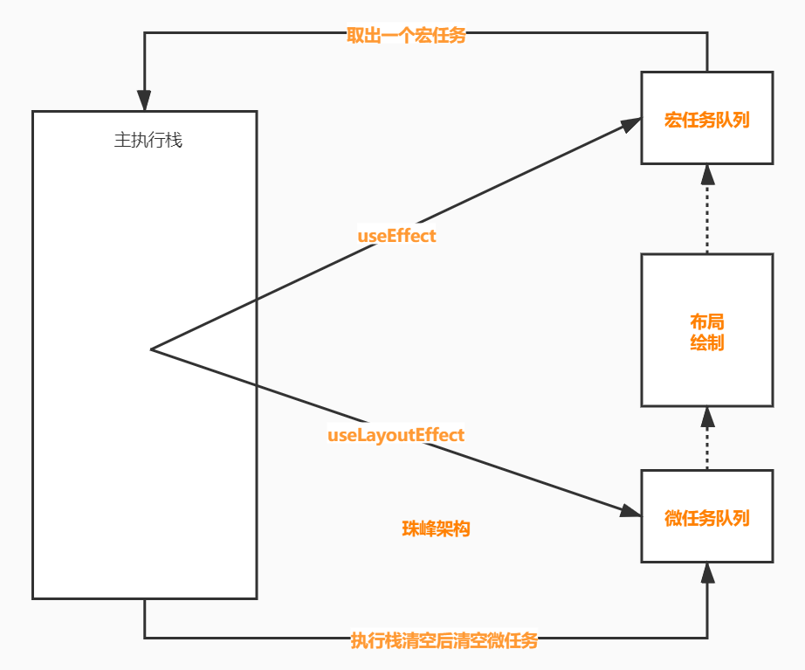

### **6.1 使用**

**import** React **from** 'react';**import** ReactDOM **from** 'react-dom';

**function** **Counter**(){

**const** [name,setName] = React.useState('珠峰');

**const** [number,setNumber] = React.useState(0);

React.useEffect(() => {

console.log(number);

}, [number]);

**return** (

<>

<p>{name}:{number}</p>

<button onClick={()=>setName('架构')}>修改名称</button>

<button onClick={()=>setNumber(number+1)}>+</button>

</>

)

}**function** **render**(){

ReactDOM.render(<Counter/>,document.getElementById('root'));

}

render();

### **6.2 实现useEffect**

import React from 'react';

import ReactDOM from 'react-dom';

+let hookStates = [];+let hookIndex = 0;+function useState(initialState){+ hookStates[hookIndex]=hookStates[hookIndex]||initialState;+ let currentIndex = hookIndex;+ function setState(newState){+ hookStates[currentIndex]=newState;+ render();+ }+ return [hookStates[hookIndex++],setState];+}

+function useEffect(callback,dependencies){+ if(hookStates[hookIndex]){+ let lastDeps = hookStates[hookIndex];+ let same = dependencies.every((item,index)=>item === lastDeps[index]);+ if(same){+ hookIndex++;+ }else{+ hookStates[hookIndex++]=dependencies;+ setTimeout(callback);+ }+ }else{+ hookStates[hookIndex++]=dependencies;+ setTimeout(callback);+ }+}

function Counter(){

const [name,setName] = useState('珠峰');

const [number,setNumber] = useState(0);

useEffect(() => {

console.log(number);

}, [number]);

return (

<>

<p>{name}:{number}</p>

<button onClick={()=>setName('架构')}>修改名称</button>

<button onClick={()=>setNumber(number+1)}>+</button>

</>

)

}

function render(){

hookIndex=0;

ReactDOM.render(<Counter/>,document.getElementById('root'));

}

render();

## **7. useLayoutEffect**

* 其函数签名与 useEffect 相同，但它会在所有的 DOM 变更之后同步调用 effect
* useEffect不会阻塞浏览器渲染，而 useLayoutEffect 会浏览器渲染
* useEffect会在浏览器渲染结束后执行,useLayoutEffect 则是在 DOM 更新完成后,浏览器绘制之前执行

### **7.1 使用**

**import** React **from** 'react';**import** ReactDOM **from** 'react-dom';

**const** Animate = () => {

**const** red = React.useRef();

**const** green = React.useRef();

React.useLayoutEffect(() => {

red.current.style.transform = `translate(500px)`;

red.current.style.transition = `all 500ms`;

});

React.useEffect(() => {

green.current.style.transform = `translate(500px)`;

green.current.style.transition = `all 500ms`;

});

**let** style = { width: '100px', height: '100px' }

**return** (

<div>

<div style={{ ...style, backgroundColor: 'red' }} ref={red}></div>

<div style={{ ...style, backgroundColor: 'green' }} ref={green}></div>

</div>

)

}**function** **render**() {

ReactDOM.render(<Animate />, document.getElementById('root'));

}

render();

### **7.2 实现**

import React from 'react';

import ReactDOM from 'react-dom';

+let hookStates = [];+let hookIndex = 0;+function useEffect(callback,dependencies){+ if(hookStates[hookIndex]){+ let lastDeps = hookStates[hookIndex];+ let same = dependencies.every((item,index)=>item === lastDeps[index]);+ if(same){+ hookIndex++;+ }else{+ hookStates[hookIndex++]=dependencies;+ setTimeout(callback);+ }+ }else{+ hookStates[hookIndex++]=dependencies;+ setTimeout(callback);+ }+}+function useLayoutEffect(callback,dependencies){+ if(hookStates[hookIndex]){+ let lastDeps = hookStates[hookIndex];+ let same = dependencies.every((item,index)=>item === lastDeps[index]);+ if(same){+ hookIndex++;+ }else{+ hookStates[hookIndex++]=dependencies;+ queueMicrotask(callback);+ }+ }else{+ hookStates[hookIndex++]=dependencies;+ queueMicrotask(callback);+ }+}

const Animate = () => {

const red = React.useRef();

const green = React.useRef();

useLayoutEffect(() => {

red.current.style.transform = `translate(500px)`;

red.current.style.transition = `all 500ms`;

});

useEffect(() => {

green.current.style.transform = `translate(500px)`;

green.current.style.transition = `all 500ms`;

});

let style = { width: '100px', height: '100px' }

return (

<div>

<div style={{ ...style, backgroundColor: 'red' }} ref={red}></div>

<div style={{ ...style, backgroundColor: 'green' }} ref={green}></div>

</div>

)

}

function render() {

ReactDOM.render(<Animate />, document.getElementById('root'));

}

render();

## **8. useContext**

* 接收一个 context 对象并返回该 context 的当前值

### **8.1 使用**

**import** React **from** 'react';**import** ReactDOM **from** 'react-dom';**const** CounterContext = React.createContext();**function** **Counter**(){

**let** {state,setState} = React.useContext(CounterContext);

**return** (

<>

<p>{state.number}</p>

<button onClick={() => setState({number:state.number+1})}>+</button>

<button onClick={() => setState({number:state.number-1})}>-</button>

</>

)

}**function** **App**(){

**const** [state, setState] = React.useState({number:0});

**return** (

<CounterContext.Provider value={{state,setState}}>

<Counter/>

</CounterContext.Provider>

)

}**function** **render**(){

ReactDOM.render(<App/>,document.getElementById('root'));

}

render();

### **8.2 实现**

import React from 'react';

import ReactDOM from 'react-dom';

const CounterContext = React.createContext();+function useContext(context){+ return context._currentValue;+}

function Counter(){

let {state,setState} = useContext(CounterContext);

return (

<>

<p>{state.number}</p>

<button onClick={() => setState({number:state.number+1})}>+</button>

<button onClick={() => setState({number:state.number-1})}>-</button>

</>

)

}

function App(){

const [state, setState] = React.useState({number:0});

return (

<CounterContext.Provider value={{state,setState}}>

<Counter/>

</CounterContext.Provider>

)

}

function render(){

ReactDOM.render(<App/>,document.getElementById('root'));

}

render();

## **9. useReducer**

* 它接收一个形如 (state, action) => newState 的 reducer，并返回当前的 state 以及与其配套的 dispatch 方法

### **9.1 使用**

**import** React **from** 'react';**import** ReactDOM **from** 'react-dom';

**function** **reducer**(state, action) {

**switch** (action.type) {

**case** 'increment':

**return** state+1;

**case** 'decrement':

**return** state-1;

**default**:

**throw** **new** Error();

}

}**function** **Counter**(){

**const** [state, dispatch] = React.useReducer(reducer, 0);

**return** (

<>

Count: {state}

<button onClick={() => dispatch({type: 'increment'})}>+</button>

<button onClick={() => dispatch({type: 'decrement'})}>-</button>

</>

)

}**function** **render**(){

ReactDOM.render(<Counter/>,document.getElementById('root'));

}

render();

### **9.2 实现**

import React from 'react';

import ReactDOM from 'react-dom';+let hookStates = [];+let hookIndex = 0;+function useState(initialState){+ hookStates[hookIndex]=hookStates[hookIndex]||initialState;+ let currentIndex = hookIndex;+ function setState(newState){+ hookStates[currentIndex]=newState;+ render();+ }+ return [hookStates[hookIndex++],setState];+} +function useReducer(reducer, initialState) {+ hookStates[hookIndex]=hookStates[hookIndex]||initialState;+ let currentIndex = hookIndex;+ function dispatch(action) {+ hookStates[currentIndex]=reducer(hookStates[currentIndex],action);+ render();+ }+ return [hookStates[hookIndex++], dispatch];+}

const reducer = (state=0,action)=>{

switch(action.type){

case 'add':

return state+1;

default:

return state;

}

}

function Counter(){

const [number1,setNumber1] = useState(0);

const [number2,dispatch] = useReducer(reducer,0);

return (

<>

<p>{number1}</p>

<button onClick={()=>setNumber1(number1+1)}>+</button>

<hr/>

<p>{number2}</p>

<button onClick={() => dispatch({type: 'add'})}>+</button>

</>

)

}

function render(){

hookIndex=0;

ReactDOM.render(<Counter/>,document.getElementById('root'));

}

render();