## **1. Redux中间件**

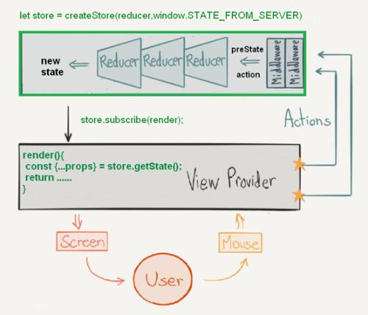

## **2. 日志中间件**

* 我们改写了，dispatch方法实现了在更改状态时打印前后的状态
* 但是这种方案并不好。所以我们可以采用中间的方式

**let** store = createStore(reducer);**let** dispatch = store.dispatch;

store.dispatch = **function** (action) {

console.log(store.getState().number);

dispatch(action);

console.log(store.getState().number)

};**export** **default** store;

## **2. 实现logger中间件**

* 中间件就是一个函数，对store.dispatch方法进行了改造，在发出 Action 和执行 Reducer 这两步之间，添加了其他功能

### **2.1 store\index.js**

src\store\index.js

**import** { createStore,applyMiddleware } **from** '../redux';**import** reducer **from** './reducers';**let** logger = store => dispatch => action=>{

console.log(store.getState().number);

dispatch(action);

console.log(store.getState().number)

};**export** **default** applyMiddleware(logger)(createStore)(reducer);

### **2.2 applyMiddleware.js**

src\redux\applyMiddleware.js

* [applyMiddleware](https://github.com/reduxjs/redux/blob/master/src/applyMiddleware.js)

**import** compose **from** './compose'**export** **default** **function** **applyMiddleware**(...middlewares) {

**return** createStore=>(...args)=>{

**const** store = createStore(...args);

**let** dispatch = ()=>{

**throw** **new** Error('不允许派发正在构建中的中间件!');

}

**const** middlewareAPI= {

getState:store.getState,

dispatch:(...args)=>dispatch(...args)

}

**const** chain = middlewares.map(middleware=>middleware(middlewareAPI));

dispatch = compose(...chain)(store.dispatch);

**return** {

...store,

dispatch

}

};

}

### **2.3 compose.js**

src\redux\compose.js

* [compose](https://github.com/reduxjs/redux/blob/master/src/compose.js)

**function** **add1**(str){

**return** '1'+str;

}**function** **add2**(str){

**return** '2'+str;

}**function** **add3**(str){

**return** '3'+str;

}

**function** **compose**(...funcs){

**return** funcs.reduce((a,b)=>(...args)=>a(b(...args)));

}

**let** result = compose(add3,add2,add1)('zfpx');console.log(result);

**export** **default** **function** **compose**(...funcs) {

**if** (funcs.length === 0) {

**return** arg => arg

}

**if** (funcs.length === 1) {

**return** funcs[0]

}

**return** funcs.reduce((a, b) => (...args) => a(b(...args)))

}

## **3. 级联中间件**

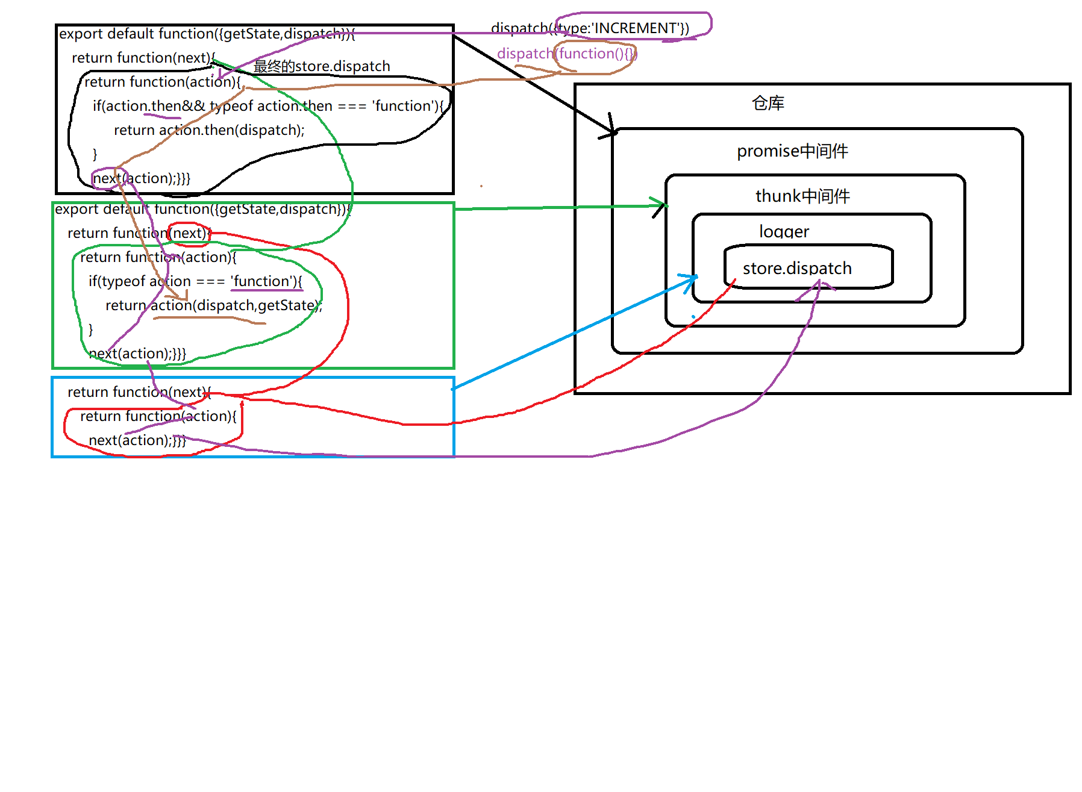

### **3.1 Counter.js**

src\components\Counter.js

**import** React, { Component } **from** 'react';**import** actions **from** '../store/actions/counter';**import** {connect} **from** '../react-redux'**class** **Counter** **extends** **Component** {

render() {

**return** (

<div>

<p>{this.props.number}</p>

<button onClick={this.props.increment}>+</button>

<button onClick={this.props.incrementAsync}>异步+1</button>

<button onClick={this.props.incrementPromise}>promise异步+1</button>

</div>

)

}

}

**let** mapStateToProps = state=>state;**export** **default** connect(

mapStateToProps,

actions

)(Counter)

### **3.2 store\index.js**

src\store\index.js

**import** { createStore,applyMiddleware } **from** '../redux';**import** reducer **from** './reducers';**import** logger **from** '../redux-logger';**import** thunk **from** '../redux-thunk';**import** promise **from** '../redux-promise';**export** **default** applyMiddleware(thunk,promise,logger)(createStore)(reducer);

### **3.3 reducers\index.js**

src\store\reducers\index.js

**import** counter **from** './counter';**export** **default** counter;

### **3.4 actions\counter.js**

src\store\actions\counter.js

**import** * **as** types **from** '../action-types';**export** **default** {

increment(){

**return** {type:types.INCREMENT};

},

decrement(){

**return** {type:types.DECREMENT};

},

incrementAsync(){

**return** **function**(dispatch){

setTimeout(()=>{

dispatch({type:types.INCREMENT});

},1000);

}

},

incrementPromise(){

**return** {

type:types.INCREMENT,

payload:**new** Promise((resolve,reject)=>{

**let** result = Math.random();

**if**(result>.5){

resolve(result);

}**else**{

reject(result);

}

},1000)

}

}

}

### **3.5 redux-logger.js**

src\redux-logger.js [redux-logger.js](https://github.com/LogRocket/redux-logger/blob/master/src/index.js)

**export** **default** store => dispatch => action=>{

console.log(store.getState().number);

dispatch(action);

console.log(store.getState().number)

};

### **3.6 redux-thunk.js**

src\redux-thunk.js [redux-thunk](https://github.com/reduxjs/redux-thunk/blob/master/src/index.js)

**function** **createThunkMiddleware**(extraArgument) {

**return** ({dispatch,getState}) => next => action => {

**if** (**typeof** action == 'function') {

**return** action(dispatch, getState, extraArgument);

}

**return** next(action);

}

}**const** thunk = createThunkMiddleware();

thunk.withExtraArgument = createThunkMiddleware;**export** **default** thunk;

### **3.7 redux-promise.js**

src\redux-promise.js [redux-promise](https://github.com/redux-utilities/redux-promise/blob/master/src/index.js)

**function** **isPromise**(obj) {

**return** !!obj && (**typeof** obj === 'object' || **typeof** obj === 'function') && **typeof** obj.then === 'function';

}**export** **default** **function** **promiseMiddleware**({ dispatch }) {

**return** next => action => {

**return** isPromise(action.payload)

? action.payload

.then(result => dispatch({ ...action, payload: result }))

.catch(error => {

dispatch({ ...action, payload: error, error: true });

**return** Promise.reject(error);

})

: next(action);

};

}

## **4. redux-persist**

### **4.1 src\index.js**

import React,{Component} from 'react';

import ReactDOM from 'react-dom';

import Counter from './components/Counter';

import {Provider} from './react-redux';+import {store,persistor} from './store';+import { PersistGate } from './redux-persist/integration/react'

ReactDOM.render(<Provider store={store}>+ <PersistGate persistor={persistor}>

<Counter/>+ </PersistGate>

</Provider>,document.getElementById('root'));

### **4.2 store\index.js**

src\store\index.js

import {createStore} from '../redux';

import reducer from './reducers';

import {applyMiddleware} from '../redux';

import logger from '../redux-logger';

import thunk from '../redux-thunk';

import promise from '../redux-promise';+import { persistStore, persistReducer } from '../redux-persist'+import storage from '../redux-persist/lib/storage'+const persistConfig = {+ key: 'root',+ storage,+}+const persistedReducer = persistReducer(persistConfig, reducer);+const store = applyMiddleware(thunk,promise,logger)(createStore)(persistedReducer);+let persistor = persistStore(store)+export {persistor,store};

### **4.3 redux-persist\index.js**

src\redux-persist\index.js

**import** persistReducer **from** './persistReducer';**import** persistStore **from** './persistStore';

**export** {

persistReducer,

persistStore

}

### **4.4 persistReducer.js**

src\redux-persist\persistReducer.js

**export** **default** **function** (persistConfig, reducer) {

**let** isInited = false;

**return** (state, action) => {

**switch** (action.type) {

**case** 'PERSIST_INIT':

isInited = true;

**let** value = persistConfig.storage.getItem('persist:'+ persistConfig.key);

state = value ? JSON.parse(value) : undefined;

**return** reducer(state, action);

**default**:

**if** (isInited) {

state = reducer(state, action);

persistConfig.storage.setItem('persist:'+ persistConfig.key, JSON.stringify(state));

**return** state;

}

**return** reducer(state, action);

}

}

}

### **4.5 persistStore.js**

src\redux-persist\persistStore.js

**export** **default** **function** (store) {

**let** persistor = {

...store,

initState() {

persistor.dispatch({

type: 'PERSIST_INIT',

})

}

};

**return** persistor;

}

### **4.6 storage.js**

src\redux-persist\lib\storage.js

**let** storage = {

setItem(key,val) {

localStorage.setItem(key,val);

},

getItem(key) {

**return** localStorage.getItem(key);

}

}**export** **default** storage;

### **4.7 react.js**

src\redux-persist\integration\react.js

**import** React, { Component } **from** 'react';

**class** **PersistGate** **extends** **Component** {

componentDidMount() {

**this**.props.persistor.initState();

}

render() {

**return** **this**.props.children;

}

}

**export** {PersistGate}

## **5. redux-actions**

* redux-actions是一个实用的库，让编写redux状态管理变得简单起来。redux-action产生的动作是[FSA](https://github.com/redux-utilities/flux-standard-action)标准的

### **5.1 单个action**

#### **5.1.1 actions\counter.js**

src\store\actions\counter.js

**import** * **as** types **from** '../action-types';//import { createAction } from 'redux-actions';**function** **createAction**(type,payloadCreator){

**return** **function** **actionCreator**(...args){

**return** {type,payload:payloadCreator(...args)};

}

}**const** add = createAction(types.ADD,(payload)=>payload*2);**const** minus = createAction(types.MINUS,(payload)=>payload*2);**export** **default** {

add,

minus

}

#### **5.1.2 reducers\counter.js**

src\store\reducers\counter.js

**import** * **as** types **from** '../action-types';//import {handleAction} from 'redux-actions';**import** actions **from** '../actions/counter';**function** **handleAction**(type,reducer ,defaultState){

**return** **function**(state=defaultState,action){

**if**(action.type === type){

**return** reducer(state,action);

}

**return** state;

}

}**const** initialState = {number:0};**const** reducer = handleAction(types.ADD,(state,action)=>{

**return** {

...state,number:state.number+action.payload

}

},initialState);**export** **default** reducer;

### **5.2 多个action**

#### **5.2.1 actions\counter.js**

actions\counter.js

**import** * **as** types **from** '../action-types';//import { createAction,createActions } from 'redux-actions';**export** **default** createActions({

[types.ADD]:(payload)=>payload*2,

[types.MINUS]:(payload)=>payload*2

});**function** **createActions**(actions){

**let** newActions = {};

**for**(**let** type **in** actions){

newActions[type]= **function**(...args){

**return** {type,payload:actions[type](...args)}

}

}

**return** newActions;

}

#### **5.2.2 reducers\counter.js**

reducers\counter.js

**import** * **as** types **from** '../action-types';//import {handleAction,handleActions } from 'redux-actions';**import** actions **from** '../actions/counter';**const** initialState = {number:0};**function** **handleActions**(reducers,initialState){

**return** **function**(state=initialState,action){

**let** types = Object.keys(reducers);

**for**(**let** i=0;i<types.length;i++){

**let** type = types[i];

**if**(type === action.type){

**return** reducers[type](state,action);

}

}

**return** state;

}

}**export** **default** handleActions({

[types.ADD]:(state,action)=>{

**return** {

...state,number:state.number+action.payload

}

},

[types.MINUS]:(state,action)=>{

**return** {

...state,number:state.number-action.payload

}

}

},initialState);

## **6. reselect**

* 使用Redux管理React应用状态时,mapStateToProps方法作为从Redux Store上获取数据过程中的重要一环，它一定不能有性能缺陷，它本身是一个函数，通过计算返回一个对象，这个计算过程通常是基于Redux Store状态树进行的，而很明显的Redux状态树越复杂，这个计算过程可能就越耗时，我们应该要能够尽可能减少这个计算过程，比如重复在相同状态下渲染组件，多次的计算过程显然是多余的，我们是否可以缓存该结果呢？这个问题的解决者就是reselect，它可以提高应用获取数据的性能
* reselect的原理是，只要相关状态不变，即直接使用上一次的缓存结果

### **6.1 基本用法**

* reselect通过创建选择器（selectors），该函数接受一个state参数，然后返回我们需要在mapStateToProps方法内返回对象的某一个数据项，一个选择器的处理可以分为两个步骤
  + 接受state参数，根据我们提供的映射函数数组分别进行计算，如果返回结果和上次第一步的计算结果一致，说明命中缓存，则不进行第二步计算，直接返回上次第二步的计算结果，否则继续第二步计算。第一步的结果比较，通常仅仅是===相等性检查，性能是足够的
  + 根据第一步返回的结果，计算并返回最终结果
* 需要注意的是，传入createSelector的映射函数返回的状态应该是不可变的，因为默认缓存命中检测函数使用引用检查，如果使用JavaScript对象，仅改变该对象的某一属性，引用检测是无法检测到属性变更的，这将导致组件无法响应更新

//import { createSelector } from 'reselect'**function** **createSelector**(selector,reducer){

**let** lastState;

**let** value;

**return** **function**(state){

**let** newState = selector(state);

**if**(lastState !== newState){

value = reducer(newState);

lastState = newState;

}

**return** value;

}

}**const** counterSelector = state => state.counter;

**const** getCounterSelector = createSelector(

counterSelector,

counter => {

console.log('重新计算number')

**return** counter.number;

}

)

**let** initialState = {

counter: {

number:0

}

}

console.log(getCounterSelector(initialState));console.log(getCounterSelector(initialState));

+console.log(getCounterSelector(initialState));+initialState.counter.number+=1;+console.log(getCounterSelector(initialState));

+ console.log(getCounterSelector(initialState));+ initialState.counter={number:1}+ console.log(getCounterSelector(initialState));

+const immutable = require("immutable");+let initialState = immutable.Map({counter: {number:0}})+console.log(getCounterSelector(initialState.toJS()));+initialState = initialState.setIn(['counter','number'],1);+console.log(getCounterSelector(initialState.toJS()));

### **6.2 案例**

#### **6.2.1 src\index.js**

src\index.js

import React from 'react';

import ReactDOM from 'react-dom';

import Counter1 from './components/Counter1';

import Counter2 from './components/Counter2';

import {Provider} from 'react-redux';

import store from './store';

ReactDOM.render(

<Provider store={store}>

<><Counter1/><Counter2/></>

</Provider>,document.getElementById('root'));

#### **6.2.2 Counter1.js**

src\components\Counter1.js

**import** React **from** 'react';**import** {connect} **from** 'react-redux';**import** { createSelector } **from** 'reselect'**import** actions **from** '../store/actions/counter1';**class** **Counter** **extends** **React**.**Component**{

render(){

**return** (

<div>

<p>{this.props.number}</p>

<button onClick={this.props.add}>+</button>

<button onClick={this.props.minus}>-</button>

</div>

)

}

}

**const** getCounterSelector = state => state.get('counter1');

**const** counterSelector = createSelector(

getCounterSelector,

counter1 =>{

console.log('重新计算counter1',counter1);

**return** counter1;

}

)**export** **default** connect(

state=>counterSelector(state),

actions

)(Counter)

#### **6.2.3 Counter2.js**

src\components\Counter2.js

**import** React **from** 'react';**import** {connect} **from** 'react-redux';**import** { createSelector } **from** 'reselect'**import** actions **from** '../store/actions/counter2';**class** **Counter** **extends** **React**.**Component**{

render(){

**return** (

<div>

<p>{this.props.number}</p>

<button onClick={()=>this.props.add(5)}>+</button>

<button onClick={()=>this.props.minus(5)}>-</button>

</div>

)

}

}

**const** getCounterSelector = state => state.get('counter2');

**const** counterSelector = createSelector(

getCounterSelector,

counter2 =>{

console.log('重新计算counter2',counter2)

**return** counter2;

}

)**export** **default** connect(

state=>counterSelector(state),

actions

)(Counter)

#### **6.2.4 src\store\index.js**

src\store\index.js

**import** {createStore,applyMiddleware} **from** 'redux';**import** reducer **from** './reducers';**import** logger **from** 'redux-logger';**import** thunk **from** 'redux-thunk';**import** promise **from** 'redux-promise';**let** store = applyMiddleware(promise,thunk,logger)(createStore)(reducer);**export** **default** store;

#### **6.2.5 reducers\index.js**

src\store\reducers\index.js

//import {combineReducers} from 'redux';**import** {combineReducers} **from** 'redux-immutable';**import** counter1 **from** './counter1';**import** counter2 **from** './counter2';**export** **default** combineReducers({

counter1,

counter2

});

#### **6.2.6 reducers\counter1.js**

src\store\reducers\counter1.js

**import** * **as** types **from** '../action-types';**import** actions **from** '../actions/counter';**const** initialState = {number:0};

**export** **default** **function**(state=initialState,action){

**switch**(action.type){

**case** types.ADD1:

**return** {number:state.number+1};

**case** types.MINUS1:

**return** {number:state.number-1};

**default**:

**return** state;

}

};

#### **6.2.7 reducers\counter2.js**

src\store\reducers\counter2.js

**import** * **as** types **from** '../action-types';**import** actions **from** '../actions/counter';**const** initialState = {number:0};

**export** **default** **function**(state=initialState,action){

**switch**(action.type){

**case** types.ADD2:

**return** {number:state.number+1};

**case** types.MINUS2:

**return** {number:state.number-1};

**default**:

**return** state;

}

};

#### **6.2.8 counter1.js**

src\store\actions\counter1.js

**import** * **as** types **from** '../action-types';**export** **default** {

add(){

**return** {type:types.ADD1}

},

minus(){

**return** {type:types.MINUS1}

}

}

#### **6.2.9 actions\counter2.js**

src\store\actions\counter2.js

**import** * **as** types **from** '../action-types';**export** **default** {

add(){

**return** {type:types.ADD2}

},

minus(){

**return** {type:types.MINUS2}

}

}

## **7.undo**

* simple undo/redo functionality for redux state containers
* [redux-undo](https://cnpmjs.org/package/redux-undo)
* [官网](http://redux-undo.js.org/)

**import** React, { Component, lazy, Suspense } **from** "react";**import** ReactDOM **from** "react-dom";**import** PropTypes **from** 'prop-types';**import** {createStore} **from** 'redux';//import undoable from 'redux-undo';**const** INCREMENT='INCREMENT';**const** DECREMENT = 'DECREMENT';**const** UNDO_COUNTER = 'UNDO_COUNTER';**const** REDO_COUNTER = 'REDO_COUNTER';**function** **reducer**(state=0,action){

**switch**(action.type){

**case** INCREMENT:

**return** state+1;

**case** DECREMENT:

**return** state-1;

**default**:

**return** state;

}

}**function** **undoable**(reducer,config){

**const** {undoType="@@redux-unto/UNDO",redoType="@@redux-unto/REDO"}= config;

**const** initialState = {

past:[],

futer:[],

present:reducer(undefined,{})

}

**return** **function**(state=initialState,action){

**const** {past,present,future} = state;

**switch**(action.type){

**case** undoType:

**const** previous = past[past.length-1];

**const** newPast = past.slice(0,past.length-1);

**return** {

past:newPast,

present:previous,

future:[present,...future]

}

**break**;

**case** redoType:

**const** next = future[0];

**const** newFuture = future.slice(1);

**return** {

past:[...past,present],

present:next,

future:newFuture

}

**break**;

**default**:

**const** newPresent = reducer(present,action);

**return** {

past:[...past,present],

present:newPresent,

future:[]

}

}

}

}**let** undoableReducer = undoable(reducer,{

undoType:UNDO_COUNTER,

redoType:REDO_COUNTER

});**let** store=createStore(undoableReducer);**class** **Counter** **extends** **Component**{

**constructor**(props) {

**super**(props);

**this**.state={value:store.getState()};

}

componentDidMount() {

**this**.unsubscribe=store.subscribe(()=>**this**.setState({value:store.getState()}));

}

componentWillUnmount() {

**this**.unsubscribe();

}

undo(){

store.dispatch({type:UNDO_COUNTER});

}

redo(){

store.dispatch({type:REDO_COUNTER});

}

add = ()=>{

store.dispatch({type:INCREMENT});

}

render() {

**const** {value,onInrement,onDecrement}=**this**.props;

//{"past":[],"present":0,"future":[],"history":{"past":[],"present":0,"future":[]}}

console.log(JSON.stringify(**this**.state.value));

**return** (

<div>

<p>{this.state.value.present}</p>

<button onClick={this.add}>+</button>

<button onClick={()=>store.dispatch({type:DECREMENT})}>-</button>

<button onClick={this.undo}>undo</button>

<button onClick={this.redo}>redo</button>

</div>

)

}

}

ReactDOM.render(<Counter/>, document.querySelector("#root"));