## **1. Serverless是什么？**

### **1.1 Serverless是什么？**

* 无服务器架构几乎封装了所有底层资源管理和系统运维工作
* 服务器布署、扩缩容、运维、监控报警交由云服务器厂商来做
* 前端开发只关注业务，不需要关注服务器

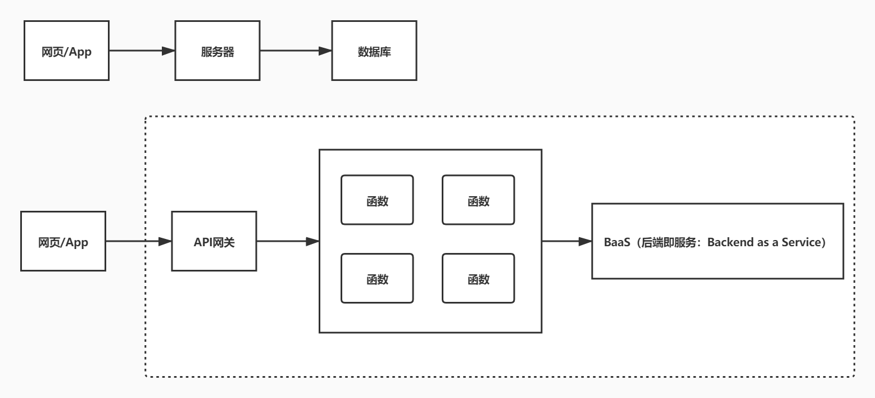

### **1.2 云函数**

* [函数服务](https://console.cloud.tencent.com/scf/list?rid=1&ns=default)

## **2. serverless framework**

* Serverless Framework 是业界非常受欢迎的无服务器应用框架，开发者无需关心底层资源即可部署完整可用的 Serverless 应用架构
* Serverless Framework 具有资源编排、自动伸缩、事件驱动等能力，覆盖编码、调试、测试、部署等全生命周期，帮助开发者通过联动云资源，迅速构建 Serverless 应用
* [Serverless Framework](https://cloud.tencent.com/product/sls)
* [Serverless Framework文档](https://cloud.tencent.com/document/product/1154)
* [安装Serverless Framework](https://cloud.tencent.com/document/product/1154/42990)

$ cnpm install -g serverless

$ cnpm update -g serverless

$ serverless -v

## **3. Serverless Components**

* [Serverless Components](https://cloud.tencent.com/document/product/1154/39270)是支持多个云资源编排和组织的场景化解决方案，主要基于客户的具体场景，如 Express 框架支持、网站部署等
* Serverless Components 可以有效简化云资源的配置和管理，将网关、COS 和 CAM 等产品联动起来，让客户更多关注场景和业务
* Serverless Framework Components 最佳实践
  + @serverless/tencent-scf - 腾讯云云函数组件
  + @serverless/tencent-express - 快速部署基于 Express.js 的后端服务到腾讯云函数的组件
  + @serverless/tencent-website - 快速部署静态网站到腾讯云的组件

### **3.1 云函数 SCF 组件**

* [腾讯云 SCF 云函数组件](https://cloud.tencent.com/document/product/1154/39271)通过使用 Tencent Serverless Framework，基于云上 Serverless 服务（云函数及触发器等），实现0配置，便捷开发，极速部署您的第一个云函数
* [查看scf](https://console.cloud.tencent.com/scf/list)
* [全量配置](https://github.com/serverless-components/tencent-scf/blob/v2/doc/serverless.yaml)

#### **3.1.1 serverless.yml**

[js-yaml](https://nodeca.github.io/js-yaml)

tencent-scf\serverless.yml

# serverless.yml

component: scf # (必填) 引用 component 的名称，当前用到的是 tencent-scf 组件

name: scfdemo # (必填) 该组件创建的实例名称

org: test # (可选) 用于记录组织信息，默认值为您的腾讯云账户 appid

app: scfApp # (可选) 该 SCF 应用名称

stage: dev # (可选) 用于区分环境信息，默认值是 dev

inputs:

name: scfFunctionName

src: ./src

runtime: Nodejs10.15 # 云函数的运行时环境。除 Nodejs10.15 外，可选值为：Python2.7、Python3.6、Nodejs6.10、Nodejs8.9、PHP5、PHP7、Golang1、Java8。

region: ap-beijing

handler: index.main_handler

events:

- apigw:

name: serverless_api

parameters:

protocols:

- http

- https

serviceName:

description: The service of Serverless Framework

environment: release

endpoints:

- path: /index

method: GET

#### **3.1.2 src\index.js**

tencent-scf\src\index.js

'use strict';

exports.main_handler = **async** (event, context, callback) => {

console.log("Hello World")

console.log(event)

console.log(event["non-exist"])

console.log(context)

**return** "Hello World";

};

#### **3.1.3 tencent-scf.env**

tencent-scf.env

* 当前默认支持 CLI 扫描二维码登录，如您希望配置持久的环境变量/密钥信息，也可以本地创建 .env 文件：
* [API密钥管理](https://console.cloud.tencent.com/cam/capi)

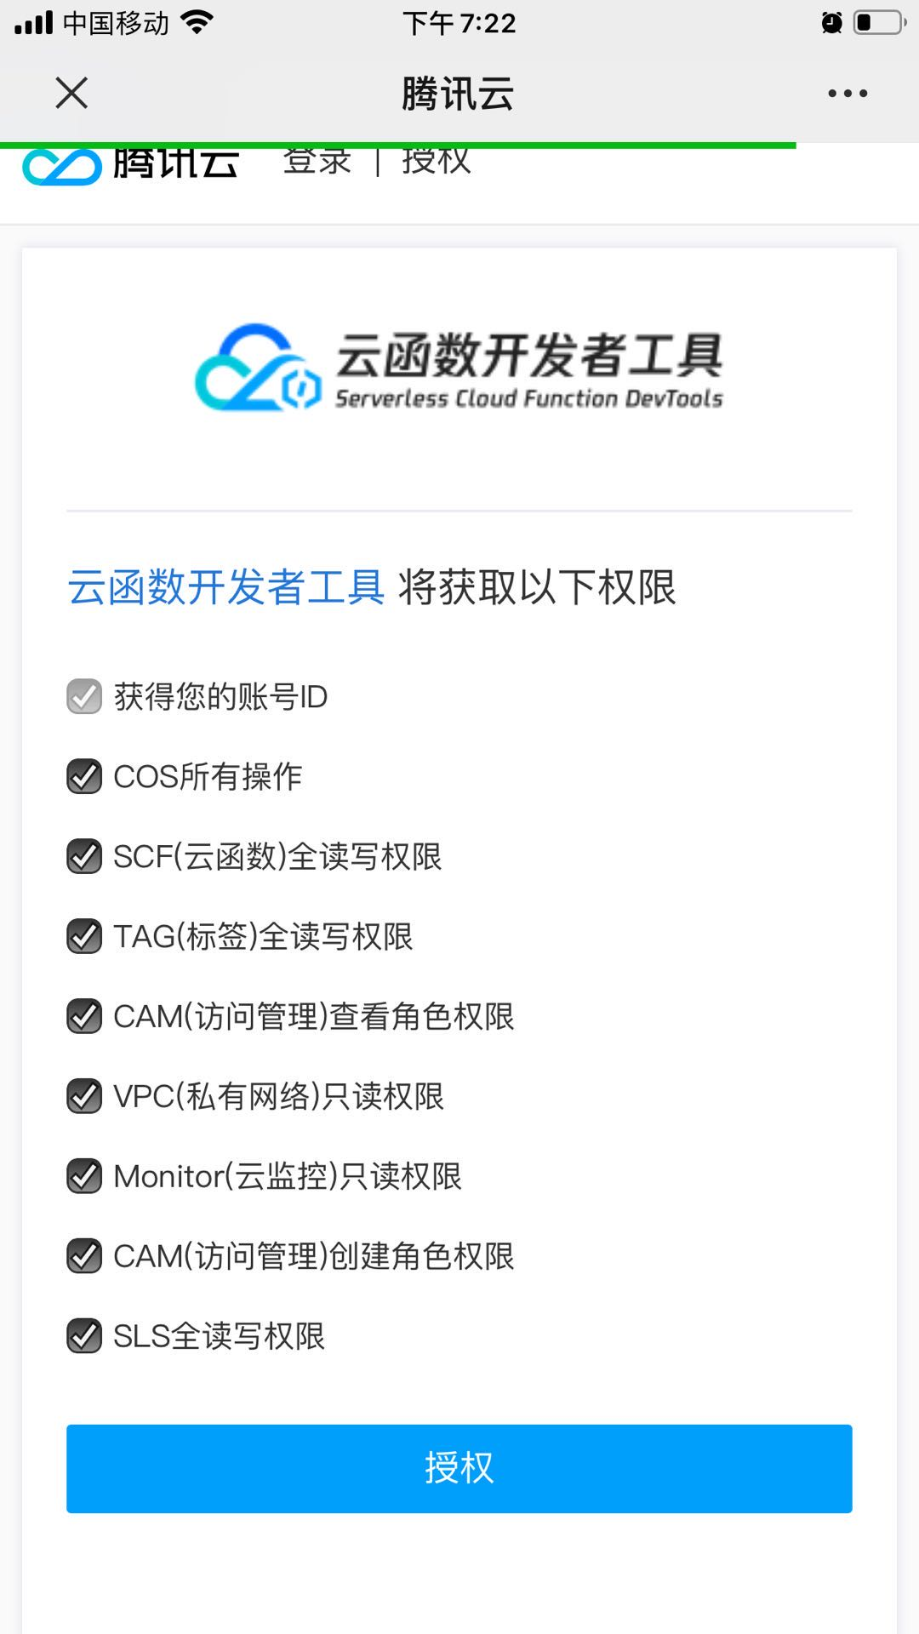

TENCENT_APP_ID=

TENCENT_SECRET_ID=

TENCENT_SECRET_KEY=

#### **3.1.4 布署**

sls --debug

### **3.2 API 网关组件**

* API网关是将所有API的调用统一接入API网关层，由网关层负责接入和输出
* API网关是用户与服务器的连接器，负责API接口的托管，实现安全防护和统一监控。
* API网关组件是 serverless-tencent 组件库中的基础组件之一，您可以通过该组件快速且方便地创建、配置和管理腾讯云的 API 网关产品。
* 通过 API 网关组件，您可以对一个 API 服务/接口进行完整的创建、配置、部署和删除等操作
* [全量配置](https://github.com/serverless-components/tencent-apigateway/blob/master/docs/configure.md)

#### **3.2.1 tencent-api\serverless.yml**

# serverless.yml

restApi:

component: "@serverless/tencent-apigateway"

inputs:

region: ap-beijing

protocol: http

serviceName: serverless

environment: release

endpoints:

- path: /users

method: GET

function:

functionName: scfFunctionName

#### **3.2.2 布署**

sls --debug

http://service-mpkd1e88-1258145019.gz.apigw.tencentcs.com/users

### **3.3 布署静态网站**

* [完整配置](https://github.com/serverless-components/tencent-website/blob/v2/doc/serverless.yaml)

#### **3.3.1 serverless.yml**

staticwebsite\serverless.yml

component: website # (必填) 引用 component 的名称，当前用到的是 tencent-website 组件

name: websitedemo # (必填) 该 website 组件创建的实例名称

org: test # (可选) 用于记录组织信息，默认值为您的腾讯云账户 appid

app: websiteApp # (可选) 该 website 应用名称

stage: dev # (可选) 用于区分环境信息，默认值是 dev

inputs:

code:

src: ./code

index: index.html

error: index.html

region: ap-beijing

bucketName: my-bucket

#### **3.3.2 index.html**

staticwebsite\code\index.html

<!DOCTYPE html>

<html lang="en">

<head>

<meta charset="UTF-8">

<meta name="viewport" content="width=device-width, initial-scale=1.0">

<title>Document</title>

</head>

<body>

static website

</body>

</html>

### **3.4 布署express项目**

* [全量配置](https://github.com/serverless-components/tencent-express/blob/v2/docs/configure.md)

#### **3.4.1 创建项目**

mkdir tencent-express

cd tencent-express

npm init -y

cnpm i express -S

#### **3.4.2 serverless.yml**

tencent-express\serverless.yml

org: orgDemo # (optional) serverless dashboard org. default is the first org you created during signup.

app: appDemo # (optional) serverless dashboard app. default is the same as the name property.

stage: dev # (optional) serverless dashboard stage. default is dev.

component: express # (required) name of the component. In that case, it's express.

name: expressDemo # (required) name of your express component instance.

inputs:

src: ./

region: ap-beijing

runtime: Nodejs10.15

apigatewayConf:

protocols:

- http

- https

environment: release

#### **3.4.3 sls.js**

tencent-express\sls.js

**const** express = require('express')**const** path = require('path')**const** app = express()

app.get(`/*`, (req, res) => {

res.send('i am express')

})module.exports = app

### **3.5 布署express+layer项目**

* [层管理](https://cloud.tencent.com/document/product/583/40159)
* [打包压缩阶段](https://github.com/serverless-components/tencent-egg/issues/5)

#### **3.5.1 serverless.yml**

tencent-express-layer\serverless.yml

org: orgDemo # (optional) serverless dashboard org. default is the first org you created during signup.

app: appDemo # (optional) serverless dashboard app. default is the same as the name property.

stage: dev # (optional) serverless dashboard stage. default is dev.

component: express # (required) name of the component. In that case, it's express.

name: expressLayerDemo # (required) name of your express component instance.

inputs:

src:

src: ./src # (optional) path to the source folder. default is a hello world app.

exclude:

- .env

region: ap-beijing

layers:

- name: nodeLayer

version: 1

runtime: Nodejs10.15

apigatewayConf:

protocols:

- http

- https

environment: release

#### **3.5.2 src\sls.js**

tencent-express-layer\src\sls.js

**const** express = require('express')**const** path = require('path')**const** app = express()

app.get(`/*`, (req, res) => {

res.sendFile(path.join(__dirname, 'index.html'))

})

app.use(**function** (err, req, res) {

console.error(err)

res.status(500).send('Internal Serverless Error')

})

module.exports = app

### **3.6 部署Vue+Express全栈应用**

* 全栈组件（Vue.js+Express.js）用于通过多个 Serverless Components 部署 Serverless 全栈应用程序
* 可以帮助开发者更方便快捷的部署 Serverless 应用，例如利用后端 API 与前端 Vue.js 结合等场景
* serverless Express.js 后端：由腾讯云 Serverless Cloud Function（云函数 SCF） 和腾讯云 API 网关提供相关能力，支持 express.js 框架，帮助开发者架构自己的项目和路由。
* serverless Vue.js 前端：由腾讯云 Cloud Object Storage（对象存储 COS）提供相关存储能力，通过后端 API 传递到前端，并使用 Vue.js 做相关渲染

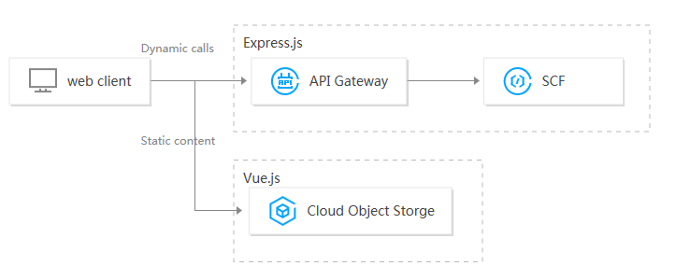

#### **3.6.1 serverless.yml**

vue-fullstack\serverless.yml

name: tencent-fullstack-vue-application

dashboard:

component: '@serverless/tencent-website'

inputs:

code:

src: dist

root: dashboard

hook: npm run build

env:

apiUrl: ${api.url}api:

component: '@serverless/tencent-express'

inputs:

code: ./api

functionName: tencent-fullstack-vue-api

apigatewayConf:

protocols:

- https

#### **3.6.2 api\package.json**

vue-fullstack\api\package.json

{

"name": "tencent-fullstack-vue-api",

"version": "0.0.0",

"dependencies": {

"cors": "^2.8.5",

"express": "^4.17.1"

},

"license": "ISC"

}

#### **3.6.3 api\app.js**

vue-fullstack\api\app.js

'use strict'**const** express = require('express');**const** cors = require('cors');**const** app = express();

app.use(cors());

app.get('/', (req, res) => {

res.send(JSON.stringify({ message: `珠峰架构` }))

});

module.exports = app;

#### **3.6.4 生成前端项目**

vue create dashboard

#### **3.6.5 src\App.vue**

vue-fullstack\dashboard\src\App.vue

<template>

<div id="app">{{message}}</div>

</template>

<script>

import "../env";

export default {

name: "App",

data() {

return {

message: "message"

};

},

mounted() {

fetch(window.env.apiUrl)

.then(res => res.json())

.then(result => {

this.message = result.message;

});

}

};

</script>

## **2.RBAC**

* 基于角色的权限访问控制（Role-Based Access Control）
* RBAC（Role-Based Access Control，基于角色的访问控制），就是用户通过角色与权限进行关联
* 一个用户拥有若干角色,每一个角色拥有若干权限。这样，就构造成用户-角色-权限的授权模型
* 在这种模型中，用户与角色之间，角色与权限之间一般是多对多的关系
* 在RBAC中最重要的概念包括：用户(User)，角色(Role)，权限(Permission)

### **2.1 示意图**

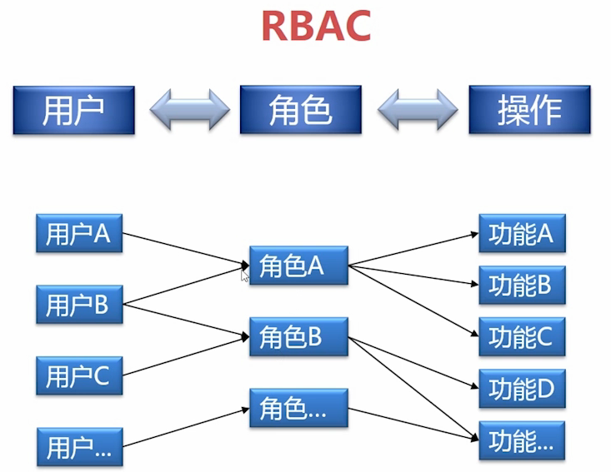

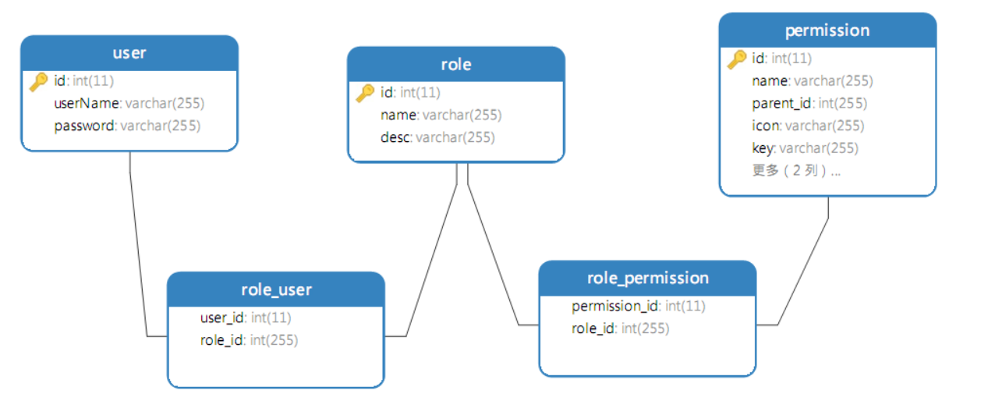

### **2.2 表设计**

#### **2.2.1 用户表(user)**

| **字段** | **字段名** | **类型** | **默认** |
| --- | --- | --- | --- |
| id | ID | int(11) |  |
| userName | 用户名 | varchar(255) |  |
| password | 密码 | varchar(255) |  |

CREATE TABLE `user` (

`id` int(11) NOT NULL AUTO_INCREMENT,

`userName` varchar(255),

`password` varchar(255),

PRIMARY KEY (`id`)

)

INSERT INTO `user` VALUES (1, 'isadmin', '123456');

INSERT INTO `user` VALUES (2, 'isuser', '123456');

#### **2.2.2 角色表(role)**

| **字段** | **字段名** | **类型** | **默认** |
| --- | --- | --- | --- |
| id | ID | int(11) |  |
| name | 名称 | varchar(255) |  |
| desc | 描述 | varchar(255) |  |

CREATE TABLE `role` (

`id` int(11) NOT NULL AUTO_INCREMENT,

`name` varchar(255) ,

`desc` varchar(255) ,

PRIMARY KEY (`id`)

) E

INSERT INTO `role` VALUES (1, 'admin', '管理员');

INSERT INTO `role` VALUES (2, 'user', '普通用户');

#### **2.2.3 权限表(permission)**

| **字段** | **字段名** | **类型** | **默认** |
| --- | --- | --- | --- |
| id | ID | int(11) |  |
| name | 名称 | varchar(255) |  |
| parent_id | 父ID | int(11) |  |
| icon | 图标 | varchar(255) |  |
| key | 路径 | varchar(255) |  |
| type | 类型 | varchar(32) |  |

CREATE TABLE `permission` (

`id` int(11) NOT NULL AUTO_INCREMENT,

`name` varchar(255) ,

`parent_id` int(11) NULL DEFAULT NULL,

`icon` varchar(255) ,

`key` varchar(255) ,

`type` varchar(255) ,

PRIMARY KEY (`id`)

);

INSERT INTO `permission` VALUES (1, '授权平台', 0, 'desktop', '/api', 'menu');

INSERT INTO `permission` VALUES (2, '角色管理', 1, 'team', '/api/role', 'menu');

INSERT INTO `permission` VALUES (3, '用户管理', 1, 'user', '/api/user', 'menu');

INSERT INTO `permission` VALUES (4, '权限管理', 1, 'idcard', '/api/resource', 'menu');

INSERT INTO `permission` VALUES (5, '添加用户', 3, 'team', '/api/user/add', 'button');

INSERT INTO `permission` VALUES (6, '删除用户', 3, 'team', '/api/user/delete', 'button');

#### **2.2.4 角色用户表(role_user)**

| **字段** | **字段名** | **类型** |
| --- | --- | --- |
| role_id | 角色ID | int(11) |
| user_id | 用户ID | int(11) |

DROP TABLE IF EXISTS `role_user`;

CREATE TABLE `role_user` (

`role_id` int(11) NOT NULL,

`user_id` int(11) NOT NULL,

PRIMARY KEY (`user_id`, `role_id`)

)

INSERT INTO `role_user` VALUES (1, 1);

INSERT INTO `role_user` VALUES (2, 2);

#### **2.2.5 角色权限(role_permission)**

| **字段** | **字段名** | **类型** |
| --- | --- | --- |
| role_id | 角色ID | int(11) |
| permission_id | 资源ID | int(11) |

CREATE TABLE `role_permission` (

`role_id` int(11) NOT NULL,

`permission_id` int(255) NOT NULL,

PRIMARY KEY (`role_id`, `permission_id`)

)

INSERT INTO `role_permission` VALUES (1, 1);

INSERT INTO `role_permission` VALUES (1, 2);

INSERT INTO `role_permission` VALUES (1, 3);

INSERT INTO `role_permission` VALUES (1, 4);

INSERT INTO `role_permission` VALUES (1, 5);

INSERT INTO `role_permission` VALUES (1, 6);

INSERT INTO `role_permission` VALUES (2, 1);

INSERT INTO `role_permission` VALUES (2, 4);

#### **2.2.6 数据库脚本**

* [cms.sql](http://img.zhufengpeixun.cn/cms.sql)

## **3.egg.js**

* [tencent-egg](https://github.com/serverless-components/tencent-egg)

### **3.1. 初始化项目**

$ mkdir egg-cms && cd egg-cms

$ cnpm init egg --type=simple

$ cnpm i

### **3.2. 添加模块**

* [mysql](https://dev.mysql.com/doc/refman/5.6/en/)
* [redis](https://github.com/microsoftarchive/redis/releases)

$ cd egg-cms

$ npm install egg-sequelize mysql2 egg-jwt egg-redis --save

### **3.3. config\plugin.js**

'use strict';

module.exports = {

sequelize: {

enable: true,

package: "egg-sequelize"

},

jwt: {

enable: true,

package: "egg-jwt"

},

redis: {

enable: true,

package: "egg-redis"

}

};

### **3.4. config\config.default.js**

/* eslint valid-jsdoc: "off" */

'use strict';

/**

* @param {Egg.EggAppInfo} appInfo app info

*/

module.exports = appInfo => {

/**

* built-in config

* @type {Egg.EggAppConfig}

**/

const config = exports = {};

// use for cookie sign key, should change to your own and keep security

config.keys = appInfo.name + '_1588409777990_9883';

// add your middleware config here

config.middleware = [];

// add your user config here

const userConfig = {+ security: {+ csrf: false+ },+ sequelize: {+ dialect: "mysql",+ host: "localhost",+ port: "3306",+ database: "egg-cms",+ username: "root",+ password: "5f8b8a5d650637f8"+ },+ redis: {+ client: {+ port: 6379, // Redis port+ host: '127.0.0.1', // Redis host+ password: 'auth',+ db: 0,+ },+ }

};

return {

...config,

...userConfig,

};

};

### **3.5. model\user.js**

app\model\user.js

module.exports = app => {

**const** { STRING, INTEGER, DATE } = app.Sequelize;

**const** User = app.model.define("user", {

id: { type: INTEGER, primaryKey: true, autoIncrement: true },

userName: STRING(30),

password: STRING(30),

created_at: DATE,

updated_at: DATE

});

**return** User;

};

### **3.6. app\controller\home.js**

* [jwt.io](https://jwt.io/)

app\controller\home.js

'use strict';

**const** Controller = require('egg').Controller;

**class** **HomeController** **extends** **Controller** {

**async** index() {

**const** { ctx } = **this**;

ctx.body = 'hi, egg';

}

**async** currentUser() {

**const** { ctx } = **this**;

**const** { user } = ctx.state;

**this**.ctx.body = {

name: user.userName,

avatar: 'http://img.zhufengpeixun.cn/tuizi.jpg',

userid: user.id

}

}

**async** login() {

**const** { ctx, app } = **this**;

**let** { userName, password } = ctx.request.body;

**const** users = **await** ctx.model.User.findAll({

where: { userName, password },

limit: 1

});

**if** (users.length > 0) {

**let** user = users[0];

ctx.status = 200;

**const** token = app.jwt.sign(

{

id: user.id,

userName: user.userName

},

app.config.jwt.secret,

{

expiresIn: "1h"

}

);

**await** app.redis.set(`token_${user.id}`, token);

ctx.body = {

status: 'ok',

type: 'account',

currentAuthority: 'admin',

token

}

} **else** {

ctx.body = {

status: 'error'

}

}

}

}

module.exports = HomeController;

### **3.7. app\router.js**

app\router.js

module.exports = app => {

const { router, controller, jwt } = app;

router.get('/', controller.home.index);+ router.post('/api/login/account', controller.home.login);+ router.get('/api/currentUser', jwt, controller.home.currentUser);

};

### **3.8. app.js**

app.js

**class** **AppBootHook** {

**constructor**(app) {

**this**.app = app;

}

**async** willReady() {

**await** **this**.app.model.sync({ logging: console.log, force: true });

**await** **this**.app.model.query(

"INSERT INTO users (user_name, password) VALUES ('admin', '123456')"

);

}

}

module.exports = AppBootHook;

## **4. 前端项目**

### **4.1. 启动项目**

* [pro.ant.design](https://pro.ant.design/docs/getting-started-cn)
* [create-umi](https://github.com/umijs/create-umi)

umi -v

cnpm create umi

### **4.2 config\config.ts**

config\config.ts

export default {

dev: {+ '/server/api/': {+ target: 'http://127.0.0.1:7001',+ changeOrigin: true,+ pathRewrite: { '^/server': '' },+ },

/* '/api/': {

target: 'https://preview.pro.ant.design',

changeOrigin: true,

pathRewrite: { '^': '' },

}, */

},

test: {

'/api/': {

target: 'https://preview.pro.ant.design',

changeOrigin: true,

pathRewrite: { '^': '' },

},

},

pre: {

'/api/': {

target: 'your pre url',

changeOrigin: true,

pathRewrite: { '^': '' },

},

},

};

### **4.3 services\login.ts**

src\services\login.ts

export async function fakeAccountLogin(params: LoginParamsType) {+ return request('/server/api/login/account', {

method: 'POST',

data: params,

});

}

### **4.4 services\user.ts**

src\services\user.ts

export async function queryCurrent(): Promise<any> {+ return request('/server/api/currentUser');

}

### **4.5 models\login.ts**

src\models\login.ts

effects: {

*login({ payload }, { call, put }) {

const response = yield call(fakeAccountLogin, payload);

yield put({

type: 'changeLoginStatus',

payload: response,

});

// Login successfully

if (response.status === 'ok') {+ if (response.token) {+ localStorage.setItem('token', response.token);+ }

const urlParams = new URL(window.location.href);

### **4.6 utils\request.ts**

src\utils\request.ts

const request = extend({

errorHandler, // 默认错误处理

credentials: 'include', // 默认请求是否带上cookie

});+request.interceptors.request.use((url: any, options: any) => {+ if (localStorage.getItem('token')) {+ options.headers.Authorization = 'Bearer ' + localStorage.getItem('token')+ }+ return { url, options };+});

export default request;