## **1.loader 的配置**

### **1.1 webpack config**

module: {

rules: [

{

test: /\.css/,

use: [

{ loader: 'style-loader' },

{ loader: 'css-loader' }

]

}

]

}

### **1.2 inline内联**

**import** 'style-loader!css-loader!style.css';

## **2.RuleSet**

* RuleSet 类主要作用于过滤加载 module 时符合匹配条件规则的 loader
* RuleSet 在内部会有一个默认的 module.defaultRules 配置
* 在真正加载 module 之前会和你在 webpack config 配置文件当中的自定义 module.rules 进行合并，然后转化成对应的匹配过滤器
* [WebpackOptionsDefaulter](https://github.com/webpack/webpack/blob/v4.43.0/lib/WebpackOptionsDefaulter.js" \l "L60)
* [RuleSet](https://github.com/webpack/webpack/blob/v4.43.0/lib/RuleSet.js" \l "L104)

[

{ type: 'javascript/auto', resolve: {} },

{ test: /\.mjs$/i,type: 'javascript/esm',resolve: { mainFields: [Array] } },

{ test: /\.json$/i, type: 'json' },

{ test: /\.wasm$/i, type: 'webassembly/experimental' }

]

**class** **NormalModuleFactory** {

**this**.ruleSet = **new** RuleSet(options.defaultRules.concat(options.rules));

}

### **2.1 rule配置**

* test 用以匹配满足条件的 loader
* include 用以匹配满足条件的 loader
* exclude 排除满足条件 loader
* resource [condition](https://github.com/webpack/webpack/blob/v4.43.0/lib/RuleSet.js" \l "L183)
* resourceQuery 在路径中带 query 参数的匹配规则
* [normalizeRule](https://github.com/webpack/webpack/blob/v4.43.0/lib/RuleSet.js" \l "L183)作用实际就是对传入的 rules 配置进行序列化(格式化)的处理为统一的格式
* [normalizeCondition](https://github.com/webpack/webpack/blob/c9d4ff7b054fc581c96ce0e53432d44f9dd8ca72/lib/RuleSet.js" \l "L413) 函数执行后始终返回的是一个函数，这个函数的用途就是接受模块的路径，然后使用你所定义的匹配使用去看是否满足对应的要求，如果满足那么会使用这个 loader，如果不满足那么便会过滤掉
* 在 RuleSet 构造函数内部使用静态方法[normalizeUse](https://github.com/webpack/webpack/blob/c9d4ff7b054fc581c96ce0e53432d44f9dd8ca72/lib/RuleSet.js" \l "L351) 方法来输出最终和 condition 对应的 rule 结果
* 经过 normalizeUse 函数的格式化处理，最终的 rule 结果为一个数组，内部的 object 元素都包含 loader/options 等字段

**static** normalizeRule(rule, refs, ident) {

**let** condition = {

test: rule.test,

include: rule.include,

exclude: rule.exclude

};

newRule.resource = RuleSet.normalizeCondition(condition);

}

**static** normalizeCondition(condition) {

**if** (**typeof** condition === "string") {

**return** str => str.indexOf(condition) === 0;

}

**if** (**typeof** condition === "function") {

**return** condition;

}

**if** (condition **instanceof** RegExp) {

**return** condition.test.bind(condition);

}

}

**static** normalizeUse(use, ident) {

**if** (**typeof** use === "function") {

**return** data => RuleSet.normalizeUse(use(data), ident);

}

}

normalizeUse结果

[

{loader:'style-loader'},

{loader:'css-loader'}

]

rules:

[

{

resource: [Function],

resourceQuery: [Function],

use: [

{loader:'style-loader'},

{loader:'css-loader'}

]

}

]

[ruleSet.exec](https://github.com/webpack/webpack/blob/v4.43.0/lib/NormalModuleFactory.js" \l "L270)

**const** result = **this**.ruleSet.exec({

resource: resourcePath,

resourceQuery

});

[

{

type: 'use',

value: {

loader: 'style-loader',

options: {}

},

enforce: undefined

},

{

type: 'use',

value: {

loader: 'css-loader',

options: {}

},

enforce: undefined

}

]

## **3.创建模块**

* [实例化ruleSet](https://github.com/webpack/webpack/blob/v4.43.0/lib/NormalModuleFactory.js" \l "L115)
* [RuleSet](https://github.com/webpack/webpack/blob/v4.43.0/lib/RuleSet.js)
* [Compilation.moduleFactory.create](https://github.com/webpack/webpack/blob/v4.43.0/lib/Compilation.js)
* [NormalModuleFactory.create](https://github.com/webpack/webpack/blob/v4.43.0/lib/NormalModuleFactory.js" \l "L373)
* [resolver](https://github.com/webpack/webpack/blob/v4.43.0/lib/NormalModuleFactory.js" \l "L159-L371)

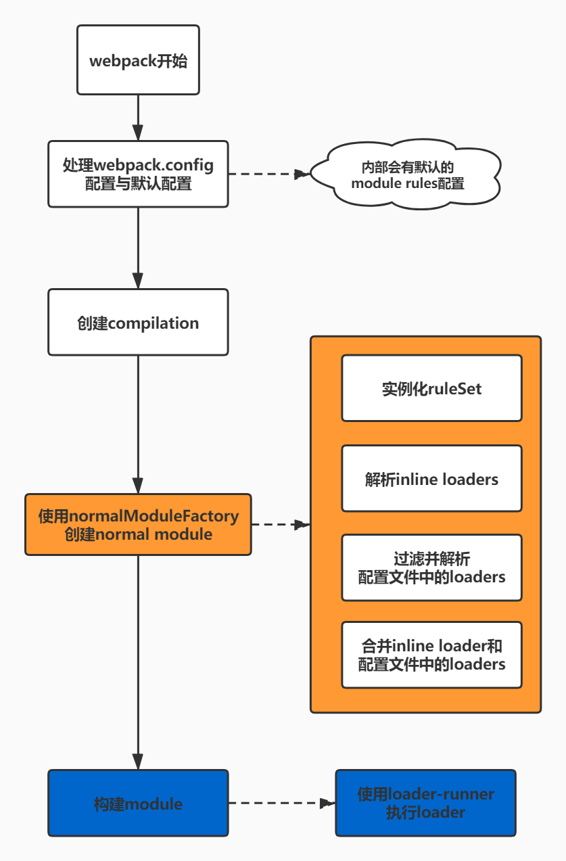

## **4.编译模块**

* [Compilation.buildModule](https://github.com/webpack/webpack/blob/v4.43.0/lib/Compilation.js" \l "L1111)
* [Compilation.module.build](https://github.com/webpack/webpack/blob/v4.43.0/lib/Compilation.js" \l "L739)
* [NormalModule.js.build](https://github.com/webpack/webpack/blob/v4.43.0/lib/NormalModule.js" \l "L427)
* [NormalModule.doBuild](https://github.com/webpack/webpack/blob/v4.43.0/lib/NormalModule.js" \l "L287)
* [NormalModule.runLoaders](https://github.com/webpack/webpack/blob/v4.43.0/lib/NormalModule.js" \l "L295)
* [NormalModule.parser](https://github.com/webpack/webpack/blob/v4.43.0/lib/NormalModule.js" \l "L482)

