## **1.module**

* 对于webpack来说每个文件都是一个module
* webpack会从配置中entry定义开始，找到全部的文件，并转化为 module

## **2.build流程**

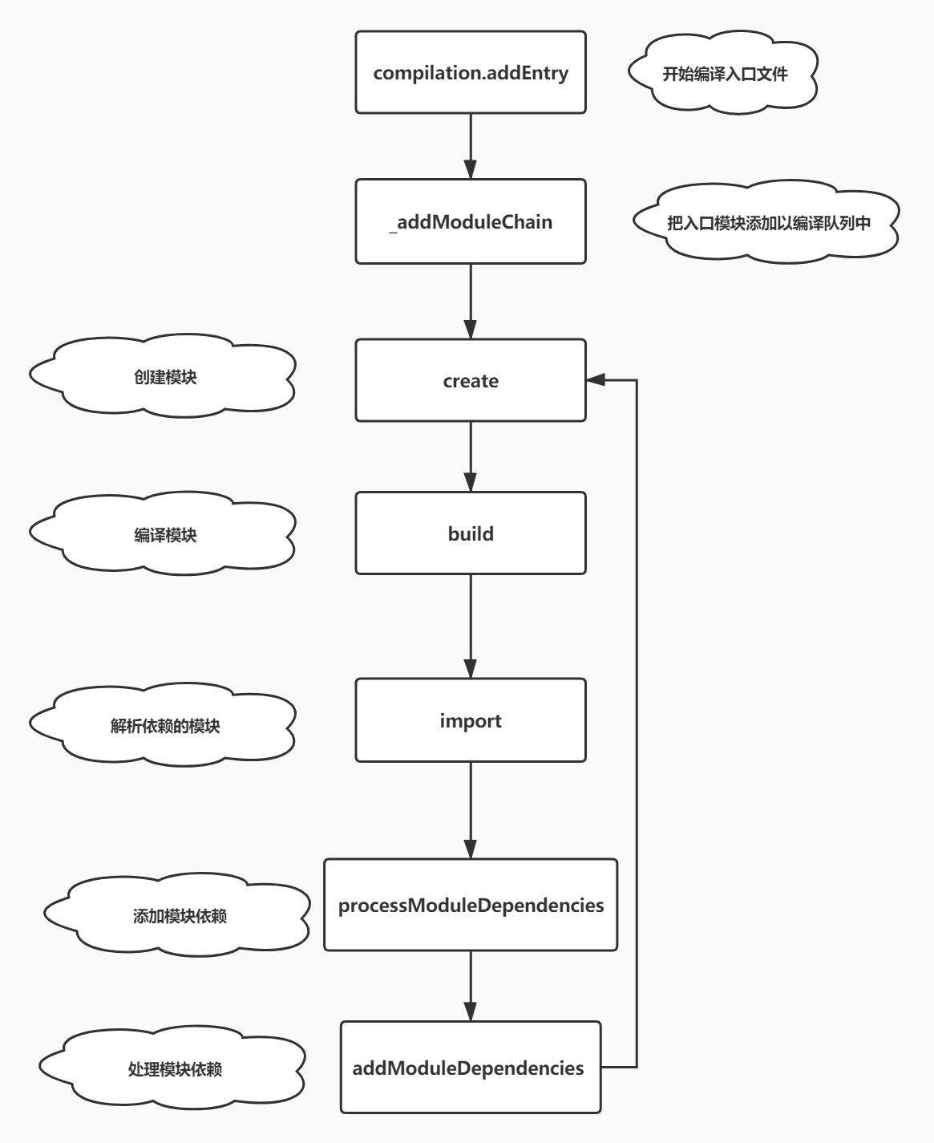

## **3.编译队列控制**

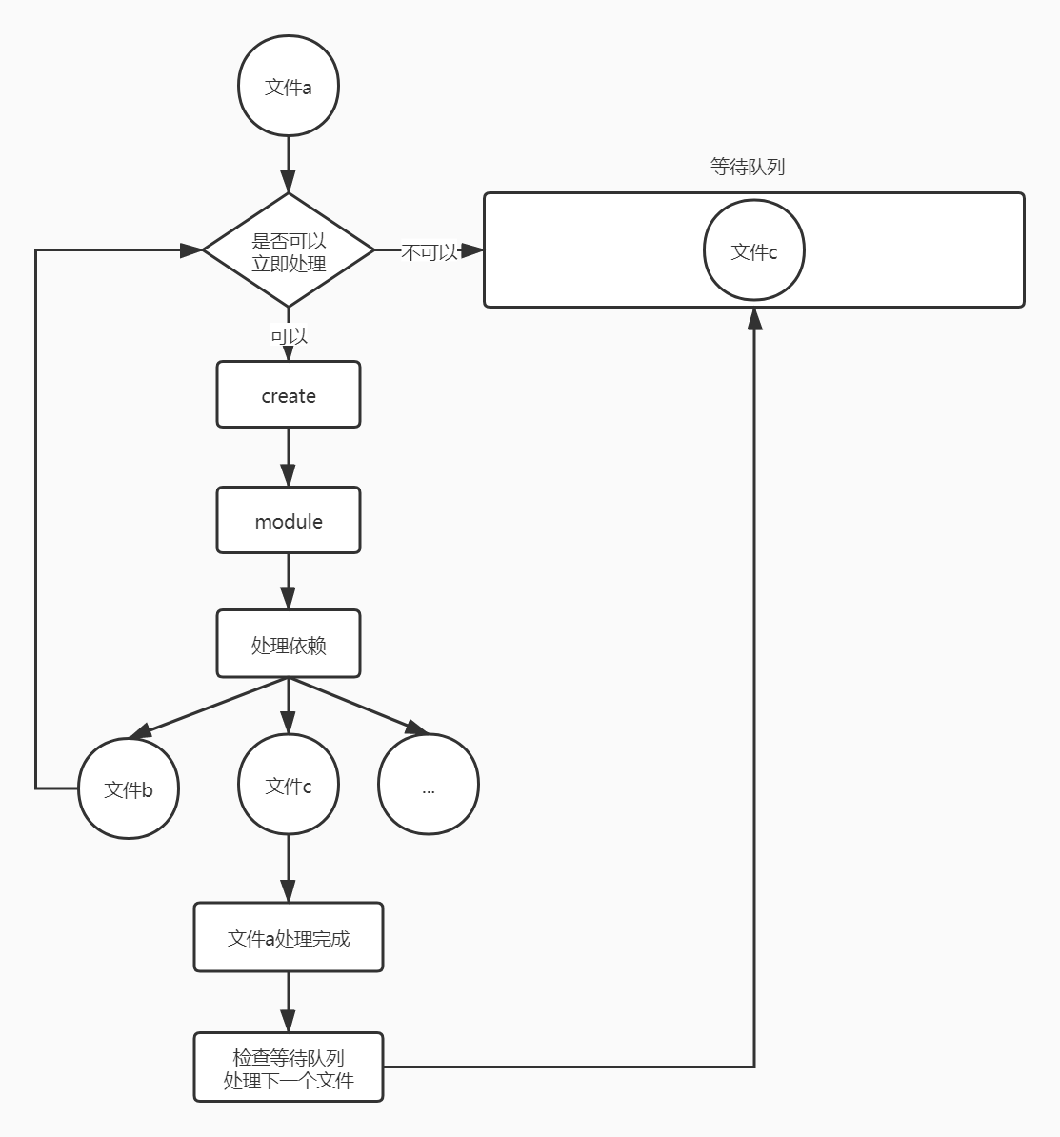

## **4.entry配置**

### **4.1 字符串**

entry: './index.js',

### **4.2 字符串数组**

entry: ['./index1.js', './index2.js']

### **4.3 对象**

entry: {

main: './main.js'

}

### **4.4 函数**

entry: () => './index.js'entry: () => **new** Promise((resolve) => resolve('./index.js'))

## **5.SingleEntryPlugin**

* [entryOption](https://github.com/webpack/webpack/blob/v4.43.0/lib/WebpackOptionsApply.js" \l "L290-L291)
* [SingleEntryPlugin.js](https://github.com/webpack/webpack/blob/v4.43.0/lib/SingleEntryPlugin.js)

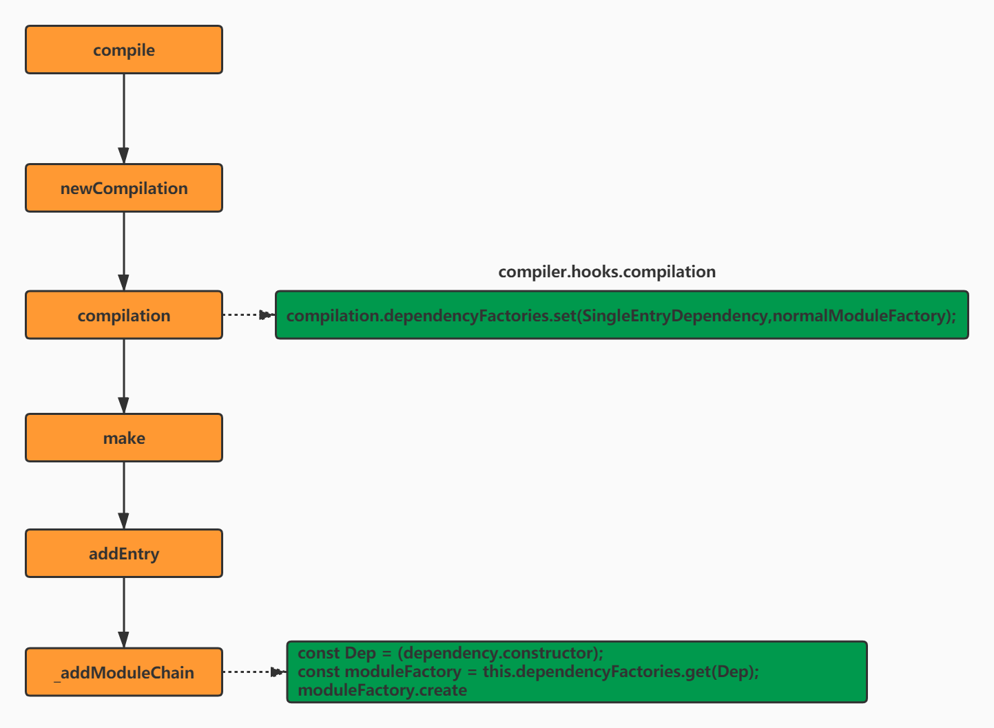

### **5.1 注册模块工厂**

compiler.hooks.compilation.tap("SingleEntryPlugin",

(compilation, { normalModuleFactory }) => {

compilation.dependencyFactories.set(SingleEntryDependency,normalModuleFactory);

}

);

### **5.2 make**

* 注册了make事件回调，在make阶段的时候调用addEntry方法，然后进入_addModuleChain进入正式的编译阶段
* [compile](https://github.com/webpack/webpack/blob/c9d4ff7b054fc581c96ce0e53432d44f9dd8ca72/lib/Compiler.js" \l "660)
* [newCompilationParams](https://github.com/webpack/webpack/blob/c9d4ff7b054fc581c96ce0e53432d44f9dd8ca72/lib/Compiler.js" \l "651-L658)
* [this.hooks.compilation.call](https://github.com/webpack/webpack/blob/v4.43.0/lib/Compiler.js" \l "L631)
* [this.dependencyFactories.get(Dep)](https://github.com/webpack/webpack/blob/c9d4ff7b054fc581c96ce0e53432d44f9dd8ca72/lib/Compilation.js" \l "L1054-L1063)

## **6.dependency**

* [dependencies](https://github.com/webpack/webpack/tree/c9d4ff7b054fc581c96ce0e53432d44f9dd8ca72/lib/dependencies)
* 生成chunk时会依靠dependency来得到依赖关系图
* 生成最终文件时会依赖dependency中方法和保存的信息将源文件中的import等语句替换成最终输出的可执行的JS语句

module: {

dependencies: [

dependency: {

module

}

]

}

## **7.文件转 module**

* create 创建 module 实例
* add module保存到 Compilation 实例上
* build 分析文件内容,并分析依赖项
* processDep 处理依赖，并添加到编译链条中

### **7.1 create**

* [NormalModuleFactory.create](https://github.com/webpack/webpack/blob/c9d4ff7b054fc581c96ce0e53432d44f9dd8ca72/lib/NormalModuleFactory.js" \l "L373-L414)

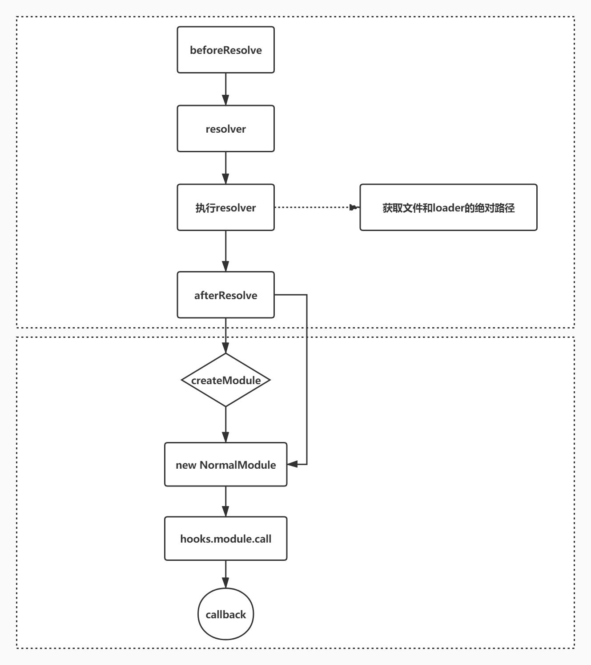

### **7.2 addModule**

add 阶段是将 module 的所有信息保存到 Compilation 中，以便于在最后打包成 chunk 的时候使用

* + 保存到全局的 Compilation.modules 数组中
  + 保存到Compilation._modules 对象
  + 添加 reason
  + 添加Compilation.entries

[moduleFactory.create.callback](https://github.com/webpack/webpack/blob/c9d4ff7b054fc581c96ce0e53432d44f9dd8ca72/lib/Compilation.js" \l "L1073-L1132)

addModule(module) {

**const** identifier = module.identifier();

**this**._modules.set(identifier, module);

**this**.modules.push(module);

**this**.entries.push(module);

module.reasons.push(**new** ModuleReason(module, dependency, explanation));

}

### **7.3 buildModule**

* [buildModule](https://github.com/webpack/webpack/blob/c9d4ff7b054fc581c96ce0e53432d44f9dd8ca72/lib/NormalModule.js" \l "L427-L506)

build(options, compilation, resolver, fs, callback) {

**return** **this**.doBuild(options, compilation, resolver, fs, err => {

// 处理 source 这里会将 source 转为 AST，分析出所有的依赖

**const** result = **this**.parser.parse(**this**._ast || **this**._source.source());

handleParseResult(result);

})

}

//获取 source

doBuild(options, compilation, resolver, fs, callback) {

runLoaders(

{

resource: **this**.resource,

loaders: **this**.loaders,

context: loaderContext,

readResource: fs.readFile.bind(fs)

},

(err, result) => {

// createSource 会将 runLoader 得到的结果转为字符串以便后续处理

**this**._source = **this**.createSource(

**this**.binary ? asBuffer(source) : asString(source),

resourceBuffer,

sourceMap

);

**return** callback();

}

);

}

### **7.4 parse**

* [astexplorer](https://astexplorer.net/)
* 将 source 转为 AST(如果 source 是字符串类型)

遍历 AST，遇到 import 语句就增加相关依赖

* + 树的遍历 program事件 -> detectStrictMode -> preWalkStatements -> walkStatements
  + 遍历过程中会给module增加dependency实例,每个 dependency 类都会有一个 template 方法，并且保存了原来代码中的字符位置 range,在最后生成打包后的文件时，会用 template 的结果替换 range 部分的内容
  + 最终得到的 dependency 不仅包含了文件中所有的依赖信息，还被用于最终生成打包代码时对原始内容的修改和替换

[parse](https://github.com/webpack/webpack/blob/c9d4ff7b054fc581c96ce0e53432d44f9dd8ca72/lib/Parser.js" \l "L2265-L2303)

[HarmonyImportDependencyParserPlugin](https://github.com/webpack/webpack/blob/c9d4ff7b054fc581c96ce0e53432d44f9dd8ca72/lib/dependencies/HarmonyImportDependencyParserPlugin.js)

得到的依赖

* + [HarmonyCompatibilityDependency](https://github.com/webpack/webpack/blob/c9d4ff7b054fc581c96ce0e53432d44f9dd8ca72/lib/dependencies/HarmonyCompatibilityDependency.js) 添加__webpack_require__.r(__webpack_exports__) [RuntimeTemplate](https://github.com/webpack/webpack/blob/c9d4ff7b054fc581c96ce0e53432d44f9dd8ca72/lib/RuntimeTemplate.js" \l "L333)
  + [HarmonyInitDependency](https://github.com/webpack/webpack/blob/c9d4ff7b054fc581c96ce0e53432d44f9dd8ca72/lib/dependencies/HarmonyInitDependency.js) var _title_js__WEBPACK_IMPORTED_MODULE_0__
  + [ConstDependency](https://github.com/webpack/webpack/blob/c9d4ff7b054fc581c96ce0e53432d44f9dd8ca72/lib/dependencies/ConstDependency.js) 放置一个占位符,在最后生成打包文件的时候将其再转为 use strict
  + [HarmonyImportSideEffectDependency](https://github.com/webpack/webpack/blob/c9d4ff7b054fc581c96ce0e53432d44f9dd8ca72/lib/dependencies/HarmonyImportSideEffectDependency.js) var _title_js__WEBPACK_IMPORTED_MODULE_0__ = __webpack_require__(/*! ./title.js */ "./src/title.js");
  + [HarmonyImportSpecifierDependency](https://github.com/webpack/webpack/blob/c9d4ff7b054fc581c96ce0e53432d44f9dd8ca72/lib/dependencies/HarmonyImportSpecifierDependency.js) console.log(_title_js__WEBPACK_IMPORTED_MODULE_0__["message"]);

title.js

**export** **const** message = 'zhufeng';

lazy.js

**export** **const** message = 'zhufeng';

index.js

**import** { message } **from** './title.js';console.log(message);**import**('./lazy.js').then(result => {

console.log(result);

})console.log(__resourceQuery);

prewalkStatements(statements) {

**for** (**let** index = 0, len = statements.length; index < len; index++) {

**const** statement = statements[index];

**this**.prewalkStatement(statement);

}

}

prewalkImportDeclaration(statement) {

**const** source = statement.source.value;//./title.js

**this**.hooks.import.call(statement, source);

**for** (**const** specifier **of** statement.specifiers) {

**const** name = specifier.local.name;//name

**this**.scope.renames.set(name, null);

**this**.scope.definitions.add(name);

**switch** (specifier.type) {

**case** "ImportDefaultSpecifier":

**this**.hooks.importSpecifier.call(statement, source, "default", name);

**break**;

**case** "ImportSpecifier":

**this**.hooks.importSpecifier.call(

statement,

source,

specifier.imported.name,

name

);

**break**;

}

}

}

HarmonyImportDependencyParserPlugin

**const** sideEffectDep = **new** HarmonyImportSideEffectDependency(

source,

parser.state.module,

parser.state.lastHarmonyImportOrder,

parser.state.harmonyParserScope

);

sideEffectDep.loc = statement.loc;

parser.state.module.addDependency(sideEffectDep);

### **7.5 依赖处理**

* 对 dependencies 按照代码在文件中出现的先后顺序排序
* [Compilation.js](https://github.com/webpack/webpack/blob/c9d4ff7b054fc581c96ce0e53432d44f9dd8ca72/lib/Compilation.js" \l "L1093-L1102)

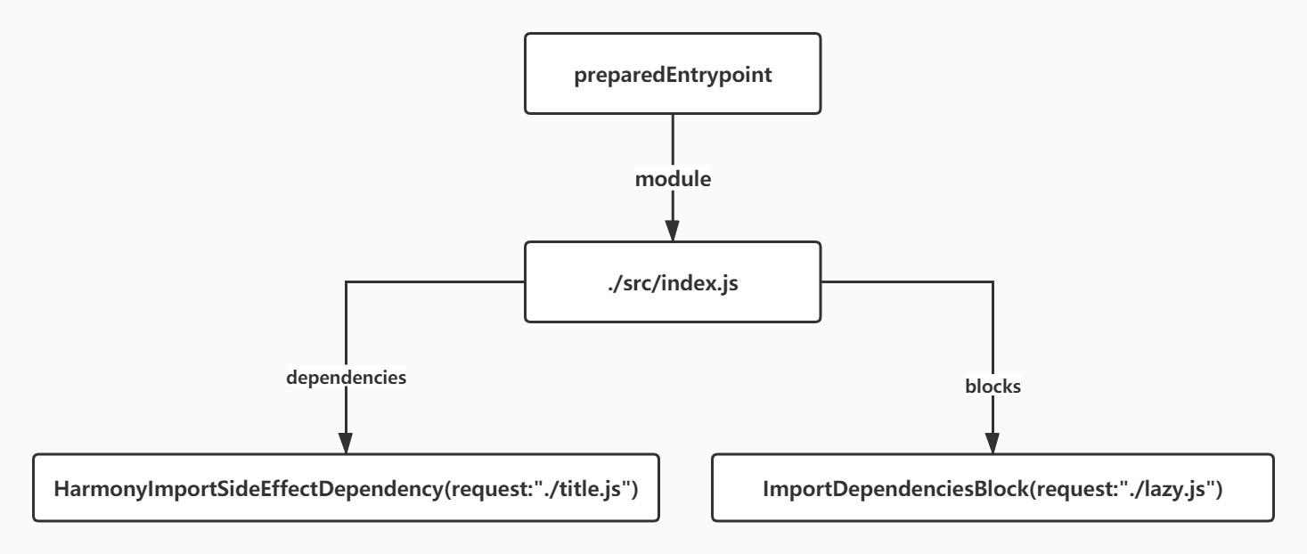

**const** afterBuild = () => {

**if** (addModuleResult.dependencies) {

**this**.processModuleDependencies(module, err => {

**if** (err) **return** callback(err);

callback(null, module);

});

} **else** {

**return** callback(null, module);

}

};

dependencies={

NormalModuleFactory: {

"module./title.js": [

HarmonyImportSideEffectDependency,

HarmonyImportSpecifierDependency

],

"module./lazy.js": [

HarmonyImportSideEffectDependency,

HarmonyImportSpecifierDependency

]

}

}

sortedDependencies = [

{

factory: NormalModuleFactory,

dependencies: [

HarmonyImportSideEffectDependency,

HarmonyImportSpecifierDependency

]

},

{

factory: NormalModuleFactory,

dependencies: [

HarmonyImportSideEffectDependency,

HarmonyImportSpecifierDependency

]

}

]

addModuleDependencies(

module,

dependencies,

bail,

cacheGroup,

recursive,

callback

) {

asyncLib.forEach(

dependencies,

(item, callback) => {

//获取依赖

**const** dependencies = item.dependencies;

//获取工厂

**const** factory = item.factory;

//创建模块

factory.create(

(err, dependentModule) => {

**const** addModuleResult = **this**.addModule(dependentModule);

dependentModule = addModuleResult.module;

// 将 module 信息写入依赖中

iterationDependencies(dependencies);

// build 阶段

**const** afterBuild = () => {

// build 阶段结束后有依赖的话继续处理依赖

**this**.processModuleDependencies(dependentModule, callback);

};

**this**.buildModule(afterBuild);

}

);

}

);

}

dependencies{

HarmonyImportSideEffectDependency(request:"./title.js")

}

blocks{

ImportDependenciesBlock(request:"./lazy.js")

}

### **7.6 流程**

