## **1. webpack的插件机制**

* 在具体介绍webpack内置插件与钩子可视化工具之前，我们先来了解一下webpack中的插件机制。 webpack实现插件机制的大体方式是：
  + 创建 - webpack在其内部对象上创建各种钩子；
  + 注册 - 插件将自己的方法注册到对应钩子上，交给webpack；
  + 调用 - webpack编译过程中，会适时地触发相应钩子，因此也就触发了插件的方法。
* Webpack本质上是一种事件流的机制，它的工作流程就是将各个插件串联起来，而实现这一切的核心就是Tapable，webpack中最核心的负责编译的Compiler和负责创建bundle的Compilation都是Tapable的实例
* 通过事件和注册和监听，触发webpack生命周期中的函数方法

**const** {

SyncHook,

SyncBailHook,

SyncWaterfallHook,

SyncLoopHook,

AsyncParallelHook,

AsyncParallelBailHook,

AsyncSeriesHook,

AsyncSeriesBailHook,

AsyncSeriesWaterfallHook

} = require('tapable');

## **2. tapable分类**

### **2.1 按同步异步分类**

* Hook 类型可以分为同步Sync和异步Async，异步又分为并行和串行

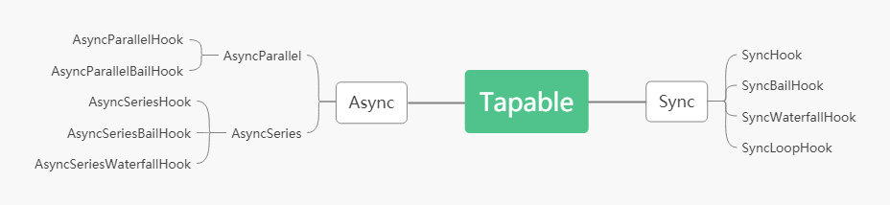

### **2.1 按返回值分类**

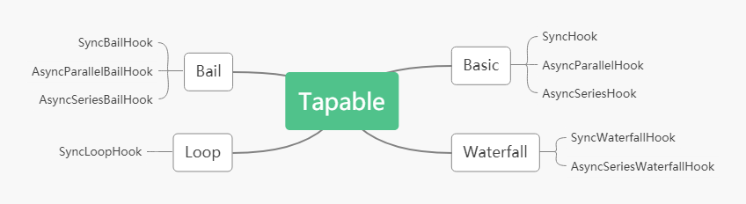

#### **2.1.1 Basic**

* 执行每一个事件函数，不关心函数的返回值,有 SyncHook、AsyncParallelHook、AsyncSeriesHook

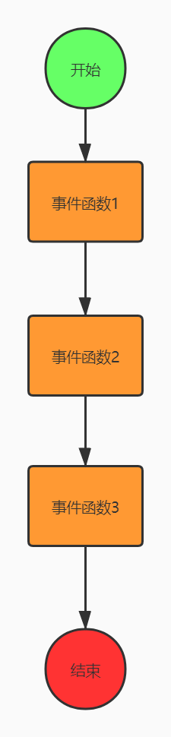

#### **2.1.2 Bail**

* 执行每一个事件函数，遇到第一个结果 result !== undefined 则返回，不再继续执行。有：SyncBailHook、AsyncSeriesBailHook, AsyncParallelBailHook

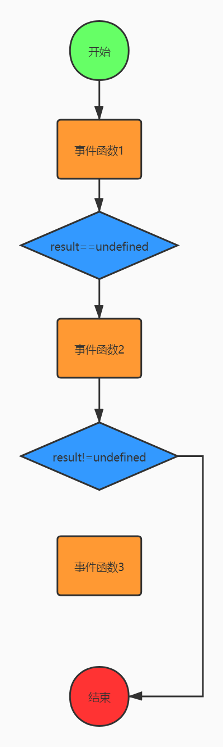

#### **2.1.3 Waterfall**

* 如果前一个事件函数的结果 result !== undefined,则 result 会作为后一个事件函数的第一个参数,有SyncWaterfallHook，AsyncSeriesWaterfallHook

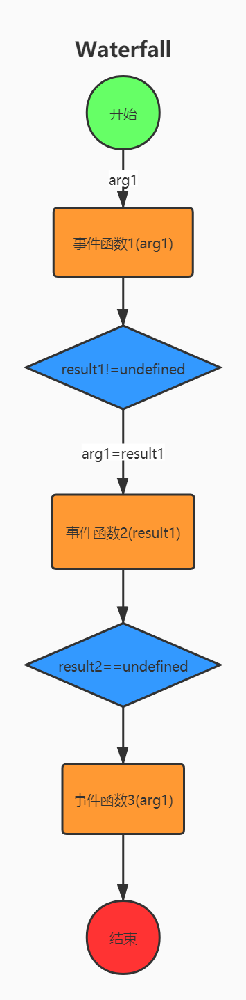

#### **2.1.4 Loop**

* 不停的循环执行事件函数，直到所有函数结果 result === undefined,有SyncLoopHook 和 AsyncSeriesLoopHook

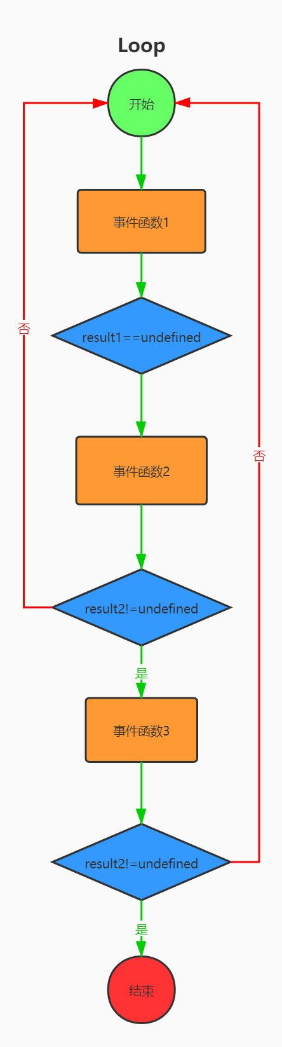

## **3.使用**

### **3.1 SyncHook**

* 所有的构造函数都接收一个可选参数，参数是一个参数名的字符串数组
* 参数的名字可以任意填写，但是参数数组的长数必须要根实际接受的参数个数一致
* 如果回调函数不接受参数，可以传入空数组
* 在实例化的时候传入的数组长度长度有用，值没有用途
* 执行call时，参数个数和实例化时的数组长度有关
* 回调的时候是按先入先出的顺序执行的，先放的先执行

**const** {SyncHook} = require('tapable');**const** hook = **new** SyncHook(['name','age']);

hook.tap('1',(name,age)=>{

console.log(1,name,age);

**return** 1;

});

hook.tap('2',(name,age)=>{

console.log(2,name,age);

**return** 2;

});

hook.tap('3',(name,age)=>{

console.log(3,name,age);

**return** 3;

});

hook.call('zhufeng',10);

1 zhufeng 102 zhufeng 103 zhufeng 10

### **3.2 SyncBailHook**

* BailHook中的回调函数也是顺序执行的
* 调用call时传入的参数也可以传给回调函数
* 当回调函数返回非undefined值的时候会停止调用后续的回调

**const** {SyncBailHook} = require('tapable');**const** hook = **new** SyncBailHook(['name','age']);

hook.tap('1',(name,age)=>{

console.log(1,name,age);

//return 1;

});

hook.tap('2',(name,age)=>{

console.log(2,name,age);

**return** 2;

});

hook.tap('3',(name,age)=>{

console.log(3,name,age);

**return** 3;

});

hook.call('zhufeng',10);

### **3.3 SyncWaterfallHook**

* SyncWaterfallHook表示如果上一个回调函数的结果不为undefined,则可以作为下一个回调函数的第一个参数
* 回调函数接受的参数来自于上一个函数的结果
* 调用call传入的第一个参数，会被上一个函数的非undefined结果替换
* 当回调函数返回非undefined不会停止回调栈的调用

**const** {SyncWaterfallHook} = require('tapable');

**const** hook = **new** SyncWaterfallHook(['name','age']);

hook.tap('1',(name,age)=>{

console.log(1,name,age);

**return** 1;

});

hook.tap('2',(name,age)=>{

console.log(2,name,age);

**return** ;

});

hook.tap('3',(name,age)=>{

console.log(3,name,age);

**return** 3;

});

hook.call('zhufeng',10);

### **3.4 SyncLoopHook**

* SyncLoopHook的特点是不停的循环执行回调函数，直到函数结果等于undefined
* 要注意的是每次循环都是从头开始循环的

**const** { SyncLoopHook } = require('tapable');//当回调函数返回非undefined值的时候会停止调用后续的回调

**let** hook = **new** SyncLoopHook(['name', 'age']);**let** counter1 = 0;**let** counter2 = 0;**let** counter3 = 0;

hook.tap('1', (name, age) => {

console.log(1, 'counter1', counter1);

**if** (++counter1 == 1) {

counter1 = 0

**return**;

}

**return** true;

});

hook.tap('2', (name, age) => {

console.log(2, 'counter2', counter2);

**if** (++counter2 == 2) {

counter2 = 0

**return**;

}

**return** true;

});

hook.tap('3', (name, age) => {

console.log(3, 'counter3', counter3);

**if** (++counter3 == 3) {

counter3 = 0

**return**;

}

**return** true;

});

hook.call('zhufeng', 10);

1 counter1 02 counter2 01 counter1 02 counter2 13 counter3 01 counter1 02 counter2 01 counter1 02 counter2 13 counter3 11 counter1 02 counter2 01 counter1 02 counter2 13 counter3 2

### **3.5 AsyncParallelHook**

* 异步并行执行钩子

#### **3.5.1 tap**

* 同步注册

**let** {AsyncParallelHook}=require('tapable');**let** queue = **new** AsyncParallelHook(['name']);console.time('cost');

queue.tap('1',**function**(name){

console.log(1);

});

queue.tap('2',**function**(name){

console.log(2);

});

queue.tap('3',**function**(name){

console.log(3);

});

queue.callAsync('zfpx',err=>{

console.log(err);

console.timeEnd('cost');

});

#### **3.5.2 tapAsync**

* 异步注册，全部任务完成后执行最终的回调

**let** {AsyncParallelHook}=require('tapable');**let** queue = **new** AsyncParallelHook(['name']);console.time('cost');

queue.tapAsync('1',**function**(name,callback){

setTimeout(**function**(){

console.log(1);

callback();

},1000)

});

queue.tapAsync('2',**function**(name,callback){

setTimeout(**function**(){

console.log(2);

callback();

},2000)

});

queue.tapAsync('3',**function**(name,callback){

setTimeout(**function**(){

console.log(3);

callback();

},3000)

});

queue.callAsync('zfpx',err=>{

console.log(err);

console.timeEnd('cost');

});

#### **3.5.3 tapPromise**

* promise注册钩子
* 全部完成后执行才算成功

**let** {AsyncParallelHook}=require('tapable');**let** queue = **new** AsyncParallelHook(['name']);console.time('cost');

queue.tapPromise('1',**function**(name){

**return** **new** Promise(**function**(resolve,reject){

setTimeout(**function**(){

console.log(1);

resolve();

},1000)

});

});

queue.tapPromise('2',**function**(name){

**return** **new** Promise(**function**(resolve,reject){

setTimeout(**function**(){

console.log(2);

resolve();

},2000)

});

});

queue.tapPromise('3',**function**(name){

**return** **new** Promise(**function**(resolve,reject){

setTimeout(**function**(){

console.log(3);

resolve();

},3000)

});

});

queue.promise('zfpx').then(()=>{

console.timeEnd('cost');

})

### **3.6 AsyncParallelBailHook**

* 带保险的异步并行执行钩子
* 有一个任务返回值不为空就直接结束

#### **3.6.1 tap**

* 如果有一个任务有返回值则调用最终的回调

**let** {AsyncParallelBailHook} = require('tapable');**let** queue=**new** AsyncParallelBailHook(['name']);console.time('cost');

queue.tap('1',**function**(name){

console.log(1);

**return** "Wrong";

});

queue.tap('2',**function**(name){

console.log(2);

});

queue.tap('3',**function**(name){

console.log(3);

});

queue.callAsync('zfpx',err=>{

console.log(err);

console.timeEnd('cost');

});

#### **3.6.2 tapAsync**

* 有一个任务返回错误就直接调最终的回调

**let** {AsyncParallelBailHook} = require('tapable');**let** queue=**new** AsyncParallelBailHook(['name']);console.time('cost');

queue.tapAsync('1',**function**(name,callback){

console.log(1);

callback('Wrong');

});

queue.tapAsync('2',**function**(name,callback){

console.log(2);

callback();

});

queue.tapAsync('3',**function**(name,callback){

console.log(3);

callback();

});

queue.callAsync('zfpx',err=>{

console.log(err);

console.timeEnd('cost');

});

#### **3.6.3 tapPromise**

* 只要有一个任务有resolve或者reject值，不管成功失败都结束

**let** { AsyncParallelBailHook } = require('tapable');**let** queue = **new** AsyncParallelBailHook(['name']);console.time('cost');

queue.tapPromise('1', **function** (name) {

**return** **new** Promise(**function** (resolve, reject) {

setTimeout(**function** () {

console.log(1);

resolve(1);

}, 1000)

});

});

queue.tapPromise('2', **function** (name) {

**return** **new** Promise(**function** (resolve, reject) {

setTimeout(**function** () {

console.log(2);

resolve();

}, 2000)

});

});

queue.tapPromise('3', **function** (name) {

**return** **new** Promise(**function** (resolve, reject) {

setTimeout(**function** () {

console.log(3);

resolve();

}, 3000)

});

});

queue.promise('zfpx').then((result) => {

console.log('成功', result);

console.timeEnd('cost');

}, err => {

console.error('失败', err);

console.timeEnd('cost');

})

### **3.7 AsyncSeriesHook**

* 异步串行钩子
* 任务一个一个执行,执行完上一个执行下一个

#### **3.7.1 tap**

**let** { AsyncSeriesHook } = require('tapable');**let** queue = **new** AsyncSeriesHook(['name']);console.time('cost');

queue.tap('1', **function** (name) {

console.log(1);

});

queue.tap('2', **function** (name) {

console.log(2);

});

queue.tap('3', **function** (name) {

console.log(3);

});

queue.callAsync('zhufeng', err => {

console.log(err);

console.timeEnd('cost');

});

#### **3.7.2 tapAsync**

**let** { AsyncSeriesHook } = require('tapable');**let** queue = **new** AsyncSeriesHook(['name']);console.time('cost');

queue.tapAsync('1',**function**(name,callback){

setTimeout(**function**(){

console.log(1);

},1000)

});

queue.tapAsync('2',**function**(name,callback){

setTimeout(**function**(){

console.log(2);

callback();

},2000)

});

queue.tapAsync('3',**function**(name,callback){

setTimeout(**function**(){

console.log(3);

callback();

},3000)

});

queue.callAsync('zfpx',err=>{

console.log(err);

console.timeEnd('cost');

});

#### **3.7.3 tapPromise**

**let** { AsyncSeriesHook } = require('tapable');**let** queue = **new** AsyncSeriesHook(['name']);console.time('cost');

queue.tapPromise('1', **function** (name) {

**return** **new** Promise(**function** (resolve) {

setTimeout(**function** () {

console.log(1, name);

resolve();

}, 1000)

});

});

queue.tapPromise('2', **function** (name) {

**return** **new** Promise(**function** (resolve) {

setTimeout(**function** () {

console.log(2, name);

resolve();

}, 2000)

});

});

queue.tapPromise('3', **function** (name) {

**return** **new** Promise(**function** (resolve) {

setTimeout(**function** () {

console.log(3, name);

resolve();

}, 3000)

});

});

queue.promise('zfpx').then(data => {

console.log(data);

console.timeEnd('cost');

});

### **3.8 AsyncSeriesBailHook**

* 只要有一个返回了不为undefined的值就直接结束

#### **3.8.1 tap**

**let** {AsyncSeriesBailHook} = require('tapable');**let** queue = **new** AsyncSeriesBailHook(['name']);console.time('cost');

queue.tap('1',**function**(name){

console.log(1);

**return** "Wrong";

});

queue.tap('2',**function**(name){

console.log(2);

});

queue.tap('3',**function**(name){

console.log(3);

});

queue.callAsync('zfpx',err=>{

console.log(err);

console.timeEnd('cost');

});

#### **3.8.1 tapAsync**

**let** {AsyncSeriesBailHook}=require('tapable');**let** queue = **new** AsyncSeriesBailHook(['name']);console.time('cost');

queue.tapAsync('1',**function**(name,callback){

setTimeout(**function**(){

console.log(1);

callback('wrong');

},1000)

});

queue.tapAsync('2',**function**(name,callback){

setTimeout(**function**(){

console.log(2);

callback();

},2000)

});

queue.tapAsync('3',**function**(name,callback){

setTimeout(**function**(){

console.log(3);

callback();

},3000)

});

queue.callAsync('zfpx',err=>{

console.log(err);

console.timeEnd('cost');

});

#### **3.8.1 tapPromise**

**let** {AsyncSeriesBailHook} = require('tapable');**let** queue = **new** AsyncSeriesBailHook(['name']);console.time('cost');

queue.tapPromise('1',**function**(name){

**return** **new** Promise(**function**(resolve){

setTimeout(**function**(){

console.log(1);

resolve();

},1000)

});

});

queue.tapPromise('2',**function**(name,callback){

**return** **new** Promise(**function**(resolve,reject){

setTimeout(**function**(){

console.log(2);

reject('失败了');

},2000)

});

});

queue.tapPromise('3',**function**(name,callback){

**return** **new** Promise(**function**(resolve){

setTimeout(**function**(){

console.log(3);

resolve();

},3000)

});

});

queue.promise('zfpx').then(data=>{

console.log(data);

console.timeEnd('cost');

},error=>{

console.log(error);

console.timeEnd('cost');

});

### **3.9 AsyncSeriesWaterfallHook**

* 只要有一个返回了不为undefined的值就直接结束

#### **3.9.1 tap**

**let** { AsyncSeriesWaterfallHook } = require('tapable');**let** queue = **new** AsyncSeriesWaterfallHook(['name', 'age']);console.time('cost');

queue.tap('1', **function** (name, age) {

console.log(1, name, age);

**return** 'return1';

});

queue.tap('2', **function** (data, age) {

console.log(2, data, age);

**return** 'return2';

});

queue.tap('3', **function** (data, age) {

console.log(3, data, age);

});

queue.callAsync('zfpx', 10, err => {

console.log(err);

console.timeEnd('cost');

});

#### **3.9.1 tapAsync**

**let** { AsyncSeriesWaterfallHook } = require('tapable');**let** queue = **new** AsyncSeriesWaterfallHook(['name', 'age']);console.time('cost');

queue.tapAsync('1', **function** (name, age, callback) {

setTimeout(**function** () {

console.log(1, name, age);

callback(null, 1);

}, 1000)

});

queue.tapAsync('2', **function** (data, age, callback) {

setTimeout(**function** () {

console.log(2, data, age);

callback(null, 2);

}, 2000)

});

queue.tapAsync('3', **function** (data, age, callback) {

setTimeout(**function** () {

console.log(3, data, age);

callback(null, 3);

}, 3000)

});

queue.callAsync('zfpx', 10, (err, data) => {

console.log(err, data);

console.timeEnd('cost');

});

#### **3.9.1 tapPromise**

**let** {AsyncSeriesWaterfallHook} = require('tapable');**let** queue = **new** AsyncSeriesWaterfallHook(['name']);console.time('cost');

queue.tapPromise('1', **function** (name) {

**return** **new** Promise(**function** (resolve) {

setTimeout(**function** () {

console.log(name, 1);

resolve(1);

}, 1000);

});

});

queue.tapPromise('2', **function** (data) {

**return** **new** Promise(**function** (resolve) {

setTimeout(**function** () {

console.log(data, 2);

resolve(2);

}, 2000);

});

});

queue.tapPromise('3', **function** (data) {

**return** **new** Promise(**function** (resolve) {

setTimeout(**function** () {

console.log(data, 3);

resolve(3);

}, 3000);

});

});

queue.promise('zfpx').then(err => {

console.timeEnd('cost');

});

## **4.SyncHook**

1. 所有的构造函数都接收一个可选参数，参数是一个参数名的字符串数组
2. 参数的名字可以任意填写，但是参数数组的长数必须要根实际接受的参数个数一致
3. 如果回调函数不接受参数，可以传入空数组
4. 在实例化的时候传入的数组长度长度有用，值没有用途
5. 执行call时，参数个数和实例化时的数组长度有关
6. 回调的时候是按先入先出的顺序执行的，先放的先执行

### **4.1 使用**

//const { SyncHook } = require("./tapable");**const** { SyncHook } = require('tapable');**let** syncHook = **new** SyncHook(["name", "age"]);

syncHook.tap("1", (name, age) => {

console.log(1, name, age);

});

syncHook.tap("2", (name, age) => {

console.log(2, name, age);

});

syncHook.call("zhufeng", 10);

(**function** **anonymous**(name, age) {"use strict";**var** _context;**var** _x = **this**._x;**var** _fn0 = _x[0];

_fn0(name, age);**var** _fn1 = _x[1];

_fn1(name, age);

})

### **4.2 实现**

#### **4.2.1 index.js**

tapable\index.js

**let** SyncHook = require('./SyncHook');module.exports = {

SyncHook

}

#### **4.2.2 Hook.js**

tapable\Hook.js

**class** **Hook** {

**constructor**(args) {

**if** (!Array.isArray(args)) args = []; //参数

**this**.args = args; // 这里存入初始化的参数

**this**.taps = []; //这里就是回调栈用到的数组

**this**._x = undefined; //这个比较重要，后面拼代码会用

}

tap(options, fn) {

**if** (**typeof** options === "string") options = { name: options };

options.fn = fn;

**this**._insert(options); //参数处理完之后，调用_insert，这是关键代码

}

_insert(item) {

**this**.taps[**this**.taps.length] = item;

}

call(...args) {

**let** callMethod = **this**._createCall();

**return** callMethod.apply(**this**, args);

}

_createCall() {

**return** **this**.compile({

taps: **this**.taps,

args: **this**.args

});

}

}

module.exports = Hook;

#### **4.2.3 SyncHook**

tapable\SyncHook.js

**const** Hook = require("./Hook");**const** HookCodeFactory = require("./HookCodeFactory");**const** factory = **new** HookCodeFactory();**class** **SyncHook** **extends** **Hook** {

**constructor**(args) {

**super**(args);

}

compile(options) {

factory.setup(**this**, options);

**return** factory.create(options);

}

}module.exports = SyncHook;

#### **4.2.4 HookCodeFactory.js**

tapable\HookCodeFactory.js

**class** **HookCodeFactory** {

args() {

**return** **this**.options.args.join(",");

}

setup(instance, options) {

**this**.options = options;

instance._x = options.taps.map(t => t.fn);

}

header() {

**return** "var _x = this._x;\n";

}

content() {

**let** code = "";

**for** (**let** idx = 0; idx < **this**.options.taps.length; idx++) {

code += `var _fn${idx} = _x[${idx}];\n

_fn${idx}(${**this**.args()});\n`;

}

**return** code;

}

create() {

**return** **new** Function(**this**.args(), **this**.header() + **this**.content());

}

}module.exports = HookCodeFactory;

## **5. AsyncParallelHook**

### **5.1 使用**

**let** { AsyncParallelHook } = require('./tapable');**let** queue = **new** AsyncParallelHook(['name', 'age']);console.time('cost');

queue.tapAsync('1', **function** (name, age, callback) {

setTimeout(**function** () {

console.log(1, name, age);

callback();

}, 1000)

});

queue.tapAsync('2', **function** (name, age, callback) {

setTimeout(**function** () {

console.log(2, name, age);

callback();

}, 2000)

});

queue.tapAsync('3', **function** (name, age, callback) {

setTimeout(**function** () {

console.log(3, name, age);

callback();

}, 3000)

});

queue.callAsync('zhufeng', 10, err => {

console.timeEnd('cost');

});

(**function** **anonymous**(name, age, _callback) {

"use strict";

**var** _x = **this**._x;

**do** {

**var** _counter = 3;

**var** _done = () => {

_callback();

};

**if** (_counter <= 0) **break**;

**var** _fn0 = _x[0];

_fn0(name, age, _err0 => {

**if** (_err0) {

**if** (_counter > 0) {

_callback(_err0);

_counter = 0;

}

} **else** {

**if** (--_counter === 0) _done();

}

});

**if** (_counter <= 0) **break**;

**var** _fn1 = _x[1];

_fn1(name, age, _err1 => {

**if** (_err1) {

**if** (_counter > 0) {

_callback(_err1);

_counter = 0;

}

} **else** {

**if** (--_counter === 0) _done();

}

});

**if** (_counter <= 0) **break**;

**var** _fn2 = _x[2];

_fn2(name, age, _err2 => {

**if** (_err2) {

**if** (_counter > 0) {

_callback(_err2);

_counter = 0;

}

} **else** {

**if** (--_counter === 0) _done();

}

});

} **while** (false);

})

### **5.2 实现**

#### **5.2.1 tapable\index.js**

tapable\index.js

let SyncHook = require('./SyncHook');+let AsyncParallelHook = require('./AsyncParallelHook');

module.exports = {

SyncHook,+ AsyncParallelHook

}

#### **5.2.2 AsyncParallelHookCodeFactory.js**

AsyncParallelHookCodeFactory.js

**const** HookCodeFactory = require("./HookCodeFactory");**class** **AsyncParallelHookCodeFactory** **extends** **HookCodeFactory** {

args({ before, after } = {}) {

**let** allArgs = **this**.options.args || [];

**if** (before) allArgs = [before, ...allArgs];

**if** (after) allArgs = [...allArgs, after];

**if** (allArgs.length === 0) {

**return** "";

} **else** {

**return** allArgs.join(",");

}

}

create() {

**return** **new** Function(

**this**.args({ after: "_callback" }),

**this**.header() + **this**.content()

);

}

content() {

**let** code = ``;

code += `

var _counter = ${**this**.options.taps.length};

var _done = () =>{

_callback();

};

`;

**for** (**let** idx = 0; idx < **this**.options.taps.length; idx++) {

code += `

var _fn${idx} = _x[${idx}];

_fn${idx}(${**this**.args()}, _err${idx} =>{

if (--_counter === 0) _done();

});

`;

}

**return** code;

}

}module.exports = AsyncParallelHookCodeFactory;

#### **5.2.3 AsyncParallelHook.js**

AsyncParallelHook.js

**const** Hook = require("./Hook");**let** AsyncParallelHookCodeFactory = require('./AsyncParallelHookCodeFactory');

**const** factory = **new** AsyncParallelHookCodeFactory();**class** **AsyncParallelHook** **extends** **Hook** {

**constructor**(args) {

**super**(args);

}

tapAsync(options, fn) {

**if** (**typeof** options === "string") options = { name: options };

options.fn = fn;

**this**._insert(options);

}

callAsync(...args) {

**let** callMethod = **this**._createCall();

**return** callMethod.apply(**this**, args);

}

compile(options) {

factory.setup(**this**, options);

**return** factory.create(options);

}

}module.exports = AsyncParallelHook;

## **6. AsyncParallelHook promise**

### **6.1 使用**

**let** { AsyncParallelHook } = require('tapable');**let** queue = **new** AsyncParallelHook(['name', 'age']);console.time('cost');

queue.tapPromise('1', **function** (name, age) {

**return** **new** Promise(**function** (resolve) {

setTimeout(**function** () {

console.log(1, name, age);

resolve();

}, 1000)

});

});

queue.tapPromise('2', **function** (name, age) {

**return** **new** Promise(**function** (resolve) {

setTimeout(**function** () {

console.log(2, name, age);

resolve();

}, 2000)

});

});

queue.tapPromise('3', **function** (name, age) {

**return** **new** Promise(**function** (resolve) {

setTimeout(**function** () {

console.log(3, name, age);

resolve();

}, 3000)

});

});

queue.promise('zhufeng', 10).then(result => {

console.timeEnd('cost');

}, error => {

console.log(error);

console.timeEnd('cost');

});

(**function** **anonymous**(name, age) {

"use strict";

**return** **new** Promise((_resolve, _reject) => {

**var** _sync = true;

**function** **_error**(_err) {

**if** (_sync)

_resolve(Promise.resolve().then(() => { **throw** _err; }));

**else**

_reject(_err);

};

**var** _x = **this**._x;

**do** {

**var** _counter = 3;

**var** _done = () => {

_resolve();

};

**if** (_counter <= 0) **break**;

**var** _fn0 = _x[0];

**var** _hasResult0 = false;

**var** _promise0 = _fn0(name, age);

**if** (!_promise0 || !_promise0.then)

**throw** **new** Error('Tap function (tapPromise) did not return promise (returned ' + _promise0 + ')');

_promise0.then(_result0 => {

_hasResult0 = true;

**if** (--_counter === 0) _done();

}, _err0 => {

**if** (_hasResult0) **throw** _err0;

**if** (_counter > 0) {

_error(_err0);

_counter = 0;

}

});

**if** (_counter <= 0) **break**;

**var** _fn1 = _x[1];

**var** _hasResult1 = false;

**var** _promise1 = _fn1(name, age);

**if** (!_promise1 || !_promise1.then)

**throw** **new** Error('Tap function (tapPromise) did not return promise (returned ' + _promise1 + ')');

_promise1.then(_result1 => {

_hasResult1 = true;

**if** (--_counter === 0) _done();

}, _err1 => {

**if** (_hasResult1) **throw** _err1;

**if** (_counter > 0) {

_error(_err1);

_counter = 0;

}

});

**if** (_counter <= 0) **break**;

**var** _fn2 = _x[2];

**var** _hasResult2 = false;

**var** _promise2 = _fn2(name, age);

**if** (!_promise2 || !_promise2.then)

**throw** **new** Error('Tap function (tapPromise) did not return promise (returned ' + _promise2 + ')');

_promise2.then(_result2 => {

_hasResult2 = true;

**if** (--_counter === 0) _done();

}, _err2 => {

**if** (_hasResult2) **throw** _err2;

**if** (_counter > 0) {

_error(_err2);

_counter = 0;

}

});

} **while** (false);

_sync = false;

});

})

### **6.2 实现**

#### **6.2.1 tapable\index.js**

tapable\index.js

let SyncHook = require('./SyncHook');

let AsyncParallelHook = require('./AsyncParallelHook');+let AsyncParallelHookForPromise = require('./AsyncParallelHookForPromise');

module.exports = {

SyncHook,

AsyncParallelHook,+ AsyncParallelHookForPromise

}

#### **6.2.2 AsyncParallelHookCodeFactoryForPromise.js**

doc\tapable\AsyncParallelHookCodeFactoryForPromise.js

**const** HookCodeFactory = require("./HookCodeFactory");**class** **AsyncParallelHookCodeFactory** **extends** **HookCodeFactory** {

args({ before, after } = {}) {

**let** allArgs = **this**.options.args || [];

**if** (before) allArgs = [before, ...allArgs];

**if** (after) allArgs = [...allArgs, after];

**if** (allArgs.length === 0) {

**return** "";

} **else** {

**return** allArgs.join(",");

}

}

create() {

**return** **new** Function(**this**.args(), **this**.header() + **this**.content());

}

content() {

**let** code = ``;

code += `

return new Promise((_resolve)=>{

var _counter = ${**this**.options.taps.length};

var _done = ()=>{

_resolve();

};

`;

**for** (**let** idx = 0; idx < **this**.options.taps.length; idx++) {

code += `

var _fn${idx} = _x[${idx}];

var _promise${idx} = _fn${idx}(${**this**.args()});

_promise${idx}.then(_result${idx} =>{

if (--_counter === 0) _done();

});

`;

}

code += `

});

`;

**return** code;

}

}module.exports = AsyncParallelHookCodeFactory;

#### **6.2.3 AsyncParallelHookForPromise.js**

AsyncParallelHookForPromise.js

**let** AsyncParallelHookCodeFactoryForPromise = require('./AsyncParallelHookCodeFactoryForPromise');**let** Hook = require('./Hook');**const** factory = **new** AsyncParallelHookCodeFactoryForPromise();**class** **AsyncParallelHookForPromise** **extends** **Hook** {

**constructor**(args) {

**super**(args);

}

tapPromise(options, fn) {

**if** (**typeof** options === "string") options = { name: options };

options.fn = fn;

**this**._insert(options);

}

promise(...args) {

**let** callMethod = **this**._createCall();

**return** callMethod.apply(**this**, args);

}

compile(options) {

factory.setup(**this**, options);

**return** factory.create(options);

}

}module.exports = AsyncParallelHookForPromise;