## **1. 微信支付**

* 扫码支付是指商户系统按微信支付协议生成支付二维码，用户再用微信“扫一扫”来完成支付。
* 适用于PC网站支付、实体店单品等场景。

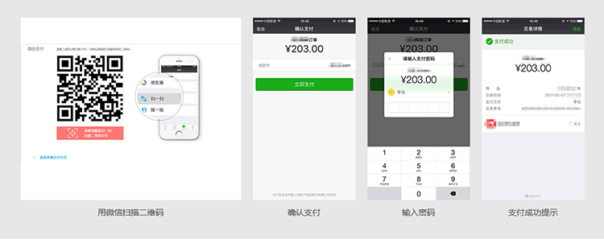

## **2. 申请流程**

### **2.1 注册公众号**

请根据营业执照类型选择以下主体注册：

* [个体工商户](http://kf.qq.com/faq/120911VrYVrA151009JB3i2Q.html)
* [企业/公司](http://kf.qq.com/faq/120911VrYVrA151013MfYvYV.html)
* [政府](http://kf.qq.com/faq/120911VrYVrA15100973ABZz.html)
* [媒体](http://kf.qq.com/faq/120911VrYVrA151013aMNfeQ.html)
* [其他类型](http://kf.qq.com/faq/120911VrYVrA151013nYFZ7Z.html)|

### **2.2 认证公众号**

公众号认证后才可申请微信支付，认证费：300元/次 查看[认证流程](http://kf.qq.com/product/weixinmp.html" \l "hid=97)

### **2.3 提交资料申请微信支付**

登录公众平台，点击左侧菜单【微信支付】，开始填写资料等待审核，审核时间为48小时内。

### **2.4 开户成功，进行账户验证**

资料审核通过后，开户信息会通过邮件、公众号发送给联系人，请按照指引填写财付通备付金汇入的随机金额，完成账户验证。（查看验证方法）

### **2.5 在线签署协议**

本协议为线上电子协议，签署后方可进行交易及资金结算，签署完立即生效。点此提前预览协议内容。

### **2.6 启动设计和开发**

支付接口已获得，可根据[开发文档](https://pay.weixin.qq.com/wiki/doc/api/index.html)进行开发，也可了解成功案例界面示意及素材。

## **3. 准备素材**

* [扫码支付](https://pay.weixin.qq.com/wiki/doc/api/native.php?chapter=6_1)
* APPID [公众平台](https://mp.weixin.qq.com/)(1959583119)->右上角->开发者ID->AppID
* 商户号码和配置回调链接 [商户平台](https://pay.weixin.qq.com/)->产品中心->开发配置->商户信息->商户号
* 配置APPID [商户平台](https://pay.weixin.qq.com/)->产品中心->APPID授权管理
* API密钥 [商户平台](https://pay.weixin.qq.com/)->账户中心->API安全->设置API密钥

## **4.接入流程**

* 商户后台系统先调用微信支付的统一下单接口
* 微信后台系统返回链接参数code_url
* 商户后台系统将code_url值生成二维码图片
* 用户使用微信客户端扫码后发起支付
* 注意：code_url有效期为2小时，过期后扫码不能再发起支付。

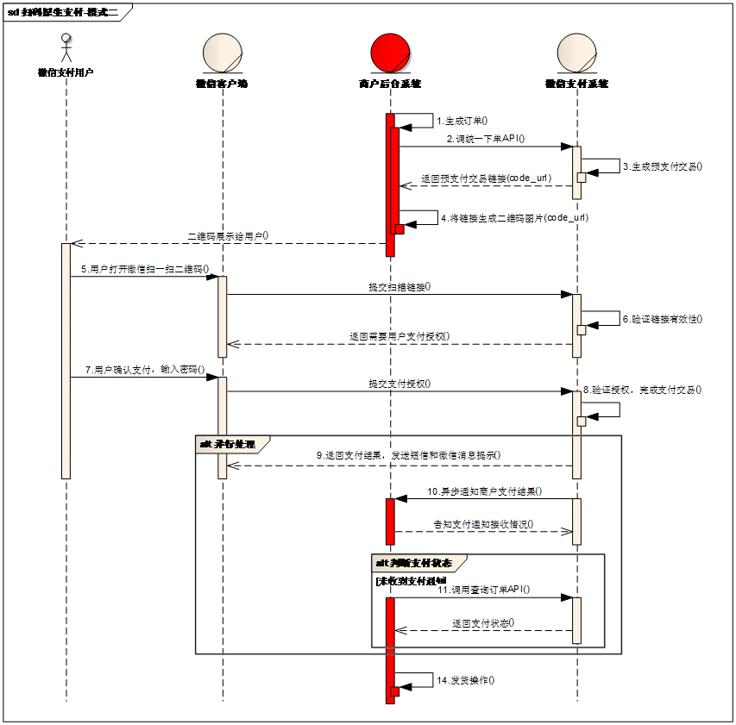

业务流程说明：

* 1）商户后台系统根据用户选购的商品生成订单。
* 2）用户确认支付后调用微信支付[统一下单API](https://pay.weixin.qq.com/wiki/doc/api/native.php?chapter=9_1)生成预支付交易；
* 3）微信支付系统收到请求后生成预支付交易单，并返回交易会话的二维码链接code_url。
* 4）商户后台系统根据返回的code_url生成二维码。
* 5）用户打开微信“扫一扫”扫描二维码，微信客户端将扫码内容发送到微信支付系统。
* 6）微信支付系统收到客户端请求，验证链接有效性后发起用户支付，要求用户授权。
* 7）用户在微信客户端输入密码，确认支付后，微信客户端提交授权。
* 8）微信支付系统根据用户授权完成支付交易。
* 9）微信支付系统完成支付交易后给微信客户端返回交易结果，并将交易结果通过短信、微信消息提示用户。微信客户端展示支付交易结果页面。
* 10）微信支付系统通过发送异步消息通知商户后台系统支付结果。商户后台系统需回复接收情况，通知微信后台系统不再发送该单的支付通知。
* 11）未收到支付通知的情况，商户后台系统调用[查询订单API](https://pay.weixin.qq.com/wiki/doc/api/native.php?chapter=9_2)
* 12）商户确认订单已支付后给用户发货。

## **5.绘制页面**

### **5.1 生成项目**

$ npm i egg-init -g

$ egg-init zhufeng-wxpay --type=simple

$ cd zhufeng-wxpay

$ npm i

$ npm run dev

$ open localhost:7001

ssh -vnNT -R 7689:localhost:7001 root@47.105.88.180

### **5.2 支持模版**

#### **5.2.1 package.json**

yarn add egg-view-ejs

#### **5.2.2 app/controller/home.js**

app/controller/home.js

async checkout() {- + const { ctx, app } = this;+ await ctx.render('checkout');

}

}

#### **5.2.3 checkout.html**

app/view/checkout.html

<!DOCTYPE html><html lang="en"><head>

<meta charset="UTF-8">

<meta name="viewport" content="width=device-width, initial-scale=1.0">

<meta http-equiv="X-UA-Compatible" content="ie=edge">

<link rel="stylesheet" href="https://cdn.bootcss.com/bootstrap/4.0.0/css/bootstrap.min.css" integrity="sha384-Gn5384xqQ1aoWXA+058RXPxPg6fy4IWvTNh0E263XmFcJlSAwiGgFAW/dAiS6JXm" crossorigin="anonymous">

<script src="https://cdn.bootcss.com/jquery/3.2.1/jquery.slim.min.js" integrity="sha384-KJ3o2DKtIkvYIK3UENzmM7KCkRr/rE9/Qpg6aAZGJwFDMVNA/GpGFF93hXpG5KkN" crossorigin="anonymous"></script>

<script src="https://cdn.bootcss.com/popper.js/1.12.9/umd/popper.min.js" integrity="sha384-ApNbgh9B+Y1QKtv3Rn7W3mgPxhU9K/ScQsAP7hUibX39j7fakFPskvXusvfa0b4Q" crossorigin="anonymous"></script>

<script src="https://cdn.bootcss.com/bootstrap/4.0.0/js/bootstrap.min.js" integrity="sha384-JZR6Spejh4U02d8jOt6vLEHfe/JQGiRRSQQxSfFWpi1MquVdAyjUar5+76PVCmYl" crossorigin="anonymous"></script>

<title>微信支付</title></head><body>

<div class="container">

<div class="row justify-content-center">

<div class="col-4">

<div class="card text-center mt-5">

<div class="card-header">

<h3>微信支付</h3>

</div>

<img src="/public/images/qrcode.png" class="card-img-top">

<div class="card-body">

<img src="/public/images/scan.png" alt="" class="w-100">

</div>

</div>

</div>

</div>

</div></body></html>

#### **5.2.4 config.default.js**

config/config.default.js

config.view={

defaultViewEngine: 'ejs',

defaultExtension:'.html',

mapping: {

'.html':'ejs'

}

}

#### **5.2.5 plugin.js**

config/plugin.js

exports.ejs = {

enable: true,

package: 'egg-view-ejs',

};

### **5.3 支付和通知**

#### **5.3.1 package.json**

"dependencies": {+ "axios": "^0.18.0",+ "moment": "^2.22.2",+ "qrcode": "^1.2.2",+ "randomstring": "^1.1.5",+ "uuid": "^3.3.2",+ "xml-js": "^1.6.7"

}

#### **5.3.2 app/router.js**

app/router.js

router.post('/wxpay/notify',controller.home.notify);

#### **5.3.3 home.js**

app/controller/home.js

**const** Controller = require('egg').Controller;**const** moment = require('moment');**const** randomstring = require('randomstring');**const** querystring = require('querystring');**const** crypto = require('crypto');**const** xmljs = require('xml-js');**const** axios = require('axios');**const** qrcode = require('qrcode');**class** **HomeController** **extends** **Controller** {

**async** index() {

**this**.ctx.body = 'hi, egg';

}

wxSign(order, key,logger) {

//对参数进行排序

**let** sortedOrder = Object.keys(order).sort().reduce((memo, key) => {

memo[key] = order[key];

**return** memo;

}, {});

logger.info('排过序的订单', sortedOrder);

//转化成字符串

**const** stringifiedOrder = querystring.stringify(sortedOrder, null, null, {

encodeURIComponent: querystring.unescape

});

logger.info('不带key的订单字符串', stringifiedOrder);

//加上密钥

**const** stringifiedOrderWithKey = `${stringifiedOrder}&key=${key}`;

logger.info('带key的订单字符串', stringifiedOrderWithKey);

//计算出签名

**const** sign = crypto.createHash('md5').update(stringifiedOrderWithKey).digest('hex').toUpperCase();

**return** sign;

}

**async** checkout() {

**const** {

ctx,

app

} = **this**;

**const** {

logger

} = ctx;

**const** {

wxpay = {}

} = app.config;

//公众账号ID

**const** appid = wxpay.appid;

//商户号码 商户平台(https://pay.weixin.qq.com)->产品中心->开发配置->商户信息->商户号

//APPID授权管理 商户平台(https://pay.weixin.qq.com)->产品中心->开发配置->商户信息->商户号

**const** mch_id = wxpay.mch_id;

//回调通知url

**const** notify_url = wxpay.notify_url;

//密钥

**const** key = wxpay.key;

//统一下单接口

**const** unifiedorder = wxpay.unifiedorder;

//商户订单号

**const** out_trade_no = moment().local().format('YYYYMMDDhhmmss');

//商品描述

**const** body = '珠峰培训';

//商品价格

**const** total_fee = 1;

//支付类型

**const** trade_type = 'NATIVE';

//商品ID

**const** product_id = 100;

//随机字符串

**const** nonce_str = randomstring.generate(32);

//构建订单

**let** order = {

appid,

mch_id,

out_trade_no,

body,

total_fee,

product_id,

notify_url,

nonce_str,

trade_type

}

**const** sign = **this**.wxSign(order, key,logger);

logger.info('签名', sign);

//转换成XML格式

**const** xmlOrder = xmljs.js2xml({

xml: {

...order,

sign

}

}, {

compact: true

});

logger.info('XML订单', xmlOrder);

//请求统一下单接口

**const** unifiedorderResponse = **await** axios.post(unifiedorder, xmlOrder);

logger.info('统一下单响应', unifiedorderResponse.data);

**const** _prepay = xmljs.xml2js(unifiedorderResponse.data, {

compact: true,

cdataKey: 'value',

textKey:'value'

});

logger.info('_prepay', _prepay);

**const** prepay = Object.entries(_prepay.xml).reduce((memo, [key, value]) => {

memo[key]=value.value;

**return** memo;

}, {});

logger.info('prepay', prepay);

**const** {

code_url

} = prepay;

**const** qrcodeUrl = **await** qrcode.toDataURL(code_url, {

width: 300

});

**await** ctx.render('checkout', {

qrcodeUrl

});

}

parseXML(req) {

**return** **new** Promise(**function**(resolve,reject){

**let** buffers = [];

req.on('data', **function**(data) {

buffers.push(data);

});

req.on('end', **function**() {

**let** ret = Buffer.concat(buffers);

resolve(ret.toString());

});

});

}

**async** notify() {

**const** {ctx,app} = **this**;

**const** { logger } = ctx;

**const** {

wxpay = {}

} = app.config;

**const** key = wxpay.key;

**let** body = **await** **this**.parseXML(ctx.req);

logger.debug('request',body);

**const** _payment = xmljs.xml2js(body, {

compact: true,

cdataKey: 'value',

textKey:'value'

});

logger.info('_payment', _payment);

**const** payment = Object.entries(_payment.xml).reduce((memo, [key, value]) => {

memo[key] = value.value;

**return** memo;

}, {});

logger.info('payment', payment);

**const** paymentSign = payment.sign;

logger.debug('paymentSign', paymentSign);

**delete** payment.sign;

**const** mySign = **this**.wxSign(payment, key,logger);

logger.debug('mySign', mySign);

**const** return_code = paymentSign === mySign ? 'SUCCESS' : "FAIL";

**const** reply = {

xml: {

return_code

}

}

**const** ret = xmljs.js2xml(reply, {

compact: true

});

logger.debug('通知返回', ret);

ctx.body = ret;

}

}

module.exports = HomeController;

#### **5.3.4 checkout.html**

app/view/checkout.html

- <img src="/public/images/qrcode.png" class="card-img-top">+ <img src="<%=qrcodeUrl%>" class="card-img-top">

#### **5.3.5 config.default.js**

config/config.default.js

config.logger={

level: 'DEBUG',

allowDebugAtProd: true,

consoleLevel: 'DEBUG'

}

exports.security = {

csrf: {

enable: false,

ignoreJSON: true

}

};

config.wxpay={

appid: '',

mch_id: '',

key: '',

notify_url: 'http://front.zhufengpeixun.cn/wxpay/notify',

unifiedorder:'https://api.mch.weixin.qq.com/pay/unifiedorder'

}

### **5.4 查询结果**

#### **5.4.1 app/router.js**

router.get('/wxpay/query',controller.home.query);

#### **5.4.2 result.html**

app/view/result.html

<body>

<div class="container">

<div class="jumbotron mt-5 text-center">

<h1><%=trade_state_desc%></h1>

</div>

</div></body>

#### **5.4.3 config.default.js**

config/config.default.js

+ unifiedorder: 'https://api.mch.weixin.qq.com/pay/unifiedorder',

+ orderquery:'https://api.mch.weixin.qq.com/pay/orderquery'

#### **5.4.4 app/controller/home.js**

home.js

'use strict';

**const** Controller = require('egg').Controller;**const** moment = require('moment');**const** randomstring = require('randomstring');**const** querystring = require('querystring');**const** crypto = require('crypto');**const** transformer = require('xml-js');**const** axios = require('axios');**const** qrcode = require('qrcode');**class** **HomeController** **extends** **Controller** {

**async** index() {

**this**.ctx.body = 'hi, egg';

}

wxSign(order, key,logger) {

//对参数进行排序

**let** sortedOrder = Object.keys(order).sort().reduce((memo, key) => {

memo[key] = order[key];

**return** memo;

}, {});

logger.info('排过序的订单', sortedOrder);

//转化成字符串

**const** stringifiedOrder = querystring.stringify(sortedOrder, null, null, {

encodeURIComponent: querystring.unescape

});

logger.info('不带key的订单字符串', stringifiedOrder);

//加上密钥

**const** stringifiedOrderWithKey = `${stringifiedOrder}&key=${key}`;

logger.info('带key的订单字符串', stringifiedOrderWithKey);

//计算出签名

**const** sign = crypto.createHash('md5').update(stringifiedOrderWithKey).digest('hex').toUpperCase();

**return** sign;

}

xml2js(data,logger) {

**const** _result = transformer.xml2js(data, {

compact: true,

cdataKey: 'value',

textKey:'value'

});

logger.info('_result', _result);

**const** result = Object.entries(_result.xml).reduce((memo, [key, value]) => {

memo[key]=value.value;

**return** memo;

},{});

logger.info('result', result);

**return** result;

}

**async** checkout() {

**const** {

ctx,

app

} = **this**;

**const** {

logger

} = ctx;

**const** {

wxpay = {}

} = app.config;

//公众账号ID

**const** appid = wxpay.appid;

//商户号码 商户平台(https://pay.weixin.qq.com)->产品中心->开发配置->商户信息->商户号

//APPID授权管理 商户平台(https://pay.weixin.qq.com)->产品中心->开发配置->商户信息->商户号

**const** mch_id = wxpay.mch_id;

//回调通知url

**const** notify_url = wxpay.notify_url;

//密钥

**const** key = wxpay.key;

//统一下单接口

**const** unifiedorder = wxpay.unifiedorder;

//商户订单号

**const** out_trade_no=moment().local().format('YYYYMMDDhhmmss');

ctx.session.out_trade_no=out_trade_no;

//商品描述

**const** body = '珠峰培训';

//商品价格

**const** total_fee = 1;

//支付类型

**const** trade_type = 'NATIVE';

//商品ID

**const** product_id = 100;

//随机字符串

**const** nonce_str = randomstring.generate(32);

//构建订单

**let** order = {

appid,

mch_id,

out_trade_no,

body,

total_fee,

product_id,

notify_url,

nonce_str,

trade_type

}

**const** sign = **this**.wxSign(order, key,logger);

logger.info('签名', sign);

//转换成XML格式

**const** xmlOrder = transformer.js2xml({

xml: {

...order,

sign

}

}, {

compact: true

});

logger.info('XML订单', xmlOrder);

//请求统一下单接口

**const** unifiedorderResponse = **await** axios.post(unifiedorder, xmlOrder);

logger.info('统一下单响应', unifiedorderResponse.data);

**const** prepay=**this**.xml2js(unifiedorderResponse.data,logger);

logger.info('prepay', prepay);

**const** {

code_url

} = prepay;

**const** qrcodeUrl = **await** qrcode.toDataURL(code_url, {

width: 300

});

**await** ctx.render('checkout', {

qrcodeUrl

});

}

parseXML(req) {

**return** **new** Promise(**function**(resolve,reject){

**let** buffers = [];

req.on('data', **function**(data) {

buffers.push(data);

});

req.on('end', **function**() {

**let** ret = Buffer.concat(buffers);

resolve(ret.toString());

});

});

}

**async** notify() {

**const** {ctx,app} = **this**;

**const** { logger } = ctx;

**const** {

wxpay = {}

} = app.config;

**const** key = wxpay.key;

**let** body = **await** **this**.parseXML(ctx.req);

logger.debug('request',body);

**const** payment=**this**.xml2js(body,logger);

logger.info('payment', payment);

**const** paymentSign = payment.sign;

logger.debug('paymentSign', paymentSign);

**delete** payment.sign;

**const** mySign = **this**.wxSign(payment, key,logger);

logger.debug('mySign', mySign);

**const** return_code = paymentSign === mySign ? 'SUCCESS' : "FAIL";

**const** reply = {

xml: {

return_code

}

}

**const** ret = transformer.js2xml(reply, {

compact: true

});

logger.debug('通知返回', ret);

ctx.body = ret;

}

**async** query() {

**const** {

ctx,

app

} = **this**;

**const** {

logger

} = ctx;

**const** {

wxpay = {}

} = app.config;

//公众账号ID

**const** appid = wxpay.appid;

//商户号码

**const** mch_id = wxpay.mch_id;

//密钥

**const** key = wxpay.key;

//统一下单接口

**const** orderquery=wxpay.orderquery;

//随机字符串

**const** nonce_str = randomstring.generate(32);

**let** query={

appid,

mch_id,

out_trade_no: ctx.session.out_trade_no,

nonce_str

}

**let** sign=**this**.wxSign(query,key,logger);

logger.info('签名', sign);

//转换成XML格式

**const** xmlQuery = transformer.js2xml({

xml: {

...query,

sign

}

}, {

compact: true

});

logger.info('XML查询条件', xmlQuery);

//请求统一下单接口

**const** orderqueryResponse = **await** axios.post(orderquery, xmlQuery);

logger.info('订单查询响应',orderqueryResponse.data);

**const** queryResult =**this**.xml2js(orderqueryResponse.data,logger);

logger.info('queryResult',queryResult);

**await** ctx.render('result',queryResult);

}

}module.exports = HomeController;