Efficient Bare Metal Auto-Scaling for NFV Platform

Xudong Pang, Jingyu Wang, Qi Qi
State Key Laboratory of Networking and Switching Technology,
Beijing University of Posts and Telecommunications, Beijing, P.R. China, 100876
email: {pangxudong,wangjingyu,qiqi}@ebupt.com

Abstract
There are always a cloud data center behind the Network Function Virtualisation (NFV) systems, and typically, elasticity is an essential attribute of cloud data center, for elasticity technique is critical for operating resources in face of peaks and valleys of business. At present, the automatic scaling technique of virtual machines is widely studied, but barely for physical machines. We all know that physical resources are an important part of the data center, that is one of the things you must consider to maximize data center automation, Good management of bare metal resources, not only is a rigid demand to the virtual resource limit of scale, but also can be significant for the data center maintenance cost and power cost. So we think auto-scaling of physical machine is worth studying. This paper proposes a bare machine automatic scaling scheme based on Zabbix monitoring platform, complete scale in half one hour, guarantee for the continuity of Virtual Network Function(VNF) processing business, and can cope with the load fluctuation better.
Keywords
bare metal; auto-scaling; NFV; Zabbix

- Introduction
Network Functions Virtualisation will leverage modern technologies such as those developed for cloud computing.[1] That is to say there are always a cloud data center behind the NFV system, and this kind of cloud data center usually consists of tens of thousands of servers, the workload time series for the whole cluster appear to be large fluctuation. If there is only auto-scaling of virtual machines cannot meet the needs of all. Managing that large number of physical servers is a hassle, if all by human operations, to ensure the quality of service(QoS) is an obvious challenge. Cloud computing itself has the characteristics of independent, safe, reliable, elastic, durable and others, so we think automatic scaling of bare-metal resources has some necessary. However, there do not have an unified operating platform for bare metals, only through some access and configuration tools such as ipmi, Cobbler, Ansible to manage. How can we make all these process automated, deployed OS, provision software, discover new machines and load workload to new machines, this requires a complete and elaborate workflow to complete.
AWS[1] developed the first virtual machine auto-scaling tech in the industry, which is a solution for the holiday’s 5 times shopping rush to normal flow, and it’s just for the virtual machine. Then the automatic scaling technique was applied to more areas, such as some of the virtualization resources of cloud computing. All these are for users’ real requirements. Can the bare-metal resources become more elastic for the ever-expanding data center? Traditional redundancy allocation can cause wasted of resources, so the main thing to do is to narrow the gap between allocating resources and actual needs, and of course, all these are based on QoS guarantee.
So why provision bare metal? Here are a few specific use-cases for bare metal provisioning in cloud:［2］
- High-performance computing clusters.(MaaS: Metal as a Service)
- Computing tasks that require access to hardware devices which can’t be virtualized.
- Database hosting (some databases run poorly in a hypervisor).
- Single tenant, dedicated hardware for performance, security, dependability and other regulatory requirements.
- Or, rapidly deploying a cloud infrastructure.
And there are doubtless many more interesting use-cases, so it’s necessary for auto-scaling of bare metal resources.
A recent survey classifies auto-scaling techniques into several major categories: static policies, threshold-based polices, reinforcement learning, control theory, and time-series analysis. [3]
It is critical to find resource bottlenecks in time, the in advance allocation of resources can greatly improve the service quality and reduce the response latency of the application. So a good monitoring software can satisfy this requirement, this paper adopted the Zabbix as a monitor, it has several particular advantages, very suitable for use in a cloud data center: (1) support the ipmi and network equipment monitoring (2) web check can be made, test the HTTP service availability (3) can be competent for large-scale cluster. (4) service discovery, auto register new machine node.
- https://aws.amazon.com/ec2/

Physical servers generally support IPMI&PXE, which can realize the bare-metal OS installation, and using tools such as Ansible can realize automatic software configuration.
Based on the above technique, this paper presents an automatic scaling algorithm for the bare metal resource, combining with the threshold rule and load prediction. The main selection is horizontal scaling.
The second section introduces the related work. The third section introduces the experiment framework, including the core algorithm. The fourth section describes detailed experiment steps and data comparisons. The fifth section summarizes the experiment results.

- RELATED WORK
When NIST defined cloud computing [4] they explained the essential characteristic “rapid elasticity” as “Capabilities can be elastically provisioned and released, in some cases automatically, to scale rapidly outward and inward commensurate with demand”. The purpose of elasticity as defined in [5] is to provide: performance, cost, increase infrastructure capacity, energy. All of these can be related to user load.
Due to the demand of the NFV system for the elasticity of the physical server resource, this paper probes into the automatic scaling of the bare metal resource. We use OpenStack［6］ powered cloud as NFV vim, and use Tacker[7] to provide VNFs for test, which is an NFV MANO Project. Besides, Zabbix is integrated to provide cluster monitoring capabilities.
It is a well-known that OpenStack is an open source cloud platform, which has an excellent distributed architecture. An normal OpenStack cluster can be divided into the control node, network nodes, computing nodes, storage nodes. Better is, there are also several placement tools that support bare metal provision. Here we use the Cobbler to do the install OS, and Ansible for software configuration.
In addition, among many monitors we choose Zabbix, not only because itself is one of the main monitoring tools of today's operation and maintenance staffs, but also it's very easy to extend. Based on monitoring the health status of cluster hardware, Zabbix can make the upper web check, which feedback VNF response speed in time. Besides, Zabbix can also automatically discover and register new nodes. We use custom monitoring strategies, which are more suitable for both bare metal and NFV scenarios. In order to ensure the stability and smoothness of the upper services, the historical data Zabbix collected is used to identify the obvious features and predict the performance of the load.
This paper presents one auto scaling algorithm, which fully consider characteristics of bare metal resources, and also make full use of workload historical data for prediction. All these enable the cluster to save as much resources as possible on the basis of ensuring the stability of the cluster. Due to the bare machine configuration process is very time consuming, so we need to do a good job in multi-stage pretreatment in advance, for example, pre-loaded OS, buffered nodes, this can make the new node services faster online.

- Architecture Design
In this section, we will explain what we do in the framework term by term.
3.1 Bare Metal Provision
According to our design, there are mainly three stages on bare metal placement, basically are as follows:
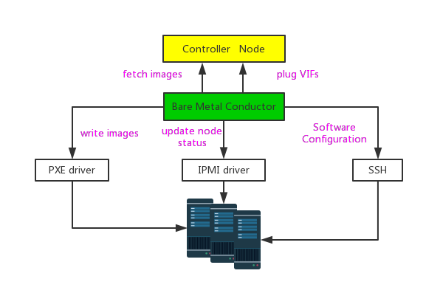
Fig. 1: bare metal placement

Resource Discovery: We use tools such as universal IPMI, SNMP or INTEL RSA to discover new electrically charged physical machines, and report their information to the Server.
OS Installation: ［翻译到这儿了］Using the PXE tool Cobbler to install operating system for the physical machines, image with OpenStack service for the new, charged, naked machine. This process is also the most time consuming phase, requiring approximately half an hour.
Software Configuration: Here we use tools like Ansible, Chef and puppet. Due to the new launched OpenStack service will report to the control node voluntarily, and

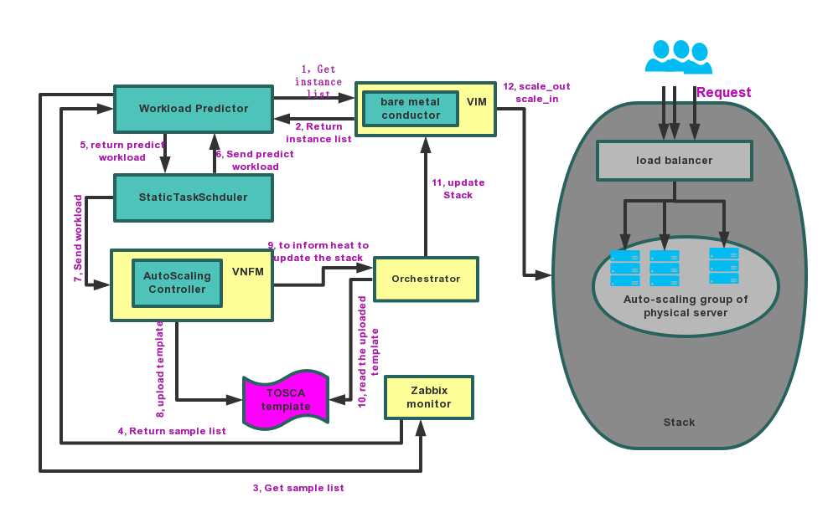
Fig. 2: bare metal auto-scaling workflow

automatically register to the corresponding cluster by the identity service. So the main thing we do here is to install and configure Zabbix agent, which will be discovered by Zabbix server and register them to a corresponding group.
3.2 Scale-out and Scale-in
Scale-out: Controller trigger scale out action, according to the need to increase the number of hosts, the first to use this power in the group on some configured off-line node, if not enough to trigger the number of vacancies Bare Metal - Provision process.
Scale-in: The ASG requires that the node VNF be either a stateless type or can be automatically migrated. Stateless VNF USES the Shared data layer, and VNF doesn't need to manage its own data, much easier, and can easily switch to meet changing requirements. [6]
After processing, the node is turned off and the next time it is switched on.
Under normal circumstances, the recovery of physical nodes to do sort of host performance, according to certain rules to release [7], in order to simplify the model, this paper USES unified configuration of the physical machine, you can shut down in FIFO order.
In addition, every new purchase physical servers to advance the MAC address registered to the ASG, that specify the ASG MAC address list in advance, if you want to put a physical server from a ASG diverted to another ASG, should put the machine hard disk format.
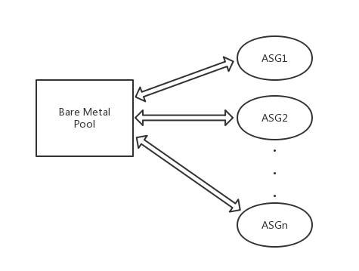

3.3 Monitor configuration
Zabbix monitoring items are as follows:

ASG  Di  Ci  Mi  Ni  Vi | Auto-scaling group of bare metals  Free_disk_space  Cpu_idle_time  Available_memory  Total_bytes_on_eth1  VNF average response relay
Oi | Other custom items
Table 1: Symbols and variables introduced in Section 3
根据研究发现，CPU占60％of主机的Power能耗，其余包括内存等，CPU基本可以代表host的整机能耗：
PCPU(u)=α(2u−ur)+σ

［ref: http://zhi.oschina.io/archives/2016/06/24/cloudsim-2-power-provisioning.html］

另外一个监控项用来反应VNF的实时response time，作为VNF的服务质量。

Discovery and Auto-Registration: the new nodes are installed and configured in the placement stage and configured with the Zabbix agent, which can then be found in the local area and registered to the corresponding host group, add host to a host group, link template to a host.
3.4 Auto-scaling control logic
First, the scaling trigger factors we considered are:
Time-series Analysis: we use arima[8] model to predict workload of servers, which can convert to the request of bare-metal resources.
Predict and buffered allocation，static policy and buffered allocation. 第一次分配(first time slot)时，预分配，（把分配上线分两阶段，较耗时的第一阶段先处理）VmAllocationPolicyMigrationByPredict
根据优先级作为权重触发伸缩，早scale_out，晚scale_in(which can be migrate, evacute)，支持cool time，这里用一个公式表示.
       
cooldown＝＝timeout
min
max
desired
count
NFVI triggerd, such as openstack hypervisor,
Workload control， based on hold-status-check, web-check…count(*) and control methods.
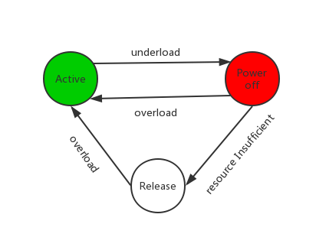
早scale-out，比如将报警的阈值设置为75%，并考虑扩展新节点的应用启动所需要的时间。
晚scale-in， 这样可以降低减少裸机资源的风险，比如在阈值低于30%并持续20分钟后，scale-in。

实时采集预测样本，实时变化预测模型，output预测结果。

3.5 Workflow
一张图：resource-pool(active ) + monitor(proactive) (bare metal group && vm group) -> autoscaling handler -> VNF orchestrator -> nova-compute -> bare metal service
This figure is the result of a basic NFV Management and Orchestration (MANO), MANO is made up of several most commonly in the figure Virtualised Infrastructure Manager (VIM) is a virtualization Infrastructure Management, be responsible for the physical hardware virtualization resources for unified Management, monitoring and optimization.
VNF Manager (VNFM) : responsible for the lifecycle management of VNF. A VNF Manager can manage one or more VNF. Note that this is not the business management of EMS online, but the ability to automate EMS and VNF including deployment/expansion/scaling/downline.
Orchestrator, choreographer, responsible for NFV resources and the basis of the upper software resource arrangement and management, this arrangement ability can be according to the requirements of the business, how many resources you will need to adjust the VNF, between each cabinet, computer room, regional migration VNF etc., is the core of the automatic ability.

- implementation and evaluation
Experiment should be in real cloud provider production environment, the biggest advantage is this can validate the stability, but in order to avoid the experiment cost and in a more controlled environment, we decided to use a customized test bed, this will cost some effort on system configuration.
We used 10 HP hosts, each powered by CentOS7, and with 16GB memory, 8cores, 1TB disk. 我们用了3台物理服务器模拟了bare metal placement和scale_in和scale_out, 又用7台VMware 虚拟检验了autoscaling算法。
There are five original nodes, one controller, one network node, three compute. We use compute group for elastic scaling.
在使用OpenStack Tacker as NFV platform， 使用Compass as bare metal driver的基础上,使用zabbix作为监控器收集sample数据以及实时的VNF respond time，并写了大约2千行的代码，包括预测算法、autoscaling control及automation combination logic。
第一张图显示了bare metal provision的time model（OS install &software configure (scale_out)， poweron， poweroff， scale_in）我们以20次测量的平均值为例。
Events | Time Cost(minites)
poweron | 5
poweroff | 2
deploy(install os & software) | 30
release | 5

第二张图显示了预测算法的预测和实际负载相比的准确率。
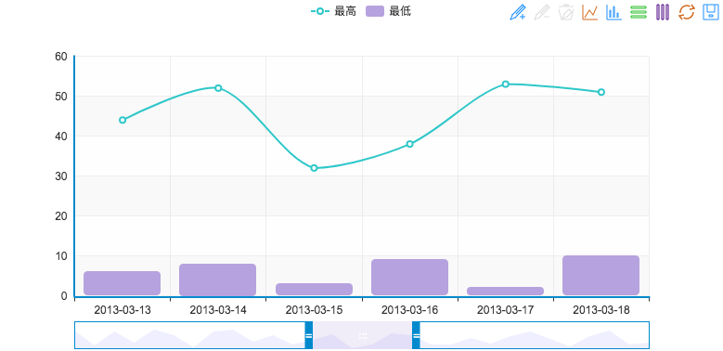

第三张图多种安置算法的性能，未使用主机数量。

显示了一些展现两种预测算法的预测准确率，这里采用平均均方误差指标MSE（Mean Squared Error）来定量分析预测性能。
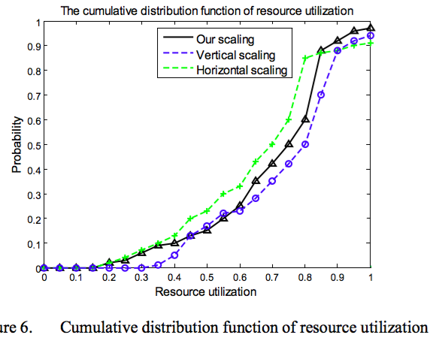
第四张图多种安置算法的性能，VNF响应速率。
这里是用了tacker集成的VNF，有

第五张图显示了和传统运维系统的功能对比
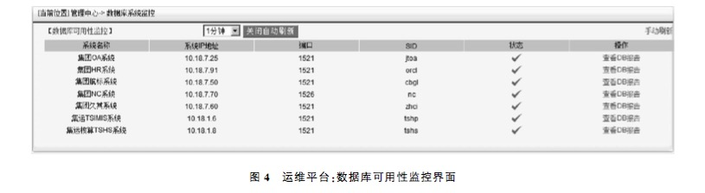
第六张图显示了和openstack系统的功能对比
就像飞行员可以使用自动驾驶功能，运维人员也可以开启自动伸缩功能。
（和人工运维比资源使用率，和基于阈值的策略比vnf反应速度）
第六张图 几种策略每个物理机的资源使用率。
第七张图 几种策略每个物理机的反应速度。

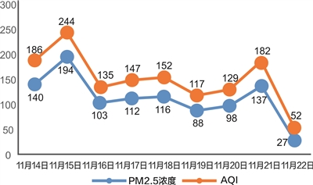
- comparation of three policys.
- Concluding Remarks
In this paper, we presented a bare metal auto scaling mechanism based on NFV system. This mechanism uses the forecasting and the way of static configuration of pre-allocated physical resources, make business automatic telescopic more smooth, compared with the traditional way of artificial cultivation provides better QoS. Our work on bare metal auto - scaling will provide an idea for the cloud data center maintenance, for more intelligent data center, green, tight.
Using this method, we believe that we opened the doors for bare metal auto scaling to obtain significant improvements in both cost and execution time.
As the future work we intend to extend the heterogeneous bare metal resources, still has great room for improvement is support for network devices (ironic), can issue mini agent to host new electricity, reporting the performance of the host to the server, so that we can let the server se lection to different host installation issued by different mirror.

References
- Network Functions Virtualisation – Introductory White Paper
- https://info.massopencloud.org/blog/anuj-thakur-ironic/
- T. Lorido-Botran, J. Miguel-Alonso, and J. A. Lozano, “A review of auto-scaling techniques for elastic applications in cloud environments,” J. Grid Comput., vol. 12, no. 4, pp. 559–592, 2014. http://www8.cs.umu.se/kurser/5DV153/HT14/literature/lorido2012autoscaling.pdf
- P. Mell and T. Grance, “The nist definition of cloud computing,” 2011.
- R. Sakellariou and H. Zhao, “A hybrid heuristic for dag scheduling on heterogeneous systems,” in Parallel and Distributed Processing Symposium, 2004. Proceedings. 18th International. IEEE, 2004, p. 111.
- http://openstack.org/
- https://wiki.openstack.org/wiki/Tacker
- http://zabbix.org
- http://www.syscompass.org/
- G. Eason, B. Noble, and I. N. Sneddon, “On certain integrals of Lipschitz-Hankel type involving products of Bessel functions,” Phil. Trans. Roy. Soc. London, vol. A247, pp. 529–551, April 1955. (references)
- J. Clerk Maxwell, A Treatise on Electricity and Magnetism, 3rd ed., vol. 2. Oxford: Clarendon, 1892, pp.68–73.
- I. S. Jacobs and C. P. Bean, “Fine particles, thin films and exchange anisotropy,” in Magnetism, vol. III, G. T. Rado and H. Suhl, Eds. New York: Academic, 1963, pp. 271–350.
- K. Elissa, “Title of paper if known,” unpublished.
- R. Nicole, “Title of paper with only first word capitalized,” J. Name Stand. Abbrev., in press.
- Y. Yorozu, M. Hirano, K. Oka, and Y. Tagawa, “Electron spectroscopy studies on magneto-optical media and plastic substrate interface,” IEEE Transl. J. Magn. Japan, vol. 2, pp. 740–741, August

