

​ **WESTERN UNIVERSITY**

**FACULTY OF ARTS, HUMANITIES AND LANGUAGES**

**DEPARTMENT OF ENGLISH**

INTERNSHIP REPORT

The Impact of Social and Communicative Anxiety

Performed at

Airsealand Logistics Co.,Ltd

In Partial fulfillment of the Requirements for the Degree of Bachelor of Arts in English for Communication

Under the Advisory of: Mr. HAM Kunthea

Submitted to: The Department of English

Summited by Ms. Pauv Mithona

07 April, 2019

# STUDENT INFORMATION

Personal Information

|  |  |  |  |
| --- | --- | --- | --- |
| Full Name | Pauv Mithona | Khmer Name | ពៅ មិថុនា |
| Gender | Female | **Date of Birth** | 12 June 1995 |
| Student ID | B13-0337 | **B/A Major** | English for Communication |
| Mobile Telephone | 017 845 559 | **E-mail Address** | pauvmithona96@gmail.com |
| Expected Graduation | 15 March 2019 | **Future Goal** | Business Owner |

**Organization Information**

|  |  |
| --- | --- |
| Company Name | Airsealand Logistics Co.,Ltd |
| Company Address | #31, Street 200, Sangkat Phsar Thmey III, Khan Daun Penh, Phnom Penh, Cambodia. |
| Type of Company | Transportation Air and Sea Freight |
| Telephone | +855 (0)23 215 670 |
| E-mail | [info@airsealandlogistics.com](mailto:info@airsealandlogistics.com) |

**Internship Information**

|  |  |
| --- | --- |
| Internship Title | The Impact of Social and Communication Anxiety |
| Duration | 120 hours |
| Position | Logistics Staff |
| Salary | Optional |
| Director Name | Nen Kalyan |
| Position | General Manager |
| Telephone | 017 214 008 |

# DECLARATION

I declare that this internship report prepared on “The Impact of Social and Communicative Anxiety at Airsealand Logistics Co.,Ltd” is written base on my real work. It is my own report and has not been submitted either in part of in full for the award of any other degree of any other Universities. To the best of my knowledges, this internship report contains no materials previously published or written by another person, except where due reference is made in text of the internship report. It is my own report, under the supervision of Mr. HAM Kunthea, Lecturer, Western University.

Phnom Penh, 21th, March 2019

Pauv Mithona

# CERTIFICATION

This is to certify that the internship report “The Impact of Social and Communicative Anxiety at Airsealand Logistics Co.,Ltd” written and summited by Ms.Pauv Mithona, in partial fulfillment of the requirement of the degree of Bachelor of Arts in English Communication, to the Department of English of Western University, is recorded as a genuine internship work carried out under direct guidance and consultation. To the best of my knowledge, the paper has not been summited previously to quality for another academic award.

Phnom Penh, 21th, March 2019

Advisor

HAM Kunthea

# ABSTRACT

Generally, every company has different development though the supplying of high technology; however, most of the companies still face the same problems such as social and communicative anxiety. Therefore, this study is to analyze the impacts of social and communicative anxiety at workplace of Airsealand Logistics. This company is an import and export company which has a clear vision to provide the best quality off transportation for the customers, but it still has some obstacles to interrupt the good progressing of this company such as staff’s behavior, working environment, and interpersonal relationship that cause social and communicative issue. This report was conducted by using both primary and secondary data, and it uses only interview for supporting the primary data. Moreover, the finding shows that most of staffs who have social and communicative disorder get the negative impact on the company progressing such as making working process more slowly, lacking communication with society, losing the networking with boss, and also preventing of expressing idea to the public or customers.

# ACKNOWLEDGEMENTS

First, I would like to show my deep thanks to my parents who gave me birth with good conditions, and offered me the opportunity to study by sacrificing energy and financial support for my studies. I would also like to offer the sincere grateful to my advisor Mr. HAM Kunthea for his great distribution and give the best efforts in guiding me during my internship. Moreover, special thanks to Western University, department of Art, Human and Languages which gives me a warm place by fulfilling knowledge and gives a chance to intern. Finally, I would like to thanks to Airsealand logistics which offers me a great chance for doing internship of the whole processes for the report.

Phnom Penh, 21 March 2018

**HAM Kunthea**

# TABLE OF CONTENTS

Student Information i

Declaration ii

Certification iii

Abstract iv

Acknowledgements v

Table Of Contents

CHAPTER I: INTRODUCTION 1

1.1. Background Information 1

1.2. Objectives 2

1.3. Significance 2

1.4. Scope and Limitation 2

CHAPTER II: DESCRIPTION OF INTERNSHIP 3

2.1. Company Profile 3

2.1.1. Introduction 3

1. Local Transportation Services 3

2. Local Customs Clearance Services 4

3. Packing and Loading Activities 4

2.1.2. Vision 4

2.1.3. Mission 4

2.1.4. Plan and Strategy 5

2.1.5. Organization Chart 5

2.1.6. Administrative Procedure 5

2.1.7. The activities of Airsealand 6

2.2. Responsibilities 8

2.2.1 Arrange Outgoing Shipment 8

2.2.2 Process Incoming Shipment 8

2.3. Work Environment 8

2.4. Challenges 9

2.4.1 Working Management 9

2.4.2 Interpersonal Skill 9

CHAPTER III: LITERATURE REVIEW 10

3.1. What is Social Anxiety? 10

3.2. What is Communicative Anxiety? 11

3.3. Causes of Social and Communicative Anxiety 12

3.4. Impacts or Effects of Social and Communicative Anxiety 12

3.5. Method to Overcome the Social and Communicative Anxiety 13

CHAPTER IV: REFLECTION OF INTERNSHIP 14

4.1. Results and Discussion 14

4.1.1 The Cause of Social and Communicative Anxiety at Workplace 14

4.1.2 The Impacts of Social and Communicative Anxiety at Workplace 14

4.1.3 Overcome the Social and Communicative Anxiety at Workplace 15

4.2. Discussion 15

CHAPTER V: CONCLUSION AND RECOMMENDATION 17

5.1. Conclusion 17

5.2. Recommendation 18

References 19

Appendices 20

Appendix A: Curriculum Vitae and application letter 20

Appendix B: Letter of Thanks 24

# CHAPTER I

# INTRODUCTION

## Background Information

Anxiety is a persistent problem in multiple field of working ((Donna J. June 2007). Anxiety is a normal and often healthy emotion. According to Adam F. (2018) found that when a person regularly feels disproportionate levels of anxiety, it might become a medical disorder. Social Anxiety Disorder (SAD) was legitimately document as a psychiatric condition- defined by an extreme fear and prevention of social situations, where is probable for valuation or denial by others (Kashdan B.T. & Mcknight, 2010). Depression is common now in worker and it has many reasons and all of those one of them is social media. Hesitate to communicate with others through face to face communication. Abilities are less to judge the people through their expressions.

According to Saleem A. (2016) Social anxiety is the blend of fear, anxiety and concern that people experience meeting with stranger in pubic settings. Sometimes, social anxiety is linked with the observation with comes dealing with others face to face to interaction. (Donna J. June 2007) Social anxieties are based upon the feelings of vulnerability, restlessness, shyness or fears to interact with others, in this fast era, everybody becomes smarts or in touch with other through technology. Social anxiety is the reasoning of depression, it effects physically and psychologically both and prevention of complexity, these all is interlinked. When they are not confident to talk everyone directly that have some psychological impacts which are psychologically have fear to talk with others Social interaction is when they meet with people or connect with people on the basis of some social needs. Especially, connection with others, day by day their interaction becomes stronger, but when they are mostly involve in electronic media those who are nearest to us these are more far to them. The psychological impact is when a victim physically appears, but can’t concentrate on work. Social anxiety refers to obstinate fears of circumstances involving social communication or social performance or situations in which there is the probable for inspection by others (*American Psychiatric Association*, 1994).

Anxiety disorders exacerbate the existing social and communication difficulties individuals with Autism Spectrum Disorder (ASD) possess such as deficits in social use of language and the inability to sustain a conversation; breakdowns in communication due to an increase in anxiety may also result in a disruption in verbal fluency. Effective therapeutic interventions are necessary to address the clinical needs of individuals with this comorbid presentation. There are many treatment options available depending on the level of functioning of the individual with ASD as well as to what degree of anxiety the individual is experiencing.

However, for people with social anxiety, thoughts and feelings of anxiety persist and show no signs of going away -- despite the fact that socially-anxious people "face their fears" every day of their lives. Anxiety can significantly interfere in an individual’s ability to communicate effectively and appropriately. Using therapy, interventions, and, in some cases, medication to reduce anxiety can make it possible for children with ASD to learn communication and other skills more easily and quickly, ultimately leading to improved quality of life now and in the future (Meleshko, K. G., & Alden, L. E. (1993).

## Objectives

This study aims to find out to explore the impacts of social and communicative anxiety for workers. Thus, the study focuses on the following specific objectives: (1) the cause of social and communicative anxiety, (2) the impacts of social and communicative anxiety, (3) the solutions for social and communicative anxiety.

## Significance

The internship will lead the intern to experience real working society, and it would be the best way to improve her technical skills. For case study provide the intern about learning skills and knowledge for gainful employment and full participation in a community. All knowledge can help the intern increase the ability, up great available skills, implement a career in the after graduating from school. By doing the internship the intern can a preparing step for intern to face-to-face obstacle in working environment.

## Scope and Limitation

The main content of this internship focuses only on the Impact of Social and Communicative Anxiety at Airsealand Logistics Co.,Ltd. To achieve this research potentially, it will be done by observing the exact process of work. In addition, the informants of this report are only from general manager, administrator and an assistant. Moreover, this research is done within two months with 120 hours for collecting data and observing the real work at Airsealand logistics Co.Ltd.

# CHAPTER II

# DESCRIPTION OF INTERNSHIP

## Company Profile

### Introduction

We offer a broad portfolio of services including Air Freight Services, Sea Cargo Services, air freight logistics, Customs Clearance Services, Port Handling Services, Warehousing Services, etc. Our expertise also includes providing a comprehensive and tailor-made solutions to meet the relocation needs of corporate and residential clients.

#### Local Transportation Services

ASL will provide wide range of local and cross-border trucking services to their clients with local established partners. Such services can be tailored and customized according to our clients’ specifications and business needs accordingly.

Trucking services would include:

* (CFS) Container Freight Station) pickup services
* Local drayage from Phnom Penh International Airport, various (ICD) (Inland Container Depot) and dry ports, to specific client locations within Phnom Penh.
* Trucking from Sihanoukville Autonomous Port and Phnom Penh Autonomous Port to Phnom Penh, and other provinces in Cambodia
* Cross-border transportation and other services to Bangkok and Ho Chi Minh via Poipet and Bavet borders respectively, and vice versa from Bangkok and Ho Chi Minh to Phnom Penh.

#### Local Customs Clearance Services

ASL is able to provide custom clearance services with our qualified local customs brokerage partners. These partnerships give ASL greater leverage in the process of addressing complex customs clearance issues, providing our clients hassle-free, streamlined services whilst maximizing their cost effectiveness.

ASL has customs brokerage service includes:

* Custom clearance services at Cambodia’s main ports of entry/exit
* Transit import/export services, and re-exports
* CO (Certificate of Origin )legalization
* Import and Export permit applications
* CFS custom & Cam Control inspection

#### Packing and Loading Activities

ASL has been providing house/office moving services to clients for decades. With long experienced in the international shipping logistics, we also take pride to deliver door-to-door with a special individualized service of international standard and highly qualify and experienced staffs will pack and take care of your products and deliver them to final destination. ASL provides you with a full range of additional services to improve the management of your supply chain and to meet your own customers’ requirements.

### Vision

ASL has offers integrated transportation solutions including full chain of logistics by means of total commitment to our clients. ASL provides full transportation services, to deliver our cargo at the highest safety standards and to complete satisfaction.

### Mission

ASL pursues new and innovative solutions to fulfill any unique and individual requirement, generates transportation support in line with international conventions and upholds the prevention of environment and property damage.  
ASL’s innovative spirit generates an attitude of continuing development. The result of ASL focused upon service and quality.

### Plan and Strategy

ASL can provide a guarantee of service through regular monitoring and compliance to standard procedures to prevent any eventualities. The goal of ASL is to make sure our company and customers are delivering to customers what they want. And accomplish all of that by spending as little money as possible. By following these guidelines, ASL can ensure that our logistics are aligned with customers' needs, inventory targets, and company's cost reduction goals.

### Organization Chart

Airsealand Logistics Co.,Ltd (ASL Functions)

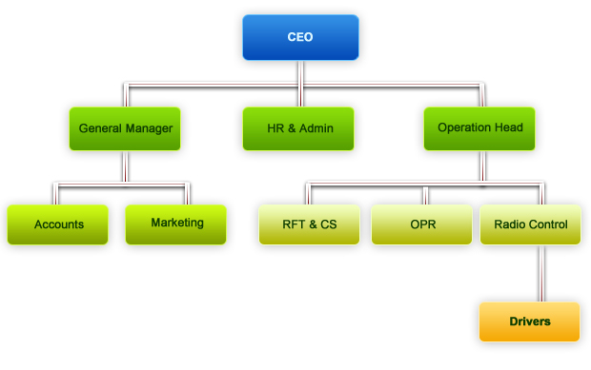

### Administrative Procedure

* Plan shipments based on product availability and customer requests
* Track orders to ensure timely deliveries
* Prepare shipping documents (like invoices, purchase orders and bills of lading)
* Coordinate our supply chain procedures to maximize quality of delivery
* Schedule shifts for our drivers and warehouse staff
* Maintain updated records of orders, suppliers and customers
* Oversee the levels of our warehouse stock and place orders as needed
* Provide information to customers about the status of their orders

### The activities of Airsealand

**Logo of Airsealand Logistics Co.,Ltd**



Import Customs clearance for 1 container

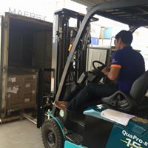

Packing of ASL teams and Export customs clearance from PNH/USA

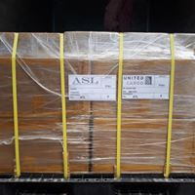 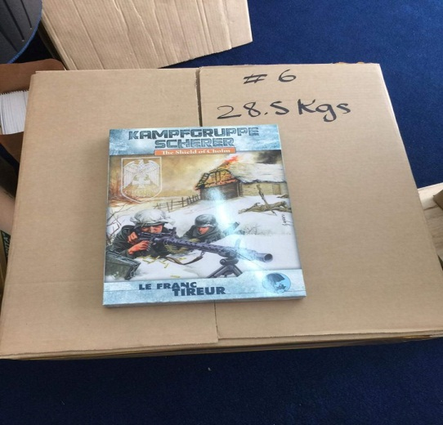

Import customs clearance for 1 Container=1 Units of Roll Royce produce in 1932 from United Kingdom via Sihanoukville port to Phnom Penh Capital on 15 August 2018.

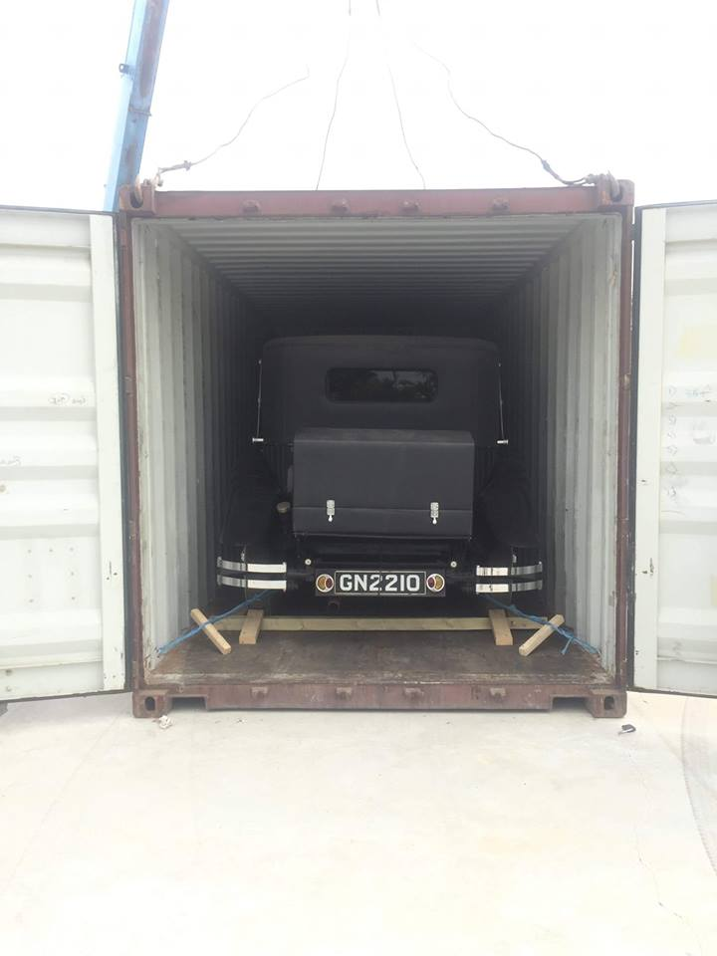

Import customs clearance for 09 Cases safe door for strong room via Sihanoukville port to Phnom Penh Capital and delivery to Takmao city on June 05, 2018.

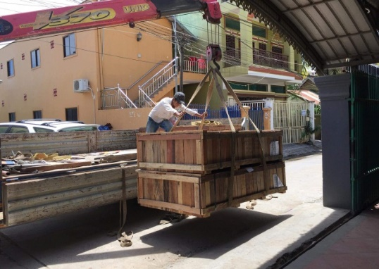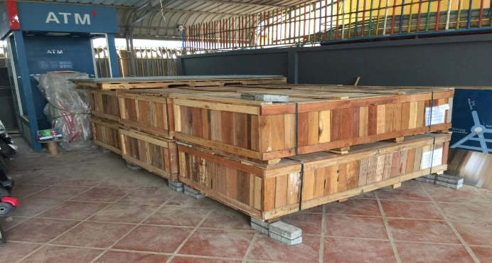

**CHAPTER II**

**DESCRIPTION OF INTERNSHIP**

## Responsibilities

Logistic administrator is a person who is responsible for many tasks, such as checking documents, preparing documents for management to be signed; moreover, he or she controls all documents in the company, and prepares payment request, petty cash, cash advance and summits to finance division. In addition, the intern works for shipping and receiving and supporting the logistics manager in all aspects of warehouse operation.

### Arrange Outgoing Shipment

From prepare packing lists to physically packing outgoing material, the intern cover on shipping process. The intern needs record customs clearance and arranging internal distribution of goods received. Especially, intern staff recording customs clearance requirement and authoring collection of cargo and calculating storage and clearance charges and billing customer.

### Process Incoming Shipment

Another main responsibility of arrange outgoing shipment is to receive incoming materials I also compare what has been shipped with the shipment order, ensure that the material in good condition, stock the material in the warehouse and file all corresponding documentation.

## Work Environment

Workplace can be caused by a number of factors from heavy workloads and lack of control. Sometimes, intern feel rushed, under pressure and overwhelmed because of excessive high workloads. A lack of inter personal support or poor working relationship leading to a sense of isolation that make intern concern of their career. In other hands, job security, lack of career opportunities and a lack of control are insufficient workloads make intern feel their skill are being underused.

## Challenges

### Working Management

As a business grows, its strategies, structure and internal processes grow with it. Because of pressure, the flow of working of intern was slowly, which intern feel less confident to communicate with senior.

### Interpersonal Skill

In company, there are three main departments and each department needs to be connected or provided the necessary information to each other. Because of being unclear about the shipping information, the intern seems to hesitate in processing the information to other departments and customers. Therefore, it can make problem in company’s workflow when intern loses some documents, the original bill of loading, which is the most important document in the entire shipping process. Sometimes, delay cost that leads to delay-related charges and fees. Missing duties and taxes and overweight cargo are problems that our company concern.

# CHAPTER III

# LITERATURE REVIEW

## What is Social Anxiety?

Social anxiety is the fear of being judged and evaluated negatively by other people, leading to feelings of inadequacy, inferiority, self-consciousness, embarrassment, humiliation, and depression (Heimberg, R. (2013, October). anxiety is now viewed as a nonspecific term, covering a wide range on behavior and experiences. Is reflects a general state of arousal and assumed to play an importance role in everyday life, as well as emergency situation (Joy Albuquerque MD, 2002). Apart from this medical point of view, social phobia has been analysed by Leary and Kowalski (1995) from a psychological perspective. They established that people suffering from social anxiety tend to express their anxiety through nervousness, annoyance, uneasiness and a desire to flee, which makes it difficult to meet people of the other sex. They cannot handle the situation properly or manage the usual stresses of life. What is most devastating for them is that they do not feel comfortable among their fellow beings. Many scholars have attempted to define the term ‘social anxiety’. Wittchen and Beloch (1996) define social phobia as “Mental disorder” characterised by “chronic, impairing anxiety” and commonly occurring among all groups of people in society. Leary and Kowalski (1995) refer to social anxiety as the “stage fright of everyday life”. To them, people may suffer from anxiety because of the different social institutions they are related to and their social interactions. Social phobia (SP) is a devastating psychiatric condition which has concerned scholars and practitioners for the past three decades. Recognition of the condition has grown with the increase in epidemiological evidence and other related research. In the 1980s, the APA defined social phobia as “a persistent fear of one or more situations (the socially phobic situations) in which the person is exposed to possible scrutiny by others, and fear that he or she may do something or act in any way that will be humiliating or embarrassing” (APA, 1987, p. 241). The situation is exacerbated by fear related to humiliation and embarrassment because of the individual’s level of anxiety. The anxiety comes from not being able to communicate with unfamiliar people, in a public speaking or other context (APA, 1994).

## What is Communicative Anxiety?

Anxiety disorders are many and diverse, varying from specific phobias to generalized anxiety Symptoms caused by stress (Stan Tian, 2018). One of the most abundant forms of anxiety is communication anxiety, which involves uneasiness and phobic attitudes towards public speaking. For some people this could be anxiety before speaking in front of crowds of 100 people plus, whereas for others just talking to a group of 5 people can be a problem. Communication anxiety is usually a problem for those whose jobs demand that they give speeches and presentations. Obviously, some degree of anxiousness is normal but it can become a hindrance when you are conscious of sweating, not being able to concentrate and having a dry mouth as you speak. There are, however, many ways of overcoming communication anxiety without needing to take tranquilizing medicine to calm you down or avoid the situation completely. Most individuals find that cognitive behavioral therapy helps to change their attitudes towards public speaking and that they can learn specific techniques for dealing with that situation without any anxiousness at all. Others will benefit greatly from hypnotherapy or simply chatting to a therapist to find out why they think public speaking is something to be nervous of. The Journal of Counselling / Revue canadienne de counseling, 2009Social phobia/social anxiety disorder is a clinical disorder characterized by fear of humiliation or embarrassment in social and/or performance situations, intense anxiety when exposed to these situations. Example, Stein, Ono, Tajima, & Muller, 2004; Widiger, 2005 excessive fear of rejection and criticism with higher levels of anxiety, more severe social skills deficits, and a higher degree of insecurity toward the upper end of the continuum. Social phobia is one of the most common anxiety disorders with lifetime prevalence rates as high as 13% (Magee, Eaton, Wittchen, McGonagle, & Kessler, 1996). Social phobia and GSP, in particular, is often chronic and comorbid with other disorders (e.g., Wittchen, Stein, & Kessler, 1999).

## Causes of Social and Communicative Anxiety

People with social anxiety disorder usually experience significant emotional distress in the following situations: Being introduced to other people, Being teased or criticized, Being the center of attention, Being watched while doing something, Meeting people in authority ("important people"), Most social encounters, especially with strangers, Going around the room (or table) in a circle and having to say something, Interpersonal relationships, whether friendships or romantic, This is certainly not a complete list of symptoms -- other feelings have been  associated with social anxiety as well.

The physiological manifestations that accompany social anxiety may include intense fear, racing heart, turning red or blushing, excessive sweating, dry throat and mouth, trembling (fear of picking up a glass of water or using utensils to eat), swallowing with difficulty, and muscle twitches, particularly around the face and neck. If a person usually becomes (irrationally) anxious in social situations, but seems better when they are alone, then "social anxiety" may be the problem (2013, October).

## Impacts or Effects of Social and Communicative Anxiety

Everyone has anxiety from time to time, but chronic anxiety can interfere with your quality of life. While perhaps most recognized for behavioral changes, anxiety can also have serious consequences on your physical health. Anxiety is a normal part of life. For example, you may have felt anxiety before addressing a group or in a job interview. In the short term, anxiety increases your breathing and heart rate, concentrating blood flow to your brain, where you need it. This very physical response is preparing you to face an intense situation. If it gets too intense, however, you might start to feel lightheaded and nauseous. An excessive or persistent state of anxiety can have a devastating effect on your physical and mental. Anxiety is an unwanted guest. For some individuals, anxiety makes a sudden appearance, showing up one day after work but before dinner, and never leaving. For others, it makes a gradual appearance, like shower scum, creeping in here and there, seeming minor and non-threatening, until you realize it has taken over most of the tub and tiles.

## Method to Overcome the Social and Communicative Anxiety

There are many ways to battle the fear of public speaking anxiety. Fear and anxiety can last for a short time and then pass, but they can also last much longer and you can get stuck with them. In some cases they can take over your life, affecting your ability to eat, sleep, concentrate, travel, enjoy life, or even leave the house or go to work or school. This can hold you back from doing things you want or need to do, and it also affects your health. Some people become overwhelmed by fear and want to avoid situations that might make them frightened or anxious. It can be hard to break this cycle, but there are lots of ways to do it. You can learn to feel less fearful and to cope with fear so that it doesn’t stop you from living. Face your fears and anxieties so they don’t become debilitating. Identify ways to create a sense of personal control or mastery in your life. To solute to problem of social and communication anxiety you should be: Preparing, practicing, having a backup plan, relaxing, easing into eye contact, and positive visualization (Joshua Acosta, 2014).

# CHAPTER IV

# REFLECTION OF INTERNSHIP

## Results and Discussion

Depending on the interview, the intern found that almost participant provided similarity kinds of the impacts of social and communicative anxiety depending on what they have met and faced. After interview researcher found negative impact of social and communicative anxiety.

### The Cause of Social and Communicative Anxiety at Workplace

The main cause of both social and communicative anxiety such as: staff’s behavior, that they are not express their in the public and cannot get the thing what they want and less confidence in communication. Working environment have depressed it makes intern are team works are not good communication and work slowly or sometimes getting worse and/or weakness. Interpersonal relationship can cause of lose friendship at workplace.

### The Impacts of Social and Communicative Anxiety at Workplace

**Negative Impacts of social and communicative Anxiety in workplace**

The P1 said that “…*it can make us think before to ask the boss*…” And P2 also comment that “… *know yourself of our feeling in order to fight the obstacle and we cannot express your idea in public and do not get something we expect*...” and P3 said “…*it is make you and he/she are not good at communication, make the work slowly* …” However the P4 said that “…*we are known of the feel that we afraid, it does not matter how much we lose ours friendship while we less communicate with them, make us and relative is getting worse and our knowledge is weakness…*.”. The P5 said that “… *it effect on workplace as slow working and lack of communication make the networking late to the boss*…” the P6 and P7 give similar opinions said that “… *anxiety in social it can make us and another people is getting worse*…” and the P8 also mentioned that “… *we cannot express your ideas in the public and cannot get the thing we want if we has anxiety disorder*..”

### Overcome the Social and Communicative Anxiety at Workplace

According to the interview, all the participants provided some tips to overcome the social and communicative anxiety at workplace on their working situation. They solving their problem depend on the real faced in their life and working time.

The P1 said “… *you need to have confidence in yourself, so that you are able to make yourself strongly when you communicate with your boss or talk to other people*…” The P2 said that “…*we need to be self-confident and we can overcome fear*…” The P3 commented that “… *the boss must to encourage the employee to talk more*…” and P4 said that “… *try to communicate in order to make the good result at your workplace and do exercise to refresh our feeling*…”

## Discussion

The results indicated that all participants in this study show that communicative and social anxiety faced some problem. Like behavior of staff is the obstacle of problem. Some staff’s behavior can run in their families. They might develop an anxiety by learning the behavior of one of their parents who has an anxiety disorder. The behavior is express anxiety through nervousness, annoyance, which makes them difficult to meet people of the other sex. And it can also rise in controlling or overprotective environment. Moreover, feeling anxious before a social interaction is cause of social and communicative anxiety. Because of this behavior it has cause of slowly working. For working environment have some issues for social and communicative anxiety. It can feeling badly about oneself, lack of confidence or low self-esteem. When intern with low self-esteem, they feel unlovable, or incompetent. Sometimes, she or he believes that other people don’t like them, they are more likely to avoid interaction with other and are quicker to react defensively. In addition, soft skill communication is influence at workplace. When intern poor of interpersonal relationship, he or she cannot completed their tasks and not help company achieve business goal and can effect of working process.

During the interview researcher gave some tip to overcome social and communicative anxiety that they face before. The intern should have confidence in themself, make them strongly communication with their boss or talk with other people. *Joy. MD., (2002),* comment that self-confidence is a tool that can help internship manage fear, tackle life’s challenges with more certainly and maintain a positive mental attitude. And other things confidence can help take on the world with more energy and determination, resulting in better relationship, quality work and a feeling of being connected with internal and external environment.

One more interviewee has more at same answer. She told that, internship should try to communicate in order to make the good result at workplace and do exercise to refresh their feeling. There are many reasons which the intern might not be getting the results what they want from teamwork, and communication is behind most of them. It could be a simple as an internship feeling left out, especially of the intern is new to the team and sees that everyone has bonds by *Stephanie, F., (2008).*

# CHAPTER V

# CONCLUSION AND RECOMMENDATION

## Conclusion

During working for Airsealand logistics, it is true that working condition is good, especially the coworkers who truthfully help each other and it is a sign of the awareness of working as a team at the workplace. All in all, ASL is a good workplace for freshly graduated students to gain new experiences in life. In workplace, it has faced some anxiety as finding previously such as staff’s behavior, low self-esteem and interpersonal relationship, however, the intern found solution to reduce these risks. To motivate staff’s behavior at workplace, Leader or Manager can inspire he or she employees by working with them at an individual level to find out what their goals and aspirations are. Moreover, inspiring leader understand the need for working an emotional connection with colleagues. Another approach to help employee continue bad habit, but to achieve an improvement in their performance, manager also help develop their skill that they need to move career forward. Open mind listen what they want to show or express. Lack of control or low self-esteem sometimes need other part supported. Being a friend, families member and teamwork give some motive and some advice to them.

## Recommendation

Based on the result from this study, it could be recommended that all the impact of social and communicative anxiety in the workplace. By interview at ASL almost participant have negative of anxiety at their workplace. Company need to improve, motive, and create innovative idea to develop business process and make good relationship with whole company.

* 1. Human Resource Department should have training course for to create more efficient and productivity after they train well. In addition, it’s reduced employee turnover.
  2. For new internship, HR also have training programmer them to avoid social sophia.
  3. Top executive should create better working environment that ultimately improves the motivational level as well as the performance of the workforce.
  4. Airsealand Logistics Co.,Ltd need to create social activity, to connect atmosphere between employees with co-workers. At least once a week set aside an hour to bring their team together in a fun environment.

# References

Beidel, D. C.,& Turner, S. M. (1999). The natural course of shyness and related

syndromes. In L.A. Schmidt & J. Schulkin (Eds.), *Extreme fear, shyness,*

*and social phobia: Origins, biological mechanisms, and clinical outcomes*

(pp.203-223). New York: Oxford University Press.

Booth-Butterfield, S. (1992a). The effect of communication anxiety.

*Communication Research Reports, 5, 187-192.*

Daly, J. A., & McCroskey , J. C. (1984). *Avoiding communication: shyness,*

*reticence, and communication apprehension*. Beverly Hills,CA: SAGE.

Goldin, P.R.,Ziv, M.,Jazaieri, H.,HahnK., Heimberg,R. (2013, October).  Impact of

Cognitive-Behavioral Therapy for Social Anxiety Disorder on the Neural

Dynamics of Cognitive Reappraisal of Negative Self-beliefs, JAMA

Psychiatry, 2013; 70(10):1048-1056

Kashdan, T. B., & Mcknight, P. E. (2010). The darker side of social anxiety:

when aggressive impulsivity prevails over shy inhibition. Current Direction

in Psychological Science,19(1), 47-50.

Leary, M. R., & Kowalski, R. M. (1993). The Interaction Anxiousness

Scale: Construct and criterion-related validity. *Journal of Personality Assessment 61,* 136-146.

Leary, M. R., & Kowalski, R. M. (1995a). The self-presentation model of social

phobia.

Leary, M. R., & Kowalski, R. M. (1995b). Social anxiety. New York: Guilford

Press.

Leary, R. M., & Kowalski, N. R. (1995a). Social Anxiety. New York: The Guilford

Press.

Mattick, R. P., & Clarke, J. C. (1998). Development and validation of

measures of social phobia scrutiny fear and social interaction anxiety. *Behaviour Research and Therapy*, 36, 455–470.

Meleshko, K. G., & Alden, L. E. (1993). Anxiety and self-disclosure: Toward

a motivational model. *Journal of Research in Personality, 22*, 308-321

Pierce, T. (2009). Social anxiety and technology: Face-to-face communication versus

Widiger, T. A. (2005). Social anxiety, social phobia, and avoidant

personality disorder. In W. R. Crozier & L. E. Alden (Eds.), *The essential handbook of social anxiety for clinicians* (pp. 219–240). Chichester, UK: Wiley.

# Appendices

## Appendix A: Curriculum Vitae and application letter

|  |
| --- |
| **Personal Information** |



|  |  |  |
| --- | --- | --- |
| Date of Birth: | *12 June 1995* |  |
| Place of Birth: | *Kompong Speu* |
| Nationality: | *Cambodian* |
| Marital Status: | *Single* |
| Home Address: | *House 13E3, St. 261, Sangkat Teuk Laork I, Khan Toul Kok, Phnom Penh, Cambodia* |
| Mobile: | *(855) 17 845 595* |
| E-mail: | [*pauvmithona96@gmail.com*](mailto:pauvmithona96@gmail.com) |  |

|  |
| --- |
| **Key Skills** |

* Good IT skills
* Ability to deliver work under tight deadlines, to work both independently and in a team

|  |
| --- |
| **Education** |

**2015–2019** Bachelor of English for Communication

Western University

Phnom Penh

**2013–2016** Bachelor of Finance and Banking

University of Economics and Finance

Phnom Penh

**2001–2013** Certificate of High School

Chea Sim Santhmok High School Phnom Penh

|  |
| --- |
| **Training Courses** |

**2015–2016** Certificate of General English Programme

Pannasastra University of Cambodia

Phnom Penh

Certificate of Basic Computer and Applications

Panasastra University of Cambodia

Phnom Penh

**2007–2008** Certificate of General English Programme

Santhormok International Language School

Phnom Penh

|  |
| --- |
| **Work Experience** |

**2017–present** Adminstrative of Marketing at Airsealand Logistics Co.,Ltd

*Duties and responsibilities*

* Write an article due to event
* Prepare payment request
* Help the administrator write management Profile
* Help Supervisor to copy document
* Update document list

|  |
| --- |
| **Languages** |

* Khmer Mother tongue
* English High level of proficiency (reading, writing, listening, and speaking)

|  |
| --- |
| **Hobbies** |

Reading books, searching reading articles in the Internet, communicating with others, etc

|  |
| --- |
| **Referees** |

* Mr LAY Sothea

Lecturer

Western University, Phnom Penh

Mobile: (855) 81 639 996

* Mr CHHIM Sopheak

Lecturer

Western University, Phnom Penh

Mobile: (855) 77 328 776



## Appendix B: Letter of Thanks

Mithona PAUV

#13E3, St. 261, Sangkat Teuk Laork I,

Khan Toul Kok, Phnom Penh, Cambodia

E-mail: [pauvmithona96@gmail.com](mailto:pauvmithona96@gmail.com)

Mobile: (855) 17 845 595

Nen Kalyan

AIRSEALAND LOGISTICS CO., LTD.

#31B, Street 200, Sangkat Phsar Thmey III,

Khan Daun Penh, Phnom Penh- Cambodia.

Phone:    +855 (0)23 215 670, 221 822

Fax:        +855 (0)23 221 822

Mobile:   +855 (0)17 214 008

E-mail:    [kalyan.nen@airsealandlogistics.com](mailto:kalyan.nen@airsealandlogistics.com)

Website: [www.airsealandlogistics.com](http://www.airsealandlogistics.com/)

Ref: Letter of Thanks

Dear Mrs. Nen Kalyan

I am writing to show my sincere thanks for allow me a priceless chance to complete my internship which is a partial fulfillment of the requirement for the degree of Bachelor of Arts, major in English for Communication at Western University.

I am excited and pound as an work in warn environment and gained experiences with real work in ASL. Team work and all staffs were extremely amazing, especially Administration Department.

Finally, I extent my best wish to you to be healthy and to enhance a great success in your progressive work. Please accept my respectfulness and thankfulness.

Sincerely Yours,

**Questions for patients**

1. How many days do you staying in here? And do you felt better now?
2. Today, we come here in order to make an interview with you by your agreement. So, I would like to interview you on the topic that I have informed to you previously.
3. What is anxiety of communication?
4. Have you ever felt nervous or worry while communicate with others? Why do you felt nervous while speak to others?
5. When you came to meet a doctor, are you having a problem with social anxiety? Why?
6. And how about of communicative anxiety in workplace? Why?
7. What are the impacts of social and communicative anxiety?
8. How do you overcome the anxiety in social and communicative at workplace?
9. What suggestions would you like to give in order to avoid social and communicative anxiety?
10. Yes, thank you again! At the end, we would like to say thank you so much for your kindness to give us making an interview. We would like to bless you and your family success with your work and please meet four kinds of the Buddha’s bless.

**Interview Transcribes**

**Interview 1**

**I: Interview, P1: Participant 1**

I: How are you today? We come here in order to make an interview with you. It has concerned to our research topic for fulfilling the requirement of our Bachelor’s Degree in Communication skill. Today I believe that you really be aware of the aim of this interview as I have informed to you previously.

P1: Emm… I’m so good.

I: Now let I ask question to you! What is anxiety of communication?

P1: Ok, anxiety is a feeling of worry or nervous or the feeling that we do not want to communicate with people near us.

I: Have you ever felt nervous or worry while communicate with others?

P1: Yes, it happened when I working in here at the first time.

I: Why do you felt nervous while speak to others?

P1: Heheh...because I do not know people in the hospital before and do not know how to speak with them.

I: Have you ever met a problem of anxiety in workplace communication? Why?

P1: Yes, I already told you it happened when I working in here at the first time. Because I do not know people in this hospital and do not know how to speak with them and afraid to say something wrong with them.

I: Have you ever met a problem of anxiety in social communication? Why?

P1: In social public we cannot speak to people around us because we cannot speak to them first, we afraid of them, afraid of say something wrong.

I: What are the impacts of social and communicative anxiety?

P1: Err… the anxiety can effects to all people and all gender but there are two main point to consider such as positive and negative of anxiety. The positive impacts of anxiety it can make people know their feeling, never have a problem with their manager, the working system are slow and communicate its easy, it can make you think before ask to the manager. The negative impacts of anxiety it can make people slow communicate with people at organization, working not improve as the organization expect, cannot achieve the goal of organization.

I: How do you overcome the anxiety in social and communicative at workplace?

P1: In order to overcome the anxiety we should dare to speak with the people, although we do not know them before and do exercise to refresh your feeling in order to prevent anxiety.

I: What suggestions would you like to give in order to avoid social and communicative anxiety?

P1: Yes, we should do exercise as I told you a moment.

I: Yes, thank you again! At the end, we would like to say thank you so much for your kindness to give us making an interview. We would like to bless you and your family success with your work and please meet four kinds of the Buddha’s bless.

P1: Thank you.

**Interview 2**

**I: Interview, P2: Participant 2**

I: How are you today? We come here in order to make an interview with you. It has concerned to our research topic for fulfilling the requirement of our Bachelor’s Degree in Communication skill which concern to your field. Today I believe that you really be aware of the aim of this interview as I have informed to you previously.

P2: Emm… I’m so good.

I: Now let I ask question to you! What is anxiety of communication?

P2: Ok, anxiety is a feeling that we do not want to speak with people and it happen when we do not know ourselves and do not have confidentially.

I: Have you ever felt nervous or worry while communicate with others?

P2: Yes, it aways happened when I speak to my boss at the first time.

I: Why do you felt nervous while speak to others?

P2: Heheh...because I afraid of say the word wrong to him and afraid he is angry with me.

I: Have you ever met a problem of anxiety in workplace communication? Why?

P2: Yes, I already told you it happened with my boss and me.

I: Have you ever met a problem of anxiety in social communication? Why?

P2: Yes, when I speak with authorities and policemen because they are have job different with me and seem they have powerful than me.

I: What are the impacts of social and communicative anxiety?

P2: Yes, it can effects to me and people in organization such as slow communicate and ours work not improve, lose confident to people and yourself, but for public social we cannot express your idea in public and do not get something we expect. In contrast, it have some good point like we can know of our bad habit, try to face the problem and it will better next time.

I: How do you overcome the anxiety in social and communicative at workplace?

P2: We should practice the word before speak it out and try to communicate with people, encourage ours employee to make them happy.

I: What suggestions would you like to give in order to avoid social and communicative anxiety?

P2: I think we should learn of other feeling to prevent anxiety and try to communicate with people.

I: Yes, thank you again! At the end, we would like to say thank you so much for your kindness to give us making an interview. We would like to bless you and your family success with your work and please meet four kinds of the Buddha’s bless.

P2: Thank you.

**Interview 3**

**I: Interview, P3: Participant 3 (patient)**

I: How many day do you staying in here? And do you felt better now? My name is Pourn Pang. Today I have a chance to interview with you by your agreement. So, I would like to interview you on the topic that I have informed to you previously.

P3: Err… I stay in here for a long time and now I’m ok, thank you.

I: Now let I ask question to you! What is anxiety of communication?

P3: It's a fear that we do not communicate with people we do not know or know before, but not so close with us, for example, people who have high position than us, our boss, that is I do not want to speak with them it is always afraid.

I: Have you ever felt nervous or worry while communicate with others?

P3: Yes, sometime.

I: Why do you felt nervous while speak to others?

P3: Because we were afraid of people we not knew before, we cannot talk to them, and it make relationship not smooth, it's always frustrating.

I: When you came to meet a doctor, are you having a problem with social and communicative anxiety? Why?

P3: I used to be met in the workplace and also in social, because sometimes we think that the place we went to have a lot of people and top manager or top ministry.

I: What are the impacts of social and communicative anxiety?

P3: When people who are less self-conscious and then you talk less with him, it is make you and he are not good at communication, make the work slowly, afraid to talk to others and we know a lot about fear and try to overcome it.

I: How do you overcome the anxiety in social and communicative at workplace?

P3: First, we need to be self-confident and we encourage ourselves to overcome the fear.

I: What suggestions would you like to give in order to avoid social and communicative anxiety?

P3: We have to talk more with other but we must think the first word to talk with them and try to do with the same people as we know.

I: Yes, thank you again! At the end, we would like to say thank you so much for your kindness to give us making an interview. We would like to bless you and your family success with your work and please meet four kinds of the Buddha’s bless.

P3: Thank you.

**Interview 4**

**I: Interview, P4: Participant 4 (patient)**

I: How many day do you staying in here? And do you felt better now? My name is Pourn Pang. Today I have a chance to interview with you by your agreement. So, I would like to interview you on the topic that I have informed to you previously.

P4: Err… I stay in here for a long time and now I’m ok, thank you.

I: Now let I ask question to you! What is anxiety of communication?

P4: The feeling of nervous when we interacting with other people, we do not know where to start. We do not know if they can come back and talk to us if we know back ground they can talk. Go to their boss, they talk to each other

I: Have you ever felt nervous or worry while communicate with others? Why do you felt nervous while speak to others?

P4: We are nervous when it comes to relationships, because we are afraid of not being able to have enough knowledge, to talk, to be afraid, to talk to them, to evaluate our words, to our knowledge, through our words.

I: When you came to meet a doctor, are you having a problem with social and communicative anxiety? Why?

P4: I was scared! Is a nervous feeling while talking with them, like did not know what to say.

I: What are the impacts of social and communicative anxiety?

P4: There are two impacts of social and communicative anxiety such as positive and negative impacts. The negative is the fear can change ourselves, it can make you stay alone and make people do not want to communicate with you in the workplace. The positive is we are known of the feel that we afraid, it does not matter how much we lose ours friendship while we less communicate with them, make us and relative is getting worse and our knowledge is weakness.

I: How do you overcome the anxiety in social and communicative at workplace?

P4: We must start talking again, but first of all, we do not say too much. We can take the first step, just smile and then repeat, then talk about the topic one by one, so the next time we will be confident to talk and we have to be prepared our behavior and the last is knowledge, so try to become more knowledgeable and we will know about anxiety.

I: What suggestions would you like to give in order to avoid social and communicative anxiety?

P4: We need to learn to practice with our community and with the people in our society, and try to do it again and again, you need to have confidence in yourself, so that you are able to make yourself strongly and start face with them or talk to him or her.

I: Yes, thank you again! At the end, we would like to say thank you so much for your kindness to give us making an interview. We would like to bless you and your family success with your work and please meet four kinds of the Buddha’s bless.

P4: Thank you.