4. Methodology
This section presents a detailed explanation of the methodology used to design, implement, and evaluate the system. The methodology is described in a structured and reproducible manner so that an independent developer can replicate the system by following the same steps, tools, and architectural decisions.

4.1 Overall Development Methodology
The project was developed using an iterative and modular development methodology. This approach was selected due to the exploratory nature of AI-driven systems, where continuous refinement of prompts, system behavior, and user interaction is required.
Development was conducted in multiple iterations, each consisting of:
- Requirement refinement
- Architectural or behavioral design
- Implementation
- Testing and validation
- Improvement based on observed results
This iterative cycle enabled continuous enhancement of realism, diagnostic accuracy, and system stability.

4.2 Project Structure and Organization
The project follows a clear package-based structure, separating responsibilities across multiple layers. The root structure includes:
- src/main/java/ – Core application source code
- prompts/ – External AI prompts
- lang/ – Runtime language support(EN-TR)
- logs/ – Runtime-generated session logs
- Diseases.json – Structured disease data
This organization ensures separation of concerns and simplifies maintenance and reproducibility.

4.3 System Architecture
The system follows a layered, modular desktop application architecture, implemented using Java Swing for the graphical user interface and external AI services for intelligent behavior.
At a high level, the system consists of the following layers:
- Presentation Layer (GUI)
- Domain Layer (Disease and Simulation Logic)
- AI Integration Layer
- Data and Prompt Management Layer
- Logging and Utility Layer
Each layer interacts through clearly defined interfaces to minimize coupling.

4.4 Graphical User Interface Design
The presentation layer is implemented using Java Swing and is organized under the gui package. The GUI is divided into distinct pages to reflect the real-world clinical workflow:

4.4.1 Start and Category Selection
- Implemented in StartPage.java and CategoryPage.java
- Allows users to select a medical category (e.g., emergency, pediatric, psychological)

4.4.2 Settings Configuration
- Users configure:
  - Disease difficulty
  - Disease rarity
- These parameters directly influence disease filtering and AI behavior

4.4.3 Chat Interface
- Implemented in ChatPage.java
- Supports:
  - Text-based interaction
  - Speech-to-text input via microphone
  - Text-to-speech output for AI responses
This structure ensures a guided and realistic simulation flow.

4.5 Disease Knowledge Base Design
Medical knowledge is stored externally in a JSON-based dataset (Diseases.json) to decouple domain data from application logic.

4.5.1 Data Schema
Each disease entry includes:
- Disease name
- Medical category
- Difficulty level
- Rarity
- Description
- Core symptoms
Diseases are grouped by category, allowing structured filtering and expansion.

4.5.2 Disease Loading Mechanism
The dataset is loaded at runtime using:
- DiseaseLoader.java
- DiseaseData.java
- DiseaseCategory.java
The Gson library is used to deserialize the JSON file into Java objects. This enables dynamic data-driven simulation without recompilation.

4.6 Disease Selection and Filtering Logic
A dedicated disease filtering engine selects an appropriate disease based on user-defined constraints.
The filtering process follows these steps:
- Filter diseases by selected medical category
- Apply difficulty constraints
- Apply rarity constraints
- Randomly select one disease from the valid subset
This logic ensures medical validity, variation, and high replayability.

4.7 AI Prompt Management Architecture
All AI prompts are stored externally under the prompts/ directory to support prompt engineering without source code modification.

4.7.1 Prompt Types
The system uses multiple prompt templates, including:
- Base system prompt
- Patient profile prompt
- Diagnosis feedback prompt
- System constraint and safety prompts

4.7.2 Prompt Loading
Prompts are dynamically loaded at runtime using:
- PromptLoader.java
- PromptGenerator.java
Template variables using {{PLACEHOLDER}} syntax are replaced with session-specific data such as disease details and symptoms.

4.8 AI-Driven Patient Simulation
The AI patient behavior is generated by injecting disease data into a patient profile prompt.
Key design principles:
- The AI internally knows the disease
- The AI is explicitly instructed never to reveal disease names or clinical terminology
- Symptoms are expressed indirectly through natural language and behavior
This enforces active questioning and reasoning by the student, closely simulating real clinical anamnesis.

4.9 AI Communication Layer
AI communication is handled through the openaiService package:
- OpenAIAPIFunctions.java manages API requests
- OkHttp is used for HTTP communication
The system integrates:
- OpenAI GPT API for conversational behavior
- OpenAI Whisper API for speech-to-text
- OpenAI Text-to-Speech API for audio output
This enables multimodal interaction.

4.10 Audio Input and Output Processing
Speech input is captured using:
- AudioRecorder.java
Captured audio is sent to the Whisper API for transcription. AI responses are converted to speech and played using the JLayer library, providing a realistic doctor–patient interaction experience.

4.11 Diagnosis Submission and Evaluation
After completing the interaction, users submit a diagnosis.
The evaluation process:
- User diagnosis is sent to the AI
- A dedicated diagnosis evaluation prompt is applied
- The AI evaluates:
  - Diagnostic correctness
  - Reasoning quality
- Structured feedback is generated
This feedback mechanism reinforces learning and reflection.

4.12 Logging and Traceability
The system includes a robust logging mechanism implemented via Logger.java.
For each simulation session:
- A timestamped log file is created
- AI responses, system messages, and debug data are recorded
This improves reproducibility, debugging, and future analysis.

4.13 Environment Configuration and Dependency Management
The project uses Maven for dependency management and build configuration. Environment variables, including API keys, are managed via a .env file and loaded at runtime using EnvLoader.java.
This ensures secure and portable configuration.

4.16 Diagram-Based System Explanation
To improve clarity and reproducibility, multiple diagrams were created to visually represent the system structure, behavior, and interactions. These diagrams provide a formal overview of the system design and support the textual explanation of the methodology.

4.16.1 Use Case Diagram Explanation

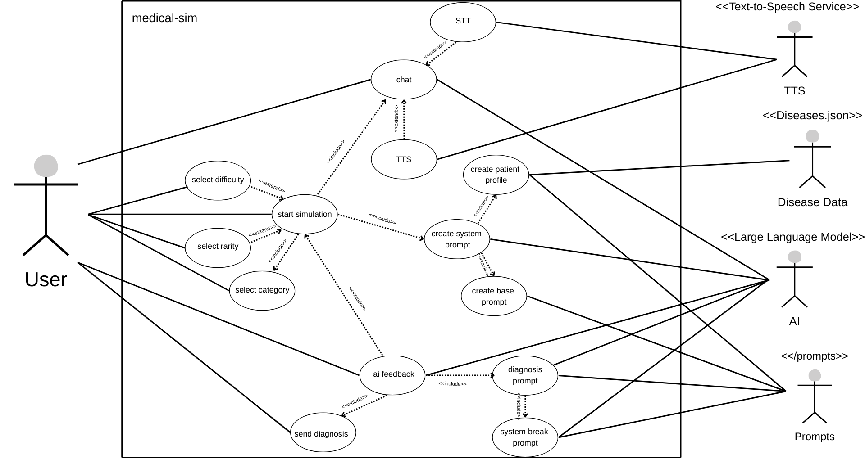
Figure 4.16.1. Use Case Diagram of the system

The Use Case Diagram illustrates the interaction between the Medical Student (User) and the system.

Primary Actor
- Medical Student

Main Use Cases
- Select Medical Category
- Configure Simulation Settings
- Interact with AI Patient
- Submit Diagnosis
- Receive Diagnostic Feedback
Each use case represents a core functional requirement of the system. The diagram demonstrates that the user is actively involved in all stages of the simulation, from preparation to evaluation. This design ensures that the system supports experiential learning and clinical reasoning rather than passive information consumption.
The use case diagram also highlights the system boundary, emphasizing that all AI-driven processes such as disease selection, patient behavior generation, and diagnosis evaluation occur internally without exposing medical answers directly to the user.

4.16.2 Class Diagram Explanation

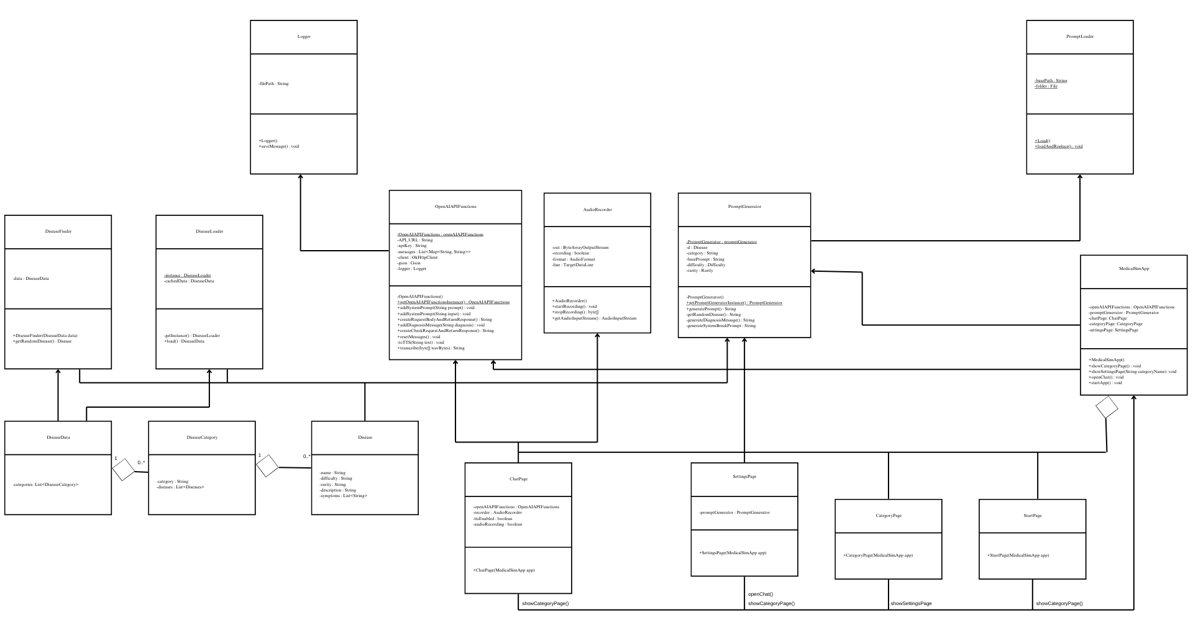
Figure 4.16.2. Class Diagram Illustrating Core System Components

The Class Diagram describes the static structure of the system and the relationships between its main components.

Key Classes and Responsibilities
- Disease, DiseaseCategory, DiseaseData
Represent the structured medical knowledge loaded from Diseases.json.
- DiseaseLoader
Responsible for parsing and loading disease data using the Gson library.
- DiseaseFilterEngine
Applies category, difficulty, and rarity constraints to select a valid disease.
- PromptLoader & PromptGenerator
Load external prompt templates and inject runtime data using placeholders.
- OpenAIAPIFunctions
Manages communication with OpenAI APIs.
- ChatPage, SettingsPage, CategoryPage
Handle user interaction and GUI logic.
- Logger
Records system events and AI responses.
The diagram demonstrates low coupling and high cohesion, ensuring that each class has a well-defined responsibility. This design choice increases maintainability and enables independent extension of system modules.

4.16.3 System Architecture Diagram Explanation

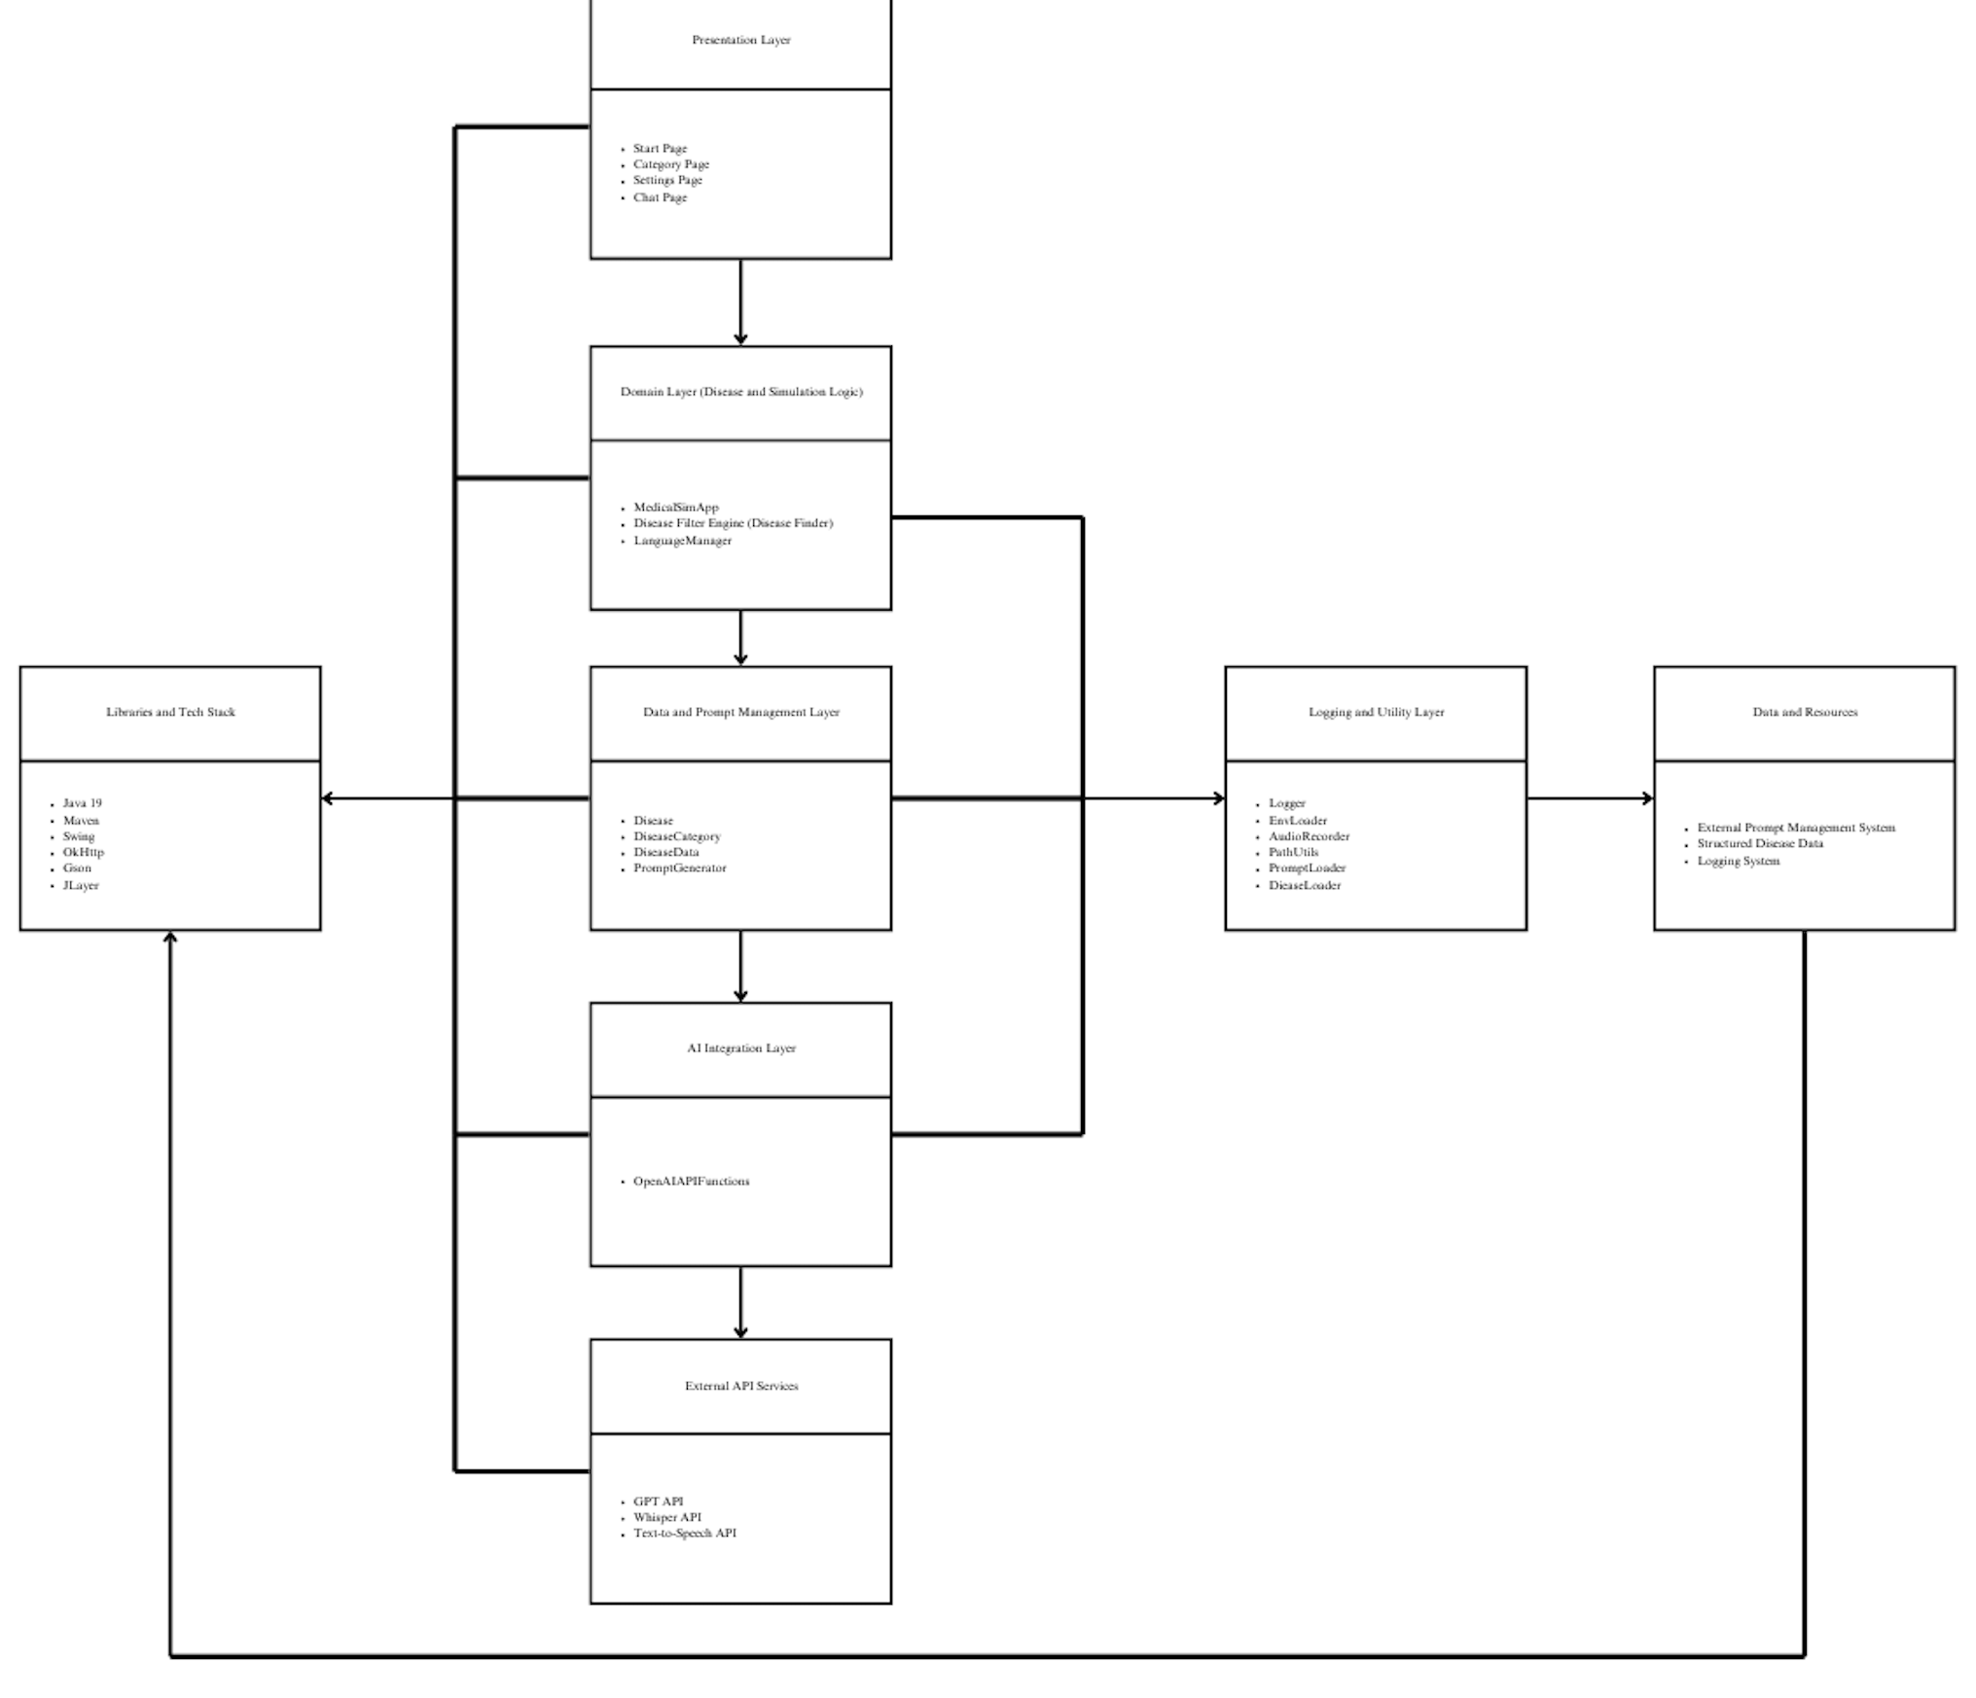
Figure 4.16.3. System Architecture Diagram Illustrating System Layers

The System Architecture Diagram presents a high-level overview of the layered design of Medical-Sim.

Layers
- Presentation Layer – Java Swing GUI components
- Domain Layer – Disease selection, simulation flow
- Data and Prompt Management Layer – Disease dataset and prompt templates
- AI Integration Layer – Prompt management and API communication
- Logging and Utility Layer – Logging and Utility logic
This layered architecture enforces separation of concerns and ensures that changes in one layer (e.g., disease data or prompts) do not require modifications in other layers.

4.17 Technology Stack and Implementation Tools
This subsection describes the technologies, libraries, and tools used in the implementation of the Medical-Sim system. The selected technology stack was chosen to ensure system stability, extensibility, and compatibility with AI-based services.

4.17.1 Programming Language and Framework
The system was implemented using Java 19, selected for its strong object-oriented capabilities, platform independence, and extensive ecosystem. The graphical user interface was developed using the Java Swing framework, which provides a stable and lightweight solution for desktop-based applications.

4.17.2 Build and Dependency Management
The project utilizes Apache Maven for build automation and dependency management. Maven ensures consistent project configuration, simplifies dependency resolution, and enables reproducible builds across different environments.
The maven-compiler-plugin (version 3.11.0) was configured to target Java 19 for both source and compilation output.

4.17.3 Libraries and Dependencies
Several third-party libraries were integrated to support system functionality:
- OkHttp (version 4.12.0) was used to handle HTTP communication with external AI services, providing efficient and reliable request–response handling.
- Gson (version 2.10.1) was employed for JSON serialization and deserialization, enabling structured parsing of the disease dataset and configuration files.
- JLayer (version 1.0.1) was used for MP3 audio playback to support text-to-speech functionality.

4.17.4 APIs and External Integrations
The intelligent behavior of the system relies on external AI services provided by OpenAI:
- The OpenAI GPT API is used to simulate patient behavior and generate conversational responses.
- The OpenAI Text-to-Speech API converts AI-generated text responses into audio output.
- The OpenAI Whisper API enables speech-to-text transcription for microphone-based user input.
These services are accessed through a dedicated AI integration layer to maintain loose coupling between the system and external dependencies.

4.17.5 Platform Compatibility
The selected technology stack ensures platform independence, allowing the system to run on any operating system that supports Java 19. This design choice enhances portability and simplifies deployment in academic environments.

