IZMIR UNIVERSITY OF ECONOMICS

FACULTY OF ENGINEERING

XXX ENGINEERING

FENG 497 PROJECT PROPOSAL



PROJECT TITLE

Author(s): …
Supervisor: …

OUTLINE
- Abstract
- Introduction
  - Problem Statement
  - Why This Project Worth Doing
- Objectives of the Project
- Scope of the Work
- Literature Survey
- Project Plan and Schedule
- References

1.Abstract
Briefly explain the motivation, aim and the methodology of the study (1 page maximum).

2.Introduction
Provide basic information about the background of your topic (2 pages maximum)
2.1. Problem Statement
Explain the problem that you are trying to solve (1 paragraph maximum).
2.2. Why is The Project Worth Doing
Justify why the problem you are trying to solve is important. What are the practical advantages of this particular field. Explain (2 paragraphs maximum).

3.Objectives of the Work

The objective of this project is to design and develop an AI-assisted medical case simulation tool that allows medical students to enhance their experience and diagnostic reasoning skills with interactive, realistic, and personalized patient simulations. The system aims to replicate real-life clinical encounters in a digital environment by allowing users to communicate with an artificial intelligence model acting as a patient, also provides AI feedback and evaluation based on the student’s diagnostic answer.
The several key objectives of project:
- Simulation of Diverse Medical Scenarios: Develop a category-based system where users can select from multiple medical branches (e.g., Emergency, Pediatric, Psychological, etc.), ensuring a wide range of medical cases.
- Customization of Case Parameters: Allow students to define disease characteristics such as diagnostic difficulty (easy, medium, hard), rarity (common, medium, rare), and patient personality traits (e.g., calm, talkative, aggressive). This customization aims to simulate the complexity and complication of real patients and the interactions with the patients.
- AI-Driven Patient Interaction: Integrate an AI that can simulate patient dialogues, answer questions, and behave according to the selected personality and disease traits. The system supports both text-based and voice-based (TTS/STT) communication for a more immersive experience.
- Diagnostic Evaluation System: Implement an evaluation system where the AI analyzes the student’s diagnosis and provides feedback to the students.
- Educational Enhancement: Provide medical students with a safe, controlled, and repeatable learning environment to practice an work on their decision-making, hypothesis testing, and clinical interviewing skills without a real patient and a risk.
Overall, the project focuses on closing the gap between theoretical medical education and practical experience by using AI as a virtual patient simulator. Through this system, students can practice, receive AI feedback, and improve their diagnostic reasoning skills and their experience with a patient.

4. Scope of The Work
Create a layout for your work. Which parameters will be included in your study? Be specific (1 page maximum).

5. Literature Survey
Mention previous studies in the same field and compare your work to these studies in terms of content and methodology (1 page minimum, 3 pages maximum).

6. Project Plan and Schedule
Prepare a Gannt chart as shown below. Please note that the tasks to be written in the first column have to be specific your project. The tasks in the sample are generalized. The Gannt chart should be prepared on a monthly scale (i.e. the entries in the first row should go like October 2018, November 2018,…………, May 2019).

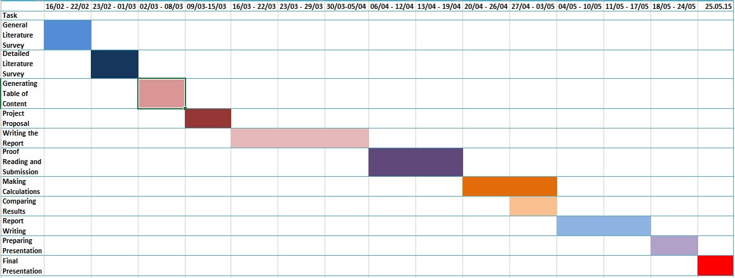

- REFERENCES
Make a list of scientific papers, books, websites, or any other material that you made use of while preparing this proposal. Give a number to each reference, starting from [1].

