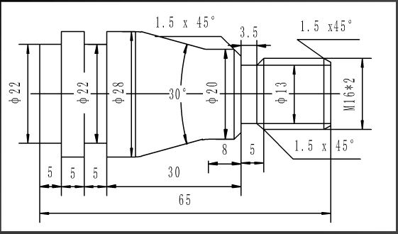

O0013

M03 S500

G00 G98 X100 Z100

T0101

G0 X30 Z3

G71 U1 R0.5

G71 P10 Q20 U0.5 F100

N10 G0 X13

G01 Z0 F30

G01 X15.9 Z1.5

G01 Z-20

X17

X20 Z-21.5

Z-27.32

G02 X20.341 Z-28.636 R5

G01 X27.659 Z-42.292

G03 X28 Z-43.586 R5

N20 G01 Z-70

S200

G70 P10 Q20

G0 X100 Z100

T0303

G0 X20 Z-19.5

G75 R0.5

G75 X13 Z-20 P2000 Q2500 F20

G0 X17 Z-18

G01 X15.9

X13 Z-19.5

G0 X28.5

Z-53

G75 R0.5

G75 X22.5 Z-55 P2000 Q2500 F20

G01 X22

Z-55

X28.5

G0 X28.5 Z-63

G75 R0.5

G75 X22.5 Z-68 P2000 Q2500 F20

G01 X22

Z-68

X28.5

G75 R0.5

G75 X0 P2000 F20

G0 X100 Z100

M30

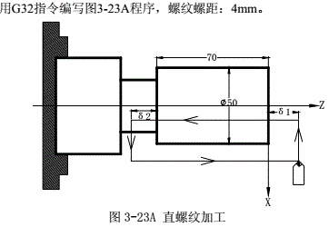

程序：

取δ1=3mm，δ2=1.5mm，总切深1mm（单边），分两次切入。

G00 X49 Z3; （第一次切入1mm）

G32 W-74.5 F4.0 J1.5;

G00 X55;

W74.5;

X48; （第二次切入1mm）

G32 W-74.5 F4.0;

G00 X55;

W74.5;

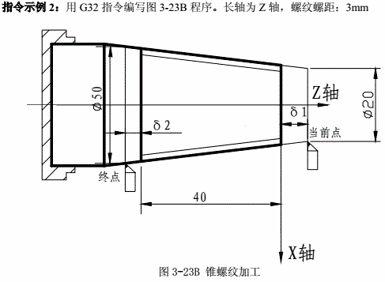

程序：

取δ1=2mm，δ2=1mm，总切深1mm（单边），分两次切入。

G00 X19 Z2; （第一次切入1mm）

G32 X49 Z-43 F3 J1;

G00 X55;

Z2;

G0 X18; （第二次切入1mm）

G32 X48 Z-43 F3;

G0 X55;

Z2;

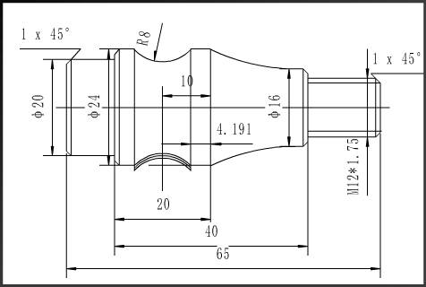

O0020

M03 S400

G0 G98 X100 Z100

T0101

G0 X26 Z3

G71 U1 R0.5

G71 P10 Q20 U0.5 F100

N10 G0 X10

G01 Z0

G01 X12 Z-1

Z-15

X14

X16 Z16

G02 X24 Z-35 R40

N20 G01 Z-70

G0 Z-39.191

G01 X26.5 F100

G02 X26.5 Z-50.809 R8 F80

G0 X24

G0 Z-39.191

G01 X24.4

G02 X24.4 Z-50.809 R8

G0 X26

G0 X26

G0 Z3

S250

G70 P10 Q20

G0 X100 Z100

T0202

G0 X15 Z3

G92 X11.3 Z-14 F1.75

X10.8

X10.5

X10.3

X10.15

X10

X9.9

G0 X24.5

Z-39.191

X24

G02 X24 Z-50.809 R8 F30

G0 X26

X50 Z100 S350

T0303

G0 X26 Z-58

G75 R0.5

G75 X20.2 Z-68 P3000 Q2500 F20

G0 X26 Z-68

G75 R0.5

G75 X16 Z-68 P3000 F20

G0 X26 Z-57

G01 X24

G01 X22 Z-58

X20

Z-67

X18 Z-68

G0 X26

G75 G1

G75 X0 P3000 F20

G0 X50 Z100

T0101

M30

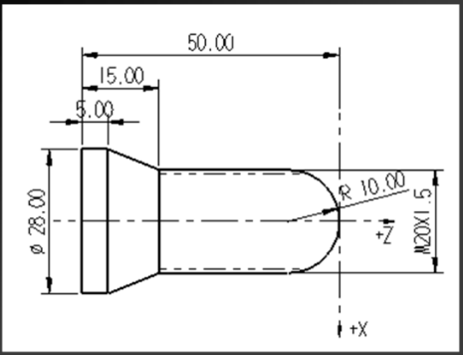

O0001

G00 G98 X50 Z100 M03 S400

T0101

G0 X30 Z2

G71 U0.8 R0.5

G71 P10 Q20 U0.5 F100

N10 G0 X0

G1 Z0 F50 S150

G3 X20 Z-10 R10

G1 Z-35

X28 Z-45

N20 Z-57

G70 P10 Q20

G0 X50 Z100

T0202

M03 S250

G0 X25 Z3

G92 X19.4 Z-35 F1.5

X18.9

X18.6

X18.4

X18.3

X18.2

G0 X50 Z100

T0303

G0 X35 Z-55 S350

G1 X0 F30

G0 X100 Z100

T0101

N03

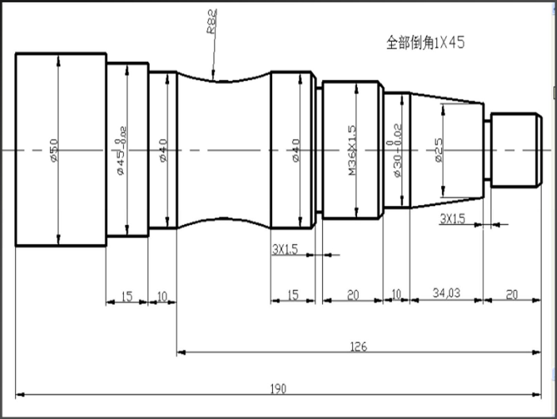

O0050

G0 X100 Z100 M03 S1000

T0101

G0 X50 Z2

G71 U1.5 R0.5

G71 P10 Q20 U0.5 F300

N10 G0 X16

G1 Z0 F100

X18 Z-1

Z-20

X25

X30 Z-54.03

Z-64.03

X34

X36 Z65.03

X38

Z-87.03

X40 Z-88.03

Z-136

X45

N20 Z-151

M03 S1200

G70 P10 Q20

G0 X100 Z100 S1000

T0202

G0 X20 Z-20

G1X15 F80

G0 X38

Z-87.03

G1 X33

G0 38

X100 Z100

T0303

S400

G0 X38 Z-64

G92 X35.4 Z-83 F1.5

X34.9

X34.6

X34.6

X34.3

X34.2

G0 X42

Z-102.03

G1 X40.5

G02 X40.5 Z-126 R82

G0 Z-102.03 M03 S1200

G1 X40

G02 X40 Z-126 R82 F50

G0 X100 Z100

T0101

M30

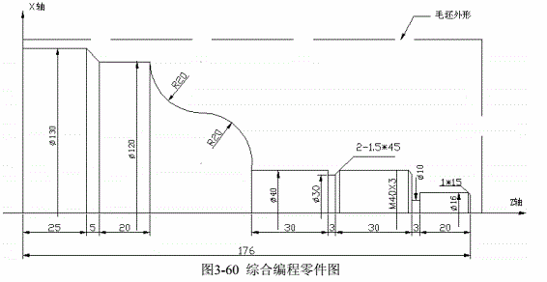

O0001; 零件程序名

N0000 G0 X150 Z185; 定位工件毛坯外一点（换刀用）

N0005 M12; 夹紧卡盘

N0010 M3 S300; 开主轴，至300转速

N0020 M8; 开冷却液

N0030 T0101; 换第一把刀

N0040 G0 X136 Z180; 靠近工件

N0050 G71 U2 R1 F200; 采用外圆粗车循环指令G71，切深4mm,退刀1mm

N0055 G71 P0060 Q0150 U1 W1; X向预留1mm，Z向1mm余量

N0060 G0 X16; 靠近到工件端面

N0070 G1 Z153 F100 S400; 车Φ16外圆

N0080 X40; 车Φ40右端面

N0100 W-63; 车Φ40外圆

N0110 G3 X80 W-20 R20; 车凸圆弧

N0120 G2 X120 W-20 R20; 车凹圆弧

N0130 G1 W-20; 车Φ120外圆

N0140 G1 X130 W-5; 车锥度

N0150 w-25; 车Φ130外圆

N0160 X150 Z185; 粗车完毕回换刀点

N0170 T0202; 换2号刀，执行2号刀偏

N0180 G70 P0060 Q0150; 精车循环

N0190 G0 X150 Z185; 精车完毕回换刀点

N0200 T0303; 换3号刀，执行3号刀偏

N0210 G0 Z120 X42; 靠近工件

N0220 G1 X30; 切Φ30槽

N0230 G1 X37; 返回

N0240 G1 X40 W1.5; 倒角

N0250 G0 X42 W31.5; 让出切槽刀宽

N0260 G1 X10; 切Φ10槽

N0270 G1 X42; 返回

N0280 G0 X150 Z185; 回回换刀点

N0290 T0404 S100; 换4号刀，至主轴100速

N0300 G0 X42 Z155; 靠近工件

N0310 G92 X39 W-34 F3; 切螺纹循环

N0320 X38.2; 进给0.8切第二刀

N0330 X37.7; 进给0.5切第三刀

N0340 G0 X150 Z185; 回换刀点

N0350 T0101 G0 U0; 换回1号刀

N0360 M5; 关主轴

N0370 M9; 关冷却液

N0380 M13; 松开卡盘

N0390 M30; 程序结束

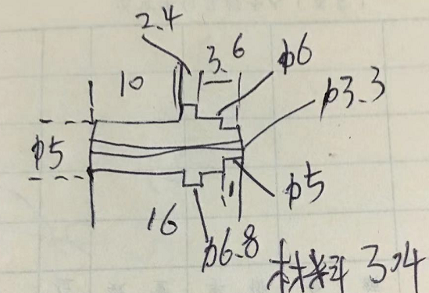

O0010

M03 S300 F200

G0 X50 Z50

G0 X5 Z2

G1 X3 Z0

X4.8

G1 X5 Z-0.2

G1 Z-10

X6.6

G1 X6.8 Z-10.2

Z-19

X8

G0 X50 Z50

T0202

G0 X7 Z-12.4

G1 X6

G0 X7

Z-15

G1 X5

G0 X6.8

Z-12.2

G1 X6.4 Z-12.4

X6

Z-14.8

G1 X5.4 Z15

G0 X7

Z-19

G1 X3

G0 X7

G0 X50 Z50

M05

T0303

G0 X0 Z-25

G0 Z0.2

M12

G0 X50 Z50

T0101

**外圆切槽循环G75**

指令格式：G75 R(e);

G75 X(U)_ Z(W)_ P(△i) Q(△k) R(△d) F_;

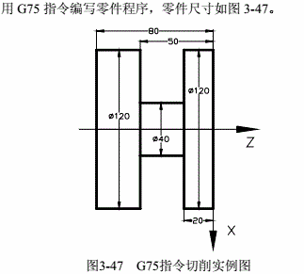

O0001; (程序名)

G0 X150 Z50; (快速定位)

M3 S500; (启动主轴，置转速500)

G0 X125 Z-20; (定位到加工起始点）

G75 R1; (加工循环)

G75 X40 Z-50 P2000 Q2000 F50;

G0 X150;

Z50;

M5 S0;

M30;