THEORY
I. SONiC 2
1. Centralized Database (Redis) 2
2. Containerized Model (Docker) 3
3. Operational Workflow Example 4
II. AOSX architecture 4
1. Docker Container Packaging 4
2. Main Components 4
3. Redis Database Segmentation 5
4. Basic Data Workflow 5

I. SONiC
The architecture of SONiC (Software for Open Networking in the Cloud) stands out as a complete Network Operating System. The architecture comprises a collection of software components & tools that work in harmony to offer serviceability, extensibility, development agility, and resource efficiency. is built upon two core principles: a Centralized Database (Redis) and a Containerized Model (Docker).

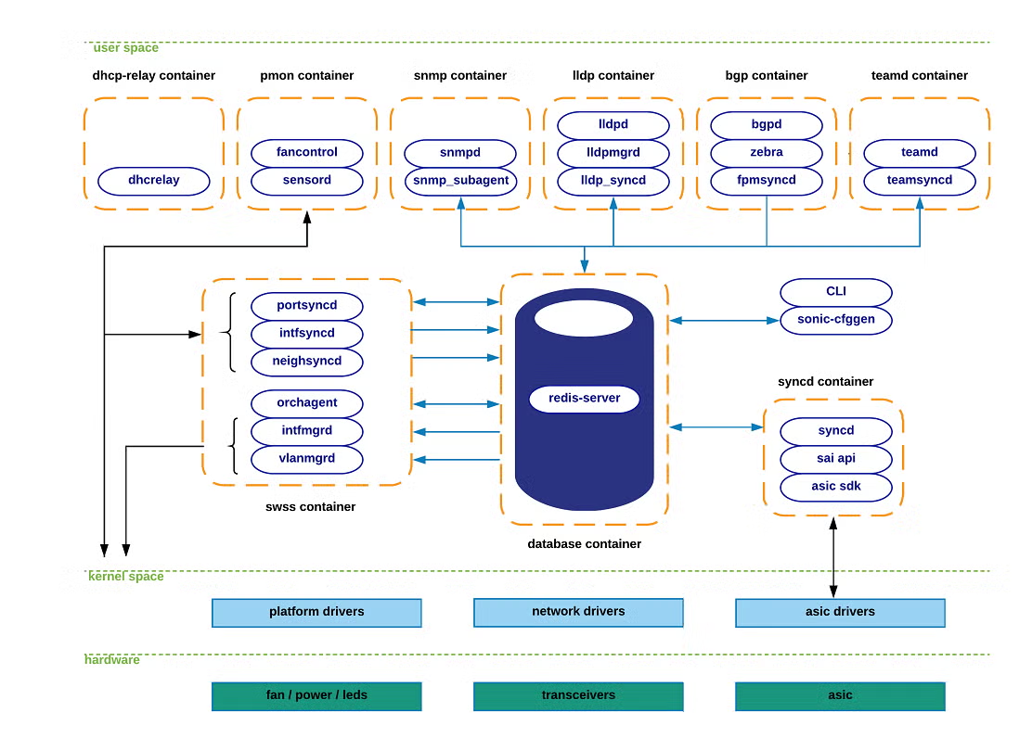
1. Centralized Database (Redis)
Instead of allowing processes to communicate directly with each other—which can create complex cross-dependencies and make debugging difficult—SONiC uses Redis as its communication and data storage infrastructure.
- Pub/Sub (Publisher/Subscriber) Model: Modules send (publish) data to Redis, and other modules that need that information register to receive it (subscribe). This keeps components entirely independent; they only need to care about their specific inputs and outputs.
- APPL_DB (Application DB): Stores state generated by applications, such as routing tables and neighbors. This acts as the main south-bound entry point for all applications.
- CONFIG_DB: Stores the configuration state created by SONiC applications, including port configurations, VLANs, and interfaces.
- STATE_DB: Stores key operational state to resolve dependencies between different modules. For example, it verifies if a physical port has actually been successfully initialized in hardware before an application is allowed to use it.
- ASIC_DB: Stores state in an ASIC-friendly format to drive the hardware chips configuration and operation.
- COUNTERS_DB: Stores statistics and counters associated with each port to serve remote telemetry or local CLI display.

2. Containerized Model (Docker)
SONiC isolates its functional components into independent Docker containers. This ensures high cohesion and means that if one service fails, it only affects that specific container without bringing down the entire switch.
a. Orchestration and State Group (SwSS - Switch State Service container)
This acts as the "coordinating brain" of SONiC, offering mechanisms for communication and arbitration between all different parties.
- syncd processes (e.g., portsyncd, intfsyncd, neighsyncd): These daemons listen for OS kernel events (like a physical port changing states or a newly discovered neighbor) and push that collected state into the APPL_DB.
- Orchagent (Orchestration Agent): The most critical component in the SwSS subsystem. It extracts relevant state injected into APPL_DB, processes the complex logic between features, and pushes the final outcome into ASIC_DB.
b. Protocol and Application Group (Application layer)
- Bgp container: Runs one of the supported routing stacks (like Quagga or FRR). Inside, a daemon named fpmsyncd fetches the routing table (FIB) and pushes it into APPL_DB.
- Teamd container: Runs the Link Aggregation (LAG / Port-channel) functionality.
- Lldp, Dhcp-relay, Snmp containers: Host their respective network protocols. For instance, the LLDP container establishes connections with peers and pushes discovered state to the Redis engine.
c. Hardware/Platform Interaction Group (Platform layer)
- Syncd container: A crucial module that reads data from ASIC_DB and programs it directly into the physical network chip (ASIC). It accomplishes this via the SAI (Switch Abstraction Interface) API. SAI is the magic that allows SONiC to run on chips from any vendor (Broadcom, Mellanox, Cisco, etc.) without the higher-level software needing to know chip-specific details.
- Pmon container (Platform Monitor): Periodically logs sensor readings from hardware components (temperature, power) and hosts the fancontrol process.

3. Operational Workflow Example
To understand how these components interact, here is a step-by-step example of what happens when the switch receives a new routing path (route) from an external peer:
a. The BGP container learns a new route. Its internal fpmsyncd daemon collects this data and writes it into the APPL_DB within Redis.
b. Orchagent (in the SwSS container), which actively subscribes to APPL_DB, receives a notification about the new route. It validates the data, processes any necessary logic, and writes the hardware-translated configuration into ASIC_DB.
c. The Syncd container, monitoring ASIC_DB, detects the new route request. It invokes the SAI APIs to command the ASIC chip to update its routing table at the physical silicon level.

II. AOSX architecture
The architecture of ALE OMNISWITCH X (AOSX) is a combination of legacy features (from the older ALE Legacy architecture) and a new infrastructure designed using modern standards introduced by Microsoft (based on the SONiC open-source architecture) that separates the management software from the hardware (Platform Abstraction), making the AOSX operating system highly flexible.
Core Features
- Modularity — Components are decoupled so parts can be replaced or upgraded independently.
- Lightweight Kernel Services — Minimal core with many services implemented as userland modules.
- Pluggable Runtime — Supports different runtimes and execution environments for workloads.
- Security by Design — Emphasis on isolation between modules and least-privilege defaults.
- Observability — Built-in telemetry and diagnostics for easier debugging and operations.

1. Docker Container Packaging
Instead of running directly on the host like the older 8X version, the 10X architecture groups features into "blocks" and packages them inside Docker Containers.
For example, there are separate containers for the Management Framework, Layer 2 (containing apps like VLAN, LACP, STP), Layer 3, etc..
Each container acts like a "small virtual machine" running closely related processes (applications/go-sets).

2. Main Components
The architecture is divided into multiple layers that communicate vertically:
- Management Framework (Management Plane): The top layer that receives user input. It contains a REST Server supporting methods like CLI, Webview, and REST config (HTTP/HTTPS). Notably, the Command Line Interface (CLI) in 10X is designed to be "Cisco-like" (context-based), making commands shorter and more intuitive compared to the very long single-line commands in 8X.
- Redis Database (Data Hub): Applications in AOSX do not communicate directly with each other. Instead, they exchange information through a Redis database using a Pub/Sub (Publisher/Subscriber) mechanism.
- Applications (Layer 2, Layer 3...): Core features inherited from the legacy generation (VLAN, STP, IP, CMM...) are brought into the new architecture. They "subscribe" to events from the database, process their logic, and write the results back to the database.
- Agent: Acts as a translator. It takes the processed data from the applications and converts it into a common standard called the SAI API (Switch Abstraction Interface) so that the hardware can understand it.
- Syncd & Platform Abstraction: The lowest layer situated right above the hardware. Syncd receives the standardized data (SAI API) and uses the manufacturer's SDKs (e.g., Broadcom) to write commands directly down to the hardware chip (Hardware/Kernel space).

3. Redis Database Segmentation
The central Redis Database is not a single monolithic block but is divided into multiple smaller databases with specific functions and IDs:
- Config DB (DB 4): Stores configurations pushed down by the user (following the YANG data model). Intervention is possible by CLI, Webview, REST API.
- State DB (DB 6): Stores the current state of the system. When a user types a "show" command, the system retrieves data from here to display.
- App DB (DB 0): Where applications store their internal data during operation.
- ASIC DB (DB 1): Stores hardware-related information and states pushed down by the Agent.
- Counter DB (DB 2): Used to store system counters.

4. Basic Data Workflow
To visualize how this system operates, this is an example of the data flow when a user configures a feature:
a. Receiving Command: The user inputs a configuration command via CLI. The REST server processes it and writes this configuration data into the Config DB.
b. Application Processing: Applications (e.g., Layer 2) that subscribe to the Config DB receive the new configuration event. The app retrieves the data, processes its logic, writes the results into the App DB, and updates the state in the State DB.
c. Translation: The Agent picks up the data from the App DB, converts it to the SAI API standard, and writes it into the ASIC DB.
d. Hardware Application: Syncd receives the standardized data from the ASIC DB, processes it through the vendor's SDK, and writes it directly down to the Hardware.
e. When a user wants to view the results (by typing a show command), the CLI client queries the State DB directly to display the information without needing to interact with the hardware layer.
