**Team - The Eigenists**

**Solution to Question 2**

The previous discrete linear wave equation was given as: $u_{i}^{n+1}= u_{i}^{n}- \frac{1}{2}\left(r\right)\left(u_{i+1}^{n+1}-{ u}_{i-1}^{n+1}\right)$

Here $r=\frac{C∆t}{∆x}$ is the Courant number from the Courant-Friedrichs–Lewy (CFL) condition.

We find that for implicit formulations, the next time-step value is written in the form of unknown spatial neighbours of the next time step itself. So, we cannot 'time march' as in explicit method because we have more unknowns.

Putting all the unknown terms on L.H.S and the known term on R.H.S, we get our equation as

$${\frac{-r}{2}u}_{i-1}^{n+1}+u_{i}^{n+1}+\frac{r}{2}u_{i+1}^{n+1}=u_{i}^{n}$$

This equation can be written for all spatial interior points, *N*. We assemble all the spatial equations for all points in a matrix form and solve them simultaneously.

**Boundary conditions**

At the left end of the wave, a Dirichlet type of boundary condition is specified as $u\left(x=0,t\right)=1$. Thus, for i=1 the equation will be

$${\frac{-r}{2}u}_{0}^{n+1}+u_{1}^{n+1}+\frac{r}{2}u_{2}^{n+1}=u_{1}^{n}$$

since the value of the boundary point $u_{0}^{n+1}=1$ is known for all time steps, we put this term ${\frac{-r}{2}u}_{0}^{n+1}$ to the R.H.S

$$u_{1}^{n+1}+\frac{r}{2}u_{2}^{n+1}=u_{1}^{n}+{\frac{r}{2}u}_{0}^{n+1}$$

Similarly, for the right end of the wave, writing the equation for *N-2* point we get

$${\frac{-r}{2}u}_{N-3}^{n+1}+u_{N-2}^{n+1}+\frac{r}{2}u_{N-1}^{n+1}=u_{N-2}^{n}$$

The discretised Neumann type of boundary condition is applied at the right end of the wave and is this given by $\frac{u_{N-1}^{n+1}-u_{N-2}^{n+1}}{∆x}=γ=0$. Neumann B.C. with zero gradient ($\frac{∂u}{∂x}$) is suitable. It simply means the end point (N) of wave is at same velocity as its left adjacent point (N-1).

Inserting the Neumann condition in the N-2 point equation, we get

$${\frac{-r}{2}u}_{N-3}^{n+1}+{\left(1+\frac{r}{2}\right)u}_{N-2}^{n+1}=u_{N-2}^{n}+\frac{r}{2}γ∆x$$

Assembling these linear systems of equations in matrix of the form $\left[A\right]\left[X\right]=\left[b\right]+\left[b_{B.C.}\right]$,we get a sparse coefficient matrix as

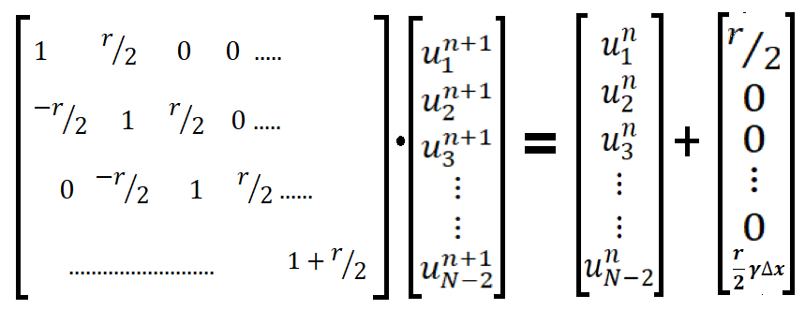

**SOLUTION**

Dividing the domain with 41 spatial points we get the spacing between points, $∆x=\frac{L}{41-1}=0.05$. The Courant number *r* is specified as equal to 2

We can calculate the time step from courant number as $∆t= \frac{r ∆x}{C}=0.01$.

The initial condition is given as $u_{0}=\left\{\begin{aligned}1 x≤0.5 \\ 2 x>0.5\end{aligned}\right.$. The plot of initial wave implemented on discrete spatial domain is as below. The square wave is not exactly square due to relatively large ∆x.

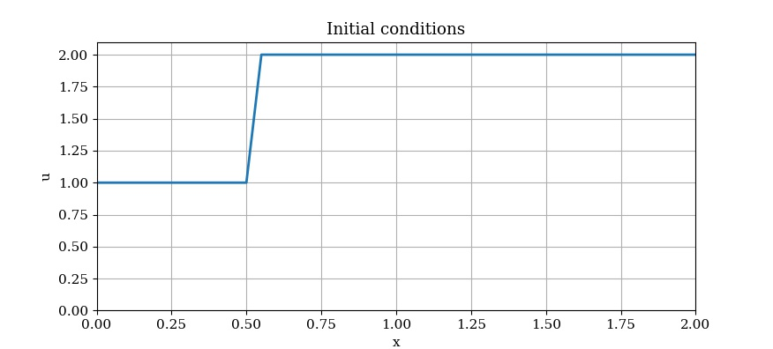

Applying the specified boundary conditions and simulating for 10 time steps we get the wave as given below.

