**Team - The Eigenists**

**Solution to Question 3**

The analytical solution for linear wave equation is given in terms of its initial condition function, $u_{0}$ as

$$u(x,t)=u_{0}\left(x-Ct\right)$$

This means its shape does not change, being always the same as the initial wave, 𝑢0, but only shifted in the 𝑥 -direction. In fact, the basic idea to do numerical simulation of wave equation is to see how well the initial shape of the wave gets carried away without the change in its shape (like in exact analytical solution). But numerical simulation would bound to have discretization and truncation errors and our wave will distort or spread out (diffusion).

The plot of analytical solution is as given below. It clearly shows in the time span of 1 second, with the positive wave speed C = 1 m/s, our initial wave would travel 1 meter to the right. Hence it is shifted from x=0.5 to x=1.5.

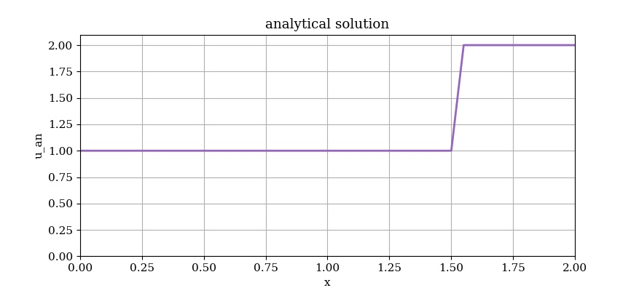

The Plot of L1 norm of the analytical solution and the numerical simulation is given below as

