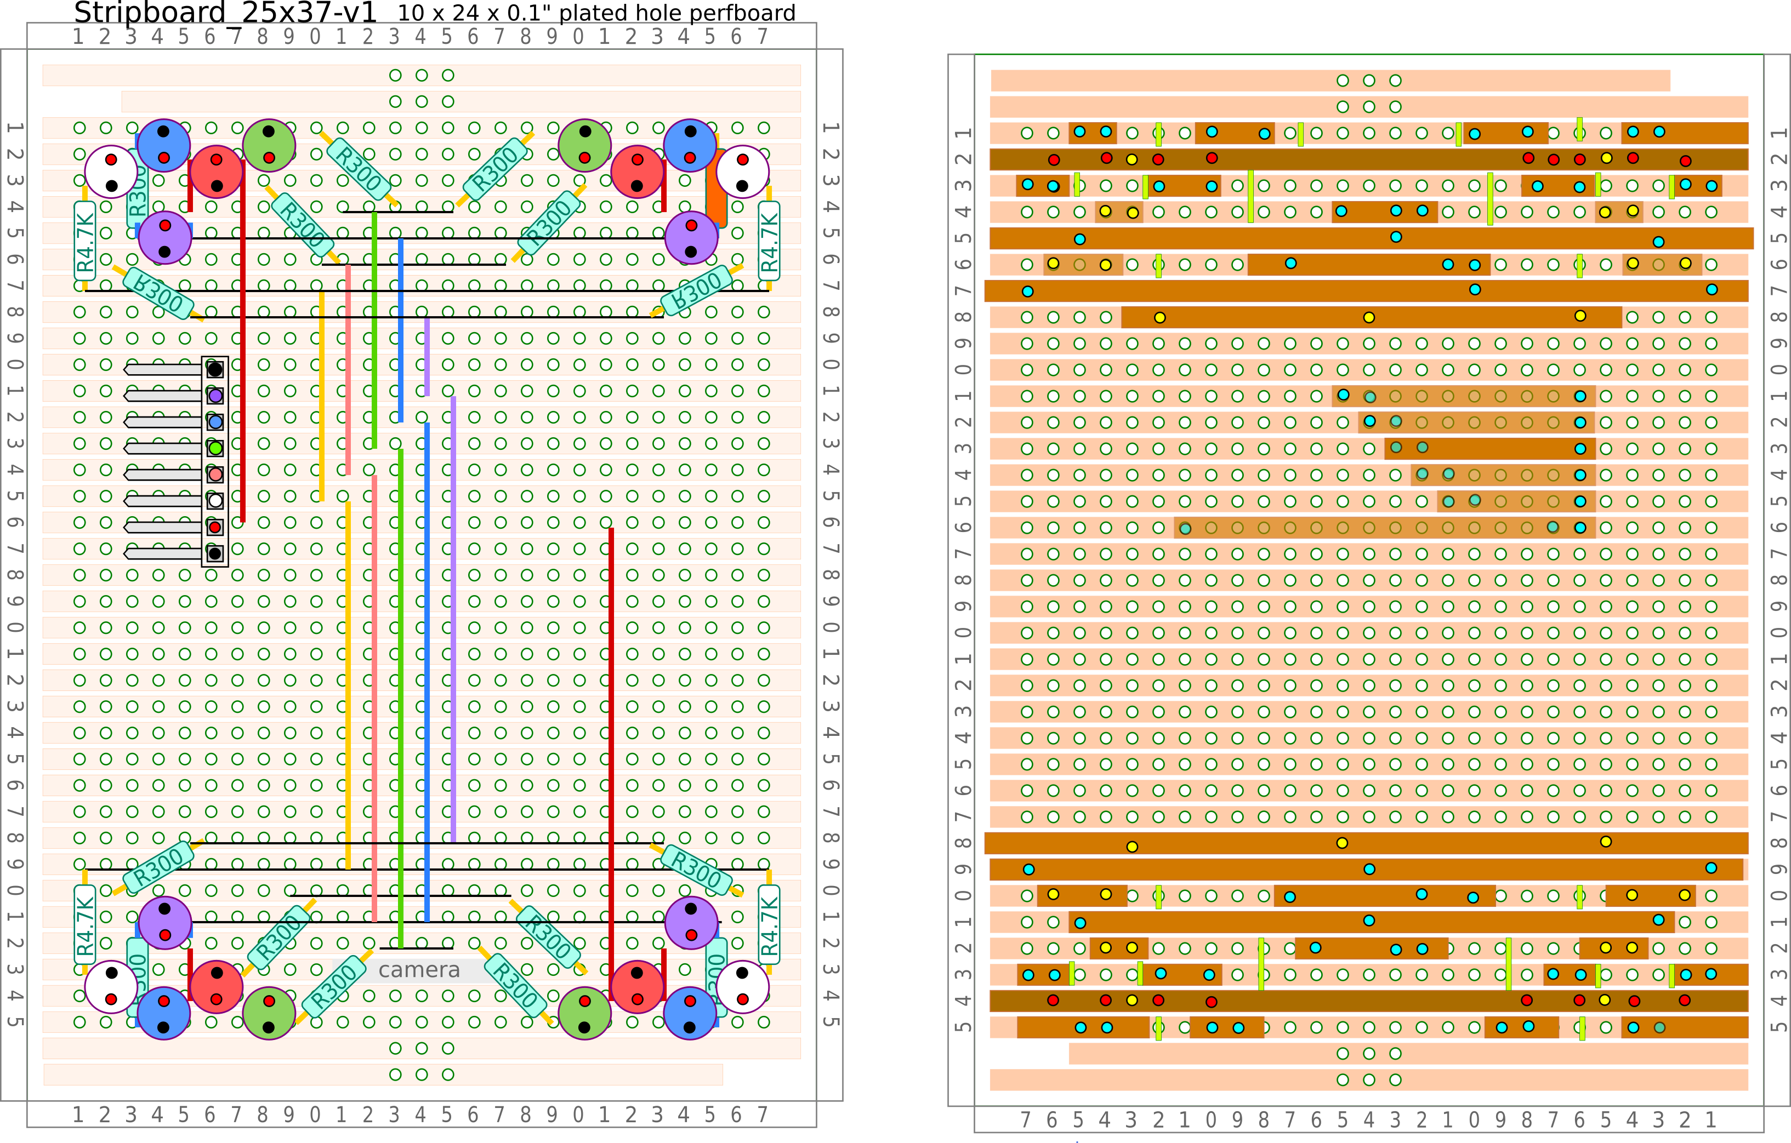
Colorimeter/test_light_1.svg / .png 2026-03-16

Colorimeter/mainboard_C.svg / .png 2026-03-16

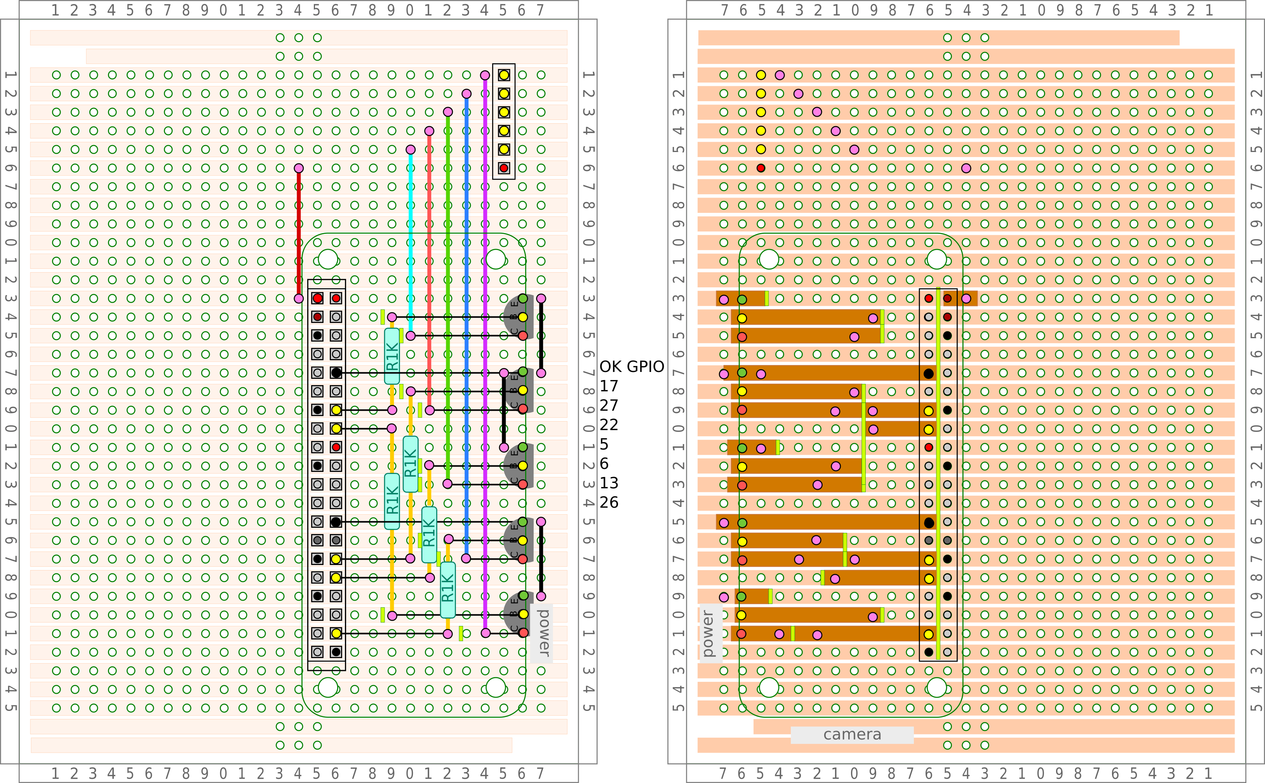
test_light_2.png. This is a single color, with 6 LEDs. The LEDs are mounted about 3/8 in high, and bent at right angles. The plug is on the back.
The LEDs face toward eachother, overlapping past each other. The plug has to be on the back side so as not to interfere.

