
Contents
TASK 1A (TASK DEFINITION) 2
TASK 1B (USER REQUIREMENTS) 2
UML DIAGRAM 3
TASK 2 (DATABASE DESIGN) 4
TASK 3 (DATA DICTIONARY) 5
TASK 4A (NAVIGATION/FLOW DIAGRAM) 6
TASK 4B (GUI) 7
TASK 5 (IPO) 8

TASK 1A (TASK DEFINITION)
Pixel Designs (PD) was tasked with designing and programming an application that will be used for managing property sales for NextGen Estates (NE).

The property market has become overly saturated during recent years as property prices have increased, this has led to an immense amount of property marketplace applications being developed, some of which do not meet the standards of users. This has caused a lack of trust for buyers as well as sellers when it comes to using application-based property marketplaces.

This has led to the Pixel Designs team being given vital key aspects to focus on during the development of this application, they include User safety, Ease of use, User friendly GUI as well as a secure database for all user information. This will ensure that users will be able to use the platform with ease as well and ensure that their private information is safe.

The application will also show the general market trends for South African Real Estate, show the users general indications of financing options, sort by location, filter by specific features of the properties as well as show users expected rates and monthly costs.

TASK 1B (USER REQUIREMENTS)
 | Buyer | Seller | Admin
Actions | A buyer will be allowed to view properties listed, filter by categories as well as view more information on financial details. | A seller will be able to list properties, edit details on their properties as well as view potential offers from buyers. | An admin will be able to create listings, login in to test account, edit;remove;create;view listings, view database (not able to edit information directly).
Limitations | They will not be able to access the database, edit other listings, remove listings. | They will only be able to edit their own listings, they will not be able to view private buyer information. | Not able to see database with private user information

UML DIAGRAM
Sign up
Admin
Lister
Buyer
View listed properties
Login
Edit record
Delete Record
Add record
IF created by user
IF created by user

TASK 2 (DATABASE DESIGN)
tblUser
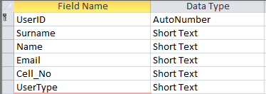

tblProperty
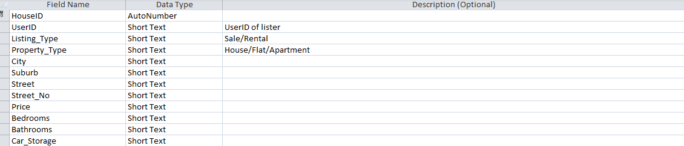

Relationship
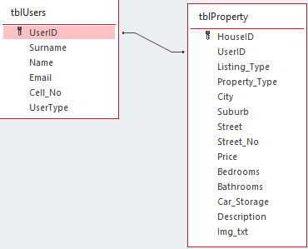

TASK 3 (DATA DICTIONARY)
Classes and Objects:
Classes and objects are vital when it comes to Object Orientation programming as it allows for tasks/instructions to be completed. It also helps in storing data that will be continually used. The class created will contain information about the properties. The object created will display the information about the property selected.
-clsHouse: Class that stores information for the properties
-objHouse: Object that displays information for the property
Text Files:
Text Files are used to store information that should be easy to access and read. It has fewer formatting issues thus allowing any user to read the file. A .txt file will be used to store details on users every time that they login.
-LoginStamp.txt
2D Array:
A 2D array is a data structure that stores elements in a grid or matrix-like format with rows and columns. A 2D array will be used to show the database of properties in a grid form.
-arrGrid
Method binding:
Method binding is determining what method or procedure to call for each specific task, this is extremely important for a property marketplace as there are numerous methods and procedures that should be called. Method binding will be used to load information on each specific property.

TASK 4A (NAVIGATION/FLOW DIAGRAM)
Login
Sign Up
Add record
Main Menu
Admin Page
About us
Admin = true
Lister = True
START
END

TASK 4B (GUI)
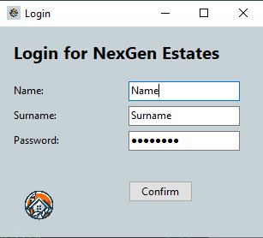
Login page

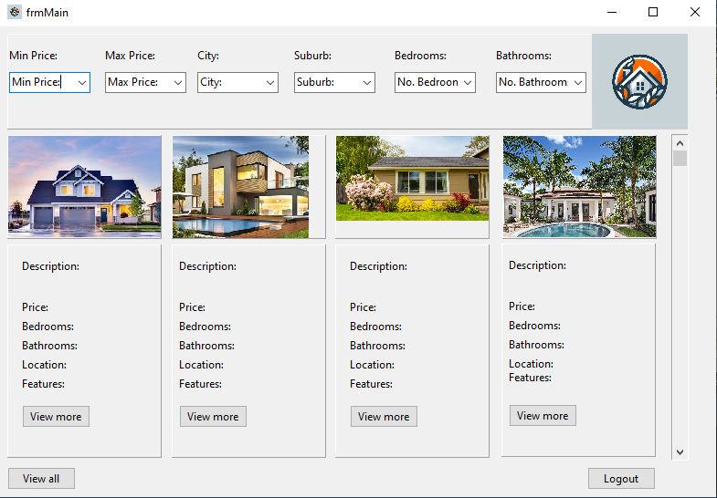
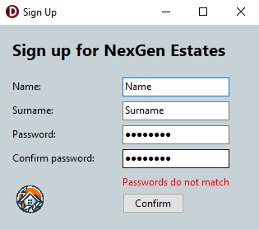
Sign up page
Main page
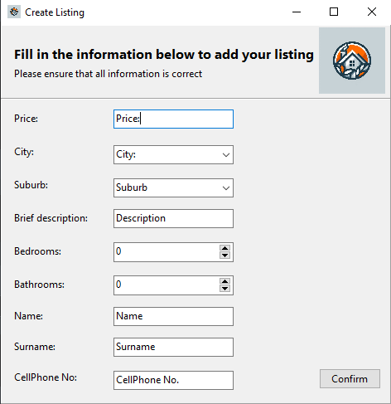
Create Listing

UML Use Case
clsHouse
Components
- pnlInfo: TPanel
- FimgMain: TImage
- FlblHouse: TLabel
- FlblPrice: TLabel
- FlblDescription: TLabel
- FlblLocation: TLabel
- FlblNoBed: TLabel
- FlblNoBath: TLabel
- FbtnView: TButton
Methods
- Constructor Create(FiID, FiPrice, FiBed, FiBath: Integer; FsHouse, FsDescription, FsImg: String
- Function GetPrice: Real
- Function GetHouse: String
- Function GetDescription: TImage
- Function GetImage: TImage
Auxiliary
- Function AddSpacing(iSpace) : Integer;
Set
- iID : FiID
- iPrice: FiPrice
- iBed: FiBed
- iBath: FiBath
- sHouse: FsHouse
- sDescription: FsDescription
- sImage: FsImg

TASK 5 (IPO)
Input |  | Processing | Output
Input component | Validation | Pseudo code | Output Code | Visible | Variable Type
Methods
Procedure CreateHouse | Validation on each inputbox | Create(Name, Price, description, Img) | Adds object to database | Adds house to visible object
Procedure ColorMode |  | Form1.Theme = Light or Form1.Theme = Dark | Changes colour of all components | Changes theme of form
Procedure DeleteHouse | Validation on ID and details | Delete(objHouse) | Deletes house from database | Deletes house from DBGrid
Procedure ButtonAnimationUp |  | Button.position + 5 | Change position of button | Moves button up
Procedure ButtonAnimationDown |  | Button.position + 5 | Change position of button | Moves button down
Button named btnConfirm (frmLogin)  Button click Confirm | Validation on all edit boxes | If Field(Name) = edtName, if Field(Surname) = edtSurname, if Field(Password) = edtPassword | Changes to main form | Form change
Button named btnConfirm (frmSignUp)  Button click Confirm |  | Insert Field(Name) = edtName, if Field(Surname) = edtSurname, if Field(Password) = edtPassword | Changes to main form  Stores information to database | Form change
Button named btnViewAll  Button click View all |  | dbGrid.filter = false | Removes all filters | All fields are visible

Input |  | Processing | Output
Input component | Validation | Pseudo code | Output Code | Visible | Variable Type
Methods
Button named btnLogout  Button click Logout |  | frmMain.close  frmLogin.open | Closes main form and opens login page | Login page opens and main form closes
ComboBox named cmbMinPrice  CmbMinPrice.change |  | Field(Price) > cmbMinPrice | Filter(DBGrid) | Removes properties with price lower than MinPrice variable | Real
ComboBox named cmbMaxPrice  cmbMaxPrice.change |  | Field(Price) < cmbMaxPrice | Filter(DBGrid) | Removes properties with price higher than MaxPrice variable | Real
ComboBox named cmbCity  cmbCity.change |  | Field(City) = cmbCity | Filter(DBGrid) | Removes properties not from City | String
ComboBox named cmbSuburb  cmbSuburb.change |  | Field(Suburb) = cmbSuburb | Filter(DBGrid) | Removes properties not from Suburb | String
ComboBox named cmbBedrooms  cmbBedrooms.change |  | Field(Bedrooms) > cmbBedroom | Filter(DBGrid) | Removes properties with less bedrooms | Integer
ComboBox named cmbBathrooms  cmbBathrooms.change |  | Field(Bathrooms) > cmbBathrooms | Filter(DBGrid) | Removes properties with less bathrooms | Integer

Input |  | Processing | Output
Input component | Validation | Pseudo code | Output Code | Visible | Variable Type
Methods
Procedure Add Listing | User Type must be Lister or admin | frmListing open  lblCaptionChange | Open frmListing  Close frmMain | Create listing form opens and main form closes
EditBox named edtPrice (frmListing)  OnChange | Ensures that variable type is Real | For length(edtPrice.text)  edtPrice[i] in 0-9 | imgCheck1.visible | Puts a check mark next to the edit box | Real
ComboBox named cmbCity (frmListing)  OnChange | Ensures that an option is selected | cmbCity.ItemIdex > 0 | imgCheck2.visible | Puts a check mark next to the edit box | String
ComboBox named cmbSuburb (frmListing)  OnChange | Ensures that an option is selected | cmbSuburb.ItemIndex > 0 | imgCheck3.visible | Puts a check mark next to the edit box | String
EditBox named edtDescription (frmListing)  OnChange_ | Ensures that a value is entered | Length(edtDescription) > 50 | imgCheck4.visible | Puts a check mark next to the edit box | String

Input |  | Processing | Output
Input component | Validation | Pseudo Code | Output Code | Visible | Variable type
SpinEdit named spnBedrooms (frmListing)  OnChange | Ensures that a value is entered | SpinEdit.value > 0 | imgCheck5.visible | Puts a check mark next to the edit box | Integer
SpinEdit named spnBathrooms (frmListing)  OnChange | Ensures that a value is entered | SpinEdit.value > 0 | imgCheck6.visible | Puts a check mark next to the edit box | Integer
EditBox named edtName (frmListing)  OnChange | Ensures that a value is entered | edtName <> “” or “ “ | imgCheck.7visible | Puts a check mark next to the edit box | String
EditBox named edtSurname (frmListing)  OnChange | Ensures that a value is entered | edtSurname <> “” or “ “ | imgCheck8.visible | Puts a check mark next to the edit box | String
EditBox named edtCellNo (frmListing)  OnChange | Ensures that a value is entered | Length(edtCell) = 10 | imgCheck9.visible | Puts a check mark next to the edit box | String
Procedure CheckInfo | Ensures that all check marks are visible | For [i] 1 to 9  Check.visible  Then  btnConfirm enable | Enables Confirm button | Confirm button is enabled
Button Named btnConfirm  OnClick |  | Procedure CreateHouse | Adds info into database  Returns to main form | Main form opens and Listing form closes

