Day04:

Create a pipeline project using jenkins to execute below tasks and finally deploy to GCP

1. checkout the dynamic web project from GIThub
2. Build ,test and package the code by using maven
3. create docker containers
4. push docker container
5. Establish SSH connection from jenkins to GCP or any cloud environment
6. Run docker container’

Note: You would have to use maven and docker as runtime provided tools to jenkins (i.e in groovy script)

Convention:

Maven tool name : maven-3

Docker tool name : docker

### Implementation:

I have two VMs created in GCP account. Installed jenkins in one VM.

I would establish the SSH connection from Jenkins VM to another VM.

Problem-1:

I have a Jenkins running as a docker container, now I want to build a Docker image using pipeline, but Jenkins container always tells Docker not found.

INFO] Packaging webapp

[INFO] Assembling webapp [DynamicWebProject] in [/var/lib/jenkins/workspace/ci_cd_pipeline/target/DynamicWebProject]

[INFO] Processing war project

[INFO] Copying webapp resources [/var/lib/jenkins/workspace/ci_cd_pipeline/src/main/webapp]

[INFO] Webapp assembled in [62 msecs]

[INFO] Building war: /var/lib/jenkins/workspace/ci_cd_pipeline/target/DynamicWebProject.war

[INFO] WEB-INF/web.xml already added, skipping

[INFO] ------------------------------------------------------------------------

[INFO] BUILD SUCCESS

[INFO] ------------------------------------------------------------------------

[INFO] Total time: 2.388 s

[INFO] Finished at: 2020-09-24T11:10:10Z

[INFO] ------------------------------------------------------------------------

[Pipeline] }

[Pipeline] // stage

[Pipeline] stage (hide)

[Pipeline] { (Build docker image) (hide)

[Pipeline] sh (hide)

+ docker build -t panikumar1001/dynamicpro:3 .

/var/lib/jenkins/workspace/ci_cd_pipeline@tmp/durable-1f537169/script.sh: 1: /var/lib/jenkins/workspace/ci_cd_pipeline@tmp/durable-1f537169/script.sh: docker: not found

[Pipeline] }

[Pipeline] // stage

[Pipeline] }

[Pipeline] // node

[Pipeline] End of Pipeline

ERROR: script returned exit code 127

Finished: FAILURE

Catch: I configured the docker in my jenkins configurations and add that at stage in groovy script as follows.

In your Jenkins interface go to "Manage Jenkins/Global Tool Configuration"

Then scroll down to Docker Installations and click *"Add Docker"*. Give it a name like *"myDocker"*

Make sure to check the box which says *"Install a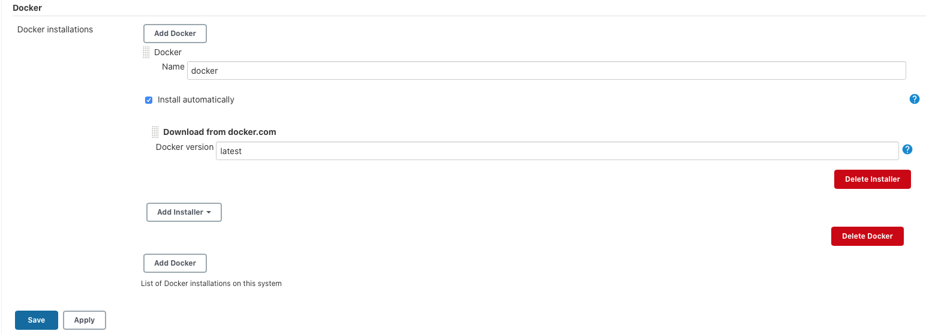utomatically"*. Click *"Add Installer"* and select *"Download from docker.com"*. Leave "latest" in the Docker version. Make sure you click Save.

In your Jenkinsfile add the following stage before you run any docker commands: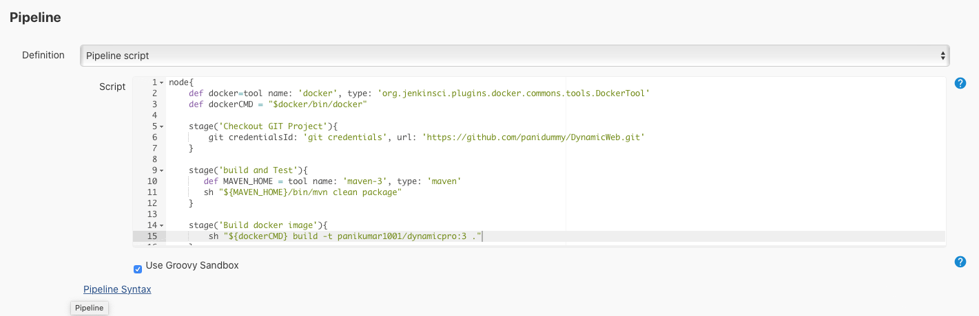

Problem-2:

[INFO] Packaging webapp

[INFO] Assembling webapp [DynamicWebProject] in [/var/lib/jenkins/workspace/ci_cd_pipeline/target/DynamicWebProject]

[INFO] Processing war project

[INFO] Copying webapp resources [/var/lib/jenkins/workspace/ci_cd_pipeline/src/main/webapp]

[INFO] Webapp assembled in [62 msecs]

[INFO] Building war: /var/lib/jenkins/workspace/ci_cd_pipeline/target/DynamicWebProject.war

[INFO] WEB-INF/web.xml already added, skipping

[INFO] ------------------------------------------------------------------------

[INFO] BUILD SUCCESS

[INFO] ------------------------------------------------------------------------

[INFO] Total time: 2.326 s

[INFO] Finished at: 2020-09-24T11:49:59Z

[INFO] ------------------------------------------------------------------------

[Pipeline] }

[Pipeline] // stage

[Pipeline] stage (hide)

[Pipeline] { (Build docker image) (hide)

[Pipeline] sh (hide)

+ /var/lib/jenkins/tools/org.jenkinsci.plugins.docker.commons.tools.DockerTool/docker/bin/docker build -t panikumar1001/dynamicpro:3 .

**Cannot connect to the Docker daemon at unix:///var/run/docker.sock. Is the docker daemon running?**

[Pipeline] }

[Pipeline] // stage

[Pipeline] }

[Pipeline] // node

[Pipeline] End of Pipeline

ERROR: script returned exit code 1

Finished: FAILURE

**Catch:** I got that there is no docker installation in VM. As soon as I installed docker in VM , this error is disappeared.

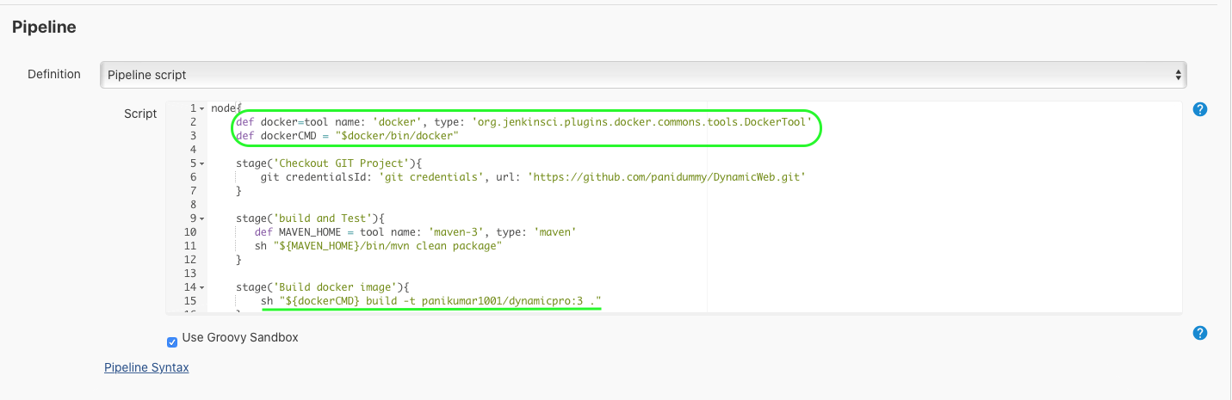Problem-3:

[INFO] Packaging webapp

[INFO] Assembling webapp [DynamicWebProject] in [/var/lib/jenkins/workspace/ci_cd_pipeline/target/DynamicWebProject]

[INFO] Processing war project

[INFO] Copying webapp resources [/var/lib/jenkins/workspace/ci_cd_pipeline/src/main/webapp]

[INFO] Webapp assembled in [80 msecs]

[INFO] Building war: /var/lib/jenkins/workspace/ci_cd_pipeline/target/DynamicWebProject.war

[INFO] WEB-INF/web.xml already added, skipping

[INFO] ------------------------------------------------------------------------

[INFO] BUILD SUCCESS

[INFO] ------------------------------------------------------------------------

[INFO] Total time: 2.909 s

[INFO] Finished at: 2020-09-24T12:30:36Z

[INFO] ------------------------------------------------------------------------

[Pipeline] }

[Pipeline] // stage

[Pipeline] stage (hide)

[Pipeline] { (Build docker image) (hide)

[Pipeline] sh (hide)

+ /var/lib/jenkins/tools/org.jenkinsci.plugins.docker.commons.tools.DockerTool/docker/bin/docker build -t panikumar1001/dynamicpro:3 .

**Got permission denied while trying to connect to the Docker daemon socket at unix:///var/run/docker.sock:** Post <http://%2Fvar%2Frun%2Fdocker.sock/v1.29/build?buildargs=%7B%7D&cachefrom=%5B%5D&cgroupparent=&cpuperiod=0&cpuquota=0&cpusetcpus=&cpusetmems=&cpushares=0&dockerfile=Dockerfile&labels=%7B%7D&memory=0&memswap=0&networkmode=default&rm=1&shmsize=0&t=panikumar1001%2Fdynamicpro%3A3&target=&ulimits=null>: **dial unix /var/run/docker.sock: connect: permission denied**

[Pipeline] }

[Pipeline] // stage

[Pipeline] }

[Pipeline] // node

[Pipeline] End of Pipeline

ERROR: script returned exit code 1

Finished: FAILURE

**Catch:** As soon as I added jenkins user to docker group in VM , this error got cleared.

sudo usermod -aG docker jenkins

and then restart jerkin using below command.

sudo service jenkins restart

Now Jenkins is able to create a docker image as follows

[INFO] Packaging webapp

[INFO] Assembling webapp [DynamicWebProject] in [/var/lib/jenkins/workspace/ci_cd_pipeline/target/DynamicWebProject]

[INFO] Processing war project

[INFO] Copying webapp resources [/var/lib/jenkins/workspace/ci_cd_pipeline/src/main/webapp]

[INFO] Webapp assembled in [164 msecs]

[INFO] Building war: /var/lib/jenkins/workspace/ci_cd_pipeline/target/DynamicWebProject.war

[INFO] WEB-INF/web.xml already added, skipping

[INFO] ------------------------------------------------------------------------

[INFO] BUILD SUCCESS

[INFO] ------------------------------------------------------------------------

[INFO] Total time: 3.394 s

[INFO] Finished at: 2020-09-24T12:44:43Z

[INFO] ------------------------------------------------------------------------

[Pipeline] }

[Pipeline] // stage

[Pipeline] stage (hide)

[Pipeline] { (Build docker image) (hide)

[Pipeline] sh (hide)

+ /var/lib/jenkins/tools/org.jenkinsci.plugins.docker.commons.tools.DockerTool/docker/bin/docker build -t panikumar1001/dynamicpro:3 .

Sending build context to Docker daemon 5.976MB

Step 1/6 : FROM tomcat:9.0

9.0: Pulling from library/tomcat

57df1a1f1ad8: Pulling fs layer

71e126169501: Pulling fs layer

1af28a55c3f3: Pulling fs layer

03f1c9932170: Pulling fs layer

881ad7aafb13: Pulling fs layer

9c0ffd4062f3: Pulling fs layer

bd62e479351a: Pulling fs layer

48ee8bc64dbc: Pulling fs layer

07cb85cca4f0: Pulling fs layer

6a78fac8d191: Pulling fs layer

03f1c9932170: Waiting

881ad7aafb13: Waiting

9c0ffd4062f3: Waiting

bd62e479351a: Waiting

48ee8bc64dbc: Waiting

07cb85cca4f0: Waiting

6a78fac8d191: Waiting

71e126169501: Verifying Checksum

71e126169501: Download complete

1af28a55c3f3: Verifying Checksum

1af28a55c3f3: Download complete

881ad7aafb13: Verifying Checksum

881ad7aafb13: Download complete

57df1a1f1ad8: Verifying Checksum

57df1a1f1ad8: Download complete

9c0ffd4062f3: Verifying Checksum

9c0ffd4062f3: Download complete

03f1c9932170: Verifying Checksum

03f1c9932170: Download complete

48ee8bc64dbc: Verifying Checksum

bd62e479351a: Download complete

57df1a1f1ad8: Pull complete

71e126169501: Pull complete

1af28a55c3f3: Pull complete

03f1c9932170: Pull complete

881ad7aafb13: Pull complete

9c0ffd4062f3: Pull complete

bd62e479351a: Pull complete

48ee8bc64dbc: Pull complete

07cb85cca4f0: Pull complete

6a78fac8d191: Pull complete

Digest: sha256:1bab37d5d97bd8c74a474b2c1a62bbf1f1b4b62f151c8dcc472c7d577eb3479d

Status: Downloaded newer image for tomcat:9.0

---> f796d3d2c195

Step 2/6 : EXPOSE 8082

---> Running in 762bf1251245

Removing intermediate container 762bf1251245

---> e65a3669af69

Step 3/6 : ARG WAR_FILE=/target/*.war

---> Running in 0e13016749cf

Removing intermediate container 0e13016749cf

---> 9f81c9064633

Step 4/6 : COPY ${WAR_FILE} /usr/local/tomcat/webapps/dynamicpro.war

---> 5d388ce538ef

Step 5/6 : MAINTAINER "Ramu Bikki"

---> Running in 02186e4351c1

Removing intermediate container 02186e4351c1

---> cbd08a4b1e4a

Step 6/6 : CMD ["catalina.sh", "run"]

---> Running in b962dffc32ff

Removing intermediate container b962dffc32ff

---> 606b354988bb

**Successfully built 606b354988bb**

**Successfully tagged panikumar1001/dynamicpro:3**

[Pipeline] }

[Pipeline] // stage

[Pipeline] }

[Pipeline] // node

[Pipeline] End of Pipeline

Finished: SUCCESS



## Now we need to establish the SSH connection from jenkins to another VM (where Docker is running)

For that I have followed “Jenkins Master Slave Setup over ssh using SSH keys”. As per this approach I created the Docker VM as slave node and ci_cd_pipleline project able to do following actions on another VM where docker is running (i.e slave node) from jenkins.

* + Download web project from GitHub to docker VM.
  + Build and test using maven in docker VM
  + Construct the docker image in docker VM
  + push docker image from docker VM to docker repository
  + Run docker image in docker VM
  + Successfully displayed the result on browser by calling address as follows.
    - dockerVM_IP:8082/dynamicpro

All the above actions are performed in docker VM from jenkins server. Note that Jenkins server is running in another VM.

Jenkins Master Slave Setup over ssh using SSH keys:

Following youtube vedic helps to configure this setup.

https://youtube.com/watch?v=TXbOw0ffTMk

[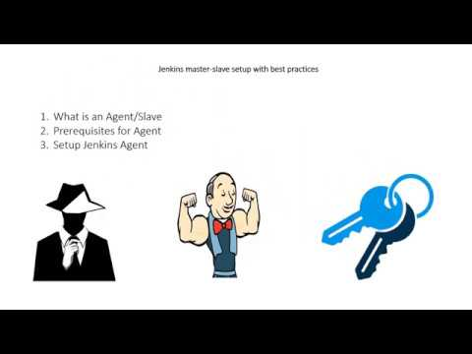](https://www.youtube.com/watch?v=TXbOw0ffTMk)

Jenkinsfile:

node{

def docker=tool name: 'docker', type: 'org.jenkinsci.plugins.docker.commons.tools.DockerTool'

def dockerCMD = "$docker/bin/docker"

stage('Checkout GIT Project'){

git credentialsId: 'git credentials', url: 'https://github.com/panidummy/DynamicWeb.git'

}

stage('build and Test'){

def MAVEN_HOME = tool name: 'maven-3', type: 'maven'

sh "${MAVEN_HOME}/bin/mvn clean package"

}

stage('Build docker image'){

sh "${dockerCMD} build -t panikumar1001/dynamicpro:3 ."

}

stage('Push docker image'){

withCredentials([string(credentialsId: 'dockerPwd', variable: 'dockerPassword')]) {

sh "${dockerCMD} login -u panikumar1001 -p ${dockerPassword}"

}

sh "${dockerCMD} push panikumar1001/dynamicpro:3"

}

stage('Run docker image'){

sh "${dockerCMD} run -p 8082:8080 -d panikumar1001/dynamicpro:3"

}

}

This file is checked-in into GitHub in ‘Maven_SpringBoot’ project

CI_CD_Pipeline project on jenkins:

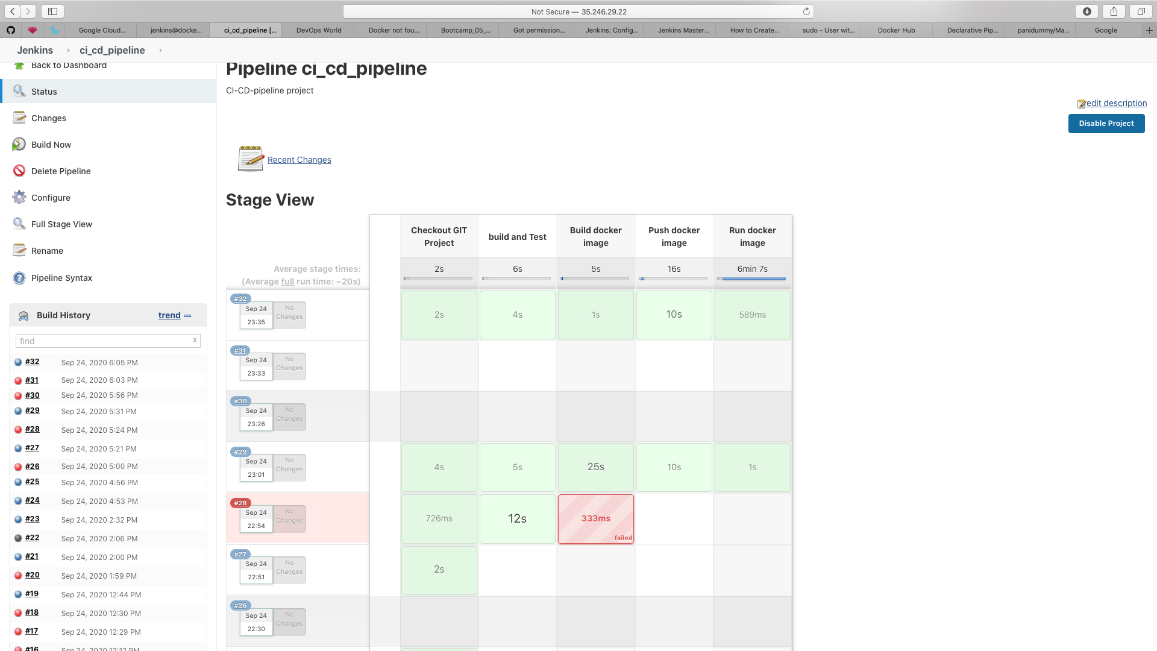

Latest build NO: 32 console log:

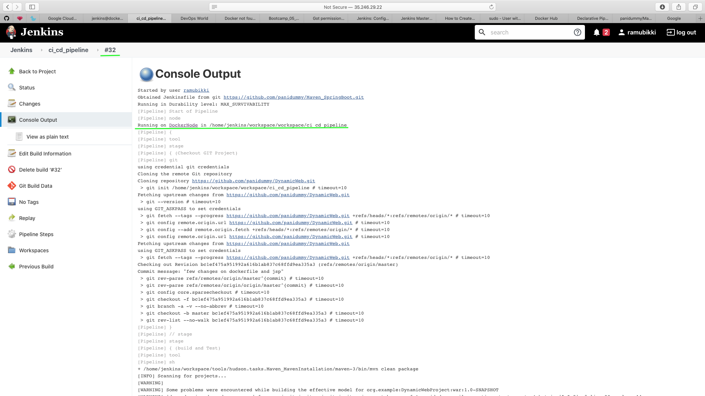

Docker Node (i.e Docker VM acting as a slave node and connected through SSH connnection):

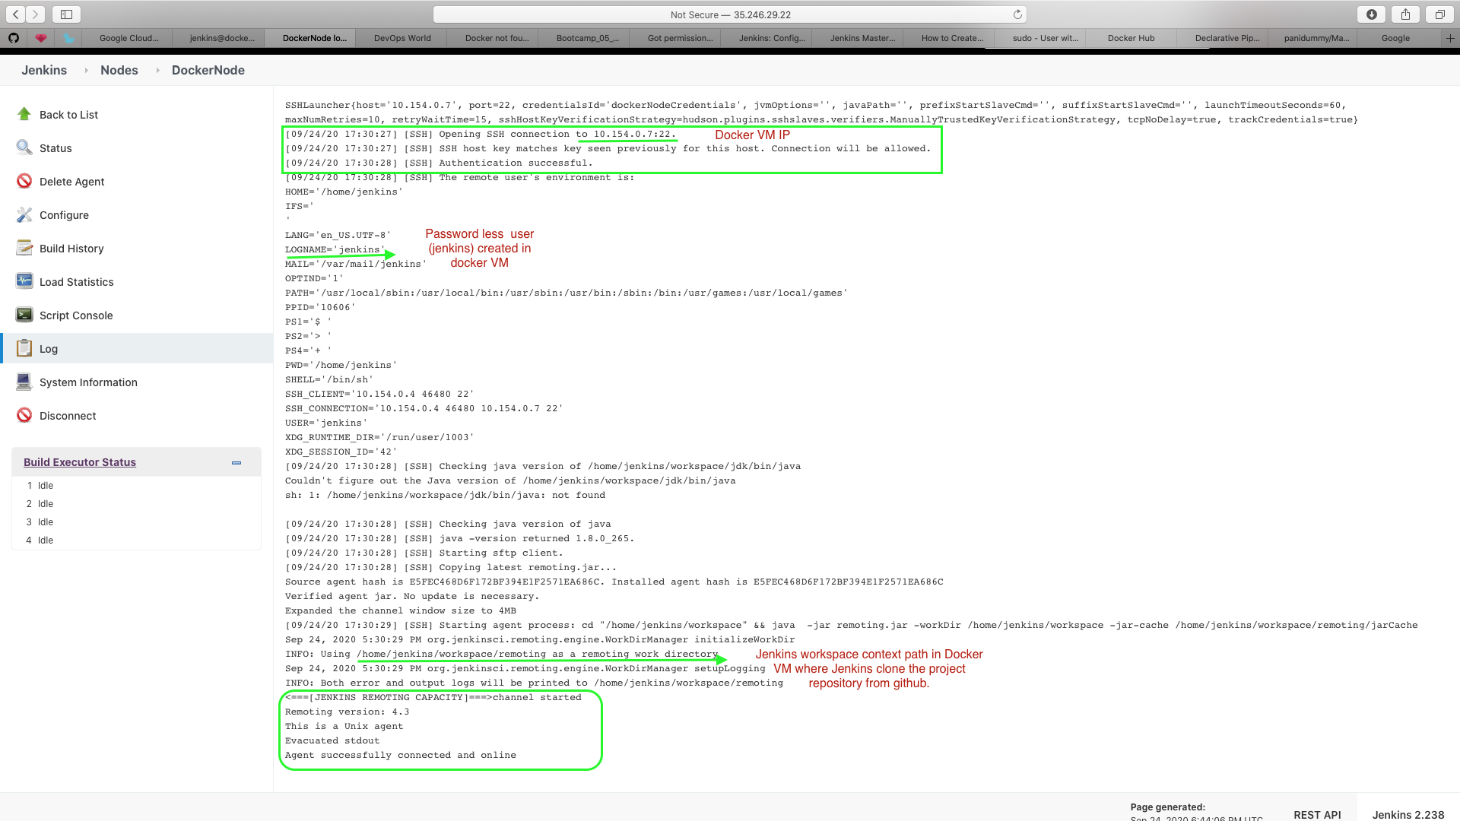

Below image illustrate that project downloaded in Docker VM :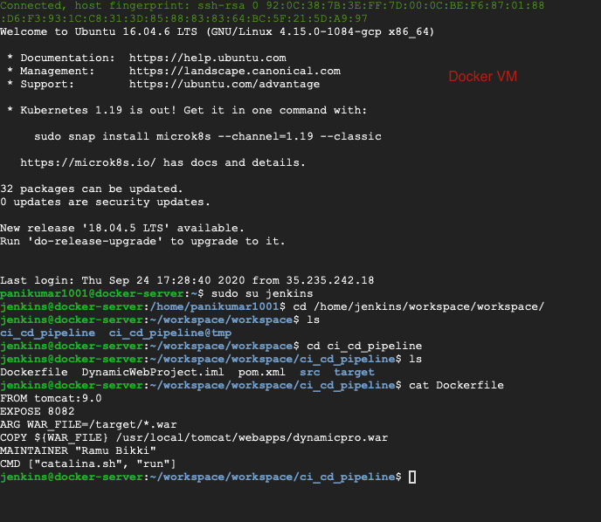

Docker image running in Docker VM:

