### Write a docker file to crate a docker image for your Springboot application and push that image to docker hub repository. then pull the same image from repository and run it.

1. Create a docker file and keep it at the same place where super pom.xml is available in springboot application.

Springboot maven project url : https://github.com/panidummy/Maven_SpringBoot.git

Dockerfile:

**FROM** openjdk:8-jdk-alpine

**EXPOSE** 8081

**ARG** JAR_FILE=target/*.jar

**COPY** ${JAR_FILE} app.jar

**RUN** echo **"docker image is in progress.."**

**ENTRYPOINT** [**"java"**, **"-jar"**, **"app.jar"**]

**MAINTAINER "panikumar1001@gmail.com"**

2. Create a docker image :

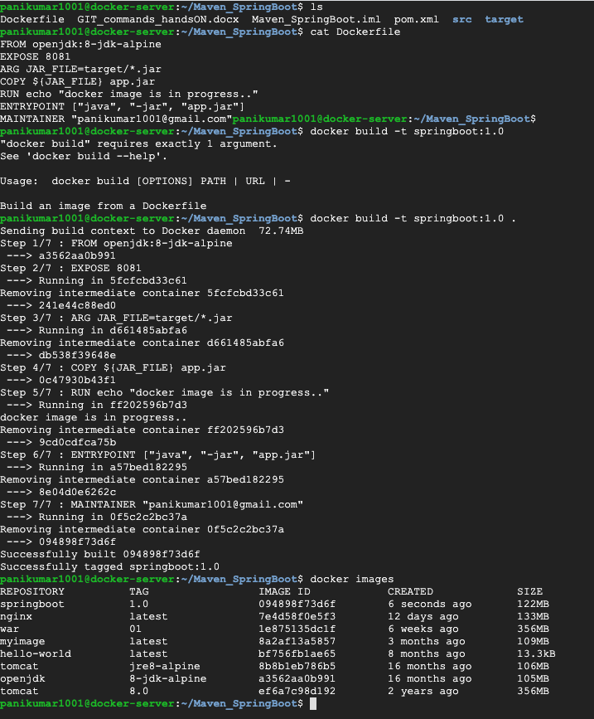

3. Run docker image as service:

-> with detached mode (i.e using -d )

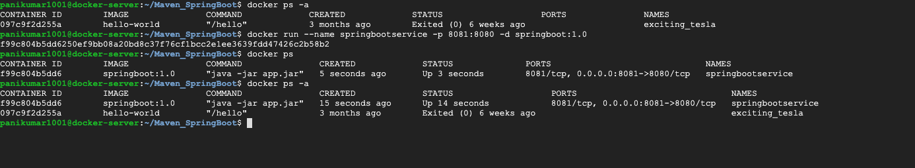

-> without detached mode (i.e with out using -d)

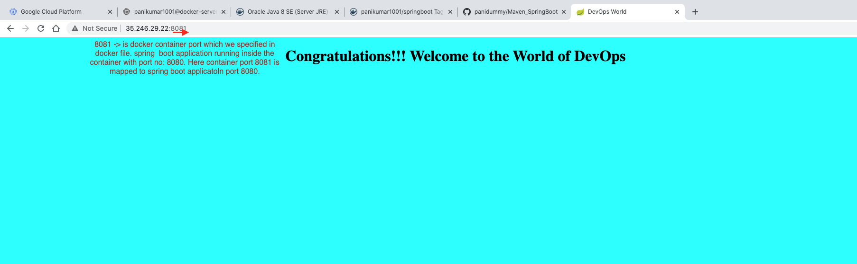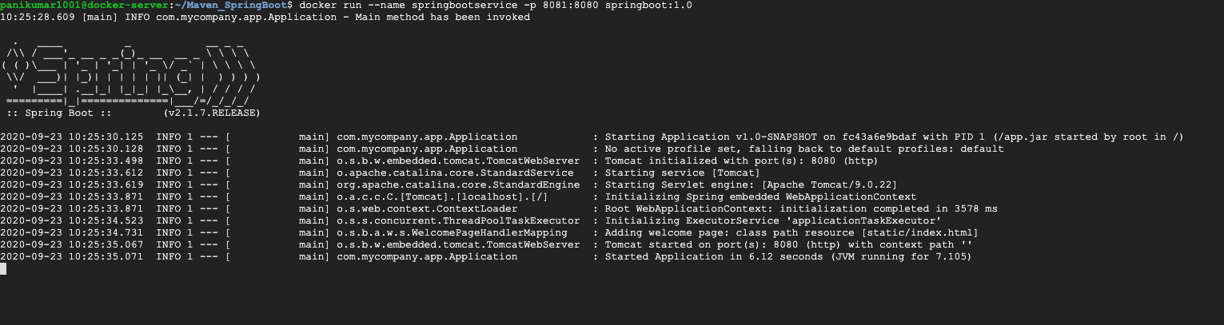

4. push docker image to docker repository (i.e. docker hub).

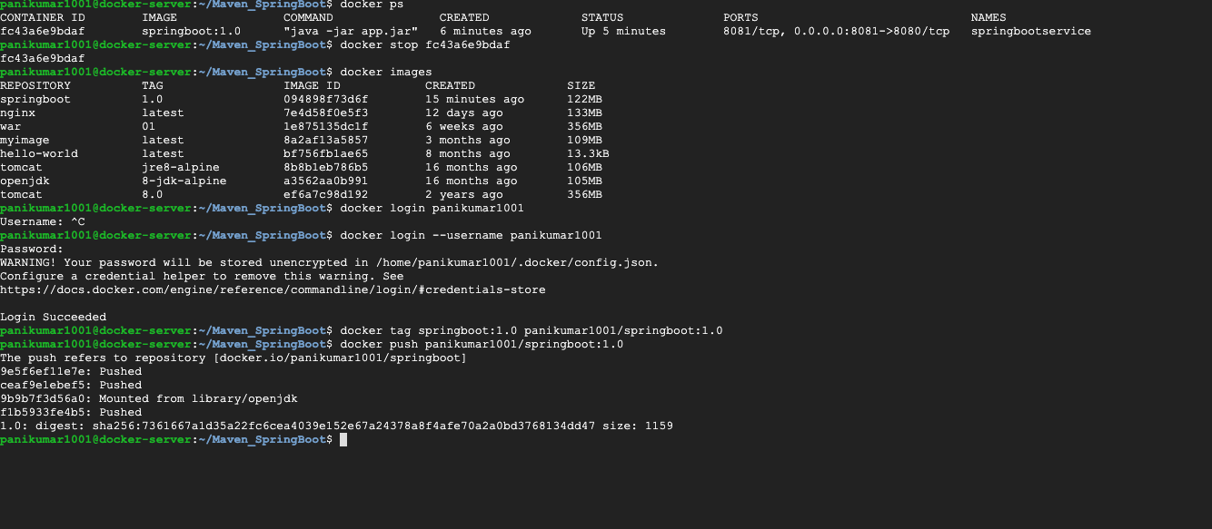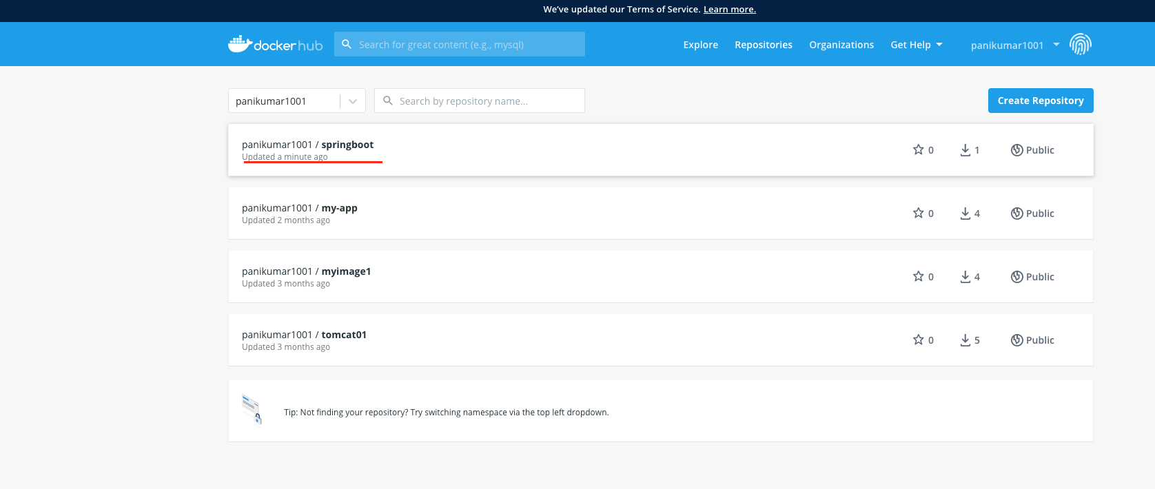

5. Pull docker image from docker hub and run it:

