Established – 1961 Subject:INTERNET OF THINGS
SEVA SADAN’S
















OF


ARTS, SCIENCE & COMMERCE ULHASNAGAR – 421 003
CERTIFICATE

This is to certify that Mr./Ms. Sarthak Panigrahi
of S.Y. Computer Science (SYCS) Roll No. 2524030 has satisfactorily completed The Internet Of Thing Mini Project entitled
Flood Level Monitoring System
during the academic year 2025 – 2026, as a part of the practical requirement. The project work is found to be satisfactory and is approved for submission.

PROF. INCHARGE HEAD OF DEPT

________________ _________________

INDEX

Sr. No. | Chapters | Page No.
1 | Introduction
2 | Requirement Specification
3 | System Design
4 | Implementation
5 | System Testing and Result
6 | Future Scope and Conclusion
7 | References
8 | Glossary

1. Introduction

Floods are one of the most common natural disasters and cause serious damage to human life, property, agriculture, and infrastructure. Many flood accidents happen because people do not receive warnings at the right time. Traditional flood monitoring methods are slow, manual, and not very accurate.

To solve this problem, the Flood Level Monitoring System is designed using IoT (Internet of Things) technology. This system continuously monitors the water level in rivers, dams, or flood-prone areas and provides early warnings when the water level rises beyond a safe limit.

In this project, an ultrasonic sensor is used to measure the distance between the sensor and the water surface. A microcontroller (ESP8266) processes this data and displays the water level on an LCD screen. LEDs and a buzzer are used to give visual and sound alerts when the water level reaches warning or danger levels.

The main advantage of this system is that it works automatically and provides real-time monitoring. It helps authorities and local people to take preventive actions early and reduce damage caused by floods. This project is simple, cost-effective, and suitable for real-time flood monitoring applications.

2. Requirement Specification

Requirement specification describes the hardware and software requirements needed to design and implement the Flood Level Monitoring System. These requirements help in accurate monitoring and timely alert generation.

2.1 Hardware Requirements

The following hardware components are used in this project:
- ESP8266 Microcontroller
It is the main controller of the system. It collects data from the ultrasonic sensor, processes it, and sends alert messages.
- Ultrasonic Sensor (HC-SR04)
Used to measure the distance between the sensor and the water surface to determine the water level.
- 16×2 LCD Display
Displays the water level and system status.
- Single LED
Acts as a visual alert indicator when the water level reaches a warning or danger level.
- Buzzer
Produces sound alerts during high water levels.
- Breadboard
Used for making circuit connections.
- Jumper Wires
Used to connect all components.
- Power Supply (USB / 5V Source)
Provides power to the ESP8266.

2.2 Software Requirements

- Arduino IDE
Used to write, compile, and upload the program to the ESP8266.
- ESP8266 Board Package
Required to program the ESP8266 in Arduino IDE.

- Telegram Bot API
Used to send real-time alert messages to users through Telegram when the water level crosses the danger limit.
- Required Libraries
Libraries such as LiquidCrystal and WiFi libraries are used for LCD display and internet connectivity.

3. System Design

System design explains how all the components of the Flood Level Monitoring System are arranged, connected, and work together to monitor water level and send alerts.
The system is designed using an IoT-based architecture, where the ESP8266 acts as the central control unit. All input and output devices are connected to the ESP8266.

3.1 System Architecture

The system consists of the following main blocks:
- Sensing Unit
The ultrasonic sensor is placed above the water surface. It continuously measures the distance between the sensor and the water level.
- Processing Unit
The ESP8266 receives distance data from the ultrasonic sensor and converts it into water level information. It compares this value with predefined threshold levels.
- Display Unit
A 16×2 LCD is used to display the current water level and alert messages.
- Alert Unit
  - A single LED glows when the water level exceeds the safe limit.
  - A buzzer sounds during dangerous water levels.
  - A Telegram Bot sends real-time alert messages to users’ mobile phones through the internet.
- Power Supply Unit
The system is powered using a USB or 5V power source.

3.2 Data Flow Description

- The ultrasonic sensor sends ultrasonic waves and receives the echo from the water surface.
- The ESP8266 calculates the distance and determines the water level.
- The water level is displayed on the LCD.
- When the water level crosses the set threshold:
  - The LED turns ON
  - The buzzer activates
  - An alert message is sent via Telegram

4. Implementation

Implementation describes the practical steps followed to develop and test the Flood Level Monitoring System using IoT technology. This phase includes hardware setup, software programming, and alert configuration.

4.1 Hardware Implementation

- The ESP8266 is placed on the breadboard and powered using a USB cable.
- The ultrasonic sensor (HC-SR04) is connected to the ESP8266 to measure the distance between the sensor and the water surface.
- The 16×2 LCD display is connected to the ESP8266 to display water level readings and system status.
- A single LED is connected as a visual alert indicator.
- A buzzer is connected to provide an audible alert during high water levels.
- All components are connected using jumper wires, ensuring proper power and ground connections.

4.2 Software Implementation

- The program is written using the Arduino IDE.
- Required libraries for LCD display, ultrasonic sensor, and WiFi connectivity are included.
- The ESP8266 is connected to a WiFi network to enable internet access.
- A Telegram Bot is created using the Telegram Bot API.
- The bot token and chat ID are added to the program to send alert messages.
- Threshold water levels are defined in the code for normal and danger conditions.

4.3 Alert Implementation

- When the water level is normal, the system only displays readings on the LCD.
- When the water level exceeds the threshold:
  - The LED turns ON
  - The buzzer activates
  - A Telegram alert message is sent to the user’s mobile phone

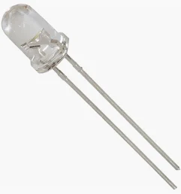
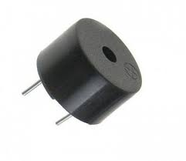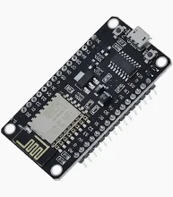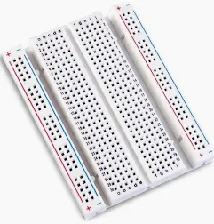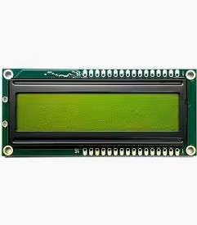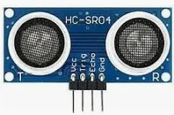

5. System Testing and Result

System testing is performed to verify whether the Flood Level Monitoring System works correctly under different water level conditions. Each component and function of the system is tested individually and as a complete system.

5.1 System Testing

The testing of the system is carried out in the following steps:
- Sensor Testing
The ultrasonic sensor is tested by placing objects at different distances to check whether it correctly measures distance and detects changes in water level.

Microcontroller Testing
The ESP8266 is tested by uploading the program and verifying that it correctly processes the sensor data.
- LCD Testing
The LCD display is tested to ensure that the water level values and alert messages are displayed clearly.
- LED and Buzzer Testing
The LED and buzzer are tested by increasing the water level beyond the threshold value to check whether visual and sound alerts are activated.
- Telegram Alert Testing
The Telegram bot is tested by simulating high water levels. When the threshold is crossed, an alert message is successfully sent to the registered Telegram user through WiFi.
- Overall System Testing
The complete system is tested by gradually increasing the water level and observing the sensor readings, alerts, and Telegram messages.

5.2 Results

The system successfully detects changes in water level and provides timely alerts. The LCD displays real-time water level data accurately. When the water level crosses the danger limit,

the LED glows, the buzzer sounds, and alert messages are instantly received on Telegram.
The testing results show that the system works reliably and can be effectively used for real-time flood monitoring and early warning applications.

6. Future Scope

The Flood Level Monitoring System can be further improved and expanded in the future to make it more efficient and useful in real-world applications.

- More sensors can be added to monitor multiple locations at the same time.
- A mobile application can be developed to show real-time water level data.
- The system can be integrated with cloud platforms for data storage and analysis.
- SMS, email, or voice call alerts can be added along with Telegram alerts.
- Solar power can be used to make the system energy-efficient and suitable for remote areas.
- AI or data analytics can be applied to predict floods in advance based on historical data.
This future enhancement will help in improving accuracy and provide better disaster management solutions.

6.1. Conclusion

In this project, an IoT-based Flood Level Monitoring System has been successfully designed and implemented. The system continuously monitors the water level using an ultrasonic sensor and processes the data using an ESP8266 microcontroller.
The current water level is displayed on an LCD screen, and alerts are provided using a single LED, buzzer, and Telegram bot. When the water level crosses the danger limit, the system immediately sends warning messages, helping people take early preventive action.
This system is simple, cost-effective, reliable, and easy to implement. It is very useful for flood-prone areas and can help reduce loss of life and property by providing early warnings. The project also demonstrates the effective use of IoT technology in real-time monitoring and alert systems.

7. References

- Arduino Official Website – Documentation and tutorials for microcontroller programming.
- Espressif Systems – ESP8266 Technical Datasheet and Wi-Fi module documentation.
- Telegram Official Documentation – Telegram Bot API reference.
- GitHub – Open-source IoT project codes and examples.
- Google – Used for technical articles and research support.
- Research papers and articles related to IoT-based Flood Monitoring Systems.

8. Glossary

IoT (Internet of Things):
A technology that allows physical devices to connect to the internet and share data automatically.
Flood Level Monitoring System:
A system used to measure and monitor the water level in rivers or flood-prone areas and provide early warnings.
ESP8266:
A Wi-Fi enabled microcontroller used to process data and send alerts through the internet.
Ultrasonic Sensor (HC-SR04):
A sensor that measures distance by sending ultrasonic waves and receiving the reflected echo from the water surface.
Microcontroller:
A small computer on a single chip used to control electronic devices.
LCD (Liquid Crystal Display):
A display device used to show water level readings and alert messages.
LED (Light Emitting Diode):
A light used as a visual indicator for warning conditions.
Buzzer:
An electronic device that produces sound alerts.

Telegram Bot:
An automated program that sends alert messages to users through the Telegram application.
Threshold Level:
A predefined water level limit used to trigger alerts.
Real-Time Monitoring:
Continuous observation and measurement of data as it happens.
Wi-Fi Connectivity:
A wireless communication technology that allows the ESP8266 to connect to the internet.
Arduino IDE:
A software platform used to write and upload programs to microcontrollers.

